NAME: KARTHIK AKULA
ID: 2534405

LAB-1

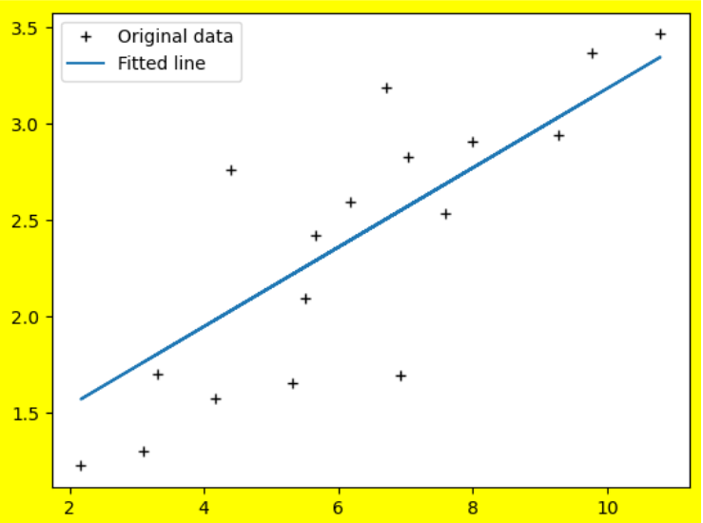

NAME: KARTHIK AKULA
ID: 2534405

LAB-2

Question-1
Accuracy: 1.000

Question-2

