NAME: KARTHIK AKULA
ID: 2534405

LAB-1

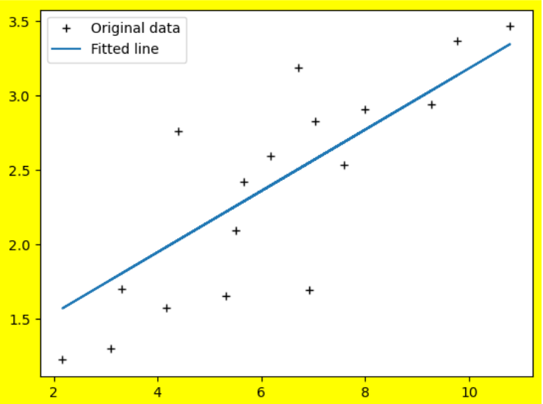

NAME: KARTHIK AKULA
ID: 2534405

LAB-2

Question-1
The accuracy of model is 0.8290
Question-2

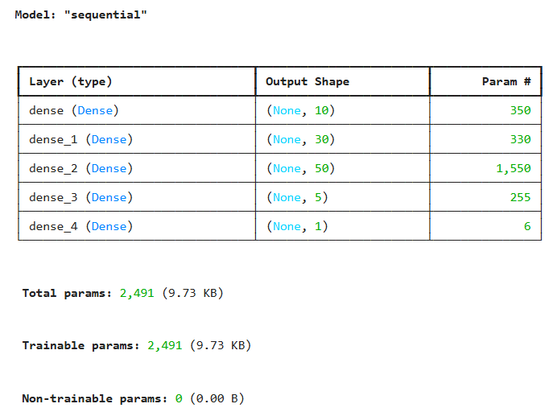

Question-3
O1=1.5787
O2=1.5787

NAME: KARTHIK AKULA
ID: 2534405

LAB-3

Question-1
Accuracy: 0.8815

Question-2

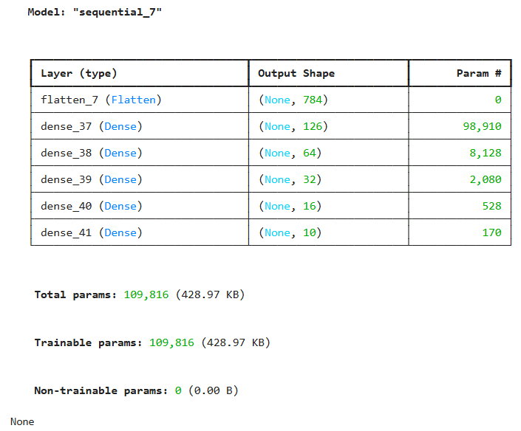

NAME: KARTHIK AKULA
ID: 2534405
LAB-4

Question-1
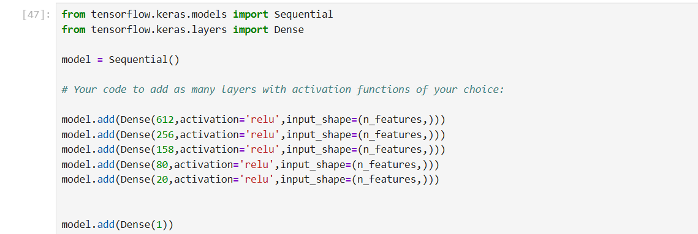

Question-2
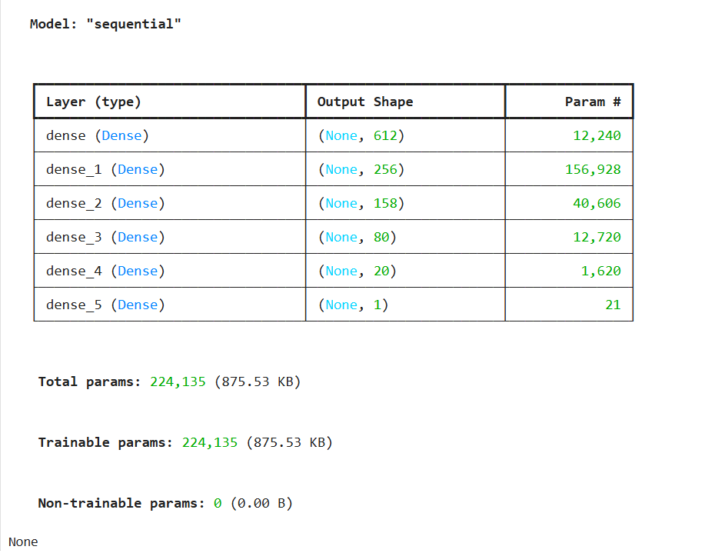
Question-3

Question-4
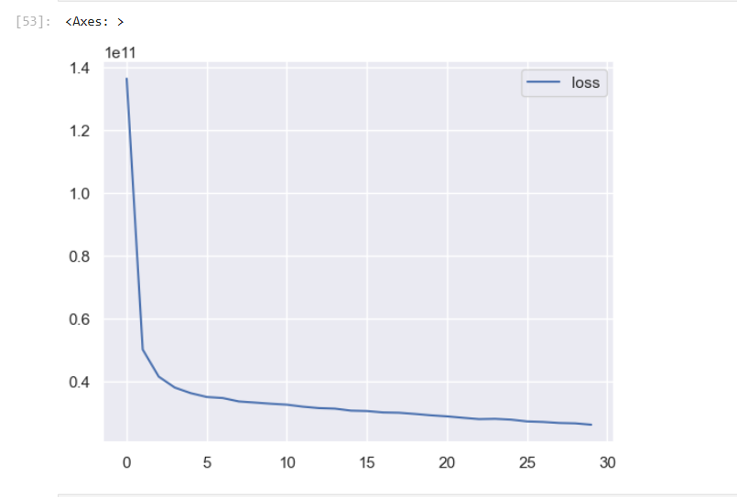Question-5
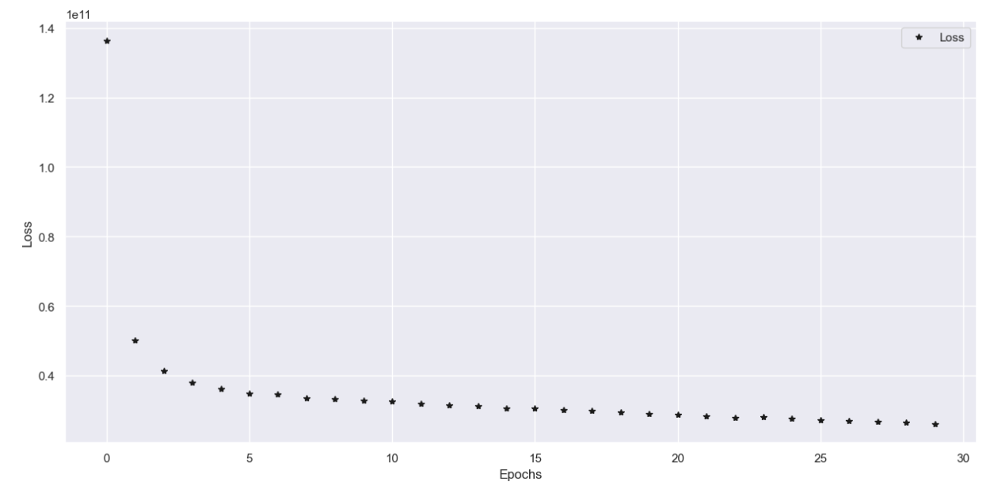
NAME: KARTHIK AKULA
ID: 2534405

LAB-5

Question-1
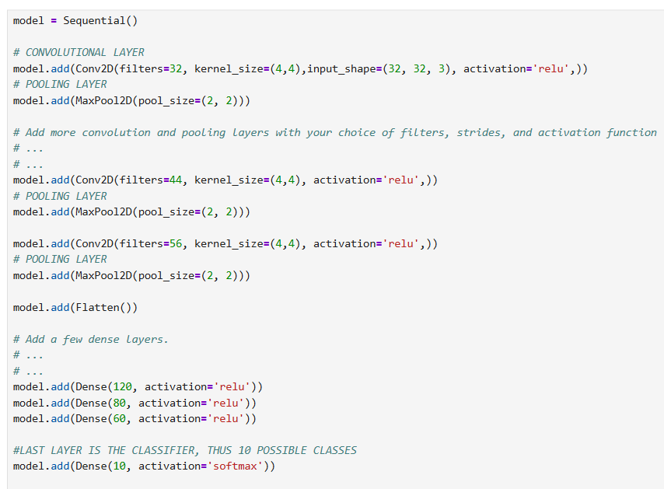

Question-2
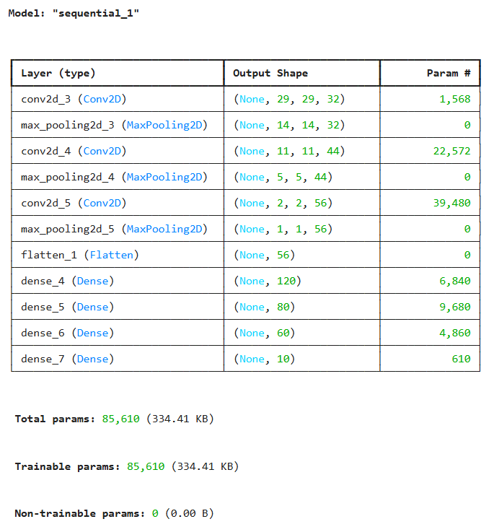

Question-3
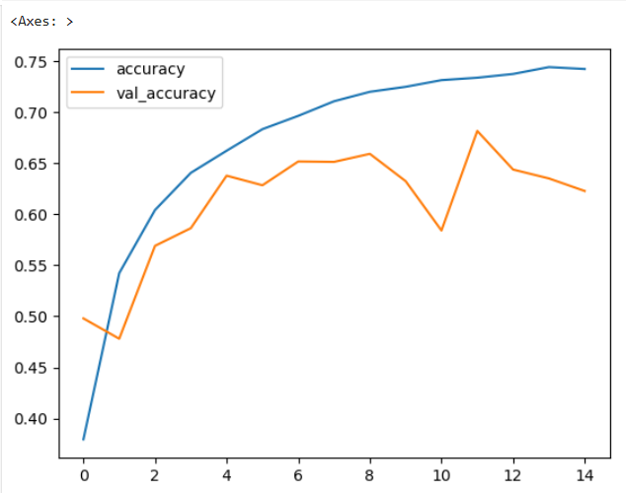
Question-4
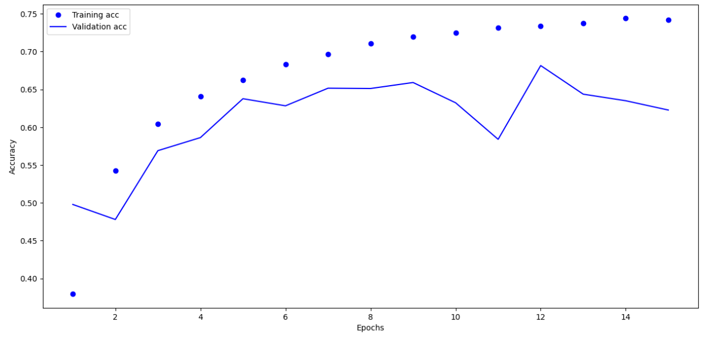

Question-5
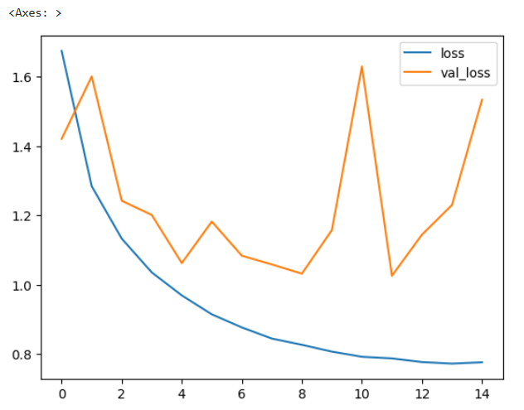
Question-6
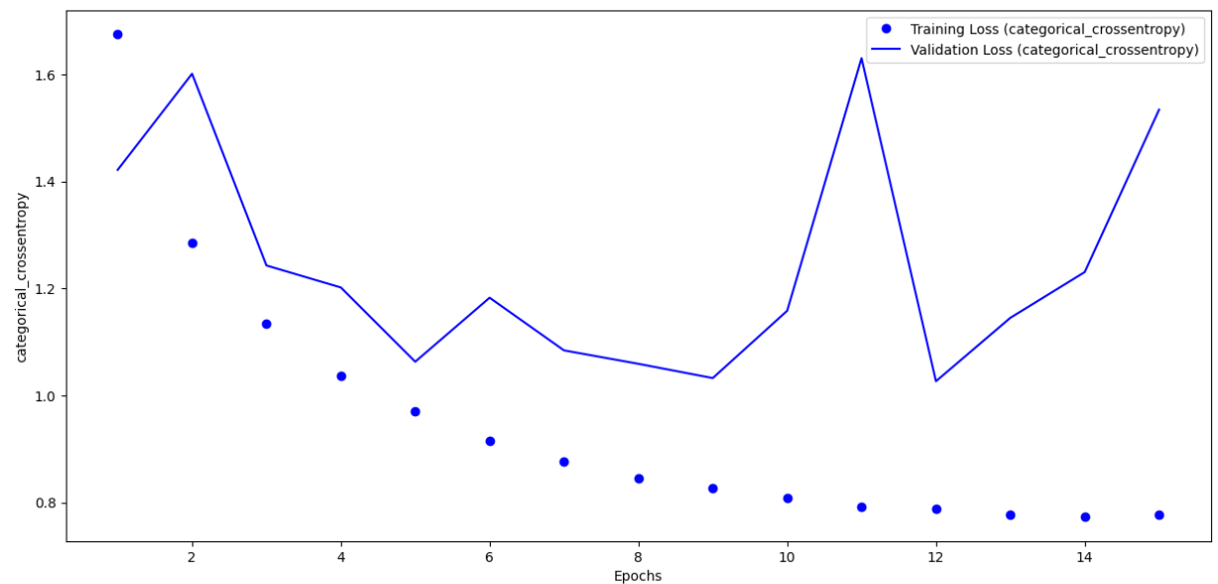
Question-7
The optimal number of epochs for training the model is 5
NAME: KARTHIK AKULA
ID: 2534405

LAB-6

Question-1
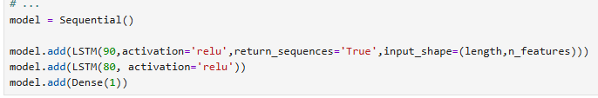
Question-2
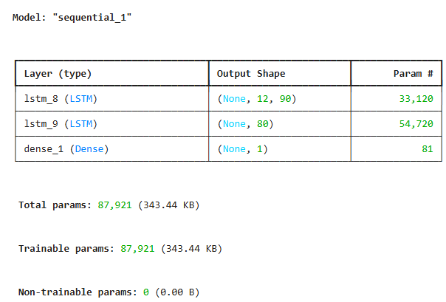
Question-3
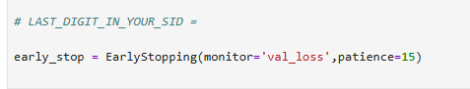

Question-4
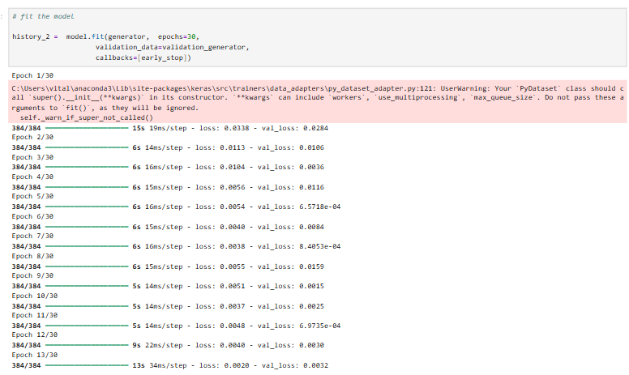

Question-5
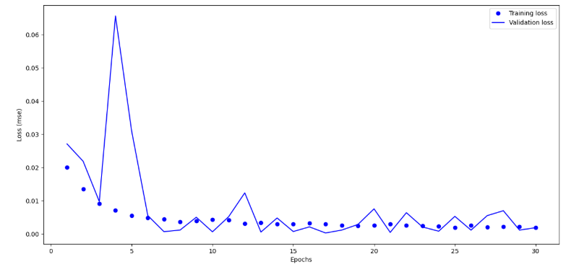
Question-6
The optimal number of epochs for training the model is 10

Question-7
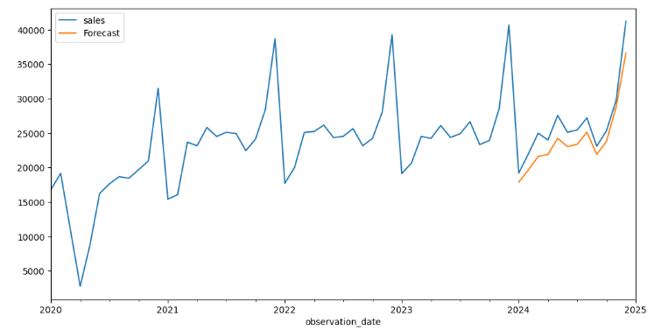

NAME: KARTHIK AKULA
ID: 2534405

LAB-7

Question-1
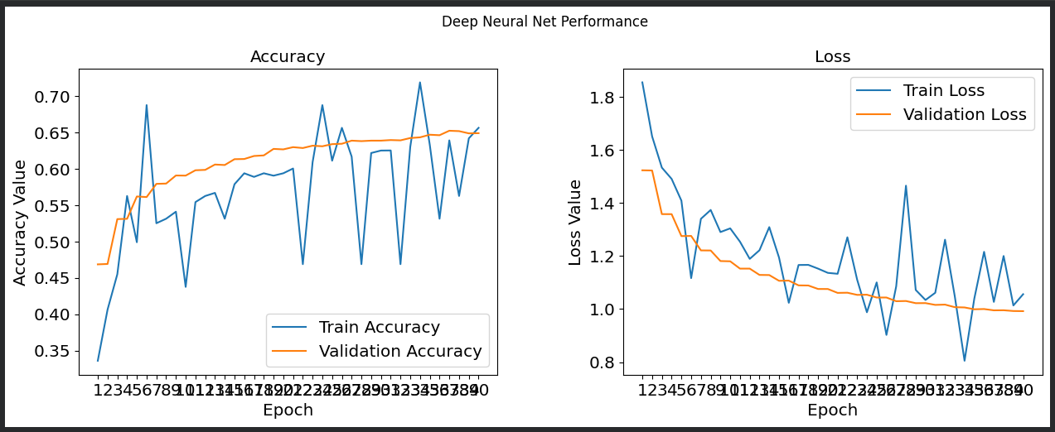
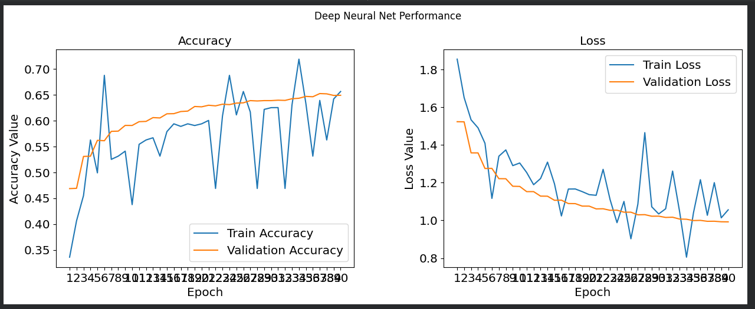
The optimal number of epochs for training your VGG16 and VGG19 models are 40 and 39
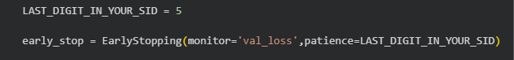


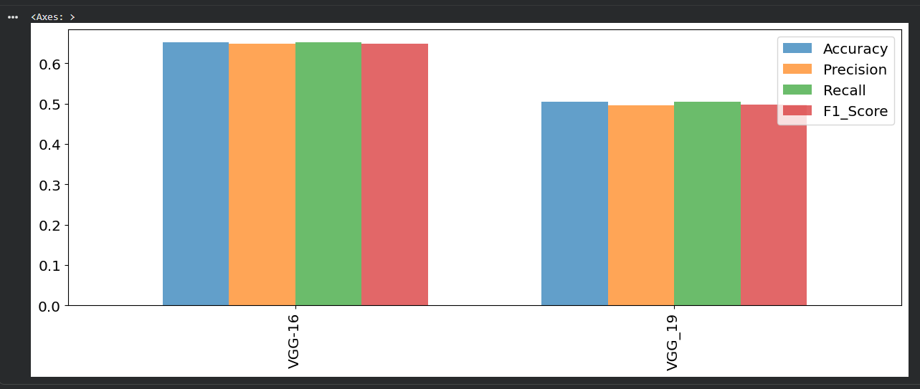

NAME: KARTHIK AKULA
ID: 2534405

LAB-8

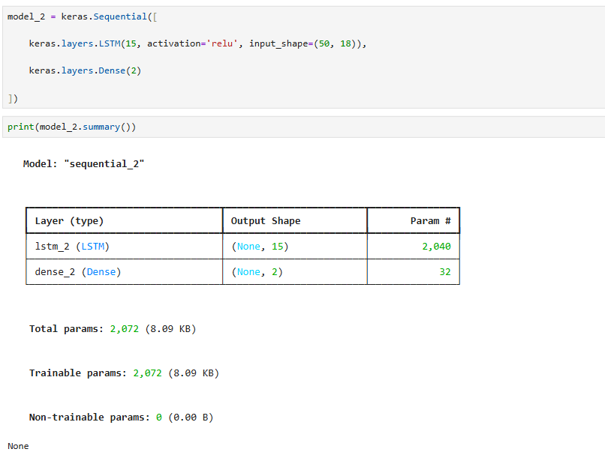

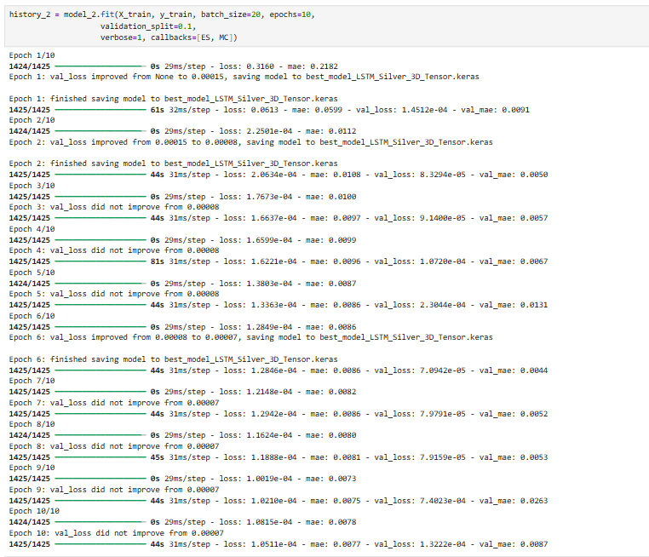
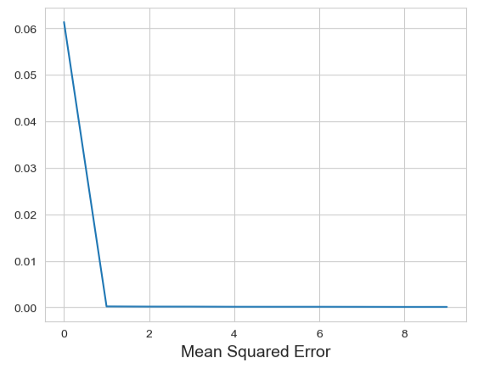

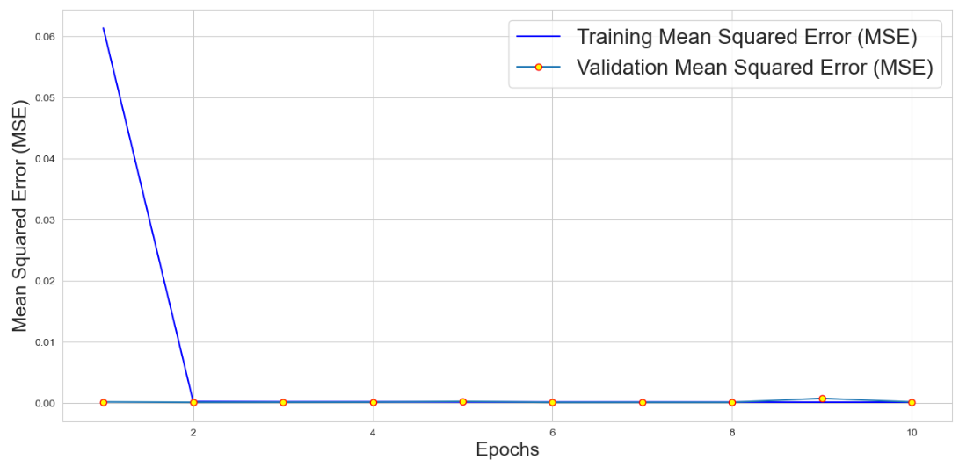
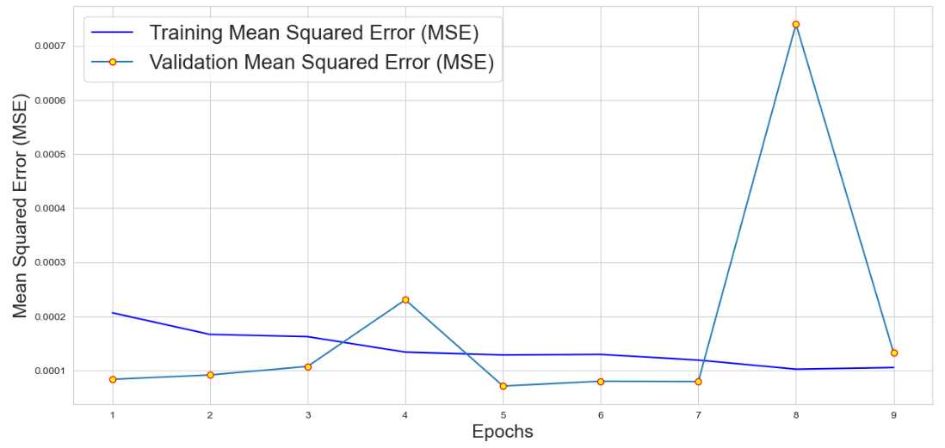

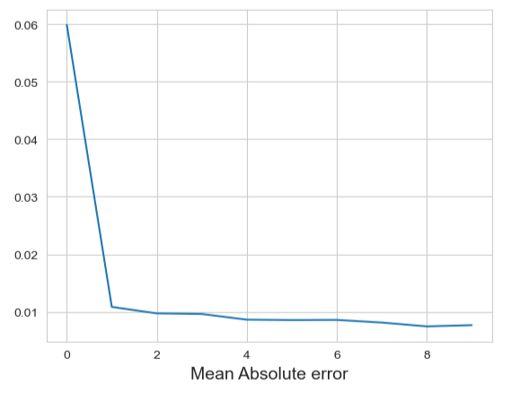
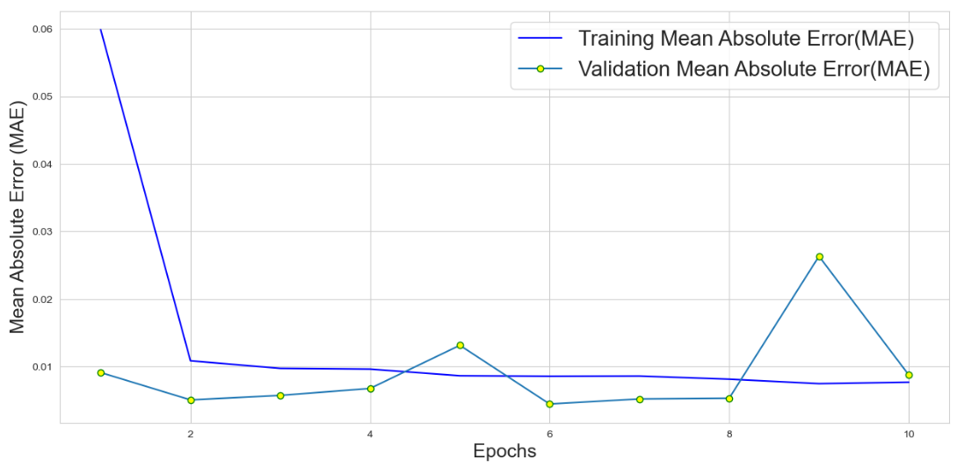

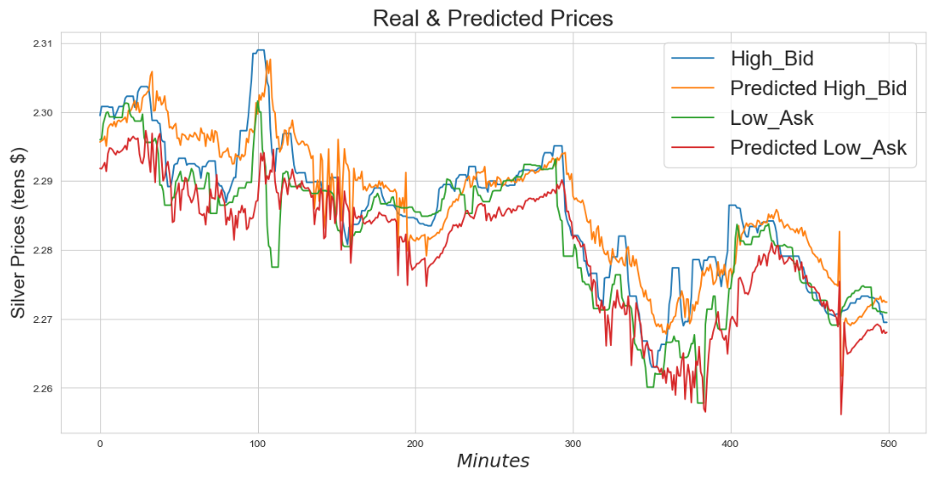

NAME: KARTHIK AKULA
ID: 2534405

LAB-9

