WEEK 3 TASK REPORT
Unsupervised Learning and Clustering Analysis
Virtual Data Science with Python Trainee
Prepared by: Allu Shyam Sundar Karthik
Dataset: Titanic — Machine Learning from Disaster
Analysis input: titanic_cleaned.csv prepared in Week 1

1. Objective
This task applies unsupervised learning, specifically clustering, to a publicly available dataset. The same cleaned Titanic dataset used in Weeks 1 and 2 is retained to provide continuity across the internship. The goal is to segment passengers into data-driven groups using measurable passenger and travel characteristics, then describe the characteristics of each cluster without treating the clusters as predefined labels.
- Prepare a suitable numeric feature matrix for clustering.
- Standardize features so variables measured on different scales contribute more comparably.
- Use K-Means clustering and evaluate candidate cluster counts.
- Use hierarchical clustering with Ward linkage as a complementary method.
- Visualize clusters and profile their characteristics using descriptive statistics and post-clustering comparisons.

2. Dataset and Continuity from Weeks 1 and 2
The input is the cleaned Titanic dataset prepared in Week 1 and analyzed in Week 2. It contains 891 passenger records and 13 columns. The dataset includes original variables such as Pclass, Sex, Age, SibSp, Parch and Fare, together with derived variables such as CabinKnown, Title, FamilySize and IsAlone.
Using the same dataset provides a consistent workflow across the first three internship tasks. Week 1 focused on acquisition and preprocessing, Week 2 focused on exploratory analysis and visualization, and Week 3 builds an unsupervised learning layer on top of that prepared data.
- Rows: 891
- Columns: 13
- Age mean: 29.36 years
- Age median: 28.00 years
- Fare mean: 32.20
- Overall observed survival rate: 38.38%

3. Initial Exploration Before Clustering
Following the feedback from the earlier tasks, the initial exploration for Week 3 includes descriptive statistics, a distribution visualization, and a correlation matrix before clustering. These checks are used to understand scale, spread and relationships among candidate clustering variables.
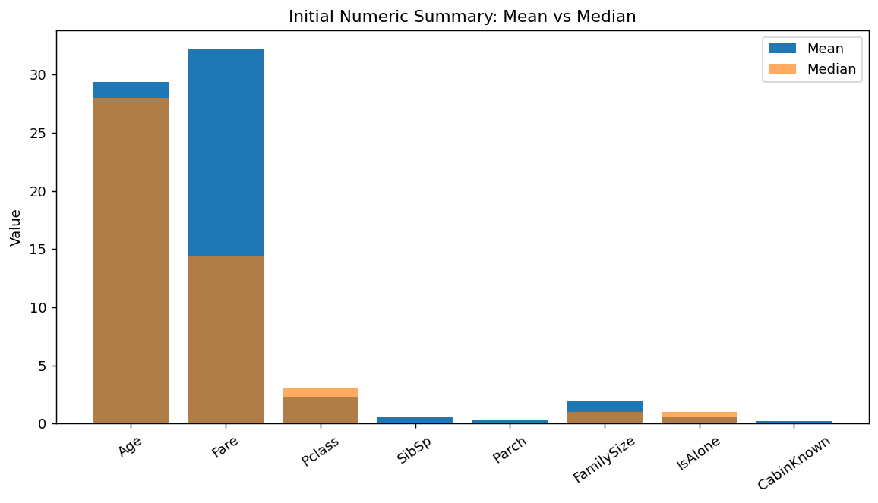
Figure 1. Mean and median of the numeric variables selected for clustering. The differences between mean and median provide a quick indication of skew or the influence of higher values, especially for Fare.
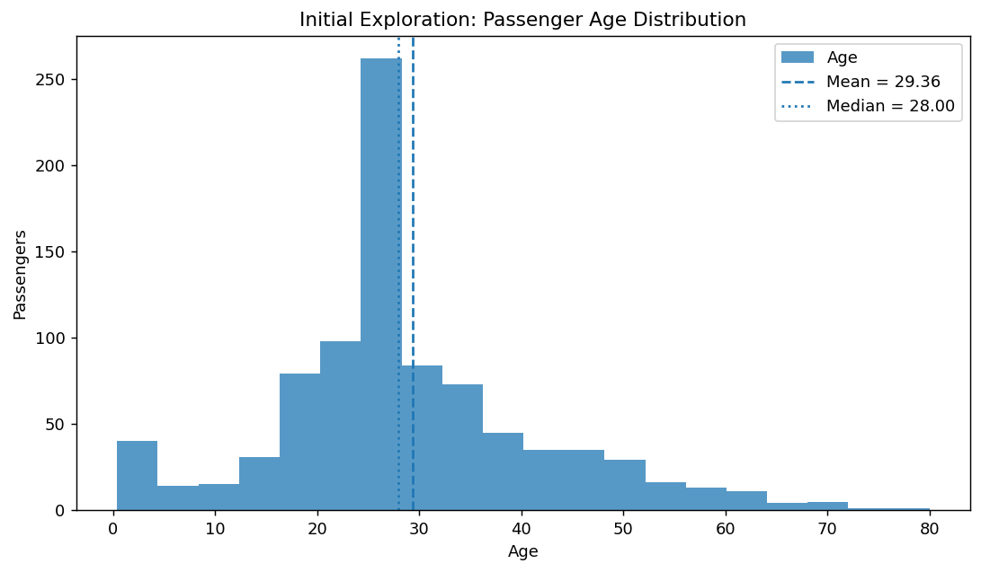
Figure 2. Age distribution used as part of the initial exploration. The distribution contains children, adults and older passengers, so the clustering input is not restricted to one narrow age range.
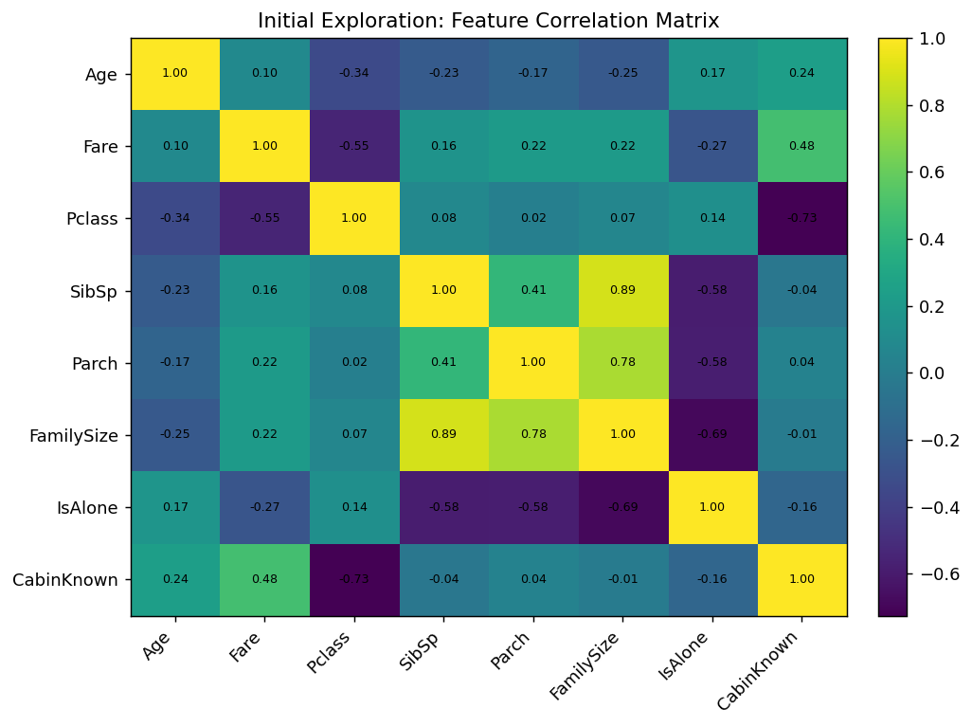
Figure 3. Correlation matrix of the candidate numeric clustering features. Strong relationships are visible among FamilySize, SibSp, Parch and IsAlone because some derived variables are constructed from related family-travel fields. These relationships are considered when interpreting clusters.

4. Feature Selection and Preprocessing
Clustering was performed using Age, Fare, Pclass, SibSp, Parch, FamilySize, IsAlone and CabinKnown. PassengerId was excluded because it is an identifier rather than a meaningful passenger characteristic. Survived was also excluded from the clustering input because it is an outcome variable; it is used only after clustering for descriptive profiling.
Sex, Embarked and Title were not directly included in the numeric K-Means matrix because they are categorical. They are retained in the original dataset and used for post-clustering descriptive comparisons where useful.
Standardization was performed with StandardScaler. This is important because Fare has a much larger numeric scale than binary indicators such as IsAlone and CabinKnown. Without scaling, large-magnitude variables could dominate Euclidean distance calculations. The standardized matrix was therefore used by both K-Means and Ward hierarchical clustering.
Reflective preprocessing note: the clustering results inherit the choices made during Week 1. In particular, Age was already imputed, Cabin was represented through CabinKnown, and FamilySize/IsAlone were derived. These choices improve consistency for analysis but also influence the geometry of the clustering space. Therefore, clusters should be interpreted as groups formed from this specific feature representation, not as universally correct passenger categories.

5. Clustering Methodology

5.1 K-Means
K-Means partitions observations into k groups by iteratively assigning observations to the nearest centroid and updating centroids. It was chosen because the task asks for a practical clustering analysis and because it provides compact cluster summaries and a straightforward interpretation of cluster centers.

5.2 Candidate Number of Clusters
Candidate values from k=2 through k=8 were evaluated using inertia and silhouette score. Inertia measures within-cluster squared distance, while the silhouette score summarizes how separated observations are from their own cluster compared with neighboring clusters.
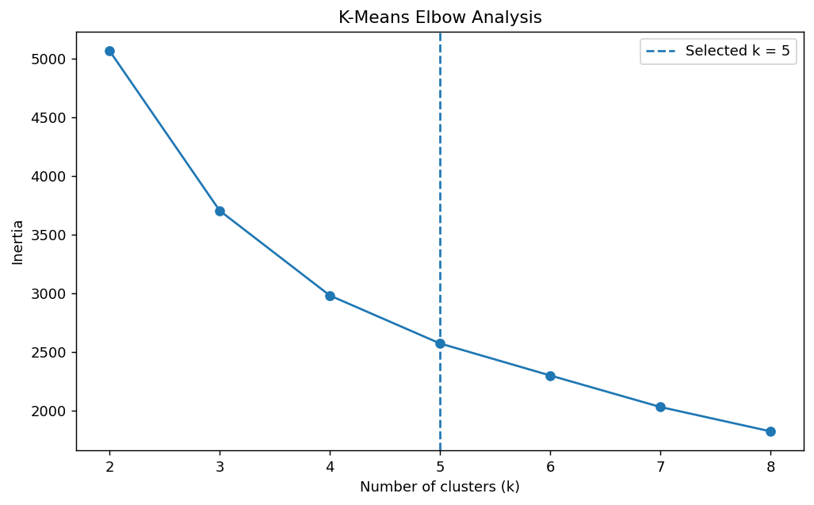
Figure 4. Elbow analysis for candidate K-Means cluster counts. Inertia decreases as k increases, so the curve is considered together with other evidence rather than using inertia alone.
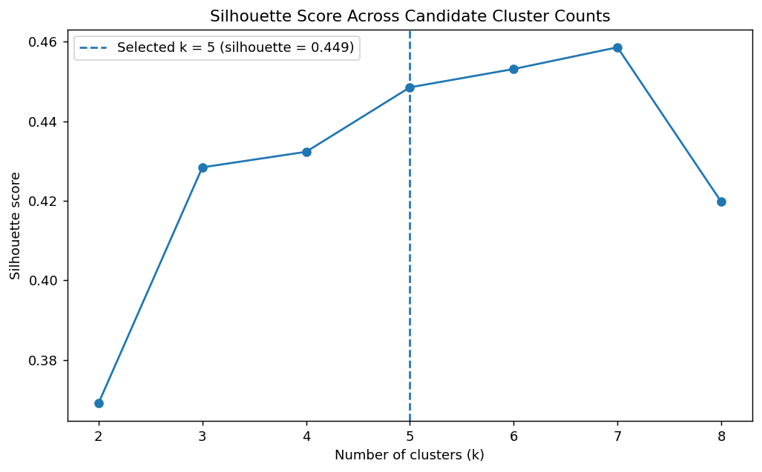
Figure 5. Silhouette scores for k=2 through k=8. The score for k=5 is 0.449. The highest tested score occurs at k=7 (0.459); however, k=5 was selected for this report because it lies in the elbow region and produces a more interpretable set of passenger segments. This is a modeling choice, not a claim that k=5 is the only valid solution.

6. K-Means Results with k=5
The selected K-Means model uses k=5, random_state=42 and n_init=20. The silhouette score is 0.449. Cluster sizes are shown below.
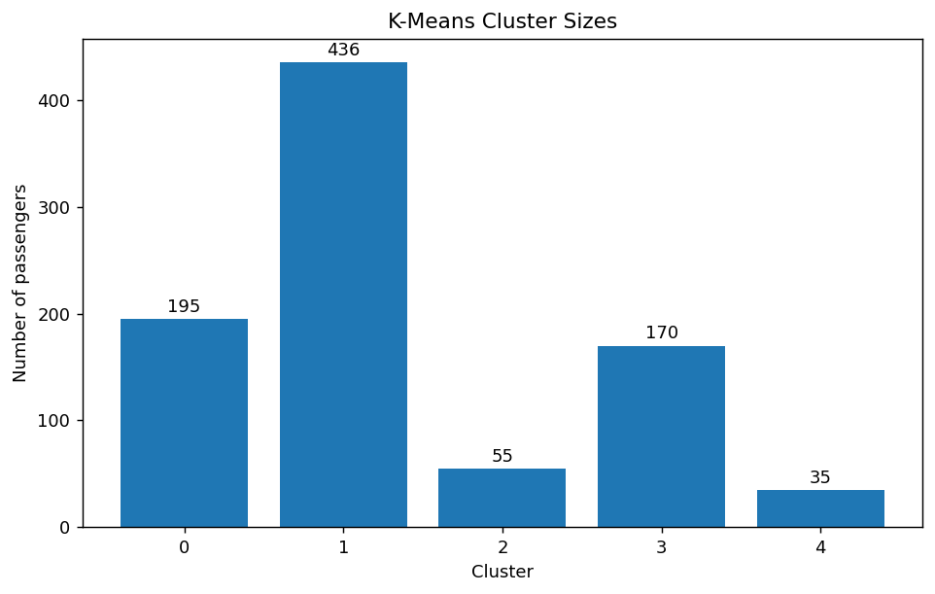
Figure 6. Number of passengers assigned to each cluster.
Cluster sizes: Cluster 0: 195, Cluster 1: 436, Cluster 2: 55, Cluster 3: 170, Cluster 4: 35.

7. Cluster Profiles
Cluster | Size | Mean Age | Mean Fare | Mean Pclass
0 | 195 | 24.24 | 22.36 | 2.56
1 | 436 | 29.34 | 11.38 | 2.70
2 | 55 | 18.09 | 36.62 | 2.98
3 | 170 | 39.31 | 57.67 | 1.07
4 | 35 | 27.51 | 215.93 | 1.00
Cluster 0: This group contains 195 passengers and is characterized as a mixed second/third-class group. Mean age is 24.24, mean fare is 22.36, mean passenger class is 2.56, mean FamilySize is 2.64, and the proportion marked IsAlone is 0.0%. CabinKnown is 5.6%. The observed survival rate is 50.8%; survival is used here only as a descriptive post-clustering profile, not as an input to K-Means.
Cluster 1: This group contains 436 passengers and is characterized as a predominantly solo-travel group. Mean age is 29.34, mean fare is 11.38, mean passenger class is 2.70, mean FamilySize is 1.00, and the proportion marked IsAlone is 100.0%. CabinKnown is 1.1%. The observed survival rate is 23.9%; survival is used here only as a descriptive post-clustering profile, not as an input to K-Means.
Cluster 2: This group contains 55 passengers and is characterized as a younger group with larger family/travel-group characteristics. Mean age is 18.09, mean fare is 36.62, mean passenger class is 2.98, mean FamilySize is 6.85, and the proportion marked IsAlone is 0.0%. CabinKnown is 0.0%. The observed survival rate is 9.1%; survival is used here only as a descriptive post-clustering profile, not as an input to K-Means.
Cluster 3: This group contains 170 passengers and is characterized as a first-class group with comparatively lower fares than the high-fare group. Mean age is 39.31, mean fare is 57.67, mean passenger class is 1.07, mean FamilySize is 1.55, and the proportion marked IsAlone is 55.3%. CabinKnown is 92.4%. The observed survival rate is 63.5%; survival is used here only as a descriptive post-clustering profile, not as an input to K-Means.
Cluster 4: This group contains 35 passengers and is characterized as a high-fare first-class group. Mean age is 27.51, mean fare is 215.93, mean passenger class is 1.00, mean FamilySize is 3.03, and the proportion marked IsAlone is 20.0%. CabinKnown is 88.6%. The observed survival rate is 74.3%; survival is used here only as a descriptive post-clustering profile, not as an input to K-Means.
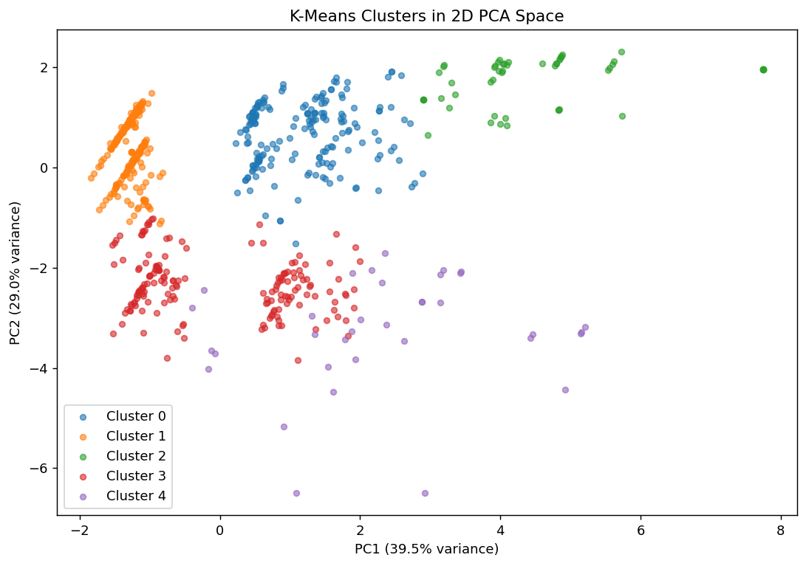
Figure 7. Two-dimensional PCA representation of the standardized feature space. The first two principal components explain 39.5% and 29.0% of the variance, respectively. The plot is a visualization aid; K-Means itself was fitted in the full standardized feature space.

8. Additional Cluster Visualizations
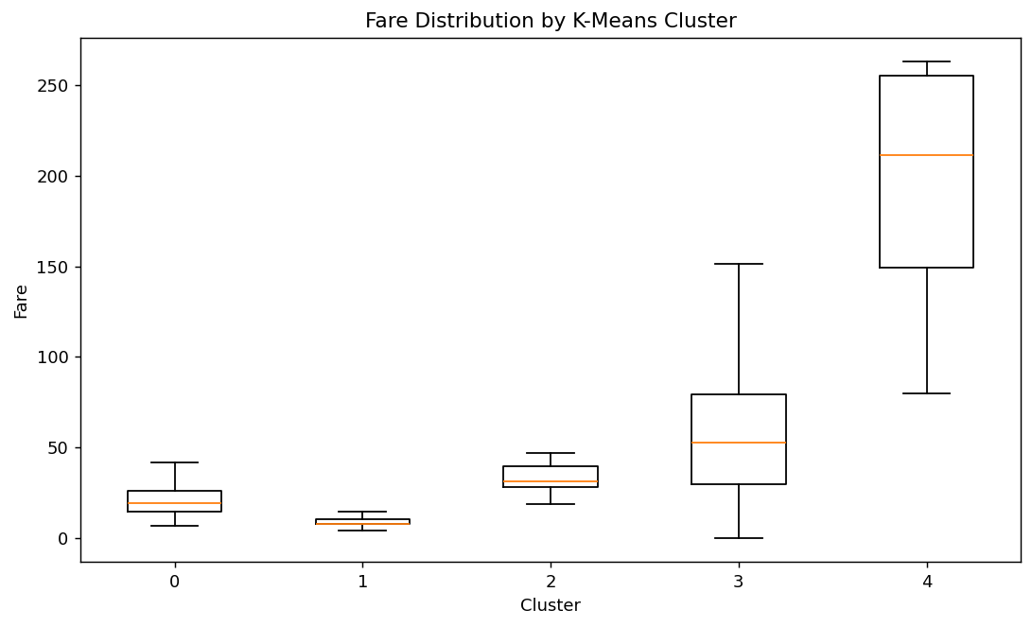
Figure 8. Fare distributions by cluster. The plot helps show how the fare variable contributes to separation between passenger groups. Extreme points are hidden for visual readability; the underlying data are unchanged.
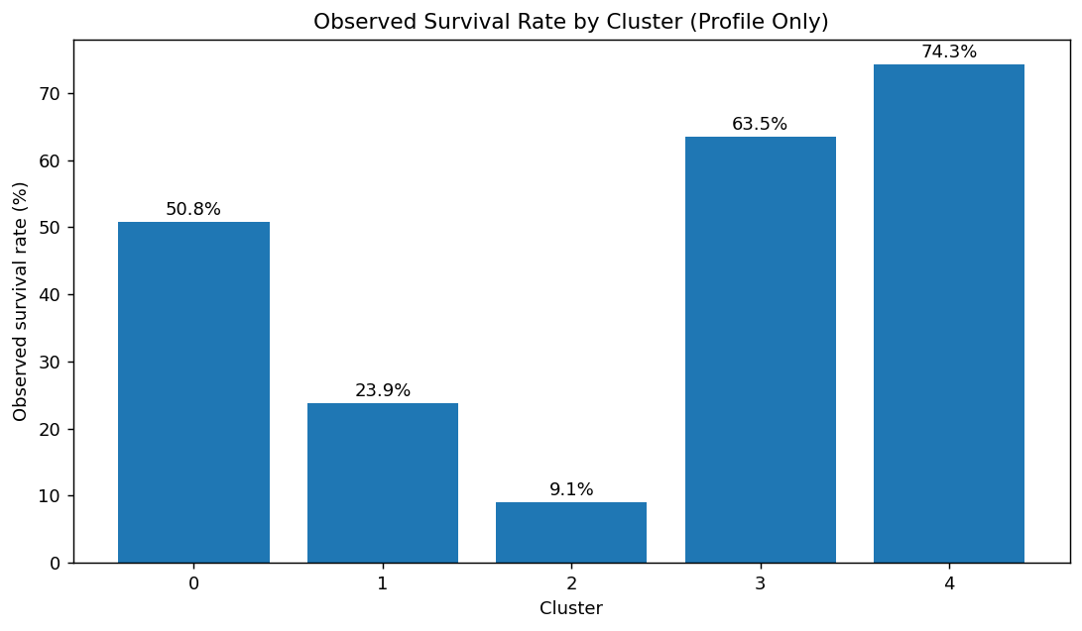
Figure 9. Observed survival rate by cluster. This is a post-clustering descriptive profile only because Survived was deliberately excluded from the clustering input.
The cluster profiles suggest that the unsupervised groups are not simply random partitions. Several clusters are differentiated by combinations of passenger class, fare, age, family-travel variables and cabin availability. For example, one small cluster has very high mean fare and entirely first-class passengers, while another large cluster is dominated by solo travelers and third-class passengers. These patterns show how clustering can reveal multidimensional segments that are not represented by a single original column.

9. Hierarchical Clustering
As a complementary method, Ward hierarchical clustering was applied to the same standardized feature matrix with five clusters. Ward linkage merges groups in a way that minimizes the increase in within-cluster variance at each step. The hierarchical model produced a silhouette score of 0.439 for five clusters.
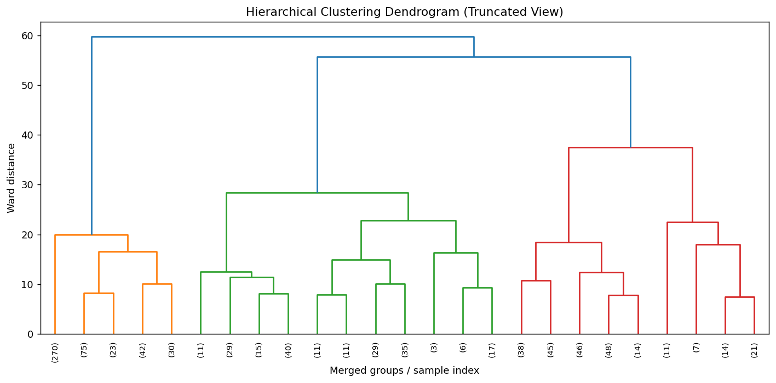
Figure 10. Truncated Ward-linkage dendrogram. The dendrogram illustrates the sequence of group merges. It is truncated because plotting all 891 observations individually would be difficult to read. The hierarchical method provides a different view of the same standardized feature space and can be used to examine whether broad group structure is present.

10. Interpretation of Cluster Characteristics
- Cluster 0 is a medium-sized group with mean Pclass around 2.56, moderate fare, and no passengers marked as alone on average. It represents a mixed second/third-class family-travel pattern.
- Cluster 1 is the largest group. It has mean Pclass around 2.70, low mean fare, and IsAlone close to 1, so it is dominated by passengers traveling alone and mostly in third class.
- Cluster 2 is a small group of younger passengers with mean age around 18 and very high third-class representation. Family/travel-group variables help distinguish it from the larger solo-traveler group.
- Cluster 3 is a first-class-oriented group with mean age around 39, moderate-to-high fare, and high CabinKnown representation. It is separated from Cluster 4 mainly by fare and related travel characteristics.
- Cluster 4 is the smallest group and has the highest mean fare, entirely first-class membership, high CabinKnown representation, and a higher observed survival rate in the post-clustering profile.
These descriptions are dataset-specific summaries rather than universal passenger types. The clusters are mathematical groupings created from the selected standardized features. Their meaning can change if different variables, transformations, scaling choices, distance measures or cluster counts are used.

11. Business / Research Interpretation
For a data-science workflow, clustering can be used to explore heterogeneous groups before building predictive models or designing follow-up analyses. In this dataset, the clusters provide a way to compare passenger segments across fare, class, age, family structure and cabin availability. A researcher could use these groups to formulate questions about how passenger characteristics interact. A business-style interpretation would treat the clusters as exploratory segments rather than customer categories with proven causal or behavioral meaning.
The analysis also demonstrates why feature engineering and preprocessing matter. FamilySize and IsAlone introduce additional structure, while standardization prevents Fare from overwhelming smaller-scale variables. Because these choices influence the resulting clusters, documenting them is essential for reproducibility.

12. Challenges and Limitations
- The Titanic dataset is historical and may not generalize to current populations or modern business settings.
- K-Means assumes distance-based structure and can be sensitive to scaling, feature selection and the chosen number of clusters.
- The selected k=5 is an interpretable modeling choice. Silhouette scores for other k values show that alternative cluster counts are also plausible.
- Some variables are mechanically related. For example, FamilySize is constructed from family-travel fields, so correlated information can have extra influence on the clustering geometry.
- Categorical variables such as Sex, Embarked and Title were not directly included in the numeric K-Means matrix. They were used only for descriptive profiling where appropriate.
- Observed survival was excluded from clustering to avoid using the target outcome as a segmentation feature.
- The PCA plot shows only two dimensions and therefore cannot display the full eight-dimensional clustering space.
- The clusters are descriptive segments, not causal explanations.

13. Reflection on Preprocessing Choices
The earlier feedback emphasized adding more reflective commentary on preprocessing. For this task, the main reflection is that preprocessing does not merely clean the data; it defines the representation on which clustering operates. Reusing the Week 1 cleaned dataset makes the internship workflow consistent, but it also means that imputation and derived-variable decisions are carried forward. Standardization changes the relative scale of features so that distance calculations are not dominated by Fare. Excluding PassengerId and Survived prevents identifier noise and target leakage. Excluding categorical variables from the initial K-Means matrix simplifies the numeric distance calculation, but it also means that some passenger attributes are absent from the segmentation itself. Therefore, these clusters should be treated as one reproducible segmentation of the chosen feature space, not as an objectively complete description of the passengers.

14. Reproducibility
The accompanying week3_clustering.py script reproduces the feature preparation, standardization, candidate k evaluation, K-Means model, hierarchical clustering, PCA visualization and selected charts. The cleaned Week 1 dataset is included in the repository, and requirements.txt lists the Python dependencies.
- Install dependencies with: pip install -r requirements.txt
- Place week3_clustering.py and titanic_cleaned.csv in the same project folder.
- Run: python week3_clustering.py
- Generated visualizations are saved in the charts folder.

15. Conclusion
This Week 3 task applied unsupervised learning to the cleaned Titanic dataset used in the previous internship tasks. The workflow included detailed initial exploration, feature selection, standardization, K-Means clustering, candidate cluster evaluation, PCA visualization, cluster profiling and complementary hierarchical clustering. Five K-Means clusters were selected as an interpretable solution in the elbow region, while alternative k values were explicitly evaluated using silhouette scores. The resulting clusters reveal different combinations of age, fare, passenger class, family structure and cabin availability. The analysis also documents preprocessing decisions and limitations so that the clustering results can be reproduced and interpreted appropriately.

16. References
- Kaggle — Titanic: Machine Learning from Disaster. Dataset and data dictionary.
- Data Science Dojo — public Titanic CSV mirror used in the earlier workflow.
- Pedregosa, F. et al. Scikit-learn: Machine Learning in Python. Journal of Machine Learning Research.
- McKinney, W. Python for Data Analysis. O'Reilly Media.

