WEEK 2 TASK REPORT
Exploratory Data Analysis and Visualization
Virtual Data Science with Python Trainee
Prepared by: Allu Shyam Sundar Karthik
Dataset: Titanic — Machine Learning from Disaster
Analysis input: titanic_cleaned.csv prepared in Week 1

1. Objective
The objective of this task is to perform exploratory data analysis (EDA) and visualization on a public dataset. The analysis uses the Titanic dataset prepared during Week 1 and focuses on understanding dataset structure, distributions, relationships, survival patterns, and potential anomalies through descriptive statistics and visualizations.

2. Dataset and Analysis Approach
The Titanic training dataset contains 891 passenger records and 12 original variables. For this Week 2 analysis, the cleaned Week 1 dataset is used so that EDA is performed on consistent, analysis-ready data. The cleaned dataset contains 891 rows and 13 columns, including derived variables such as CabinKnown, Title, FamilySize, and IsAlone.
The analysis uses Pandas for data manipulation and summary statistics and Matplotlib for visualization. The workflow begins with structural checks, followed by univariate analysis, group comparisons, relationship analysis, and interpretation of findings.

3. Initial Data Exploration
The analysis dataset contains 891 rows and 13 columns. The overall observed survival rate is 38.38%. Missing-value and duplicate checks were performed before visualization. The Week 1 preprocessing step had already addressed missing Age and Embarked values and converted the highly incomplete Cabin field into the CabinKnown indicator.
- Rows: 891
- Columns: 13
- Mean age: 29.36 years
- Median age: 28.00 years
- Mean fare: 32.20
- Overall survival rate: 38.38%

4. Survival Outcome Analysis
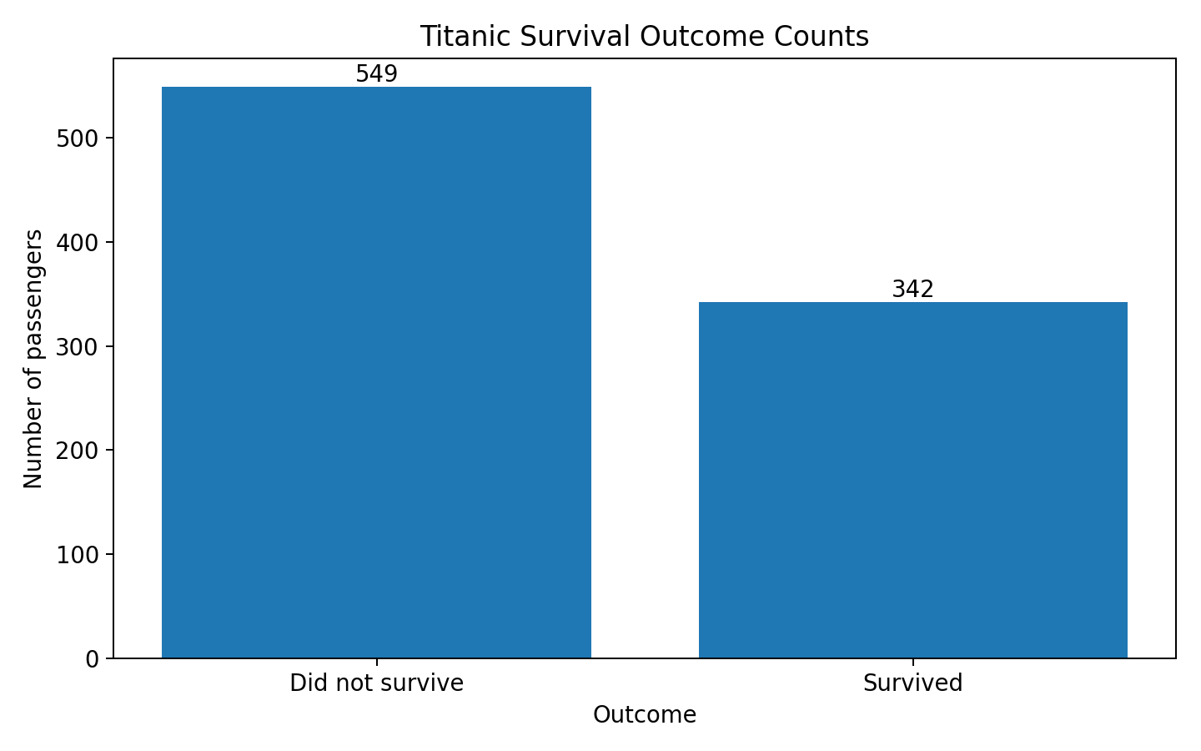
Figure 1. Distribution of survival outcomes.
The survival-count chart shows the number of passengers in each outcome category. The two classes are not evenly distributed: the number of passengers who did not survive is larger than the number who survived. This imbalance is relevant when interpreting later group comparisons and when considering classification models.

5. Survival Rate by Sex
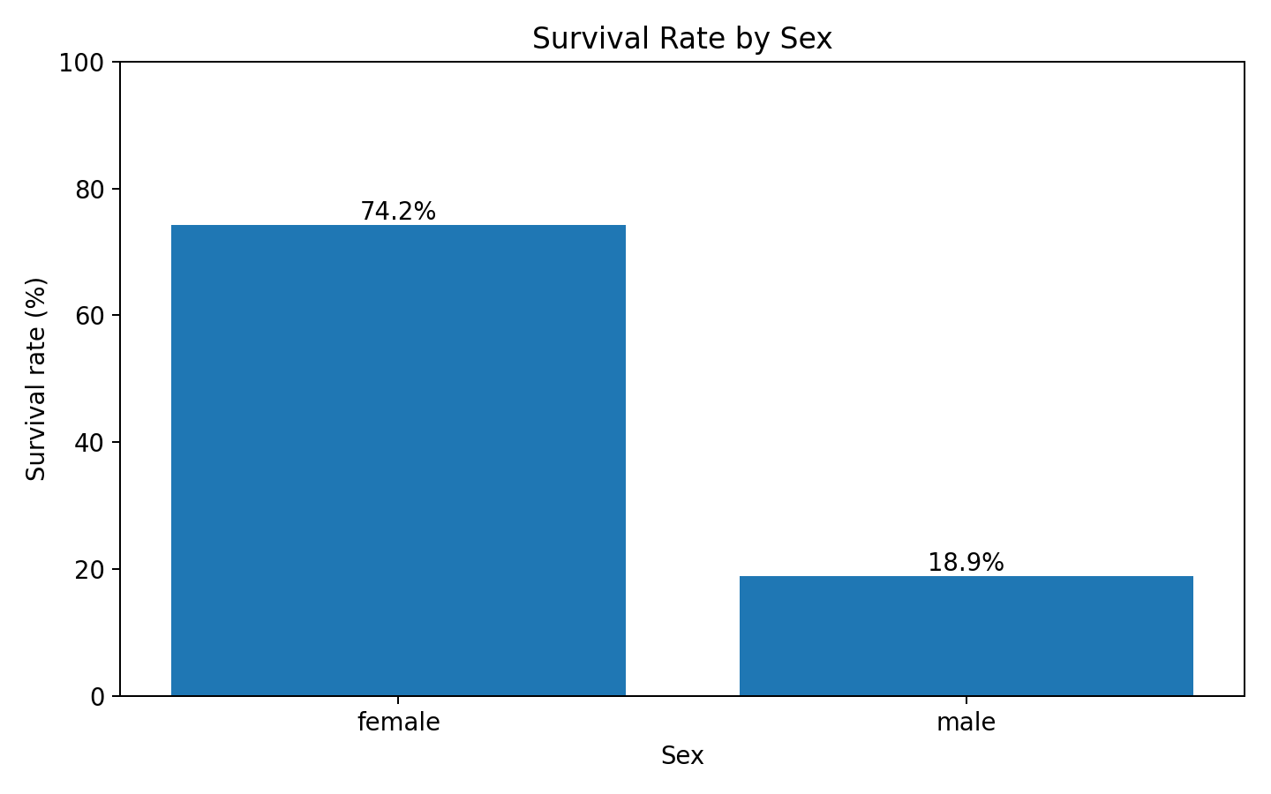
Figure 2. Survival rate by sex.
- Female: 74.20% survival rate.
- Male: 18.89% survival rate.
The grouped analysis shows a substantial difference in observed survival rates between the sex categories. This is a descriptive association in this dataset; it does not by itself establish a causal explanation.

6. Survival Rate by Passenger Class
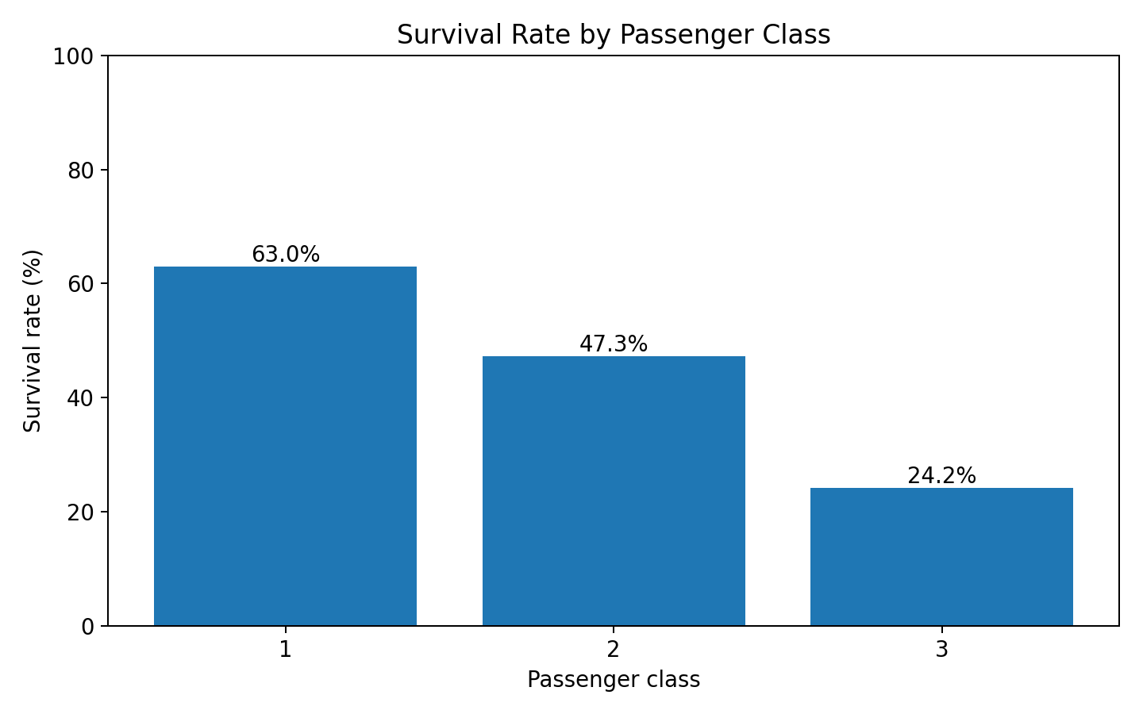
Figure 3. Survival rate by passenger class.
- Class 1: 62.96% survival rate.
- Class 2: 47.28% survival rate.
- Class 3: 24.24% survival rate.
Survival rates vary across passenger classes. The class variable therefore provides a useful dimension for further investigation because it may be associated with other passenger and travel characteristics. The chart describes the sample and should not be interpreted as proof of a single causal mechanism.

7. Age Distribution
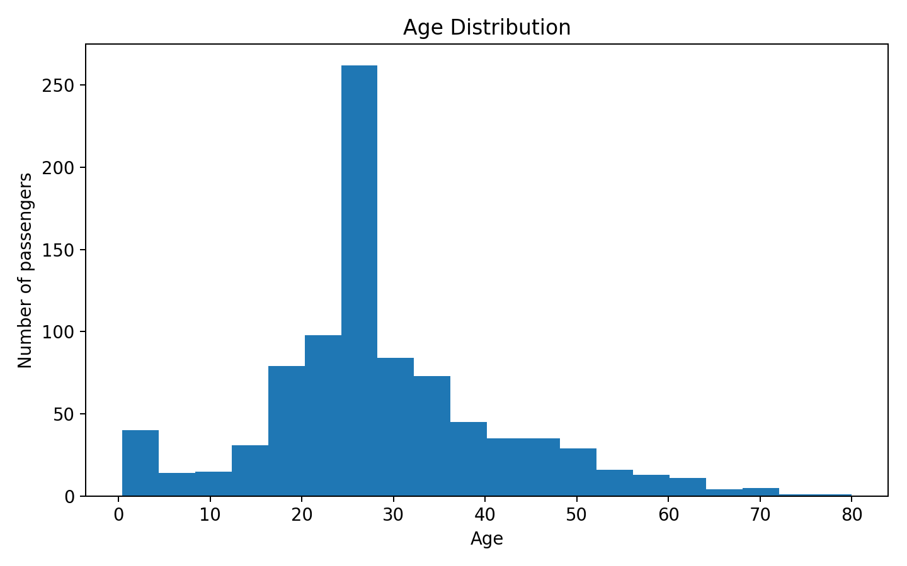
Figure 4. Distribution of passenger ages.
The age distribution is concentrated around younger and middle-aged passengers, with a mean of 29.36 years and a median of 28.00 years. The distribution also contains children and older passengers, so age is not restricted to a narrow range. The shape of the distribution supports using both central-tendency statistics and a histogram rather than relying on a single summary value.

8. Fare Distribution by Passenger Class
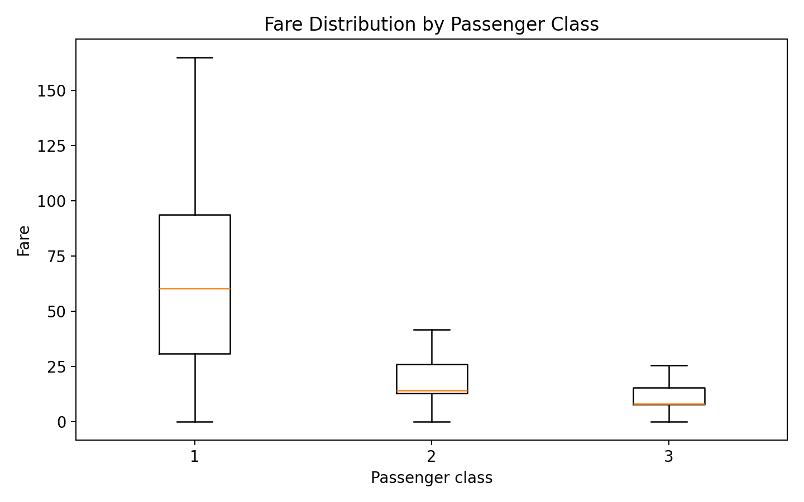
Figure 5. Fare distributions by passenger class.
The boxplot shows differences in fare distributions between passenger classes. The distributions overlap, but their central locations and spreads differ. The chart is displayed without extreme points so that the central distribution can be compared more clearly; the underlying data remain unchanged.

9. Correlation Analysis
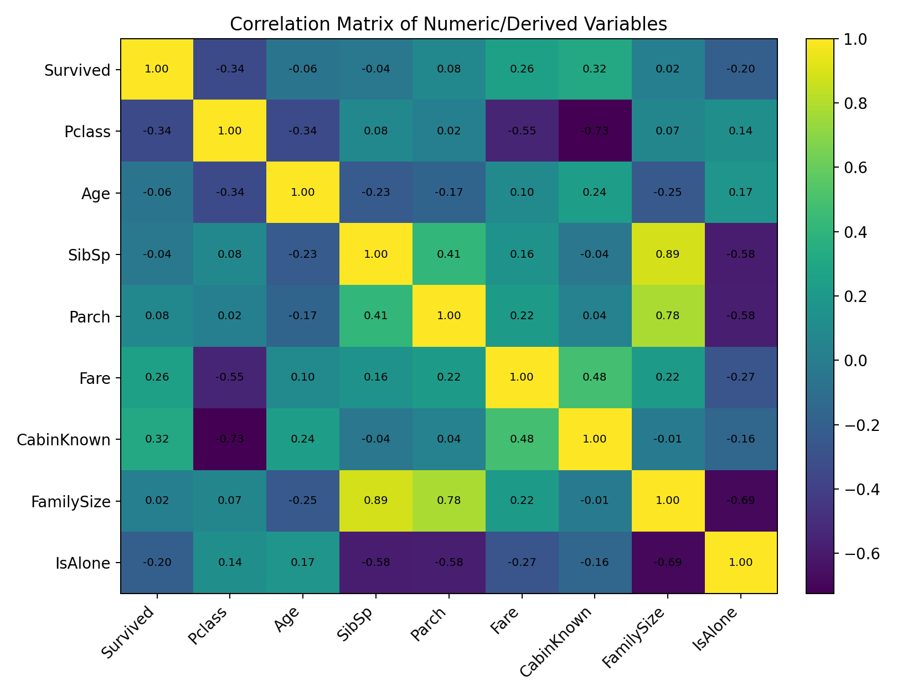
Figure 6. Correlation matrix for selected numeric and derived variables.
The correlation matrix summarizes pairwise linear association among selected numeric and derived variables. Survival has a negative association with Pclass in the encoded numeric representation, while Fare has a positive association with Survival. FamilySize is mechanically related to SibSp and Parch because it was constructed from those variables. Correlation measures association, not causation, and does not capture every type of relationship.

10. Key Findings
- The dataset contains 891 passenger records and 13 analysis columns.
- The observed overall survival rate is 38.38%.
- Survival rates differ across sex categories: female = 74.20% and male = 18.89%.
- Survival rates also vary across passenger classes.
- Age is distributed across children, adults, and older passengers, with a mean and median that are close but not identical.
- Fare distributions differ by passenger class and contain high-value observations.
- Derived variables such as FamilySize and IsAlone provide additional dimensions for subgroup analysis.

11. Data Transformations and Aggregations
No additional imputation was performed during Week 2 because the input dataset had already been cleaned in Week 1. For EDA, groupby aggregations were used to calculate survival rates by sex and passenger class. The analysis also used descriptive statistics, value counts, correlation calculations, and distributions. These transformations are analytical summaries rather than modifications to the underlying dataset.

12. Challenges and Limitations
- The cleaned dataset inherits the preprocessing choices made during Week 1, so EDA results depend on those decisions.
- Survival is not evenly distributed across the two outcome categories, which should be considered in later predictive modeling.
- Correlation values summarize linear association and should not be treated as causal evidence.
- Some passenger characteristics are historically specific to the Titanic dataset and may not generalize to other populations.
- The visualizations describe patterns in the available sample; additional statistical testing would be needed for formal inference.

13. Reproducibility
The accompanying week2_eda.py script reproduces the summary statistics, grouped survival-rate calculations, and six visualizations. The charts are stored in the charts folder. The requirements file lists the Python packages used by the workflow.

14. Conclusion
This Week 2 task completed an exploratory data analysis and visualization workflow using the Titanic dataset. The analysis examined dataset structure, survival outcomes, demographic patterns, passenger class differences, age distribution, fare distributions, and correlations among selected variables. Multiple visualizations were used to communicate the findings clearly, while interpretations were kept descriptive and separated from causal claims. The resulting report, Python script, dataset, charts, and requirements file provide a reproducible foundation for future statistical analysis and machine-learning work.

15. References
Kaggle — Titanic: Machine Learning from Disaster. Dataset and data dictionary.
Data Science Dojo — public Titanic CSV mirror used as the reproducible source in Week 1.
McKinney, W. Python for Data Analysis. O'Reilly Media.

