WEEK 6 INTEGRATIVE CAPSTONE PROJECT AND EVALUATION
End-to-End Titanic Data Science Pipeline using Python
Virtual Data Science with Python Trainee Internship

1. Executive Summary
This capstone integrates the major data science stages completed during Weeks 1-5 into one coherent workflow. The Titanic dataset is used as a common case study for data acquisition and preprocessing, exploratory analysis, unsupervised segmentation, supervised prediction, deep learning, evaluation, interpretation, and reflection. The project demonstrates how different analytical methods answer different questions: EDA describes the data, K-Means discovers groups without using the target, supervised models predict the target, and the PyTorch neural network demonstrates a deep learning approach for the same classification problem.

2. Problem Statement and Analytical Questions
The central problem is to understand patterns in historical Titanic passenger data and investigate whether passenger characteristics can support survival classification. The capstone addresses four questions: (1) What are the main patterns and distributions in the cleaned dataset? (2) Can passengers be segmented into meaningful groups without using survival as a clustering input? (3) How accurately can supervised models predict the historical survival label? (4) How does a compact neural network perform relative to classical machine-learning models?

3. Data Acquisition and Dataset Continuity
The project uses the publicly available Titanic: Machine Learning from Disaster dataset. The same cleaned dataset was retained from the earlier internship tasks to maintain continuity. It contains 891 passenger records and 13 original columns. The observed target distribution is 549 non-survivors (61.62%) and 342 survivors (38.38%). The raw and cleaned CSV files are included in the repository.

4. Data Cleaning and Preprocessing
The preprocessing stage established a consistent representation for the later analyses. PassengerId was treated as an identifier rather than a predictive feature. Age and other numeric fields were handled through the cleaned dataset and model-specific imputation pipelines. Cabin information was represented through CabinKnown, while Title and other categorical variables were encoded for supervised models. FamilySize and IsAlone capture family-travel structure, and FarePerPerson was engineered as Fare divided by FamilySize.
A key reflection from the earlier internship feedback is that preprocessing choices are not neutral. Imputation, feature engineering, standardization, and encoding influence the representation seen by each algorithm. For clustering, standardization is particularly important because Fare has a much larger numeric scale than binary variables. For supervised learning, preprocessing is placed inside Scikit-learn pipelines so that transformation parameters are learned from training data rather than from the held-out test set.

5. Exploratory Data Analysis
The initial numerical exploration shows an average passenger age of 29.36 years and a median of 28.00 years. Mean fare is 32.20, while median fare is 14.45, showing a substantial difference between the two values and indicating that fare is right-skewed. The overall observed survival rate is 38.38%.
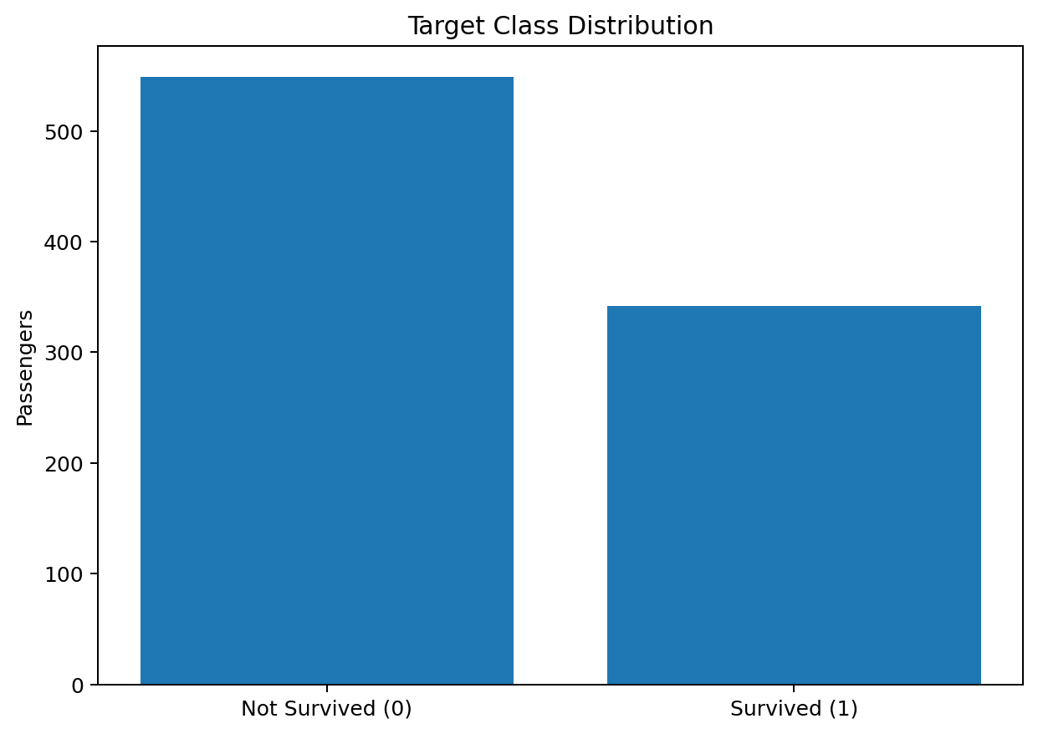
Figure 1. Distribution of the target class.
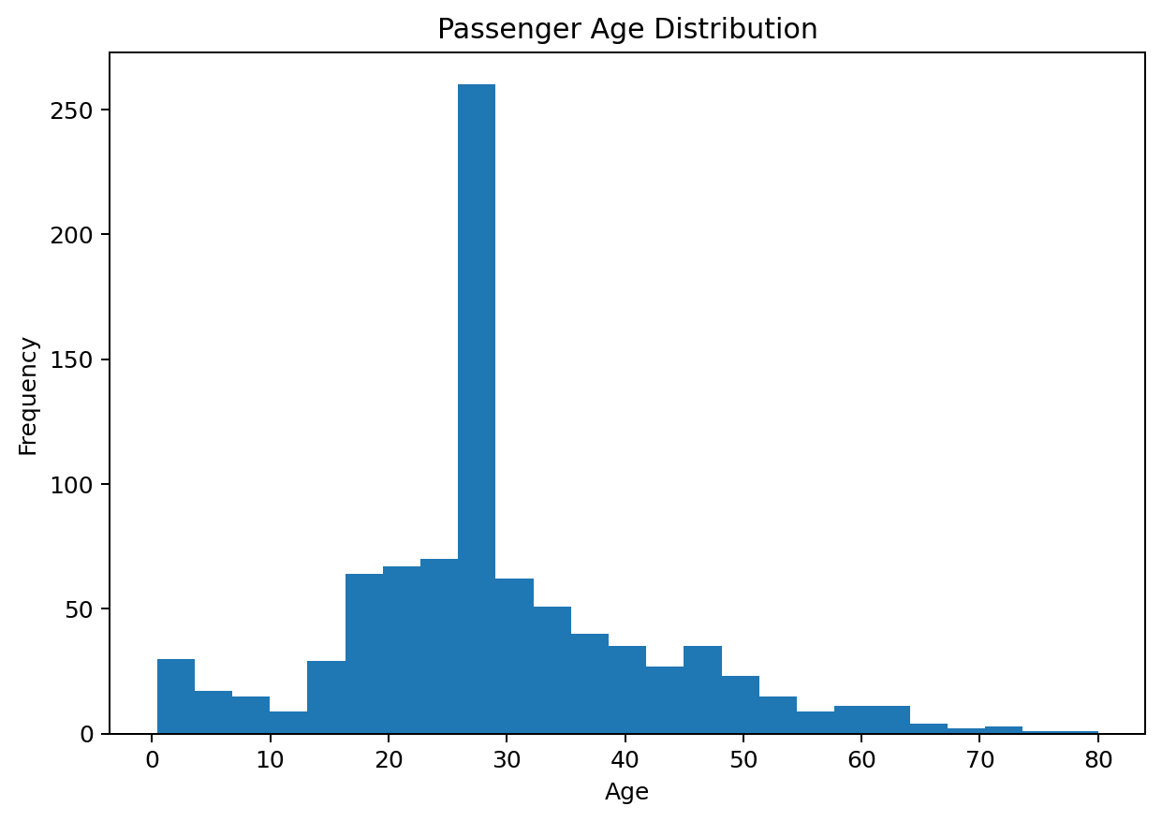
Figure 2. Passenger age distribution.
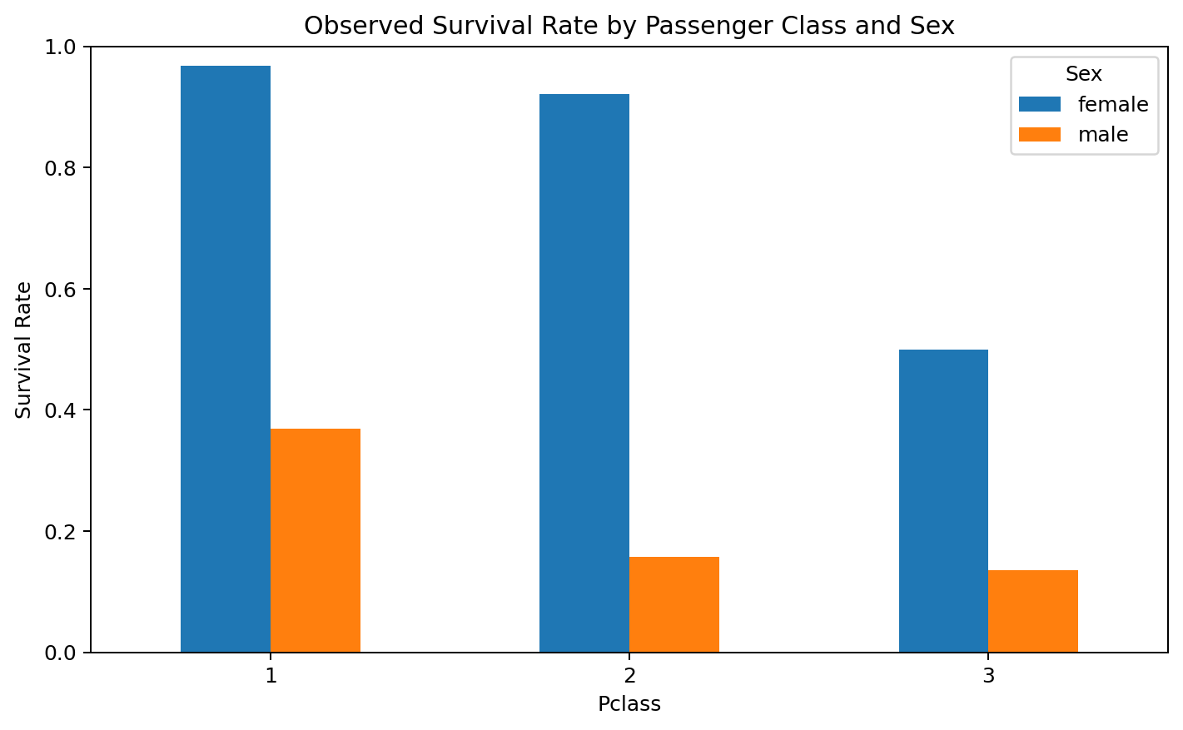
Figure 3. Observed survival rates by passenger class and sex.
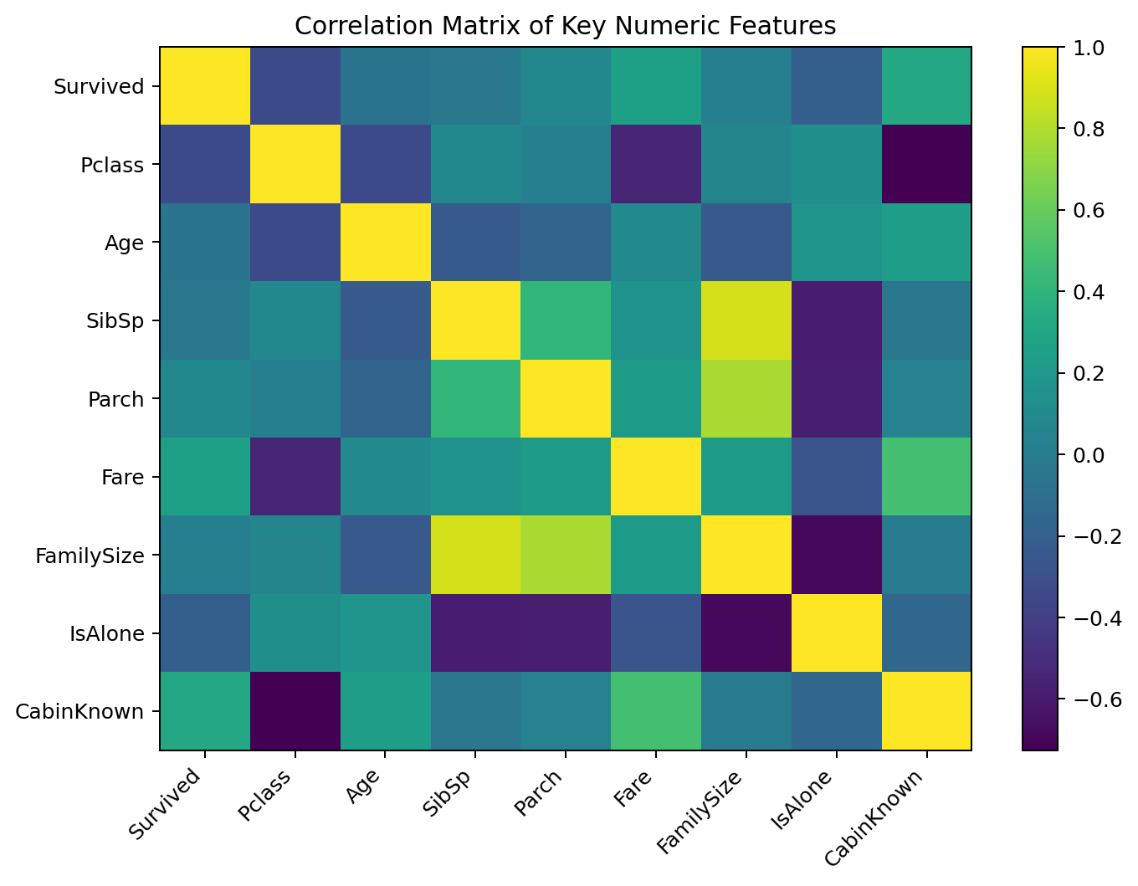
Figure 4. Correlation matrix of selected numeric features.

6. Unsupervised Learning: K-Means Clustering
K-Means was applied without using Survived as an input. The clustering feature matrix contained Age, Fare, Pclass, SibSp, Parch, FamilySize, IsAlone, and CabinKnown. StandardScaler was used before Euclidean-distance-based clustering. Candidate values from k=2 to k=8 were evaluated using silhouette scores. The scores were 0.369, 0.428, 0.432, 0.449, 0.453, 0.459, and 0.420 respectively. The five-cluster solution was retained because it matches the earlier Week 3 analysis and provides interpretable segments while remaining in the region of strong silhouette performance.
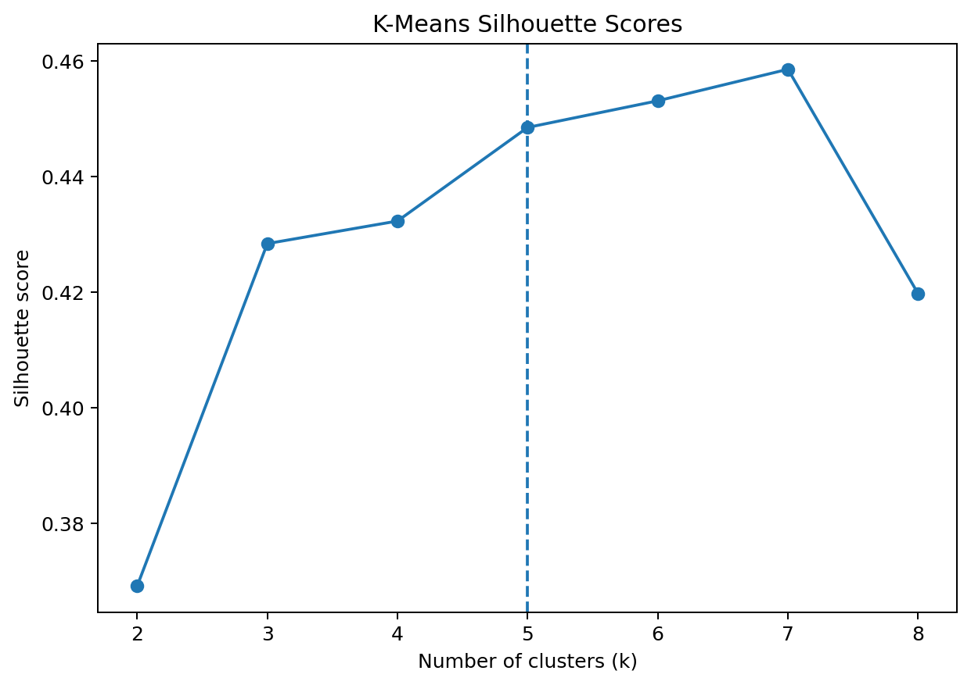
Figure 5. Silhouette scores for candidate K-Means cluster counts.
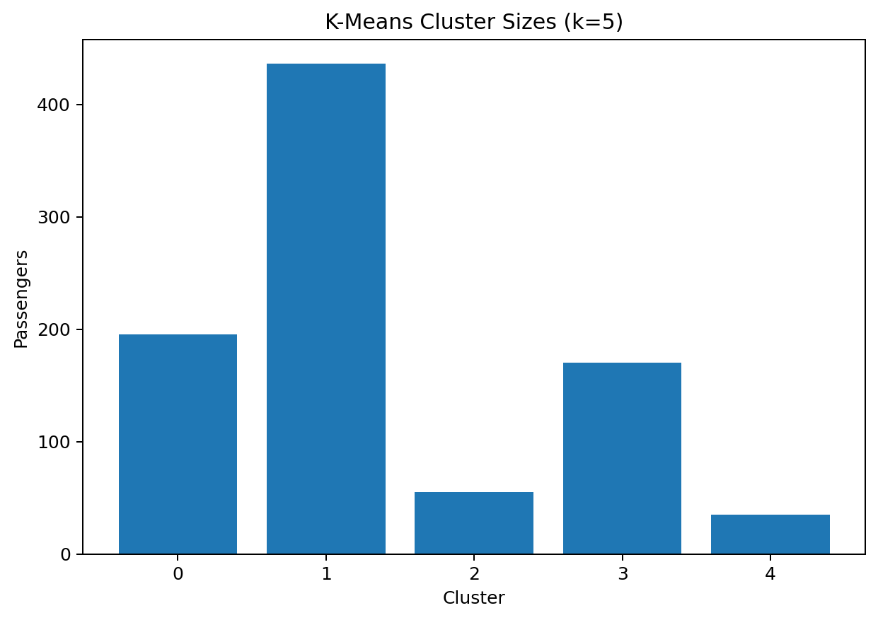
Figure 6. Sizes of the five K-Means clusters.
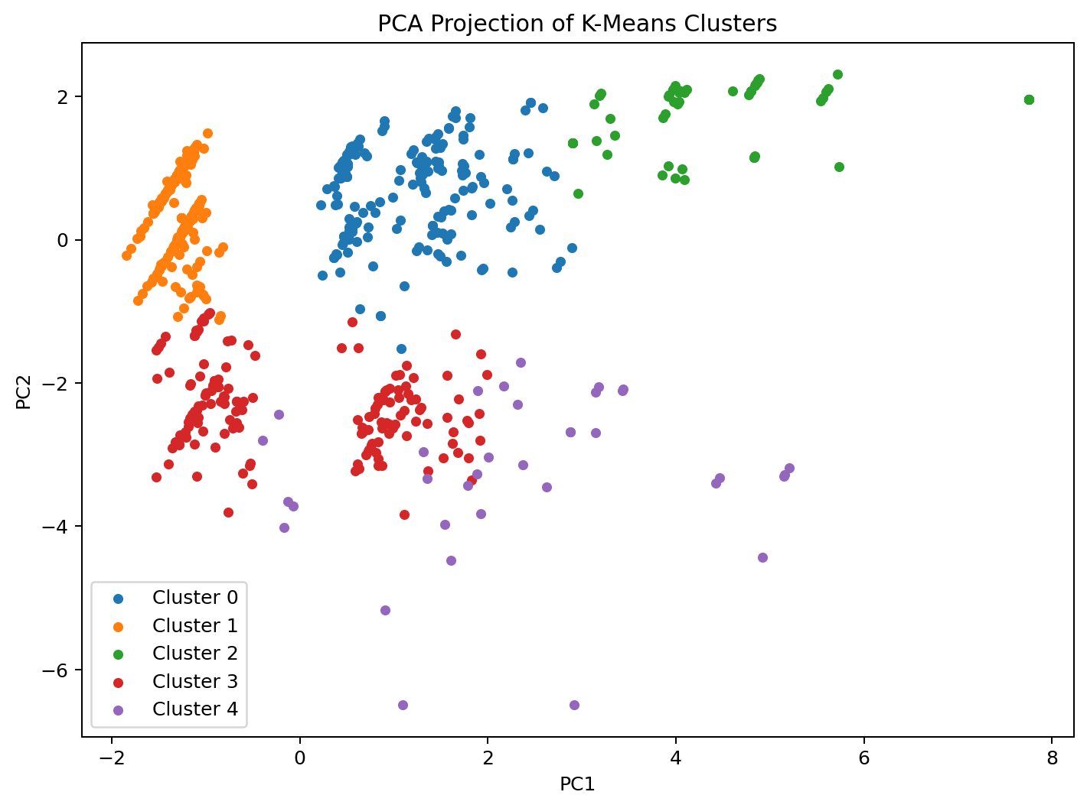
Figure 7. PCA visualization of the clusters. PC1 explains 39.5% and PC2 explains 29.0% of variance.

7. Cluster Characteristics
Cluster | N | Mean Age | Mean Fare | Mean Pclass | Family Size | Observed Survival
0 | 195 | 24.24 | 22.36 | 2.56 | 2.64 | 50.8%
1 | 436 | 29.34 | 11.38 | 2.70 | 1.00 | 23.9%
2 | 55 | 18.09 | 36.62 | 2.98 | 6.86 | 9.1%
3 | 170 | 39.31 | 57.67 | 1.07 | 1.55 | 63.5%
4 | 35 | 27.51 | 215.93 | 1.00 | 3.03 | 74.3%
The five clusters reflect combinations of class, fare, age, and family-travel structure. Cluster 1 is the largest group (436 passengers) and is characterized by solo travel, low mean fare, and low cabin availability. Cluster 4 is the smallest group (35 passengers) and has a very high mean fare and first-class profile. Cluster 2 contains 55 younger passengers with larger family groups and low observed survival. Cluster 3 has older passengers, high cabin availability, and first-class characteristics. These are descriptive segments created from the selected feature representation, not universal passenger categories.
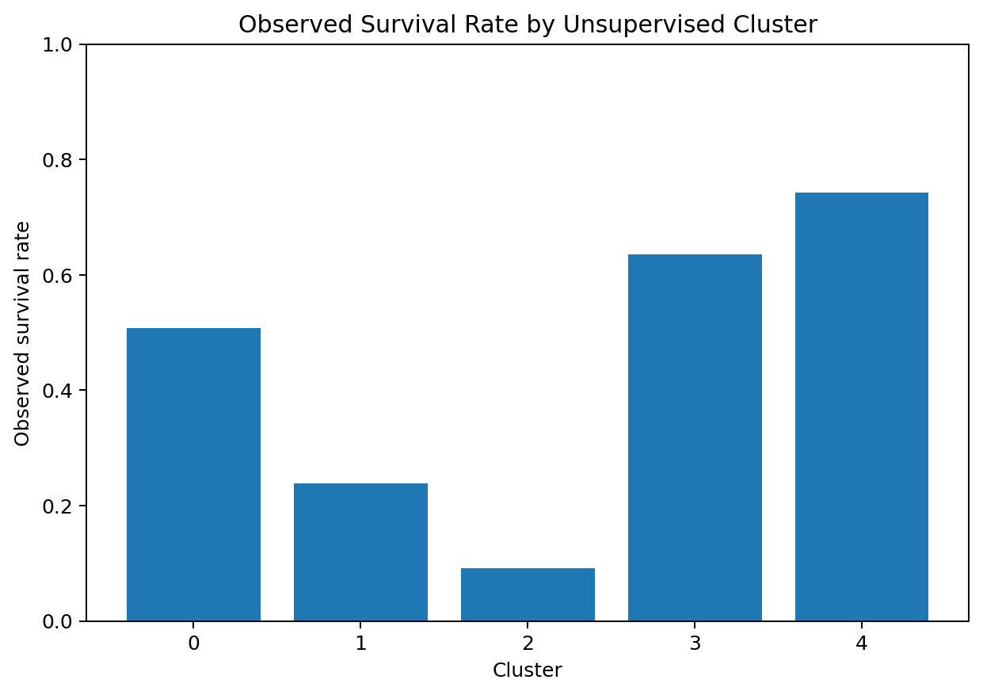
Figure 8. Observed survival rate by cluster. Survival is a post-clustering descriptive variable and was not used to form the clusters.

8. Supervised Learning
The supervised stage treats Survived as the target. Logistic Regression provides an interpretable linear baseline, while Random Forest provides a nonlinear ensemble comparison. Both models use the same 80/20 stratified train-test split and the same preprocessing strategy: median imputation and standardization for numeric variables, and most-frequent imputation plus one-hot encoding for categorical variables.
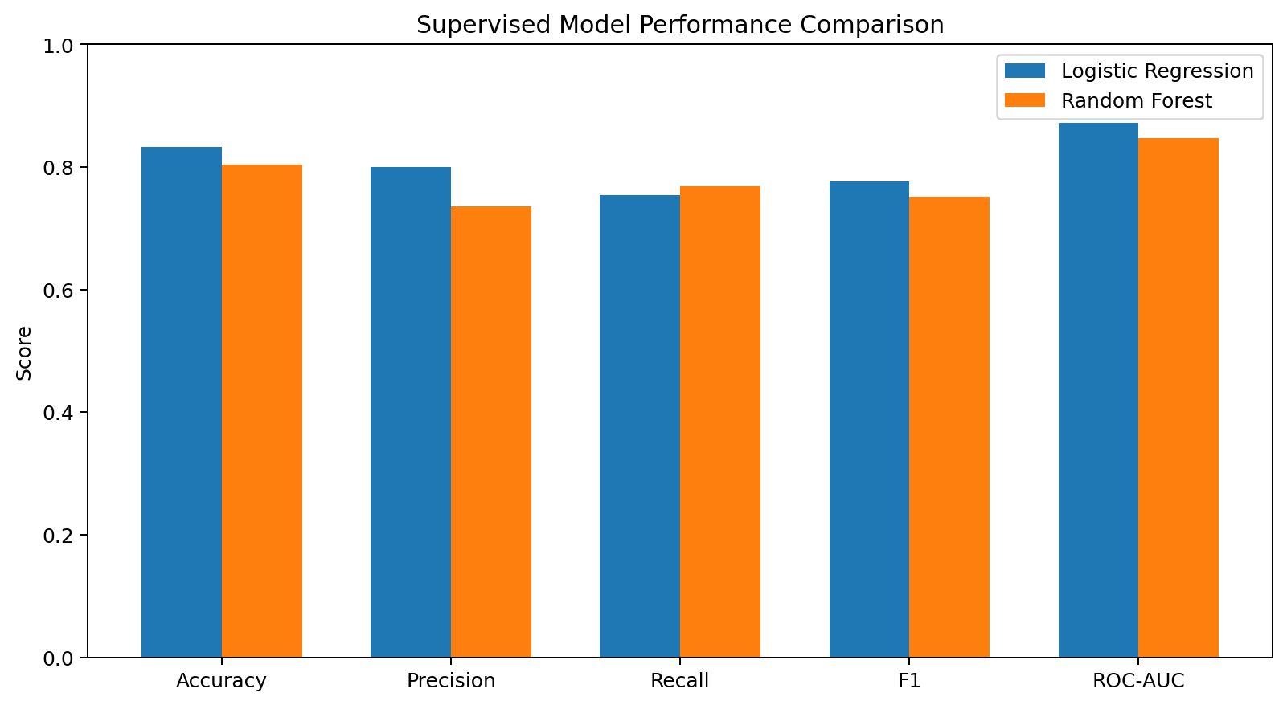
Figure 9. Test-set performance comparison of the two classical supervised models.
Model | Accuracy | Precision | Recall | F1 | ROC-AUC
Logistic Regression | 0.8324 | 0.8000 | 0.7536 | 0.7761 | 0.8718
Random Forest | 0.8045 | 0.7361 | 0.7681 | 0.7518 | 0.8474
Logistic Regression achieved 83.24% test accuracy and 0.872 ROC-AUC. Random Forest achieved 80.45% test accuracy and 0.847 ROC-AUC on this fixed test split. These are descriptive measurements for this experiment; they are not evidence that one method will perform identically on other datasets.

9. Classification Diagnostics
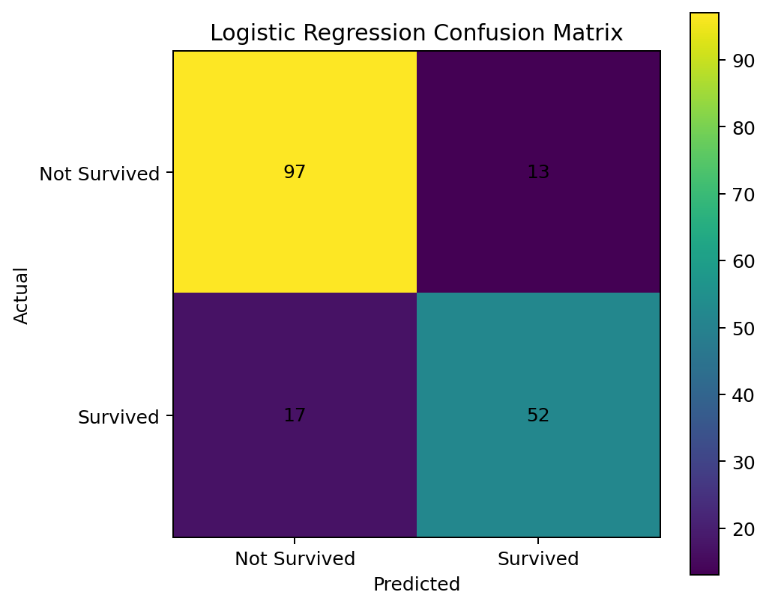
Figure 10. Logistic Regression confusion matrix on the held-out test set.
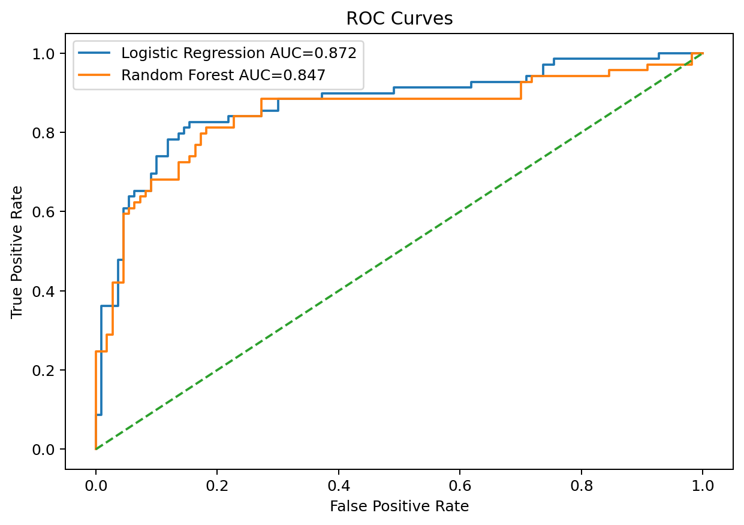
Figure 11. ROC curves for Logistic Regression and Random Forest.
The Logistic Regression confusion matrix contains 98 true negatives, 12 false positives, 16 false negatives, and 53 true positives. ROC-AUC summarizes discrimination across thresholds rather than depending on the single 0.5 classification threshold.

10. Deep Learning Integration
Week 5 added a PyTorch feed-forward neural network to the same broader classification problem. The network used 19 encoded features, dense layers of 32 and 16 neurons, ReLU activations, dropout, Adam optimization, BCEWithLogitsLoss, and early stopping. The held-out test results reported in Week 5 were 84.36% accuracy, 81.54% precision, 76.81% recall, 79.10% F1-score, and 0.857 ROC-AUC.
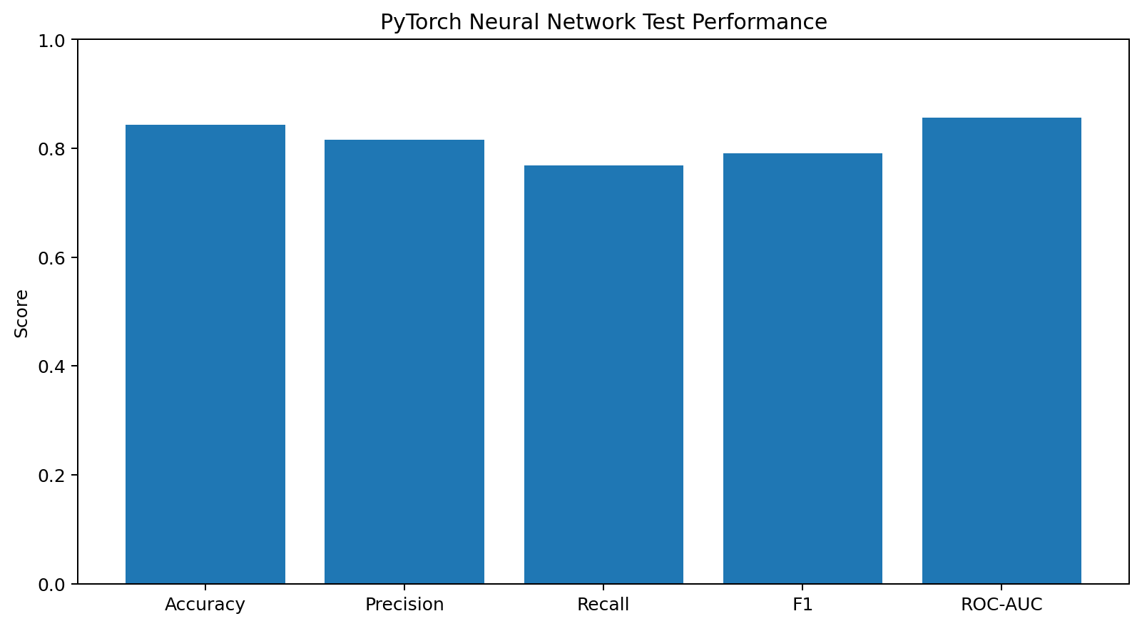
Figure 12. Week 5 PyTorch neural-network test metrics.
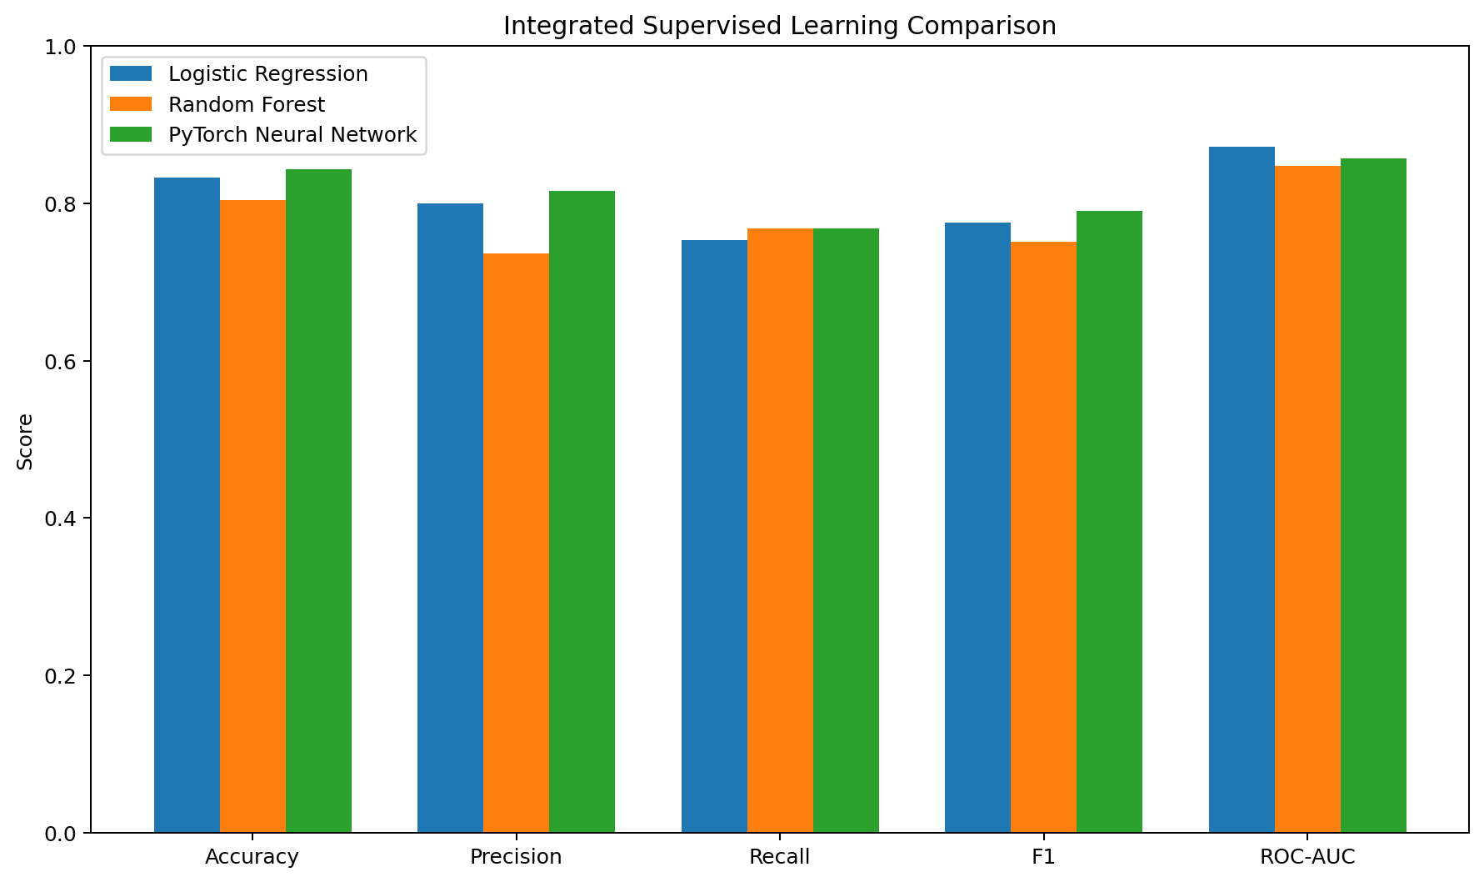
Figure 13. Integrated comparison of classical and deep-learning test metrics.
The neural network demonstrates the practical deep-learning workflow, but the Titanic dataset is relatively small. Therefore, the capstone does not assume that a neural network is automatically preferable for tabular data. Model selection should depend on the objective, dataset size, interpretability needs, validation evidence, and computational cost.

11. Integrated Evaluation
The three supervised approaches were evaluated using accuracy, precision, recall, F1-score, and ROC-AUC. Logistic Regression provides a transparent baseline, Random Forest introduces nonlinear ensemble learning, and the PyTorch network demonstrates deep learning. The comparison shows that the methods produce different metric profiles, so a single metric does not fully describe model behavior.

12. Challenges Encountered and Solutions
- Small tabular dataset: kept the neural network compact and used regularization and early stopping.
- Mixed feature types: used separate numeric and categorical preprocessing paths.
- Different feature scales for clustering: standardized the clustering matrix before K-Means.
- Risk of data leakage: fitted supervised preprocessing only on the training split through pipelines.
- Class imbalance: used stratified splitting and reported precision, recall, F1 and ROC-AUC in addition to accuracy.
- Cluster interpretation: excluded Survived from the clustering input and used it only as a post-clustering descriptive variable.
- Earlier feedback requested more numerical evidence and visual interpretation: the capstone includes descriptive statistics, multiple charts, cluster profiles, confusion matrices and model metric tables.

13. Strengths and Successful Practices
- One dataset is followed consistently from acquisition through modeling, making the internship progression easy to demonstrate.
- Both unsupervised and supervised methods are included where they address different analytical questions.
- The supervised models use reproducible random seeds and stratified splitting.
- The deep-learning stage includes validation monitoring and early stopping.
- The report combines numerical results, visual evidence, code, interpretation and limitations.
- Preprocessing choices and their consequences are explicitly discussed.

14. Limitations
- The Titanic dataset is historical and relatively small, so results are specific to this dataset and split.
- Observed associations should not be interpreted as causal effects.
- The clustering structure depends on the selected variables, scaling method and number of clusters.
- The classical model and neural-network results were developed in separate weekly experiments; direct benchmark comparisons should ideally use identical preprocessing, splits and repeated validation.
- The dataset does not contain every factor that may have influenced survival.

15. Recommendations for Further Analysis
- Use repeated stratified cross-validation to obtain more stable performance estimates.
- Perform systematic hyperparameter tuning within training data.
- Compare models under exactly the same preprocessing and evaluation protocol.
- Test alternative clustering representations and cluster-validation measures.
- Investigate feature importance and explainability methods such as permutation importance or SHAP on suitable models.
- Evaluate the pipeline on an external or newly collected dataset before making generalization claims.

16. Final Conclusion
The capstone demonstrates a complete Python data science pipeline: data preparation, exploratory analysis, unsupervised learning, supervised learning, deep learning, evaluation, interpretation and reflection. The cleaned Titanic dataset contains 891 records with an observed survival rate of 38.38%. K-Means identified five interpretable passenger segments with a silhouette score of 0.449. Logistic Regression and Random Forest provided classical predictive baselines, while the PyTorch neural network extended the workflow into deep learning. The project also documents the limitations of the dataset and methods, emphasizing that model results are empirical measurements for this experiment rather than causal or universally generalizable conclusions.

17. Project Files
- Week6_Integrative_Capstone_Project_Report.docx
- week6_capstone.py
- week5_deep_learning.py
- titanic_raw.csv
- titanic_cleaned.csv
- titanic_capstone_analysis.csv
- cluster_profiles.csv
- training_history.csv
- titanic_deep_learning_model.pth
- requirements.txt
- README.md
- Week6_Submission_Description.txt
- charts/ (13 visualization files)

