Image Processing-Blue Eyes Technology
KARTHIKA P, KANNAN KUMAR T.R,LAVANYA M.
KARTHIKA, 54,SASTHIRI STREET, SIVAGANGAI, 630561,INDIA
LAVANYA,VILLAPURAM,MADURAI,625009,INDIA
KANNAN KUMAR,10/184,ASHOK STREET,C.M.R. ROAD,MADURAI,625009,INDIA

Abstract
Blue Eyes is the technology to make computer sense, understand human feelings and to react accordingly. IBM[4] has been conducting research on the Blue Eyes technology at its Almaden Research Center (ARC) in San Jose, California since 1997. The ARC is IBM's main laboratory for the basic research. The basic idea behind this technology is to give human power to the computer. We all have some perceptual abilities.

Using the Blue eyes Technology it is able to record and monitor the user’s physiological condition by a technical approach. The aim of this Blue Eyes technology is to provide a machine or system having sensory and perceptual abilities like human beings thus it will support healthy stress free surroundings where the computers and humans can work together as intimate partners.

- Introduction:
Imagine yourself in a world where humans interact with computers. If a human is sitting in front of his/her personal computer that can listen, talk, or even scream aloud. It has the ability to gather information about him/her and interact with you through special techniques like facial recognition[2], speech recognition, etc. It can even understand your emotions at the touch of the mouse. It verifies your identity, feels your presence, and starts interacting with them. If they want the computer to dial to your home urgently, it realizes the urgency of the situation through the mouse, dials accordingly, and establishes a connection.
Human recognition depends on highly developed abilities to perceive, integrate, and interpret visual, auditory, and touch information. Without any doubt, computers would be much more powerful if they had even a small fraction of the perceptual ability of animals or humans. These are to be brought in a computer through the help of small systems built for each function. Researchers are attempting to add more capabilities to computers that will allow them to interact like humans, recognize human presents, talk, listen, or even guess their feelings.

  - Objectives of blue eyes:
1.Mobile measuring device or Data Acquisition Unit (DAU)

2.Central System Unit (CSU)
3.The Hardware

4.For Eye - Expression Glass:

5.Verify your identity, feels your presence and interact with you.

2. The Simple User Interest Tracker (suitor)

Tracker (Suitor) is used to know, understand and interpret the speech and interest of the user at that instance of time.

The four things considered for implementation of Affective Computing are:
2.1 Expression Glass
2.2 Manual and Gaze Input Cascaded (MAGIC) Pointing [4]
2.3 IBM Almaden Eye Tracker [4]
2.1 Expression Glass

Expression Glass is a wearable glass that allows any person to visualise the confusion of the person.
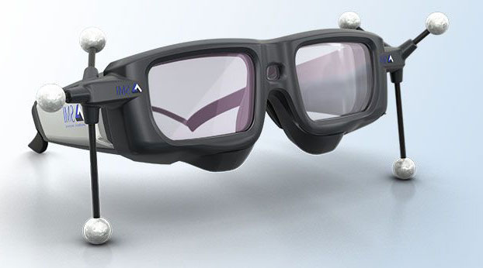

Expression Glass is an alternative for the usually available machine vision face or eye recognition methods. By analyzing pattern recognition methods and facial muscle variations, the glass senses and identifies the expressions such as interest or confusion of the user. The prototype used for this glass uses piezoelectric sensors.

Two basic ideas are included in the Artificial intelligence (AI),

Study the thought of human beings.

Represents the thought process of human beings through robots, computers etc.

Actually Artificial intelligence (AI) denotes the behavior of a computer or any machines but it is carried out by the humans is called as ‘intelligent’. This AI makes machines more power full, useful, and smarter and also it is less expensive compared to natural intelligence. Natural language processing (NLP) makes artificial intelligence systems to communicate English. The main goal of the Natural language processing (NLP) is to understand the users input and react according to these inputs. The input data or words are continuously scanned and finds matches against inside stored known data or words. And after identifying the key words, the corresponding actions are carried out by the machine. In this way the Blue Eyes technology enables the users to communicate with the machines with their own languages.

2.2 Manual and Gaze Input Cascaded (MAGIC) Pointing

This work explores a new direction in utilizing eye gaze for computer input. Gaze tracking has long been considered as an alternative or potentially superior pointing method for computer input. It`s believed that many fundamental limitations exist with traditional gaze pointing. In particular, it is unnatural to overload a perceptual channel such as vision with a motor control task.
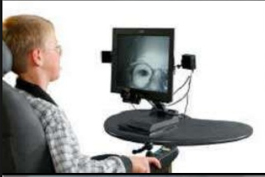

Therefore an alternative approach, clubbed MAGIC (Manual And Gaze Input Cascaded) pointing is proposed. Pointing appears to the user to be a manual task, used for fine manipulation and selection with such an approach. The pros and cons of the two techniques are discussed in light of both performance data and subjective reports.

In order to minimize directional uncertainty after the cursor appears in the conservative technique, we introduced an "intelligent" bias. We hope that with the intelligent BIAS the user would not have to gaze position reported by eye tracker. Eye tracking boundary with 95% confidence correct target will be within the circle with 95% probability.

2.3 IBM Almaden Eye Tracker

The goal of this work is to explore MAGIC pointing as a user interface technique, so we started out by purchasing a commercial eye tracker (ASL Model 5000) after a market survey. In comparison to the system reported in early studies, this system is much more compact and reliable.

It is important to consider the environment in which the speech recognition system has to work. The grammar used by the speaker and accepted by the system, noise level, noise type, position of the microphone, and speed and manner of the user's speech are some factors that may affect the quality of speech recognition. When you dial the telephone number of a big company, you are likely to hear the sonorous voice of a cultured lady who responds to your call with great courtesy saying "Welcome to company X. Please give me the extension number you want". You pronounce the extension number, your name, and the name of person you want to contact. If the called person accepts the call, the connection is given quickly. This is artificial intelligence where an automatic call-handling system is used without employing any telephone operator.

2.4.1 The Eye Movement Sensor Design

A personal area network for linking all the operators and the supervising system

Two major units:

2.4.1.1 DAU (Data Acquisition Unit)

2.4.1.2 CSU (Central System Unit)

2.4.1.3 The Hardware

2.4.1.4 Data Acquisition Unit
The main function of DAU is to gather the physiological information from sensors and forward to the CSU for processing and verification purposes. The blue tooth module, which is integrated with the mobile device (DAU), provides a wireless interface between the Central System Unit (CSU) and the user or operator having the sensors.

Features:
- Lightweight
- Runs on batteries - low power consumption
- Easy to use
- ID cards for operator authorization
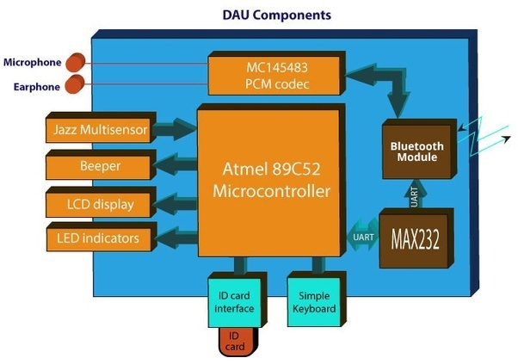

2.4.1.2 Central System Unit

A computer system unit is the enclosure that contains the main components of a computer.

Components:

  - Connection Manager – main task to perform low-level blue tooth communication

  - Data Analysis Module – performs the analysis of the raw sensor data in order to obtain information about operator’s physiological condition

  - Data Logger Module – provides support for storing the monitored data.

  - Visualization Module – provides user interface 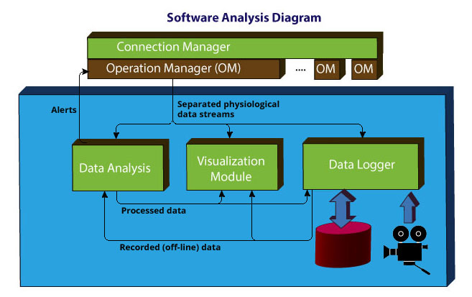

2.4.1.3 The Hardware
- Artificial intelligence (AI) denotes the behavior of a computer or any machines but it is carried out by the humans is called as ‘intelligent’.
- This AI makes machines more power full, useful, and smarter and also it is less expensive compared to natural intelligence. Natural language processing (NLP) makes artificial intelligence systems to communicate English.
- The main goal of the Natural language processing (NLP) is to understand the users input and react according to these inputs.
detected facial landmarks to help us label and extract face regions, including:
Mouth
Right eyebrow
Left eyebrow
Right eye
Left eye
Nose
Jaw

will start with a discussion on the (x, y)-coordinates associated with facial landmarks and how these facial landmarks can be mapped to specific regions of the face.
then write a bit of code that can be used to extract each of the facial regions.

3.Facial landmark
Detecting Facial landmark is therefore a two step process.
Step1:Localize the face in the image.
Step2:Detect the key facial such on the face ROI(specify object of interest).
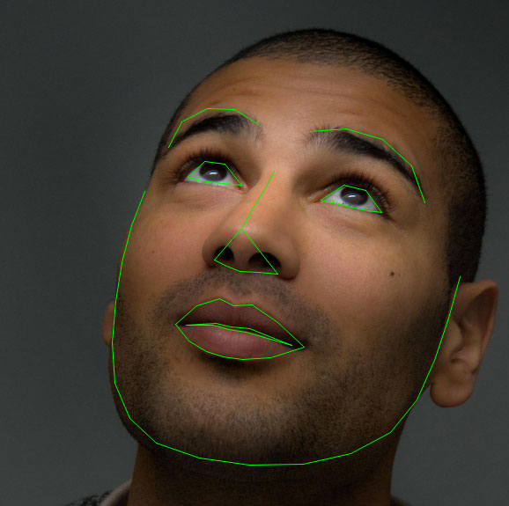
Understanding dlib’s facial landmark detector
The pre-trained facial landmark detector inside the dilb library is used to estimate the location of 68(x,y)-co-
Ordinates that map to facial structures on the face.
The indexes of the 68 coordinates can be visualized on the image below;
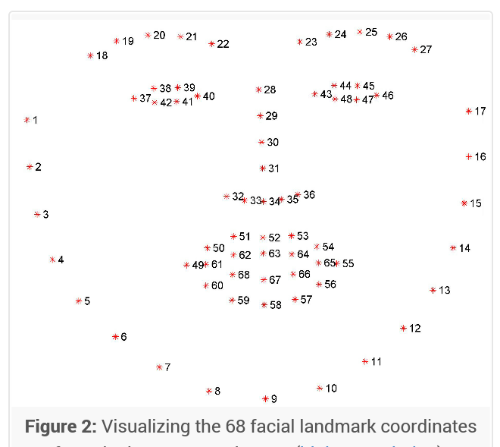
4. Advantages

- Physiological condition monitoring
- Reduces manual work
- Increases efficiency

5. Disadvantages

- Not 100% accurate
- System is bulky, needs minimization
- Expensive

6. Conclusion

This project is still in the developing stage by IBM[4]. “Even Machine can see and feel too” is the tag line of Blue Eyes Technology. This project can be very useful in reducing manual work and can be User friendly. It is actually developing to reduce human inconvenience like tiredness, mental illness, and avoid loneliness.

7. REFERENCES

- Johnson, R.C. (1999). Computer Program Recognizes Facial Expressions. http://www.eetimes.com April 5.

- Picard, R. (1997). Affective Computing. MIT Press: Cambridge.

- http://www.almaden.ibm.com/u/zhai/papers/magic/magic.pdf

[4] www.ibmresearchcenter.com

