WEEK-1

Module 1 - Design Patterns and Principles

NAME : SIDHARTH K
SUPERSET ID : 6430194

Exercise 1: Implementing the Singleton Pattern
Code:
Logger.java:
public class Logger{
private static Logger instance;
private Logger(){
System.out.println("Logger initialized Successfully.....");
}
public static Logger getInstance(){
if (instance == null){
instance = new Logger();
}
return instance;
}
public void log(String msg){
System.out.println(msg);
}
}
Main.java:
public class Logger{
private static Logger instance;
private Logger(){
System.out.println("Logger initialized Successfully.....");
}
public static Logger getInstance(){
if (instance == null){
instance = new Logger();
}
return instance;
}
public void log(String msg){
System.out.println(msg);
}
}
Output:
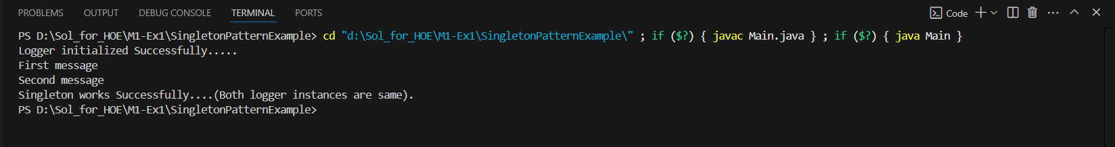

Exercise 2: Implementing the Factory Method Pattern
Code:
Document.java:
public interface Document {
void open();
}
WordDocument.java:
public class WordDocument implements Document {
@Override
public void open() {
System.out.println("Opening the Word document.......");
}
}
PdfDocument.java:
public class PdfDocument implements Document {
@Override
public void open() {
System.out.println("Opening 'PDF document'.....");
}
}
ExcelDocument.java:
public class ExcelDocument implements Document {
@Override
public void open() {
System.out.println("Opening 'Excel document'.....");
}
}

DocumentFactory.java:
public abstract class DocumentFactory {
public abstract Document createDocument();
}
WordDocumentFactory.java:
public class WordDocumentFactory extends DocumentFactory {
@Override
public Document createDocument() {
return new WordDocument();
}
}
PdfDocumentFactory.java:
public class PdfDocumentFactory extends DocumentFactory {
@Override
public Document createDocument() {
return new PdfDocument();
}
}
ExcelDocumentFactory.java:
public class ExcelDocumentFactory extends DocumentFactory {
@Override
public Document createDocument() {
return new ExcelDocument();
}
}
Main.java:
public class Main {
public static void main(String[] args) {
DocumentFactory wordFactory = new WordDocumentFactory();
Document wordDoc = wordFactory.createDocument();
wordDoc.open();

DocumentFactory pdfFactory = new PdfDocumentFactory();
Document pdfDoc = pdfFactory.createDocument();
pdfDoc.open();

DocumentFactory excelFactory = new ExcelDocumentFactory();
Document excelDoc = excelFactory.createDocument();
excelDoc.open();
}
}
Output:
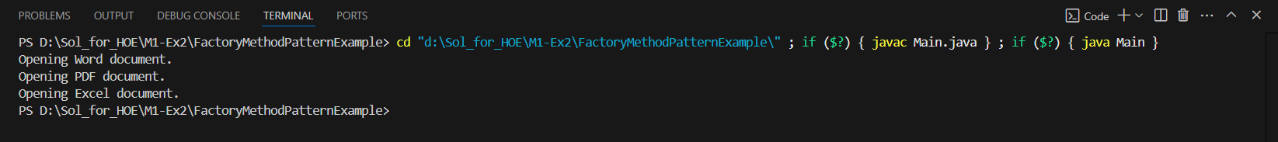

Exercise 3: Implementing the Builder Pattern
Code:
Computer.java:
public class Computer {
private final String cpu;
private final String ram;
private final String storage;
private final String graphicsCard;
private final String os;

private Computer(Builder builder) {
this.cpu = builder.cpu;
this.ram = builder.ram;
this.storage = builder.storage;
this.graphicsCard = builder.graphicsCard;
this.os = builder.os;
}

public void showSpecs() {
System.out.println("Computer Specs:");
System.out.println("CPU: " + cpu);
System.out.println("RAM: " + ram);
System.out.println("Storage: " + (storage != null ? storage : "Not specified"));
System.out.println("Graphics Card: " + (graphicsCard != null ? graphicsCard : "Not specified"));
System.out.println("OS: " + (os != null ? os : "Not specified"));
}

public static class Builder {
private final String cpu;
private final String ram;
private String storage;
private String graphicsCard;
private String os;

public Builder(String cpu, String ram) {
this.cpu = cpu;
this.ram = ram;
}

public Builder setStorage(String storage) {
this.storage = storage;
return this;
}

public Builder setGraphicsCard(String graphicsCard) {
this.graphicsCard = graphicsCard;
return this;
}

public Builder setOS(String os) {
this.os = os;
return this;
}

public Computer build() {
return new Computer(this);
}
}
}
Main.java
public class Main {
public static void main(String[] args) {
Computer basicComputer = new Computer.Builder("Intel i3", "8GB")
.build();
Computer gamingComputer = new Computer.Builder("Intel i9", "32GB")
.setStorage("1TB SSD")
.setGraphicsCard("NVIDIA RTX 4080")
.setOS("Windows 11")
.build();
System.out.println("**** Basic Computer ****");
basicComputer.showSpecs();

System.out.println("\n**** Gaming Computer ****");
gamingComputer.showSpecs();
}
}

Output:
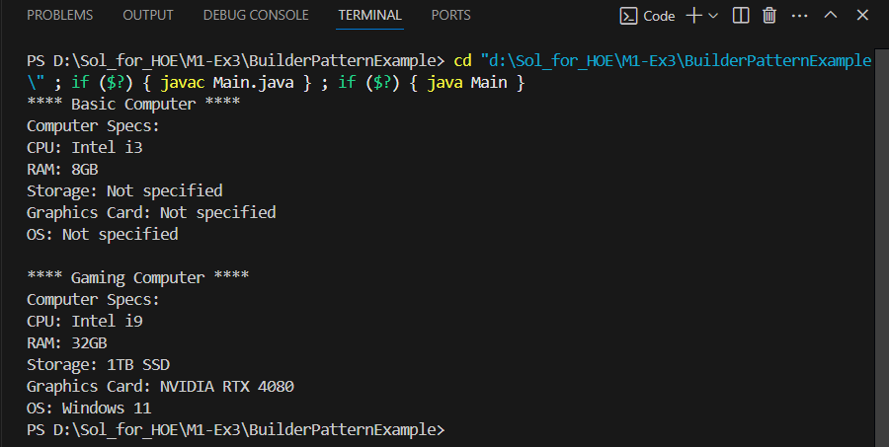

Exercise 4: Implementing the Adapter Pattern
Code:
PaymentProcessor.java:
public interface PaymentProcessor {
void processPayment(double amount);
}
StripeGateway.java:
public class StripeGateway {
public void makeStripePayment(double amountInDollars) {
System.out.println("Stripe processed payment of $" + amountInDollars);
}
}
PayPalGateway.java:
public class PayPalGateway {
public void sendPayment(double usdAmount) {
System.out.println("PayPal processed payment of $" + usdAmount);
}
}
StripeAdapter.java:
public class StripeAdapter implements PaymentProcessor {
private StripeGateway stripe;

public StripeAdapter(StripeGateway stripe) {
this.stripe = stripe;
}
@Override
public void processPayment(double amount) {
stripe.makeStripePayment(amount);
}
}
PayPalAdapter.java:
public class PayPalAdapter implements PaymentProcessor {
private PayPalGateway paypal;

public PayPalAdapter(PayPalGateway paypal) {
this.paypal = paypal;
}
@Override
public void processPayment(double amount) {
paypal.sendPayment(amount);
}
}
Main.java:
public class Main {
public static void main(String[] args) {
StripeGateway stripe = new StripeGateway();
PaymentProcessor stripeProcessor = new StripeAdapter(stripe);
stripeProcessor.processPayment(150.0);
PayPalGateway paypal = new PayPalGateway();
PaymentProcessor paypalProcessor = new PayPalAdapter(paypal);
paypalProcessor.processPayment(300.0);
}
}
Output:
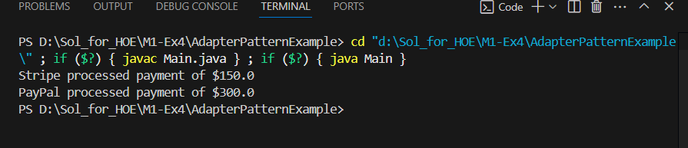
Exercise 5: Implementing the Decorator Pattern
Code:
Notifier.java:
public interface Notifier {
void send(String message);
}
EmailNotifier.java:
public class EmailNotifier implements Notifier {
@Override
public void send(String message) {
System.out.println("Sending Email: " + message);
}
}
NotifierDecorator.java:
public abstract class NotifierDecorator implements Notifier {
protected Notifier wrappedNotifier;

public NotifierDecorator(Notifier notifier) {
this.wrappedNotifier = notifier;
}

@Override
public void send(String message) {
wrappedNotifier.send(message);
}
}
SMSNotifierDecorator.java:
public class SMSNotifierDecorator extends NotifierDecorator {

public SMSNotifierDecorator(Notifier notifier) {
super(notifier);
}

@Override
public void send(String message) {
super.send(message);
System.out.println("Sending SMS: " + message);
}
}
SlackNotifierDecorator.java:
public class SlackNotifierDecorator extends NotifierDecorator {

public SlackNotifierDecorator(Notifier notifier) {
super(notifier);
}

@Override
public void send(String message) {
super.send(message); // Call base notifier
System.out.println("Sending Slack message: " + message);
}
}

Main.java:
public class Main {
public static void main(String[] args) {
Notifier emailNotifier = new EmailNotifier();
Notifier smsNotifier = new SMSNotifierDecorator(emailNotifier);
Notifier multiChannelNotifier = new SlackNotifierDecorator(smsNotifier);
multiChannelNotifier.send("System alert: CPU usage at 95%");
}
}
Output:
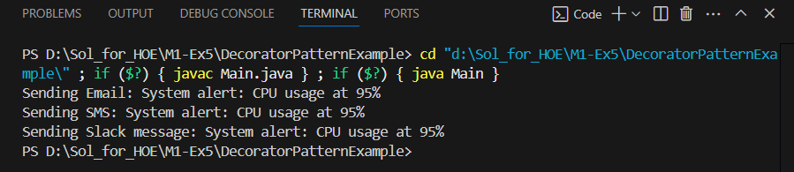

Exercise 6: Implementing the Proxy Pattern
Code:
Image.java:
public interface Image {
void display();
}
RealImage.java:
public class RealImage implements Image {
private String fileName;

public RealImage(String fileName) {
this.fileName = fileName;
loadFromServer();
}

private void loadFromServer() {
System.out.println("Loading image from remote server: " + fileName);
try {
Thread.sleep(2000); // Simulate network delay
} catch (InterruptedException e) {
e.printStackTrace();
}
}

@Override
public void display() {
System.out.println("Displaying image: " + fileName);
}
}
ProxyImage.java:
public class ProxyImage implements Image {
private String fileName;
private RealImage realImage;

public ProxyImage(String fileName) {
this.fileName = fileName;
}

@Override
public void display() {
if (realImage == null) {
System.out.println("Creating RealImage object for: " + fileName);
realImage = new RealImage(fileName); // Lazy initialization
} else {
System.out.println("Using cached RealImage for: " + fileName);
}
realImage.display();
}
}
Main.java:
public class Main {
public static void main(String[] args) {
Image image1 = new ProxyImage("photo1.jpg");
image1.display();
System.out.println();
image1.display();
System.out.println();
Image image2 = new ProxyImage("holiday.jpg");
image2.display();
}
}
Output:
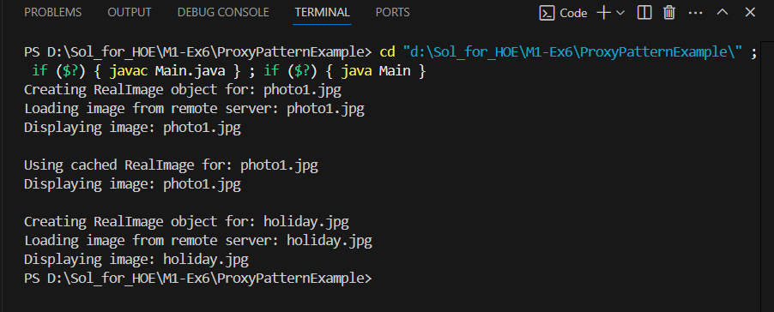

Exercise 7: Implementing the Observer Pattern
Code:
Stock.java:
public interface Stock {
void registerObserver(Observer o);
void removeObserver(Observer o);
void notifyObservers();
}
Observer.java:
public interface Observer {
void update(String stockName, double newPrice);
}
StockMarket.java:
import java.util.ArrayList;
import java.util.List;

public class StockMarket implements Stock {
private List<Observer> observers = new ArrayList<>();
private String stockName;
private double price;

public StockMarket(String stockName, double initialPrice) {
this.stockName = stockName;
this.price = initialPrice;
}

public void setPrice(double newPrice) {
System.out.println("\nUpdating " + stockName + " stock price to RS." + newPrice);
this.price = newPrice;
notifyObservers();
}

@Override
public void registerObserver(Observer o) {
observers.add(o);
System.out.println("Observer registered: " + o.getClass().getSimpleName());
}

@Override
public void removeObserver(Observer o) {
observers.remove(o);
System.out.println("Observer removed: " + o.getClass().getSimpleName());
}

@Override
public void notifyObservers() {
for (Observer observer : observers) {
observer.update(stockName, price);
}
}
}
MobileApp.java:
public class MobileApp implements Observer {
@Override
public void update(String stockName, double newPrice) {
System.out.println("[MobileApp] " + stockName + " updated to Rs." + newPrice);
}
}

WebApp.java:
public class WebApp implements Observer {
@Override
public void update(String stockName, double newPrice) {
System.out.println("[WebApp] " + stockName + " updated to RS." + newPrice);
}
}
Main.java:
public class Main {
public static void main(String[] args) {
StockMarket appleStock = new StockMarket("AAPL", 150.0);
Observer mobileApp = new MobileApp();
Observer webApp = new WebApp();
appleStock.registerObserver(mobileApp);
appleStock.registerObserver(webApp);
appleStock.setPrice(155.0);
appleStock.setPrice(160.5);
appleStock.removeObserver(webApp);
appleStock.setPrice(162.75);
}
}

Output:

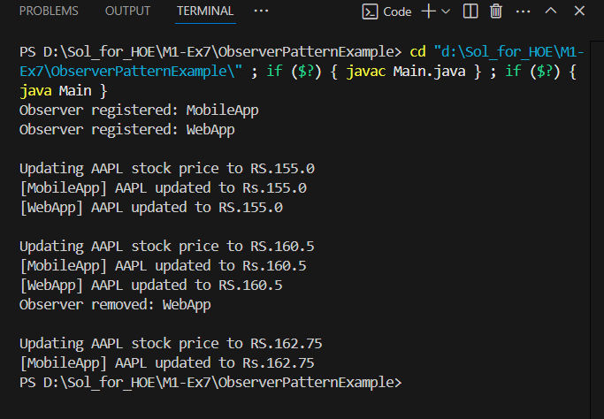

Exercise 8: Implementing the Strategy Pattern
Code:
PaymentStrategy.java:
public interface PaymentStrategy {
void pay(double amount);
}
CreditCardPayment.java:
public class CreditCardPayment implements PaymentStrategy {
private String cardNumber;

public CreditCardPayment(String cardNumber) {
this.cardNumber = cardNumber;
}

@Override
public void pay(double amount) {
System.out.println("Paid RS." + amount + " using Credit Card ending with " +
cardNumber.substring(cardNumber.length() - 4));
}
}
PayPalPayment.java:
public class PayPalPayment implements PaymentStrategy {
private String email;

public PayPalPayment(String email) {
this.email = email;
}

@Override
public void pay(double amount) {
System.out.println("Paid RS." + amount + " via PayPal account: " + email);
}
}
PaymentContext.java:
public class PaymentContext {
private PaymentStrategy strategy;

public void setStrategy(PaymentStrategy strategy) {
this.strategy = strategy;
}

public void processPayment(double amount) {
if (strategy == null) {
System.out.println("Payment strategy not set.");
} else {
strategy.pay(amount);
}
}
}

Main.java:
public class Main {
public static void main(String[] args) {
PaymentContext context = new PaymentContext();
PaymentStrategy creditCard = new CreditCardPayment("1234-5678-9876-5432");
context.setStrategy(creditCard);
context.processPayment(25000.00);
PaymentStrategy paypal = new PayPalPayment("user@example.com");
context.setStrategy(paypal);
context.processPayment(18000.50);
}
}
Output:
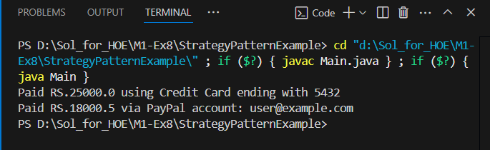

Exercise 9: Implementing the Command Pattern
Code:
Command.java:
public interface Command {
void execute();
}
LightOnCommand.java:
public class LightOnCommand implements Command {
private Light light;
public LightOnCommand(Light light) {
this.light = light;
}
@Override
public void execute() {
light.turnOn();
}
}
LightOffCommand.java:
public class LightOffCommand implements Command {
private Light light;
public LightOffCommand(Light light) {
this.light = light;
}
@Override
public void execute() {
light.turnOff(); } }
RemoteControl.java:
public class RemoteControl {
private Command command;
public void setCommand(Command command) {
this.command = command;
}
public void pressButton() {
if (command != null) {
command.execute();
} else {
System.out.println("No command assigned.");
}
}
}
Light.java:
public class Light {
public void turnOn() {
System.out.println("The light is ON.");
}
public void turnOff() {
System.out.println("The light is OFF.");
}
}

Main.java:
public class Main {
public static void main(String[] args){
Light livingRoomLight = new Light();
Command lightOn = new LightOnCommand(livingRoomLight);
Command lightOff = new LightOffCommand(livingRoomLight);
RemoteControl remote = new RemoteControl();
remote.setCommand(lightOn);
remote.pressButton();
remote.setCommand(lightOff);
remote.pressButton();
}
}

Output:
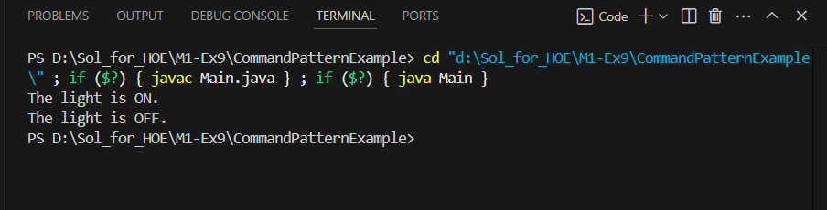

Exercise 10: Implementing the MVC Pattern
Code:
Student.java:
public class Student {
private String name;
private String id;
private String grade;
public Student(String name, String id, String grade) {
this.name = name;
this.id = id;
this.grade = grade;
}
public String getName() { return name; }
public void setName(String name) { this.name = name; }

public String getId() { return id; }
public void setId(String id) { this.id = id; }

public String getGrade() { return grade; }
public void setGrade(String grade) { this.grade = grade; }
}
StudentView.java:
public class StudentView {
public void displayStudentDetails(String name, String id, String grade) {
System.out.println("\n--- Student Details ---");
System.out.println("Name : " + name);
System.out.println("ID : " + id);
System.out.println("Grade : " + grade);
}
}
StudentController.java:
public class StudentController {
private Student model;
private StudentView view;
public StudentController(Student model, StudentView view) {
this.model = model;
this.view = view;
}
public void setStudentName(String name) {
model.setName(name);
}
public void setStudentId(String id) {
model.setId(id);
}
public void setStudentGrade(String grade) {
model.setGrade(grade);
}
public void updateView() {
view.displayStudentDetails(model.getName(), model.getId(), model.getGrade());
}
}

Main.java:
public class Main {
public static void main(String[] args) {
Student student = new Student("Roshan", "S239", "B");
StudentView view = new StudentView();
StudentController controller = new StudentController(student, view);
controller.updateView();
controller.setStudentName("Kumar");
controller.setStudentGrade("A+");
controller.updateView();
}
}
Output:
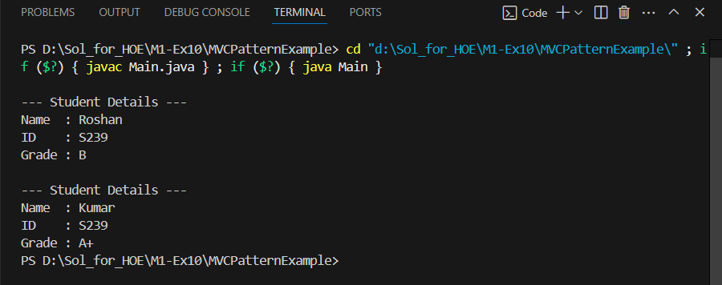

Exercise 11: Implementing Dependency Injection
Code:
Customer.java:
public class Customer {
private String id;
private String name;
public Customer(String id, String name) {
this.id = id;
this.name = name;
}
public String getId() { return id; }
public String getName() { return name; }
@Override
public String toString() {
return "Customer{id='" + id + "', name='" + name + "'}";
}
}
CustomerRepository.java:
public interface CustomerRepository {
Customer findCustomerById(String id);
}
CustomerRepositoryImpl.java:
import java.util.HashMap;
import java.util.Map;

public class CustomerRepositoryImpl implements CustomerRepository {
private Map<String, Customer> customerDatabase = new HashMap<>();

public CustomerRepositoryImpl() {
// Simulate data
customerDatabase.put("C531", new Customer("C531", "Sid"));
customerDatabase.put("C202", new Customer("C202", "Raja"));
}

@Override
public Customer findCustomerById(String id) {
return customerDatabase.get(id);
}
}
CustomerService.java:
public class CustomerService {
private final CustomerRepository customerRepository;
public CustomerService(CustomerRepository customerRepository) {
this.customerRepository = customerRepository;
}
public void showCustomerDetails(String id) {

Customer customer = customerRepository.findCustomerById(id);
if (customer != null) {
System.out.println("Customer Found: " + customer);
} else {
System.out.println("Customer not found for ID: " + id);
}
}
}
Main.java:
public class Main {
public static void main(String[] args) {
CustomerRepository repository = new CustomerRepositoryImpl();
CustomerService service = new CustomerService(repository);
service.showCustomerDetails("C531");
service.showCustomerDetails("C742");
}
}
Output: 