1. Find all the information about each product:  
  
 **db.products.find({})**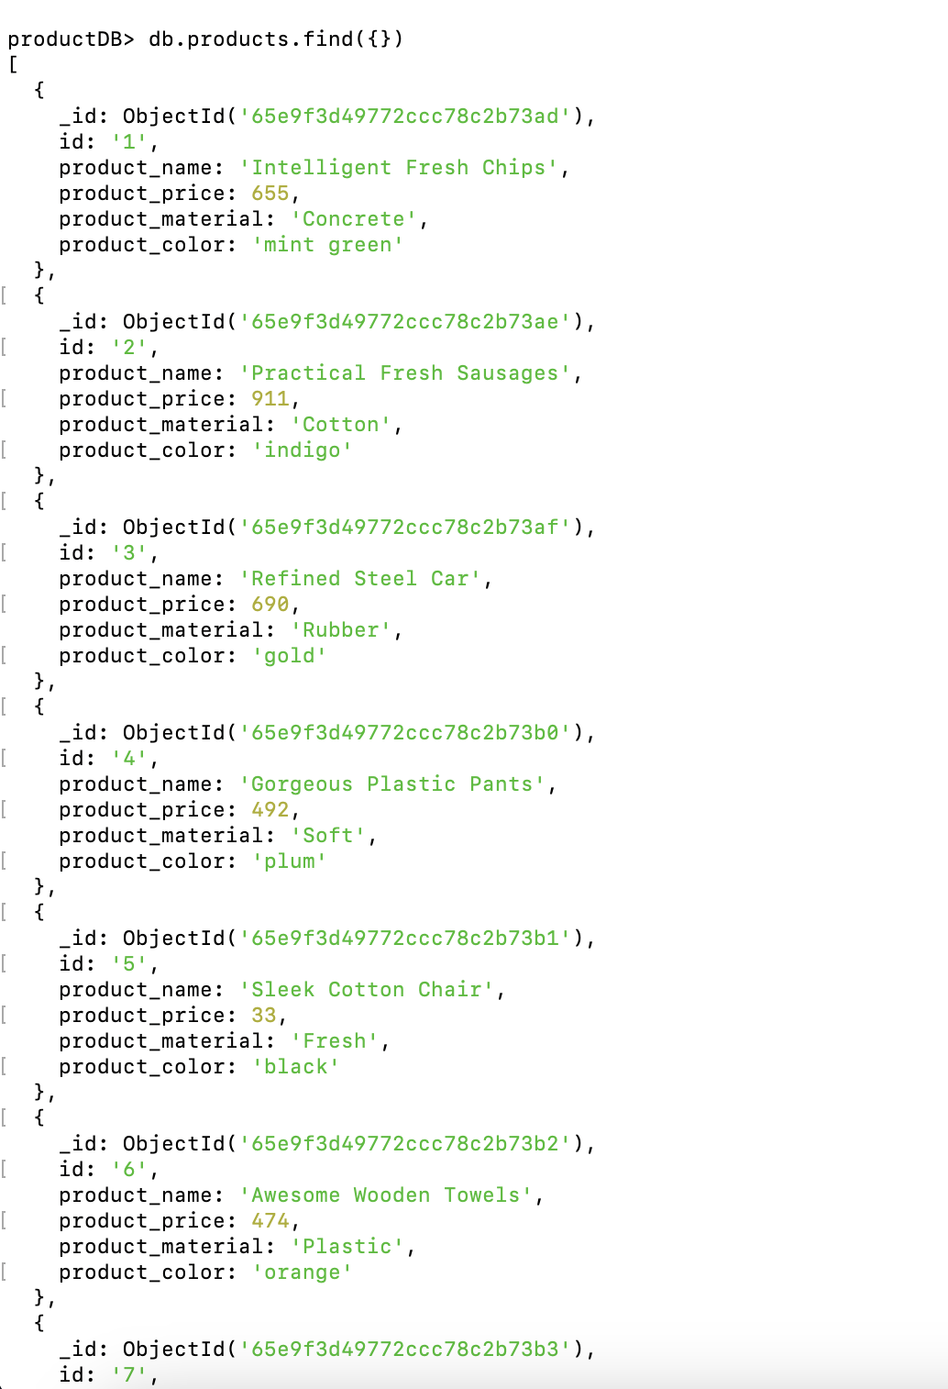

2. Find the product price which are between 400 to 800:  
  
 **db.products.find({ product_price: { $gte: 400, $lte: 800 } })**

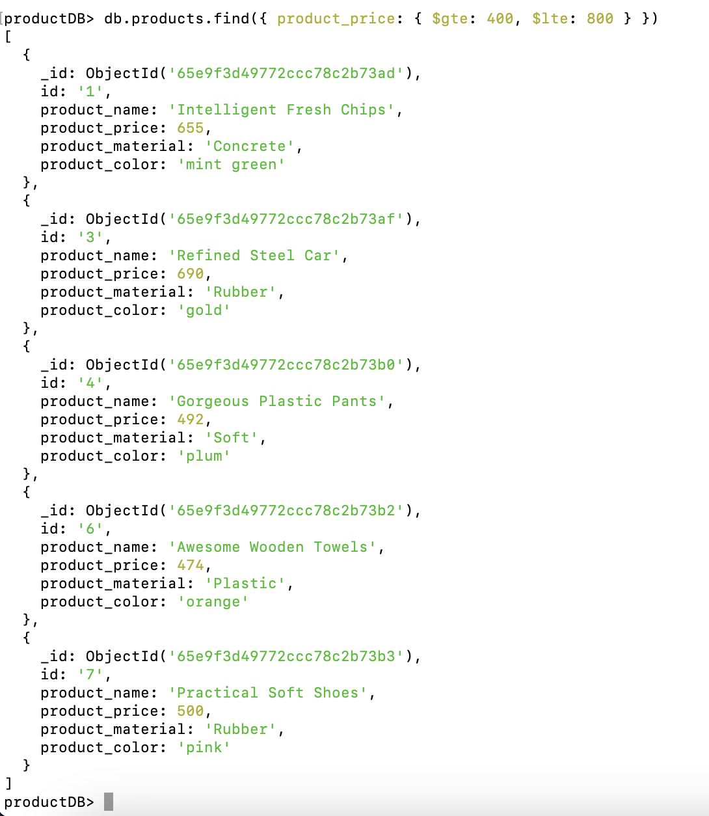

3. Find the product price which are not between 400 to 600:  
  
 **db.products.find({ product_price: { $not: { $gte: 400, $lte: 600 } } })**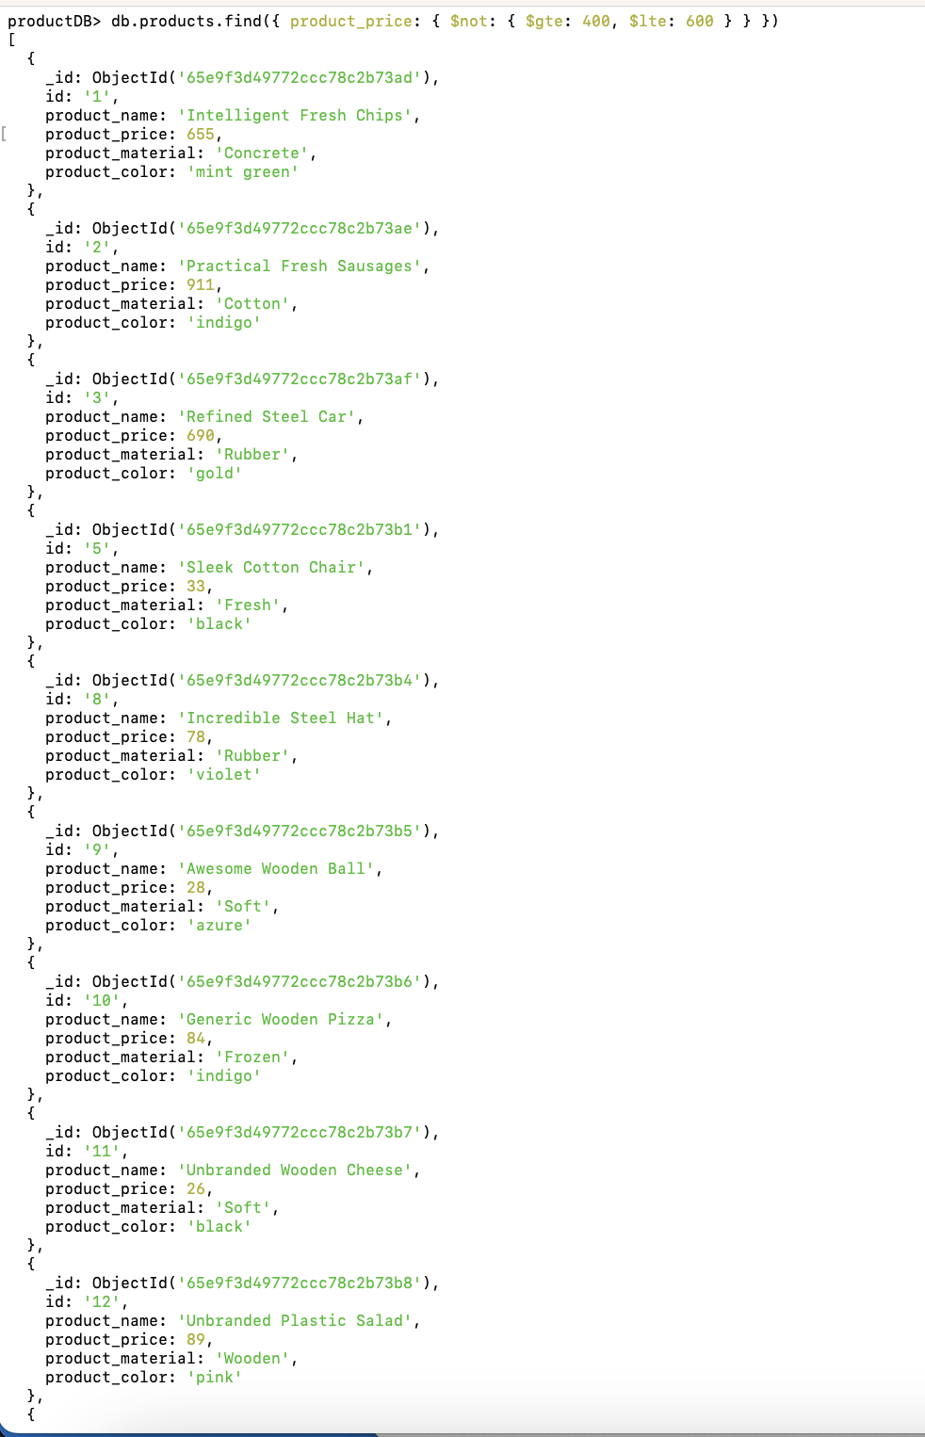

4. List the four products which are greater than 500 in price:  
  
 **db.products.find({ product_price: { $gt: 500 } }).limit(4)**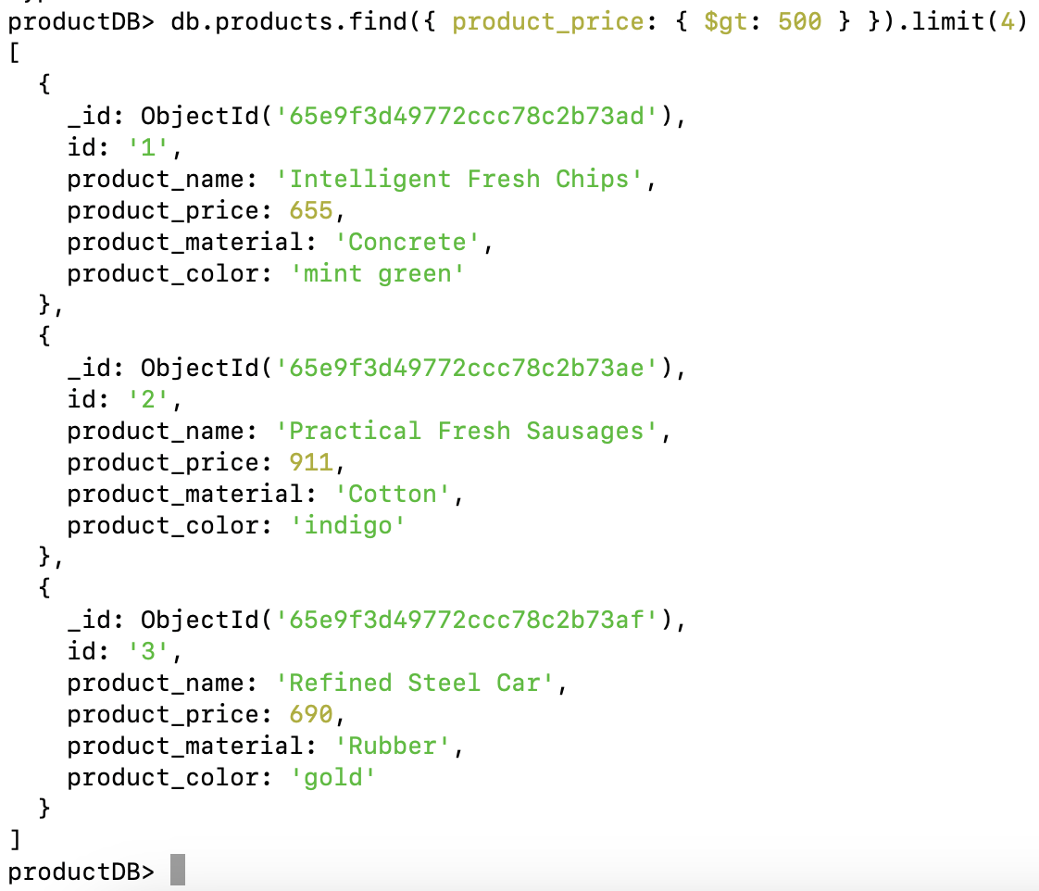

5. Find the product name and product material of each product:  
  
 **productDB> db.products.find({}, {product_name: 1, product_material: 1, })**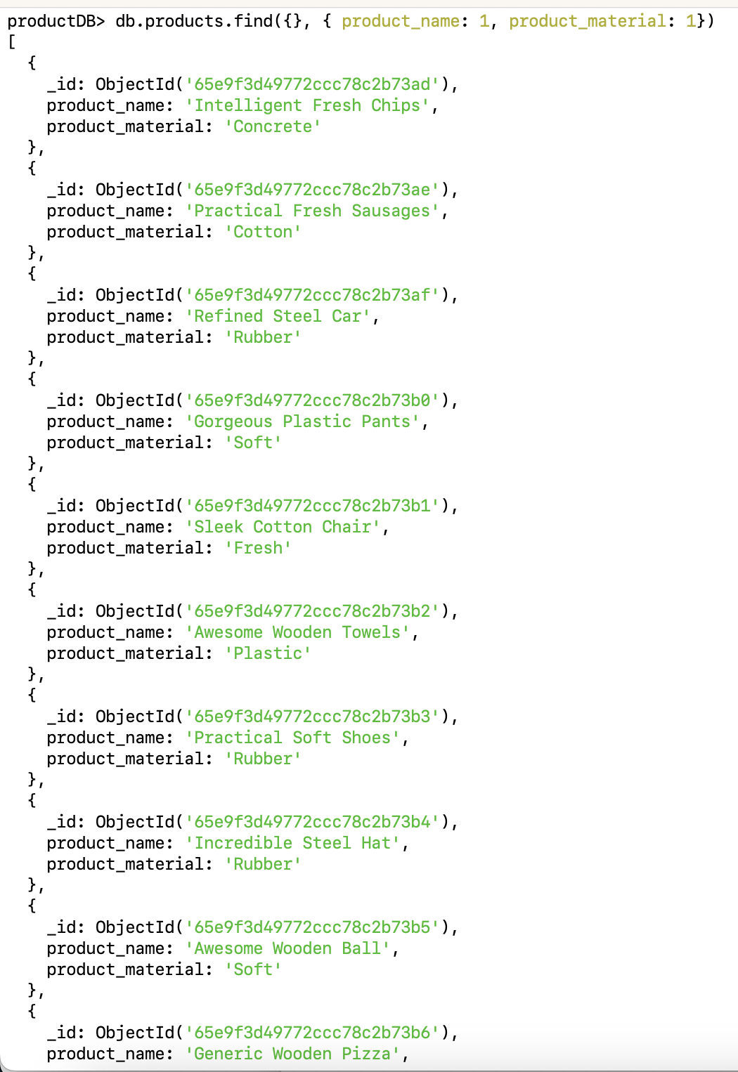

6. Find the product with a row id of 10:  
  
 **db.products.findOne({ "id": "10" })**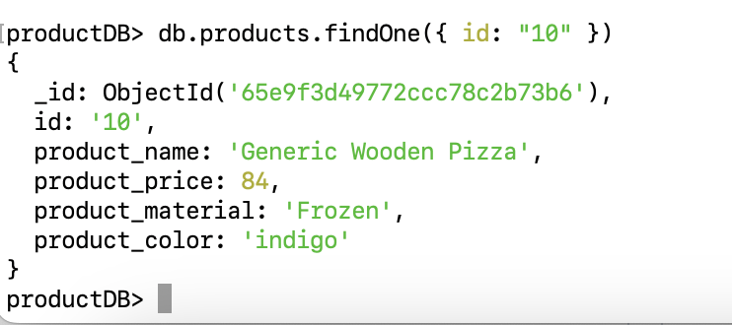

7. Find only the product name and product material:  
  
 **db.products.find({}, { product_name: 1, product_material: 1})**

8. Find all products which contain the value "soft" in product material:  
  
 **db.products.find({ product_material: /soft/i })**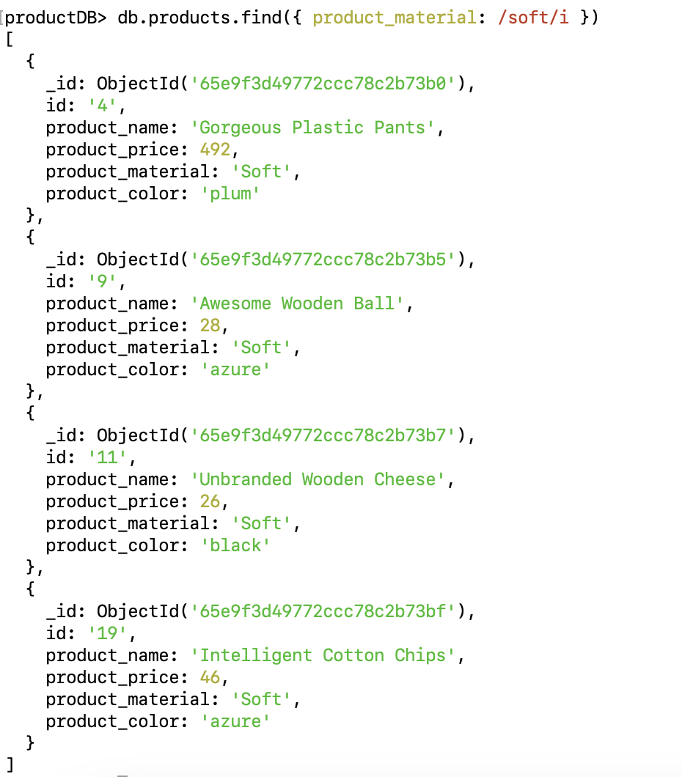

9. Find products which contain product color "indigo" and product price 492.00:

**db.products.find({product_color: "indigo", product_price: 492.00 })**



10. Delete the products which product price values are the same:

**db.products.aggregate([**{

**$group: { id: “$product_price", count: { $sum: 1 }, ids: { $push: "$_id" }}**

**},{$match: {count: { $gt: 1 }}**

**}]).forEach(function(doc) {**

**db.products.deleteMany({ "_id": { $in: doc.ids } });**

**});**