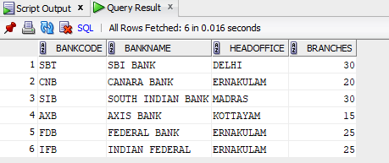
GRANT SELECT ON BANK TO c24csa50;

select * from c24csa50.BANK;

revoke select on BANK from c24csa50;

