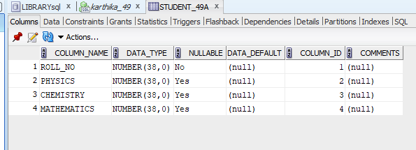
CREATE TABLE STUDENT_49A(ROLL_NO INT PRIMARY KEY,PHYSICS INT,CHEMISTRY INT,MATHEMATICS INT);

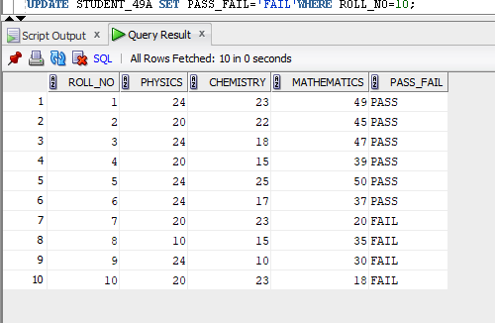
INSERT INTO STUDENT_49A VALUES(1,24,23,49);
INSERT INTO STUDENT_49A VALUES(2,20,22,45);
INSERT INTO STUDENT_49A VALUES(3,24,18,47);
INSERT INTO STUDENT_49A VALUES(4,20,15,39);
INSERT INTO STUDENT_49A VALUES(5,24,25,50);
INSERT INTO STUDENT_49A VALUES(6,24,17,37);
INSERT INTO STUDENT_49A VALUES(7,20,23,38);
INSERT INTO STUDENT_49A VALUES(8,21,15,35);
INSERT INTO STUDENT_49A VALUES(9,24,12,30);
INSERT INTO STUDENT_49A VALUES(10,20,23,42);

ALTER TABLE STUDENT_49A ADD(PASS_FAIL VARCHAR(55));

UPDATE STUDENT_49A SET PASS_FAIL='PASS'WHERE ROLL_NO=1;
UPDATE STUDENT_49A SET PASS_FAIL='PASS'WHERE ROLL_NO=2;
UPDATE STUDENT_49A SET PASS_FAIL='PASS'WHERE ROLL_NO=3;
UPDATE STUDENT_49A SET PASS_FAIL='PASS'WHERE ROLL_NO=4;
UPDATE STUDENT_49A SET PASS_FAIL='PASS'WHERE ROLL_NO=5;
UPDATE STUDENT_49A SET PASS_FAIL='PASS'WHERE ROLL_NO=6;

UPDATE STUDENT_49A SET MATHEMATICS=20 WHERE ROLL_NO=7;
UPDATE STUDENT_49A SET PHYSICS=10 WHERE ROLL_NO=8;
UPDATE STUDENT_49A SET CHEMISTRY=10 WHERE ROLL_NO=9;
UPDATE STUDENT_49A SET MATHEMATICS=18 WHERE ROLL_NO=10;

UPDATE STUDENT_49A SET PASS_FAIL='FAIL'WHERE ROLL_NO=7;
UPDATE STUDENT_49A SET PASS_FAIL='FAIL'WHERE ROLL_NO=8;
UPDATE STUDENT_49A SET PASS_FAIL='FAIL'WHERE ROLL_NO=9;
UPDATE STUDENT_49A SET PASS_FAIL='FAIL'WHERE ROLL_NO=10;

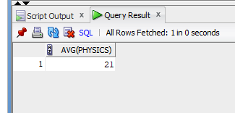
SELECT AVG (PHYSICS) FROM STUDENT_49A;
3.

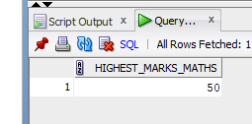
SELECT MAX (MATHEMATICS) AS highest_marks_maths FROM STUDENT_49A;

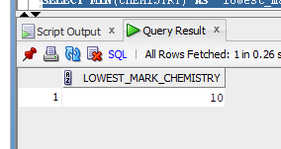
SELECT MIN(CHEMISTRY) AS lowest_mark_chemistry FROM STUDENT_49A;

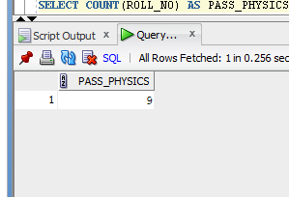
SELECT COUNT(ROLL_NO) AS PASS_PHYSICS FROM STUDENT_49A WHERE PHYSICS>=12;
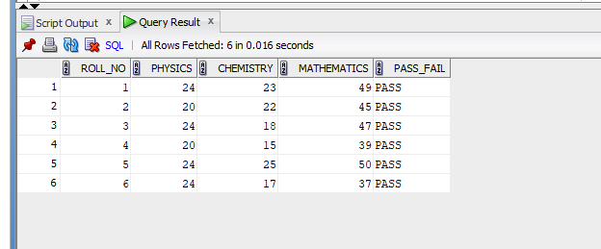
SELECT * FROM STUDENT_49A WHERE PHYSICS>=12 AND CHEMISTRY>=12 AND MATHEMATICS>=25;
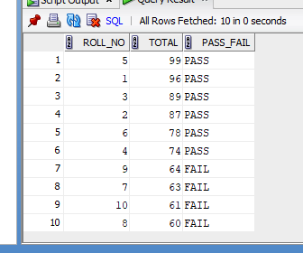
SELECT ROLL_NO,(PHYSICS+MATHEMATICS+CHEMISTRY)AS TOTAL,PASS_FAIL FROM STUDENT_49A ORDER BY TOTAL DESC;

