create table BANK_49(bankcode VARCHAR(3) PRIMARY KEY,
bankname VARCHAR(50) NOT NULL,
headoffice VARCHAR(50),
branches INT CHECK (branches > 0)
);
INSERT INTO BANK_49 VALUES ('SBI', 'State Bank of India', 'Mumbai', 22000);
INSERT INTO BANK_49 VALUES ('HDF', 'HDFC Bank', 'Mumbai', 6000);
INSERT INTO BANK_49 VALUES ('ICI', 'ICICI Bank', 'Mumbai', 5000);
INSERT INTO BANK_49 VALUES ('PNB', 'Punjab National Bank', 'New Delhi', 10000);
INSERT INTO BANK_49 VALUES ('CAN', 'Canara Bank', 'Bangalore', 9000);

CREATE TABLE BRANCH (
branchid INT PRIMARY KEY,
branchname VARCHAR(50) DEFAULT 'New Delhi',
bankid VARCHAR(3),
FOREIGN KEY (bankid) REFERENCES BANK_49(bankcode)
);

INSERT INTO BRANCH VALUES (1, 'Kochi', 'SBI');
INSERT INTO BRANCH VALUES (2, 'Ernakulam', 'HDF');
INSERT INTO BRANCH VALUES (3, 'Chennai', 'ICI');
INSERT INTO BRANCH VALUES (4, 'Delhi', 'PNB');
INSERT INTO BRANCH VALUES (5, 'Bangalore', 'CAN');
INSERT INTO BRANCH (branchid, bankid) VALUES (6, 'SBI');

drop table BRANCH;

CREATE VIEW bank_head_office AS
SELECT *
FROM BANK_49
WHERE headoffice = 'ERNAKULAM';
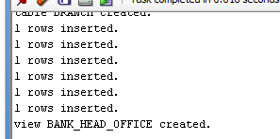
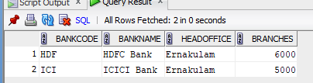
CREATE VIEW bank_branch AS
SELECT B.*
FROM BANK_49 B
JOIN BRANCH BR ON B.bankcode = BR.bankid
WHERE BR.branchname = 'Kottayam';
select * from bank_branch;
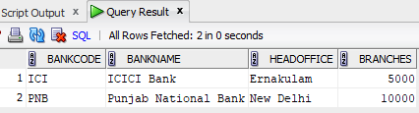
CREATE VIEW bank_more_than_50 AS SELECT * FROM BANK_49 WHERE branches>50;

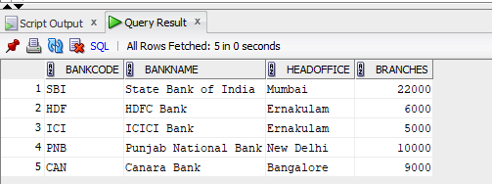

CREATE VIEW bank_branch_details AS SELECT b.bankname, br.branchname FROM BANK_49 b JOIN Branch br ON b.bankcode=br.bankid;

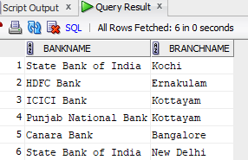
CREATE VIEW bank_outside_ernakulam AS SELECT * FROM BANK_49 WHERE headoffice<>'Ernakulam';
