CREATE TABLE CUSTOMER_49A(CUSTOMER_ID INT PRIMARY KEY,CUSTOMER_NAME VARCHAR(50),CONTACT_NO INT,ADDRESS VARCHAR(50),CITY VARCHAR(50),POSTALCODE INT,COUNTRY VARCHAR(50));
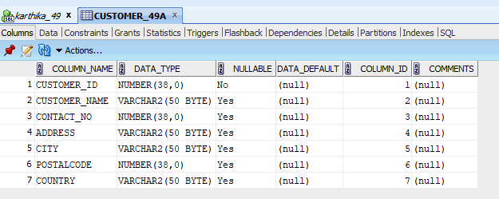
CREATE TABLE ORDER_49A(ORDER_ID INT PRIMARY KEY,CUSTOMER_ID INT,EMPLOYEE_ID INT, FOREIGN KEY (CUSTOMER_ID)REFERENCES CUSTOMER_49A(CUSTOMER_ID),FOREIGN KEY(EMPLOYEE_ID)REFERENCES EMPLOYEE_49A(EMPLOYEE_ID) ,ORDER_DATE DATE,SHIPPER_ID INT);
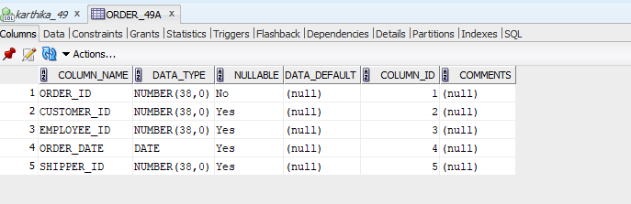
CREATE TABLE EMPLOYEE_49A(EMPLOYEE_ID INT PRIMARY KEY,LAST_NAME VARCHAR(50),FIRST_NAME VARCHAR(50),BIRTH_DATE DATE,PHOTO VARCHAR(50));
