CREATE TABLE EMPLOYEE_1(EMP_ID INT, EMP_NAME VARCHAR(50), SALARY INT, DEPT VARCHAR(50), PRIMARY KEY(EMP_ID));
DESC EMPLOYEE_1;
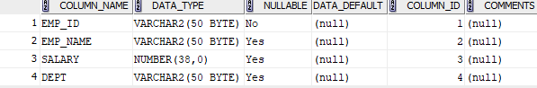

INSERT INTO EMPLOYEE_1(EMP_ID, EMP_NAME, DEPT, SALARY) VALUES(1,'DORA','HR', 10000);
INSERT INTO EMPLOYEE_1(EMP_ID, EMP_NAME, DEPT, SALARY) VALUES(2,'CHARLIE','MARKETING', 8000);
INSERT INTO EMPLOYEE_1(EMP_ID, EMP_NAME, DEPT, SALARY) VALUES(3,'OHM','PRODUCTION', 6000);
INSERT INTO EMPLOYEE_1(EMP_ID, EMP_NAME, DEPT, SALARY) VALUES(4,'AMMU','SALES', 5000);
SELECT * FROM EMPLOYEE_1;
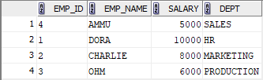

SELECT SALARY FROM EMPLOYEE_1 WHERE SALARY>7000;


SELECT * FROM EMPLOYEE_1 WHERE SALARY>7000;


UPDATE EMPLOYEE_1 SET SALARY = 8200.00 WHERE EMP_NAME='DORA';
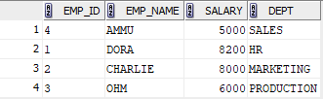

INSERT INTO EMPLOYEE_1(EMP_ID, EMP_NAME, DEPT, SALARY) VALUES(6,'Daniel Harris','Production',6700.00);
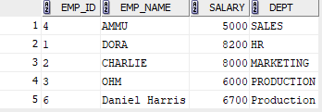

DELETE FROM EMPLOYEE_1 WHERE EMP_ID='3';
