INSERT INTO BANK VALUES('IFB','INDIAN FEDERAL BANK','ERNAKULAM',25);
COMMIT;
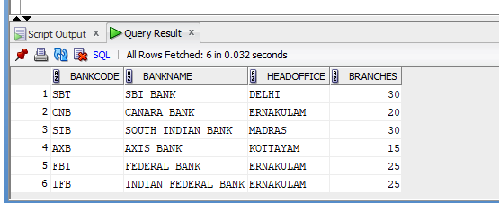

INSERT INTO BANK VALUES('ICL','ICL FINCORP','ERNAKULAM',5);
SAVEPOINT A;

SELECT * FROM BANK;

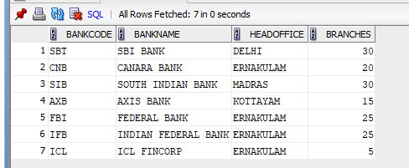
INSERT INTO BANK VALUES('GMB','GRAMEEN BANK','PUNE',15);
SAVEPOINT B;
SELECT * FROM BANK;

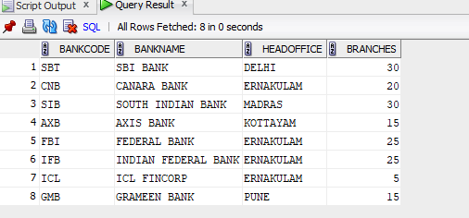
ROLLBACK TO B;

SELECT * FROM BANK;
