**Alma Mater Studiorum – Università di Bologna**

Report of the project about Bayesian Networks on Loan Approval

Fundamentals of Artificial Intelligence and Knowledge Representation Module – 3

# Professor: Paolo Torroni

Ganesh Pavan Kartikeya Bharadwaj Kolluri    -   [ganeshpavan.kolluri@studio.unibo.it](mailto:ganeshpavan.kolluri@studio.unibo.it)

Matricola : 0000976948

GitHub Repository: <https://github.com/karthikbharadhwajKB/LoanApprovalBayesianNet/>

1. **Introduction**

The problem statement is “A Company wants to automate the loan approval process based on customer detail provided while filling online application form. These details are Gender, Marital Status, Education, Number of Dependents, Income, Loan Amount, Credit History, and others”. Here target is Loan Status which has two values yes or no. yes means that Loan Approved and no means Loan is not Approved.

Here I am going to build a Bayesian network with Loan Approval dataset. Where it can infer that a person will get Loan Approved or not by providing Evidence.

1. **Dataset and Preprocessing**

Loan Approval dataset consists of Loan_ID, Gender, Married, Dependents, Education, Self_Employed, ApplicantIncome, CoaaplicantIncome, LoanAmount, Loan_Amount_Term, Credit_History, Property_Area, Loan_Status. Here Loan_Status variable is Target.

I have downloaded the dataset from Kaggle challenge. Here below I am providing source link.

Dataset Source : <https://www.kaggle.com/altruistdelhite04/loan-prediction-problem-dataset/>

Description of Each Variable:

| **Variable** | **Description** |
| --- | --- |
| Loan_ID | Unique Loan ID |
| Gender | Male/ Female |
| Married | Applicant married (Y/N) |
| Dependents | Number of dependents |
| Education | Applicant Education (Graduate/ Under Graduate) |
| Self_Employed | Self employed (Y/N) |
| ApplicantIncome | Applicant income |
| CoapplicantIncome | Coapplicant income |
| LoanAmount | Loan amount in thousands |
| Loan_Amount_Term | Term of loan in months |
| Credit_History | credit history meets guidelines |
| Property_Area | Urban/ Semi Urban/ Rural |
| Loan_Status | Loan approved (Y/N) |

Firstly, we have to load the dataset into notebook using pandas library method pd.read_csv(Loan_approval.csv). and we have to drop “Loan_ID” feature because it not an informative feature. we are going to check for the missing variables. Here we can observe that there are missing values in Gender, Married, Dependents, Self_Employed, LoanAmount, Loan_Amount_Term, Credit_History Variables. Here we have to treat the missing values by using fillna() method with mode.

After that I have converted continuous features into equal bins discrete features by take their max and min value and I opted 3 bins and I have used cut() method to create discrete intervals.

For Example:

**ApplicantIncome Binned into Three bins**

min(data['ApplicantIncome'].unique()), max(data['ApplicantIncome'].unique())

output: (150, 81000)

Here, we can observe that min value is 150 and max value is 81000.

bin_applicantincome = ['150 to 20,250', '20,250 to 40,500', '40,500 to 81000']

I have grouped the intervals like 150 to 20,250, 20,250 to 40,500 and 40,500 to 81,000.

data['ApplicantIncome'] = pd.cut(data['ApplicantIncome'], 3, labels= bin_applicantincome)

data.ApplicantIncome.value_counts()

150 to 20,250 607

20,250 to 40,500 5

40,500 to 81000 2

1. **Bayesian Model**

A Bayesian network, Bayes network, belief network, Bayesian model or probabilistic directed acyclic graphical model is a probabilistic graphical model (a type of statistical model) that represents a set of random variables and their conditional dependencies via a directed acyclic graph (DAG). Bayesian networks are mostly used when we want to represent causal relationship between the random variables. Bayesian Networks are parameterized using Conditional Probability Distributions (CPD). Each node in the network is parameterized using  where  represents the parents of node in the network.

**Building the Bayesian Model**

model = BayesianModel([('Married', 'Gender'), ('Dependents', 'Married'), ('ApplicantIncome', 'LoanAmount'), ('ApplicantIncome', 'Dependents'), ('ApplicantIncome', 'Loan_Status'), ('CoapplicantIncome', 'Loan_Status'), ('CoapplicantIncome', 'Married'), ('CoapplicantIncome', 'Property_Area'), ('Education','Loan_Status'), ('LoanAmount', 'Education'), ('LoanAmount', 'Dependents'), ('Credit_History', 'Loan_Status'), ])

**Visualizing the Bayesian Network**

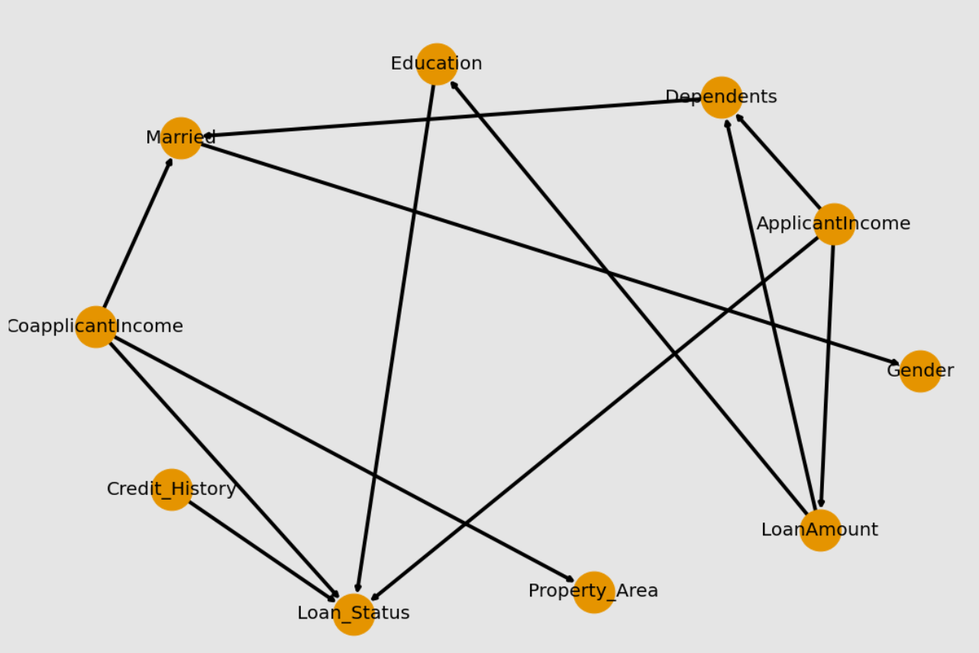

**Fitting the model with Loan Approval dataset**

fit() method will estimate the CPD for each variables based on a given dataset and it will take estimator. Here I am providing BayesianEstimator as estimator, “BDeu” as prior type and 10 equivalent_sample_size.

model.fit(data,estimator=BayesianEstimator,prior_type='BDeu', equivalent_sample_size=10)

1. **Conditional Probability Distribution (CPD)**

**Conditional probability Distribution of Gender**

----------------+---------------------+---------------------+

| Married | Married(No) | Married(Yes) |

+----------------+---------------------+---------------------+

| Gender(Female) | 0.37844036697247707 | 0.08497536945812807 |

+----------------+---------------------+---------------------+

| Gender(Male) | 0.6215596330275229 | 0.9150246305418719 |

+----------------+---------------------+---------------------+

**Conditional probability Distribution of ApplicantIncome**

+-----------------------------------+------------+

| ApplicantIncome(150 to 20,250) | 0.978098 |

+-----------------------------------+------------+

| ApplicantIncome(20,250 to 40,500) | 0.0133547 |

+-----------------------------------+------------+

| ApplicantIncome(40,500 to 81000) | 0.00854701 |

+-----------------------------------+------------+

**Conditional probability Distribution of CoapplicantIncome**

+------------------------------------------+------------+

| CoapplicantIncome(0.0 to 10,416.75) | 0.982906 |

+------------------------------------------+------------+

| CoapplicantIncome(10,416.75 to 20,833.5) | 0.00854701 |

+------------------------------------------+------------+

| CoapplicantIncome(20,833.5 to 41,667.0) | 0.00854701 |

+------------------------------------------+------------+

**Conditional probability Distribution of Credit History**

+---------------------+----------+

| Credit_History(0.0) | 0.150641 |

+---------------------+----------+

| Credit_History(1.0) | 0.849359 |

+---------------------+----------+

1. **Conditional Independencies**

**Independence of Married:**

(Married ⟂ Education, LoanAmount, Property_Area, Loan_Status, ApplicantIncome, Credit_History | Dependents, CoapplicantIncome)

**Independence of Gender:**

(Gender ⟂ CoapplicantIncome, Loan_Status, Dependents, Property_Area, Education, LoanAmount, Credit_History, ApplicantIncome | Married)

**Independence of Dependents:**

(Dependents ⟂ CoapplicantIncome, Loan_Status, Credit_History, Property_Area, Education | ApplicantIncome, LoanAmount)

**Independence of Loan Status:**

(Loan_Status ⟂ Married, Gender, Dependents, LoanAmount, Property_Area | CoapplicantIncome, Education, ApplicantIncome, Credit_History)

**Independence of Credit History:**

(Credit_History ⟂ CoapplicantIncome, Dependents, Property_Area, Education, Married, LoanAmount, Gender, ApplicantIncome)

We can observe that Credit history is Independent but conditionally independent.

1. **Markov Blanket**

The Markov Blanket of a Node is its parents, children & parents of its children (excluding itself).

**Markov Blanket for Education:**

Markov Blanket of "Education" are Loan_Status, ApplicantIncome, Credit_History, CoapplicantIncome, LoanAmount.

**Markov Blanket for LoanAmount:**  
Markov Blanket of "LoanAmount" are Dependents, Education, ApplicantIncome.

**Markov Blanket for Credit History:**

Markov Blanket of "Credit_History" are Education , ApplicantIncome, CoapplicantIncome, Loan_Status.

**Markov Blanket for ApplicantIncome:**

Markov Blanket of "ApplicantIncome" are Education , ApplicantIncome, CoapplicantIncome, Loan_Status, Credit_History, Dependents.

**Markov Blanket for Loan_Status:**

Markov Blanket of "Loan_Status" are Education , ApplicantIncome, CoapplicantIncome, Loan_Status, Credit_History, Dependents.

1. **Reasoning Patterns and Active Trails**

**Q1. Is there is any active trail between Education and LoanAmount ?**

There is active trail between Education and LoanAmount. So, Education and LoanAmount are Not Independent.

**Q2. Is there is any active trail between Loan_Status and Credit_History ?**

There is active trail between Loan_Status and Credit_History. So, Loan_Status and Credit_History are Not Independent.

**Q3. Is there is any active trail between Property Area and Gender ?**

There is no active trail between Property_Area and LoanAmount. So, Property_Area and LoanAmount are Independent of each other.

**Causal reasoning (Prediction)**

**Q1. Do Tony get Loan Approved without any Evidence?**

There is 68% of chance that Tony will get Loan Approved.

**Q2. Do Tony get Loan Approved with given Evidence he is "Graduate”, and his Credit Score is 1.0 and his income is between 40,500 to 81000 ?**

There is 88% of chance that Tony will get Loan Approved.

**Evidential Reasoning (Explaining)**

**Q1. Is Tony being a Graduate given that he got Loan Approved ?**

There is 79% of chance that Tony is Graduated given evidence that he got Loan Approved.

**Q2. Is Tony is Married given that he got Loan Approved ?**

There is 65% of chance that Tony is Married given evidence that he got Loan Approved. May be his wife is also working and earning money.

**8 Inference**

**8.1 Variable Elimination**

Infer = VariableElimination(model)

**Q1) Loan_Status given evidence 'Education':'Graduate','ApplicantIncome':'40,500 to 81000' ?**

print(infer.query(['Loan_Status'], evidence={'Education':'Graduate','ApplicantIncome':'40,500 to 81000'}))

+----------------+--------------------+

| Loan_Status | phi(Loan_Status) |

+================+====================+

| Loan_Status(N) | 0.2313 |

+----------------+--------------------+

| Loan_Status(Y) | 0.7687 |

+----------------+--------------------+

Loan_Status given Education = Graduate and ApplicantIncome = 40,500 to 81000 has 76.87% chance to get Loan Approved.

**Q2) Loan_Status given evidence 'Education':'Graduate','ApplicantIncome':'40,500 to 81000', 'CoapplicantIncome':'0.0 to 10,416.75' ?**

print(infer.query(['Loan_Status'], evidence={'Education':'Graduate','ApplicantIncome':'40,500 to 81000','CoapplicantIncome':'0.0 to 10,416.75'}))

+----------------+--------------------+

| Loan_Status | phi(Loan_Status) |

+================+====================+

| Loan_Status(N) | 0.2266 |

+----------------+--------------------+

| Loan_Status(Y) | 0.7734 |

+----------------+--------------------+

Loan_Status given Education = Graduate, ApplicantIncome = 40,500 to 81000 and CoapplicantIncome = 0.0 to 10,416.75 has 77.34% chance to get Loan Approved.

**Q3) Loan_Status given evidence 'Education':'Graduate','ApplicantIncome':'40,500 to 81000', 'CoapplicantIncome':'0.0 to 10,416.75', ‘Credit_History’: 1.0 ?**

+----------------+--------------------+

| Loan_Status | phi(Loan_Status) |

+================+====================+

| Loan_Status(N) | 0.1087 |

+----------------+--------------------+

| Loan_Status(Y) | 0.8913 |

+----------------+--------------------+

Loan_Status given Education = Graduate, ApplicantIncome = 40,500 to 81000, CoapplicantIncome = 0.0 to 10,416.75 and Credit_History = 1.0 has 89.13% chance to get Loan Approved.

**Conclusion**

Loan_Status given Education = Graduate, ApplicantIncome = 40,500 to 81000, CoapplicantIncome = 0.0 to 10,416.75 and Credit_History = 1.0 has 89.13% chance to get Loan Apporved.

There is nearly 90% of chance to get Loan Approved with these Evidence.

A person who graduated in master’s degree and earning 40,500 to 81000 euros and his wife who has income of 0 to 10,416.75 euros and has Credit History of 1.0 has nearly 90% chance to get Loan Approved.

1. **Sampling**

There are two Sampling techniques I have used in this Notebook they are Rejection sampling and Likelihood weighting sampling that are based on inference by stochastic simulation drawing N samples from a sampling distribution and compute an approximate posterior probability.

**9.1 Rejection Sampling**

The rejection sampling method is to reject those samples that disagree with the given evidence of the query and compute the probability as a mean of the samples.

**Calculating the Probabilities from Samples**

$$\frac{Number of times Query and Evidence variables occurs}{Number of times Evidence occurs}$$

Q1) Query -> Loan_Status: Y

Evidence -> Education: Graduate, ApplicantIncome = 40,500 to 81000

There is 77% of chance getting Loan Approved given Evidence Education = "Graduate", ApplicantIncome = "40,500 to 81000".

Q2) Query --> Loan_Status: Y

Evidence --> Education: Graduate, ApplicantIncome = 40,500 to 81000, Credit_History = 1.0

There is 87.5% of chance getting Loan Approved with given Evidence Education = "Graduate", ApplicantIncome = "40,500 to 81000", Credit_History = 1.0.

**9.2 Likelihood Weighted Sampling**

The likelihood weighting method adopts the approach to use the evidence to weight the samples in the calculation of the probability.

**Calculating probabilities from weighted samples**

$\frac{\sum{ Weights of samples that have Query and Evidence }}{\sum{ Weights of Sample that have Evidence }}$

Q1) Query -> Loan_Status: Y

Evidence -> Education: Graduate, ApplicantIncome = 40,500 to 81000

There is 76% of chance getting Loan Approved with given Evidence Education = "Graduate", ApplicantIncome = "40,500 to 81000".

Q2) Query --> Loan_Status: Y

Evidence --> Education: Graduate, ApplicantIncome = 40,500 to 81000, Credit_History = 1.0

There is 85% of chance getting Loan Approved with given Evidence Education = "Graduate", ApplicantIncome = "40,500 to 81000", Credit_History = 1.0.