**Traffic Sign Recognition**

**Writeup Template**

**Build a Traffic Sign Recognition Project**

The goals / steps of this project are the following:

* Load the data set (see below for links to the project data set)
* Explore, summarize and visualize the data set
* Design, train and test a model architecture
* Use the model to make predictions on new images
* Analyze the softmax probabilities of the new images
* Summarize the results with a written report

**Rubric Points**

**Here I will consider the**[**rubric points**](https://review.udacity.com/#!/rubrics/481/view)**individually and describe how I addressed each point in my implementation.**

**Data Set Summary & Exploration**

**1. Provide a basic summary of the data set. In the code, the analysis should be done using python, numpy and/or pandas methods rather than hardcoding results manually.**

* The size of training set is 34799
* The size of the validation set is 4410
* The size of test set is 12630
* The shape of a traffic sign image is (32,32,3)
* The number of unique classes/labels in the data set is 43

**2. Include an exploratory visualization of the dataset.**

* In the below pie charts, the numbers in the outer circle represent the ID of the different classes and the numbers inside the pie chart displays the percent of the particular class
* **Train Distribution :**

**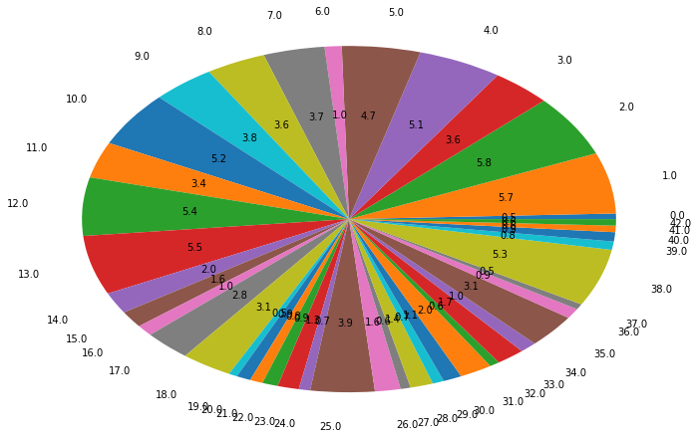**

* **Validation Distribution:**

**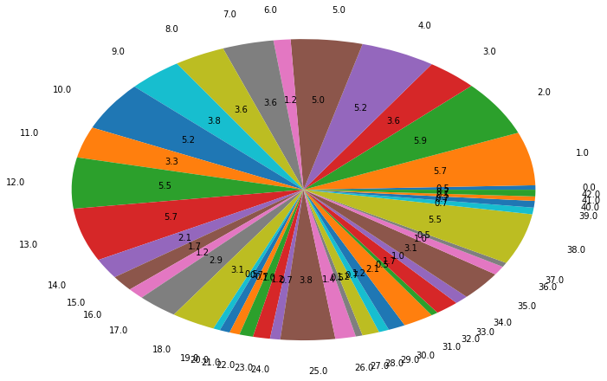**

* **Test Distribution**

**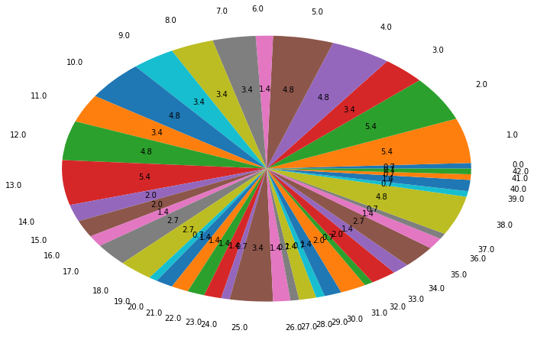**

**Design and Test a Model Architecture**

**1. Describe how you preprocessed the image data. What techniques were chosen and why did you choose these techniques? Consider including images showing the output of each preprocessing technique. Pre-processing refers to techniques such as converting to grayscale, normalization, etc. (OPTIONAL: As described in the "Stand Out Suggestions" part of the rubric, if you generated additional data for training, describe why you decided to generate additional data, how you generated the data, and provide example images of the additional data. Then describe the characteristics of the augmented training set like number of images in the set, number of images for each class, etc.)**

* Image rotation was used as a data augmentation technique.
* For Normalization, I experiment with the traditional method of mean subtraction and division by variance, but the train accuracy was low for this method. Hence, I simply divided by 128, and the accuracy improved

**2. Describe what your final model architecture looks like including model type, layers, layer sizes, connectivity, etc.) Consider including a diagram and/or table describing the final model.**

|  |  |
| --- | --- |
| **Layer** | **Description** |
| Conv2D­­­ | Input = 32x32x1. Output = 28x28x6. Padding = Valid. Activation = ReLu |
| Conv2D­­­ | Input = 28x28x6. Output = 26x26x6. Padding = Valid. Activation = ReLu |
| Max\_Pool | Input = 13x13x6. Output = 9x9x6. Padding = Valid |
| Conv2D­­­ | Input = 28x28x6. Output = 9x9x16. Padding = Valid. Activation = ReLu |
| Max\_Pool | Input = 9x9x16. Output = 5x5x16. Padding = Valid |
| Fully Connected | Input = 400. Output = 120. Activation = ReLU |
| Dropout | Keep\_prob = 0.8 |
| Fully Connected | Input = 120. Output = 84. Activation = ReLU |
| Dropout | Keep\_prob = 0.8 |
| Fully Connected | Input = 84. Output = 43. Activation = None­­ |

**3. Describe how you trained your model. The discussion can include the type of optimizer, the batch size, number of epochs and any hyperparameters such as learning rate.**

* Optimizer : Adam
* Batch Size : 32
* Epochs : 50
* Learning Rate : 0.0009

**4. Describe the approach taken for finding a solution and getting the validation set accuracy to be at least 0.93. Include in the discussion the results on the training, validation and test sets and where in the code these were calculated. Your approach may have been an iterative process, in which case, outline the steps you took to get to the final solution and why you chose those steps. Perhaps your solution involved an already well known implementation or architecture. In this case, discuss why you think the architecture is suitable for the current problem.**

My final model results were:

* training set accuracy of 98.5%
* validation set accuracy of 95.3%
* test set accuracy of 94.75%

Initially, I started off with learning rate as 0.001, and batch size as 64. However, the training accuracy was in low 80s. Hence I slightly reduced learning rate to 0.0009. Training accuracy increased nicely. After batch size was reduced to 32 from 64, the accuracy became even better.

**Test a Model on New Images**

**1. Choose five German traffic signs found on the web and provide them in the report. For each image, discuss what quality or qualities might be difficult to classify.**

C:\Users\karthik.b.m\AppData\Local\Microsoft\Windows\INetCache\Content.Word\no_entry.pngC:\Users\karthik.b.m\AppData\Local\Microsoft\Windows\INetCache\Content.Word\120.pngC:\Users\karthik.b.m\AppData\Local\Microsoft\Windows\INetCache\Content.Word\30.pngC:\Users\karthik.b.m\AppData\Local\Microsoft\Windows\INetCache\Content.Word\stop.png



The first image “Road Work” might be difficult to classify as there is noise in background. The rest of images seems to have less background noise

**2. Discuss the model's predictions on these new traffic signs and compare the results to predicting on the test set. At a minimum, discuss what the predictions were, the accuracy on these new predictions, and compare the accuracy to the accuracy on the test set (OPTIONAL: Discuss the results in more detail as described in the "Stand Out Suggestions" part of the rubric).**

Here are the results of the prediction:

|  |  |
| --- | --- |
| **Ground Truth** | **Prediction** |
| Speed limit (120km/h) | Speed limit (120km/h) |
| Speed limit (30km/h) | Speed limit (30km/h) |
| No entry | No entry |
| Road work | Road work |
| STOP | End of no passing |

The model predicts 4 of the 5 traffic signs correctly, which gives an accuracy of 80%. This is lower than the test set accuracy , as it is tested on just 5 images.

**3. Describe how certain the model is when predicting on each of the five new images by looking at the softmax probabilities for each prediction. Provide the top 5 softmax probabilities for each image along with the sign type of each probability. (OPTIONAL: as described in the "Stand Out Suggestions" part of the rubric, visualizations can also be provided such as bar charts)**

**IMAGE 1**

Speed limit (120km/h) 0.91271585

Priority road 0.021782106

Speed limit (80km/h) 0.021500872

Speed limit (100km/h) 0.015487953

No vehicles 0.0051490283

**IMAGE 2**

Speed limit (30km/h) 0.90182775

Speed limit (20km/h) 0.09806955

Speed limit (50km/h) 4.7459976e-05

Speed limit (120km/h) 1.9852812e-05

Speed limit (80km/h) 1.9163626e-05

**IMAGE 3**

No entry 0.99984145

Keep right 0.00015637308

No passing 1.9485121e-06

No passing for vehicles over 3.5 metric tons 1.6985318e-07

Turn left ahead 5.9539744e-08

**IMAGE 4**

Road work 0.98681474

Right-of-way at the next intersection 0.0129026575

Beware of ice/snow 0.00014104374

Double curve 0.00013360186

Traffic signals 4.093772e-06

**IMAGE 5**

End of no passing 0.21254909

No entry 0.20675896

No passing 0.10295688

Priority road 0.081048734

No passing for vehicles over 3.5 metric tons 0.06440334