Principles of Testing:

Testing shows the presence of defects, not their absence: Testing can find defects, but it can never prove that there are no defects left. The goal is to reduce the number of defects, not to achieve complete bug-free software.
Exhaustive testing is impossible: It's not feasible to test every possible input and combination of conditions for even simple software. Testers must use risk analysis and prioritize efforts to focus on the most critical areas.
Early testing saves time and money: Finding and fixing defects early in the development lifecycle is significantly cheaper and faster than finding them later. Static and dynamic testing should start as early as possible.
Defects cluster together: Most defects are often found in a small number of modules within the software. This principle, also known as the 80/20 rule, suggests focusing testing efforts on those high-risk areas.
The pesticide paradox: If you keep running the same set of tests, they will eventually become ineffective at finding new defects. To overcome this, tests need to be updated and new, different tests must be created regularly.
Testing is context-dependent: The right testing strategy depends on the context of the software being tested. For example, the testing required for an e-commerce site will differ from the testing for a simple mobile game.
The absence-of-errors fallacy: Finding and fixing many defects does not guarantee that the software is useful. If the system built was the wrong one and doesn't meet the user's needs, then finding no defects in it is irrelevant.

QA (Quality Assurance):
Quality Assurance (QA) is a proactive, process-oriented approach that aims to prevent defects by improving development processes.

QC(Quality Control):
Quality Control (QC) is a reactive, product-oriented approach that aims to detect and correct defects
QA vs QC:

Feature | Quality Assurance (QA) | Quality Control (QC)
Approach | Proactive; focuses on preventing defects | Reactive; focuses on finding and correcting defects
Focus | The process and system used to create the product | The final product itself
Goal | To improve the development process and prevent future errors | To identify and fix defects in the current product
Timeline | Occurs throughout the entire product lifecycle, before and during development | Primarily occurs at the end of the development cycle, during the testing phase
Responsibility | Involves the entire team | Usually performed by a dedicated quality control team or specific personnel
Activities | Process planning, setting standards, code reviews, and training | Inspections, testing, bug fixing, and user acceptance testing

Tester

- A tester is an individual who performs Quality Control activities, specifically the execution of test cases to find bugs and issues in a software product.
- Testers are a part of the QC process, which falls under the broader umbrella of QA

QA Testing (Tester) | Dev Testing (Developer)
Done to ensure the entire software ecosystem is free of bugs, anomalies and errors. | Done to get rid of any many bugs in the code as possible early in the SDLC.
Involves QAs putting the entire codebase through multiple, exhaustive tests. | Involves developers testing their own code.
Conducted after the software has been built | Conducted right before devs push their own code to the shared repo.
Requires collaboration between devs, testers and business stakeholders. | Requires collaboration between multiple devs (for code review and such).
Ensures that the final product is closely aligned with customer expectations. | Ensures that newly written code is not riddled with avoidable bugs before it goes into the CI/CD pipeline.
Generally comprises multiple tests – regression tests, accessibility tests, usability tests, performance tests, stress tests, etc. | Generally comprises unit tests.

SDLC: (Software Development Life Cycle)

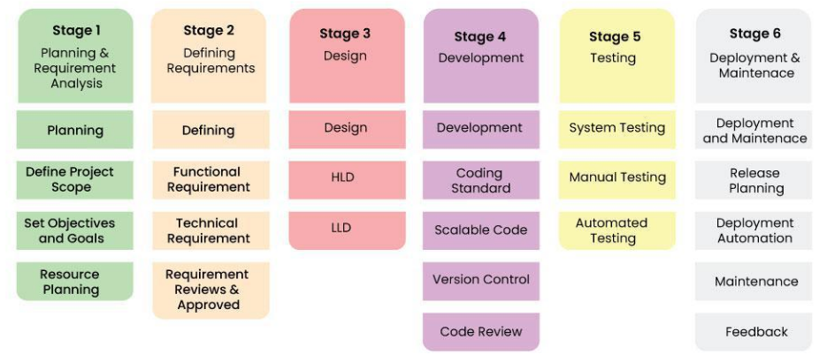
LLD vs HLD:

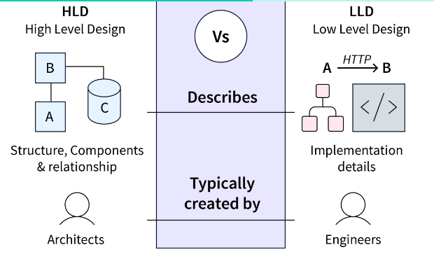
STLC:

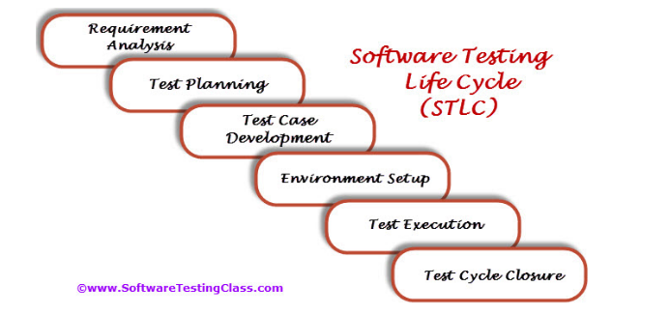
Requirement Analysis:

Entry Criteria | Activities | Deliverable
Following documents should be available:  – Requirements Specification.  – Application architectural  Along with above documents Acceptance criteria should be well defined. | Prepare the list of questions or queries and get resolved from Business Analyst, System Architecture, Client, Technical Manager/Lead etc.  Make out the list for what all Types of Tests performed like Functional, Security, and Performance etc.  Define the testing focus and priorities.  List down the Test environment details where testing activities will be carried out.  Checkout the Automation feasibility if required & prepare the Automation feasibility report. | List of questions with all answers to be resolved from business i.e. testable requirements  Automation feasibility report (if applicable)

Test Planning:

Entry Criteria | Activities | Deliverable
Requirements Documents (Updated version of unclear or missing requirement).  Automation feasibility report. | Define Objective & scope of the project.  List down the testing types involved in the STLC.  Test effort estimation and resource planning.  Selection of testing tool if required.  Define the testing process overview.  Define the test environment required for entire project.  Prepare the test schedules.  Define the control procedures.  Determining roles and responsibilities.  List down the testing deliverable.  Define the entry criteria, suspension criteria, resumption criteria and exit criteria.  Define the risk involved if any. | Test Plan or Test strategy document.  Testing Effort estimation document.

Test Case Development:

Entry Criteria | Activities | Deliverable
Requirements Documents (Updated version of unclear or missing requirement).  Automation feasibility report. | Preparation of test cases.  Preparation of test automation scripts (if required).  Re-requisite test data preparation for executing test cases. | Test cases.  Test data.  Test Automation Scripts (if required).

Test Environment Setup:

Entry Criteria | Activities | Deliverable
Test Plan is available.  Smoke Test cases are available.  Test data is available. | Analyze the requirements and prepare the list of Software & hardware required to set up test environment.  Setup the test environment.  Once the Test Environment is setup execute the Smoke test cases to check the readiness of the test environment. | Test Environment will be ready with test data.  Result of Smoke Test cases.

Test Execution:

Entry Criteria | Activities | Deliverable
Test Plan or Test strategy document.  Test cases.  Test data. | Based on test planning execute the test cases.  Mark status of test cases like Passed, Failed, Blocked, Not Run etc.  Assign Bug Id for all Failed and Blocked test cases.  Do Retesting once the defects are fixed.  Track the defects to closure. | Test case execution report.  Defect report.

Test Cycle Closure:

Entry Criteria | Activities | Deliverable
Test case execution is completed  Test case Execution report  Defect report | Evaluate cycle completion criteria based on Test coverage, Quality, Cost, Time, Critical Business Objectives, and Software Prepare test metrics based on the above parameters.  Prepare Test closure report  Share best practices for any similar projects in future | Test Closure report  Test metrics

