Software Development Models:

Software development models provide a framework for managing the software development lifecycle, with common examples including the sequential Waterfall model and the iterative/incremental Agile models like Scrum and Kanban.

Waterfall Model:

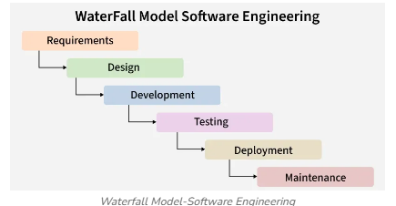

Requirements:
- Gathering the requirements from customer
- Preparing list of questions / clarifications
- Send the clarifications to the customer through Business Analyst and get it clarified
- Freezing the requirement (Last version of BRD)

Design:
- Dev Architect designs the High Level Design document
- Dev Software Engineer designs the Low Level Design document
- Test Engineer designs the Test cases

Coding:
- Software development process starts here in this stage
- Dev team starts to write code.
- Developer sends the code for review.
- Dev changes the code based on review comments.
- Dev integrates all the modules and gives the complete software for testing.

Testing:
- Testing team starts different types of testing
- Performs Smoke Test once the fresh build received from Dev team
- Once the smoke test is pass, the team will continue with full functional testing.
- Tester starts to find defects and post the defects in defect tracking tool or defect tracker sheet (Excel)
- Dev team fixes the defect and send it back to Testing team for Re-Test & Regression Test.
- Testing team prepares a Test Report after Successful Test Execution and sends the report to all stack holders.

Deployment:
- Dev pushes the complete code to remote repository like Github or some other version control system.
- Here the complete software is given to the user (public). It is formally called as Software is on Live.

Maintenance:
- In this stage, the user or customer may ask for some small changes in the software.
- The dev team implements the changes and again push the code to repository.
- The changes happening in this stage is after the full release of the software product.

V – Model:

The V-model is a software development methodology that extends the waterfall model by associating a corresponding testing phase with each development phase, creating a V-shaped process of sequential development and parallel testing

This parallel approach allows for early test planning and helps identify flaws early in the lifecycle.

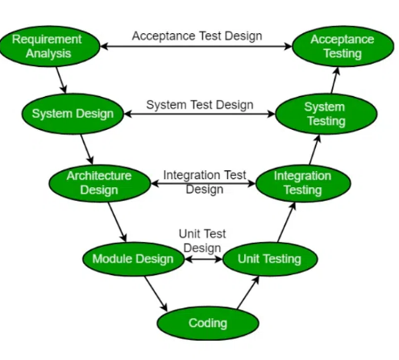

Agile Model: (Iterative and Incremental model)

The agile model is an iterative and incremental approach to project management and software development that prioritizes flexibility, customer collaboration, and quick delivery.

It breaks projects into small, manageable cycles or "sprints," where a small piece of functional software is developed, tested, and deployed for feedback before the next iteration begins.

Characteristics:

Iterative and incremental:
Projects are completed in a series of short cycles (sprints) where the product is built and delivered incrementally.
- Customer-focused:
Close collaboration with the customer is essential to ensure the final product meets their needs and to gather feedback for improvements.
- Flexible and adaptable:
The model is designed to accommodate changing requirements, making it suitable for dynamic projects.
- Team-oriented:
It relies on self-organizing, cross-functional teams and emphasizes collaboration and communication.
- Rapid delivery:
The focus is on delivering a working product frequently, rather than a single large delivery at the end of the project.

Agile (Common Term):

- Scrum
- Kanban

Scrum:

A popular framework that uses fixed-length iterations (sprints) with specific roles (Product Owner, Scrum Master, Development Team) and events (daily scrums, sprint planning) .

Sprint: It can be 2 weeks or 3 weeks duration.
Product Owner: He is the one who communicates with the customer, he has the complete product knowledge.
Scrum Master: He planning the sprint, resolves the issues in the team, organising the team etc.,

daily scrums: It happens on daily basis for short period like 15-20 mins duration. It is a stand up meeting.

In this meeting the person will discuss about the task, blocker issues in the task. What they did yesterday?, what they are planning to do today? Everything will be discussed.

MOM (Minutes of meeting) will be taken for this meeting for reference purpose.

MOM is a document which contains the discussion and action items gathered from the meeting.

Kanban:

Kanban Board:

Card:

Todo -> Inprogress -> Done

Backlog -> Todo -> Dev in progress -> Dev done-> Test in progress-> Test done -> Completed Deployement

Dev:
Backlog: Tasks awaiting assignment.
- To do: Tasks ready to be picked up.
- In Progress: Tasks actively being worked on.
- Code Review: Tasks under review by peers.
- Done: Completed tasks.

Dev Ops: Dev – Development process Ops – IT operations

DevOps combines software product development with IT operations through the software development lifecycle, including development, testing, and support.

This methodology helps improve the efficiency, speed, and security of the software development lifecycle and enhances the quality of delivery.

