**REPORT**

The aim of this solution was to find the cheapest flight for a given value of N where N is the elapsed time in minutes. The data set provided to us had data of flights of the last 30 years. Here is the approach we followed to find the cheapest flight –

* Read the input and check for sanity.
* Next we extracted the elapsed time and the average price for the flight
* The key of the first mapper contains the carrier code and year. The value is the elapsed time and the average price.
* These was passed to the reducer.
* In the reducer, we extracted the elapsed time and average price.
* We passed these 2 values to a linear regression library.
* After this we were able to retrieve the intercept and slope of the regression line.
* The key of the first reducer contains the carrier code and year. The value is the intercept and the slope of the regression line.
* The output of the first map-reduce job is sent to a processing file.
* Here we compute the Intercept + (Slope * N) for each carrier and each year.
* For each year we compare this computed value for each carrier and the carrier with the least value was the cheapest for that year.
* Similarly we found the cheapest carrier for each year. Finally whichever carrier was the cheapest for the most number of years was chosen as the cheapest flight for the last 30 years.
* Once we got the cheapest flight, we run another map-reduce job to plot the median price of that carrier for each week.
* So in the second map-reduce we read the input data and do a sanity test.
* We also filter out all other carriers.
* The mapper output is the year and week number and the value is the average price.
* The reducer computes the median for each year and each week
* This completes all the computation and the output of the final reduce job is used to plot a graph using R.

For the value of **N=200**, we found out the **AS** was the cheapest flight.

Seen below is a graph of Median ticket price versus week number of all the years starting from 1986.

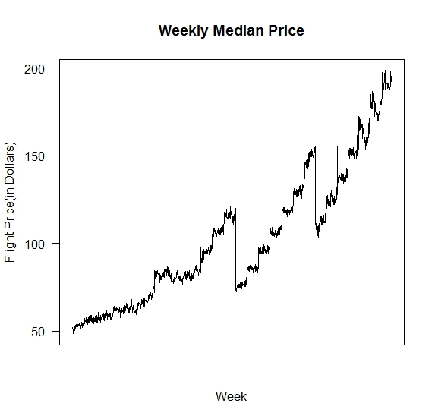

For the value of **N=1**, we found out the **CO** was the cheapest flight.

Seen below is a graph of Median ticket price versus week number of all the years starting from 1986.

