M.S.RAMAIAH INSTITUTE OF TECHNOLOGY
(Autonomous Institute, Affiliated to VTU)
www.msrit.edu
BANGALORE-560054

ONLINE PARKING TRACKING SYSTEM

Submitted by
Jivitesh Mopuri 1MS12CS042
Keshava R 1MS12CS045
Charan Rao S 1MS13CS406
Karthik M 1MS13CS407

Guided by
Dr.T.N.R.Kumar
Assistant Professor
Department of Computer Science and Engineering

ONLINE PARKING TRACKING SYSTEM
PROCESS MODELS
In the Development of online parking tracking system, we have chosen the Iterative model.
In Iterative model, iterative process starts with a simple implementation of a small set of the software requirements and iteratively enhances all the versions until the complete system is implemented and ready to be deployed.
At each iteration, design modifications are made and new functional capabilities are added.
The basic idea behind this method is to develop a system through repeated cycles (iterative) and in smaller portions at a time (incremental).
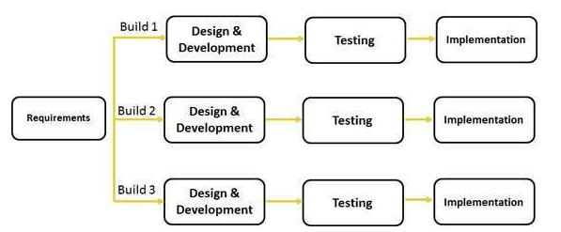
This model is most often used in the following scenarios:
Requirements of the complete system are clearly defined and understood.
There is a time to the market constraint.
A new technology is being used and is being learnt by the development team while working on the project.
Resources with needed skill set are not available and are planned to be used on contract basis for specific iterations.
There are some high risk features and goals which may change in the future.
Effort Estimation using COCOMO Model

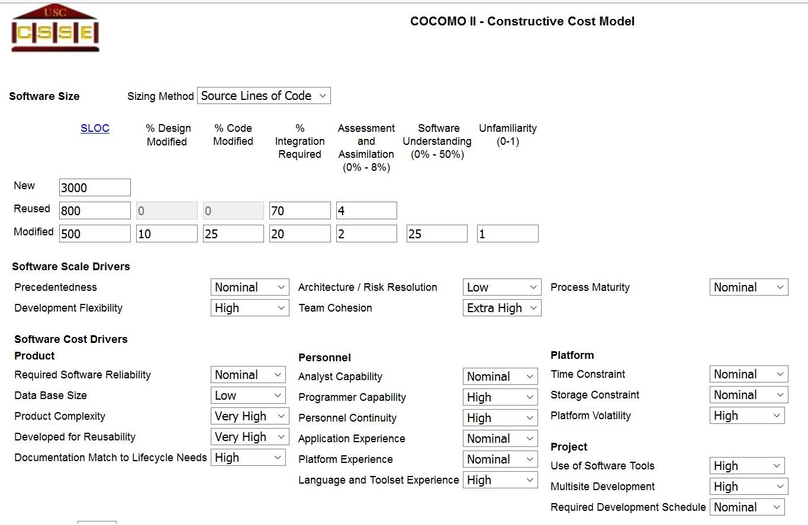

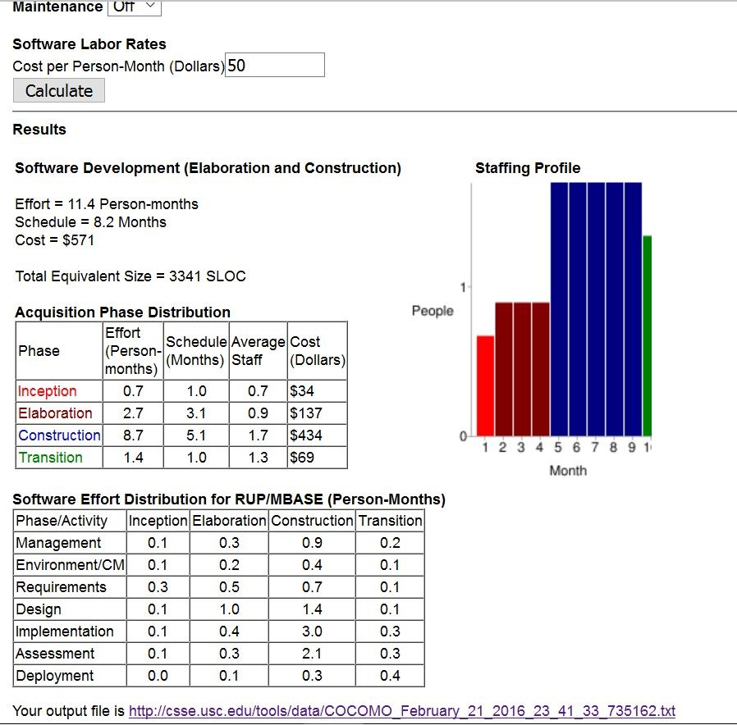

Schedule of project activities using Gantt Chart

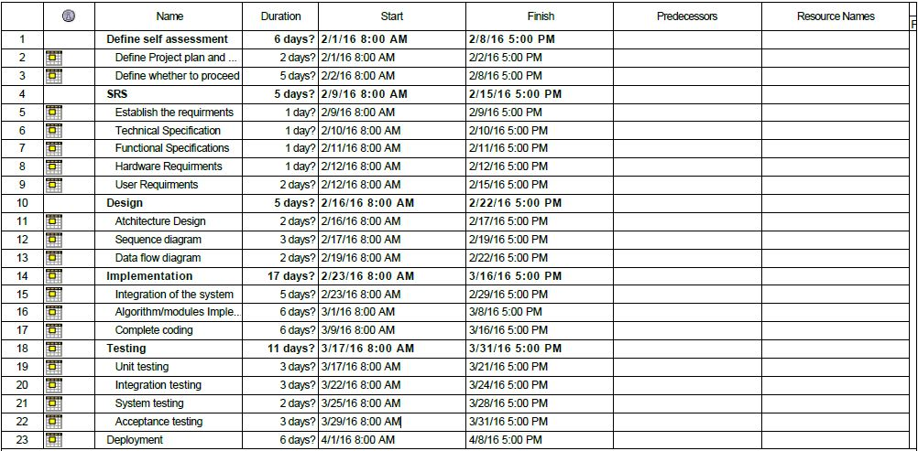

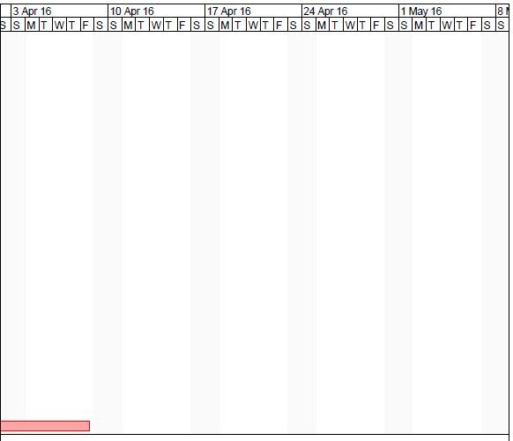
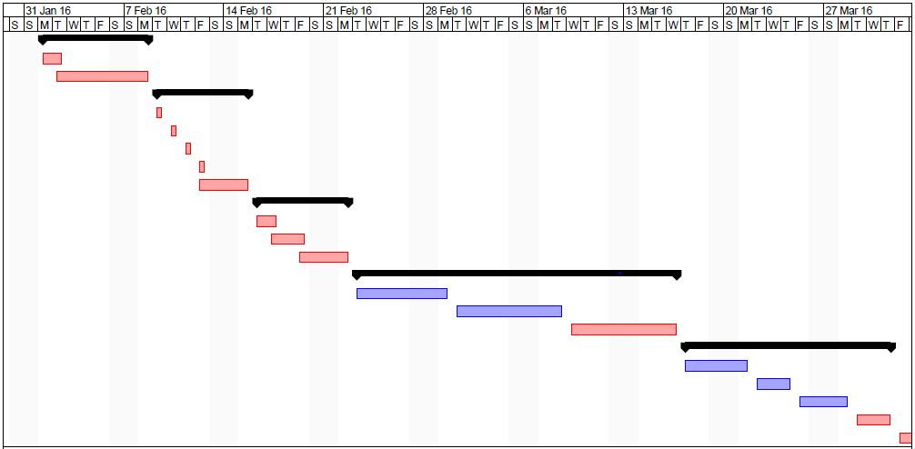

Risk Identification (Top 5 Risks) with Risk Mitigation Steps for each

