Machine Learning Operations (AIMLCZG523)
Assignment 01
Heart Disease Risk Prediction
End-to-end ML model development, CI/CD and production deployment
Student | C V R Karthik
BITS ID | 2025AE05851
Code repository | https://github.com/<your-account>/heart-disease-mlops
Pipeline video | <link to pipeline video recording>
Champion model | Logistic Regression - CV ROC-AUC 0.888, hold-out ROC-AUC 0.930
Stack | scikit-learn, MLflow, FastAPI, Docker, Kubernetes (Minikube), GitHub Actions, Prometheus, Grafana

Contents
Contents 2
1. Introduction and architecture 3
Key design decisions 3
2. Setup and installation 3
3. Data acquisition and exploratory analysis 4
3.1 Acquisition and cleaning 4
3.2 Findings 4
4. Feature engineering and model development 6
4.1 Feature pipeline 6
4.2 Models and tuning 6
4.3 Results 7
4.4 Model selection 7
5. Experiment tracking (MLflow) 8
6. Model packaging and reproducibility 9
7. CI/CD pipeline and automated testing 10
7.1 Unit tests 10
7.2 GitHub Actions workflow 10
8. Model containerisation 11
9. Production deployment (Kubernetes) 11
10. Monitoring and logging 12
10.1 Logging 12
10.2 Metrics, dashboard and alerts 12
11. Conclusion and deliverables 13
Possible extensions 13

1. Introduction and architecture
The goal is a reproducible, monitored, cloud-ready API that estimates the risk of heart disease from routine clinical measurements. The work follows the full MLOps lifecycle: data acquisition and EDA, feature engineering and model tuning, experiment tracking, packaging, automated testing and CI/CD, containerisation, Kubernetes deployment and runtime monitoring.
Figure 1 shows the system. Everything is driven from one Python package (src/heart), so the same code runs in notebooks, in the CLI, in CI, and inside the serving container.
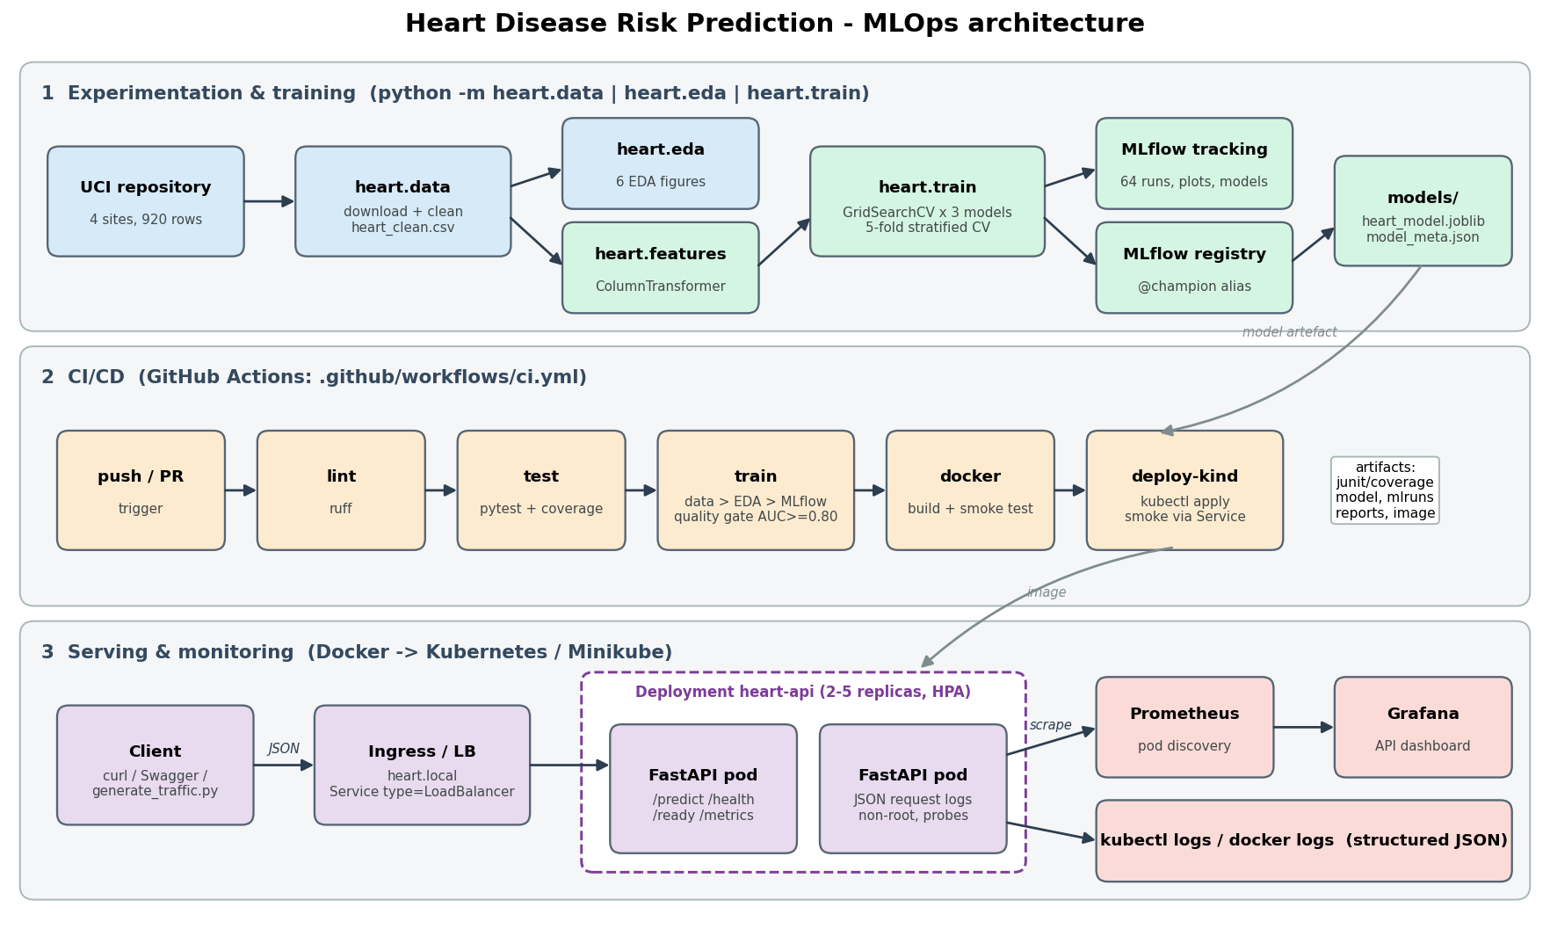
Figure 1. End-to-end architecture: training lane, CI/CD lane and serving/monitoring lane.

Key design decisions
- All four UCI sites (920 patients) are used rather than the usual 303-row Cleveland subset. This gives three times more data and makes the pipeline handle real missing values.
- Preprocessing is part of the persisted model (one sklearn Pipeline), so training and serving can never diverge.
- Model selection uses cross-validation only; the 20 % hold-out set is used just for reporting.
- Missingness is modelled explicitly (indicator flags plus a 'missing' category level), and the API accepts patients with unmeasured fields.
- Observability is built in: structured JSON request logs, Prometheus metrics (including a prediction-mix drift signal), a provisioned Grafana dashboard and alert rules.

2. Setup and installation
Prerequisites: Python 3.10-3.12, Docker, Git and internet access. kubectl and minikube are installed automatically into ~/.local/bin if missing. The whole pipeline runs with one command:
git clone https://github.com/<your-account>/heart-disease-mlops
cd heart-disease-mlops
bash scripts/lab_run.sh all # setup data eda train test nb mlflow docker k8s traffic
Each stage can also be run on its own, and each writes its console output to logs/<stage>.log:
Stage | Command / effect
setup | python -m venv .venv and pip install -r requirements.txt (pinned versions)
data / eda / train | python -m heart.data, python -m heart.eda, python -m heart.train
test | ruff check . and pytest --cov=heart
mlflow | mlflow ui --backend-store-uri sqlite:///mlflow.db on port 5000
docker | build heart-disease-api:1.0.0, run it, 9-check smoke test, show container logs
k8s | minikube start, minikube image load, scripts/deploy_k8s.sh, smoke test through the Service
traffic / compose | sample load for dashboards / Docker-Compose alternative (API, Prometheus, Grafana)

Windows without Docker: create the venv, pip install -r requirements.txt, run the three python -m heart.* modules, then uvicorn heart.serving:app.

3. Data acquisition and exploratory analysis

3.1 Acquisition and cleaning
heart.data.download() fetches processed.{cleveland,hungarian,switzerland,va}.data from the UCI repository and caches them in data/raw/. heart.data.clean() then applies the following rules (unit-tested in tests/test_data.py):
Issue found in raw data | Treatment
? used as missing marker | parsed as NaN
Diagnosis num is a 0-4 severity | binary target = num > 0 (presence of disease)
chol = 0 in 172 rows (all 123 Swiss rows + 49 VA), trestbps = 0 once | physiologically impossible, so set to NaN
Codes outside the data dictionary | set to NaN (e.g. thal must be 3, 6 or 7)
2 exact duplicate rows | dropped, leaving 918 rows (55.3 % positive)

Imputation is intentionally not done during cleaning. It is part of the model pipeline (Section 4), so identical logic is applied to API requests.

3.2 Findings
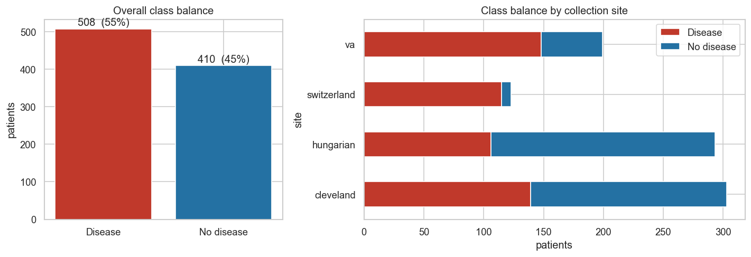
Figure 2. Class balance overall and per collection site.
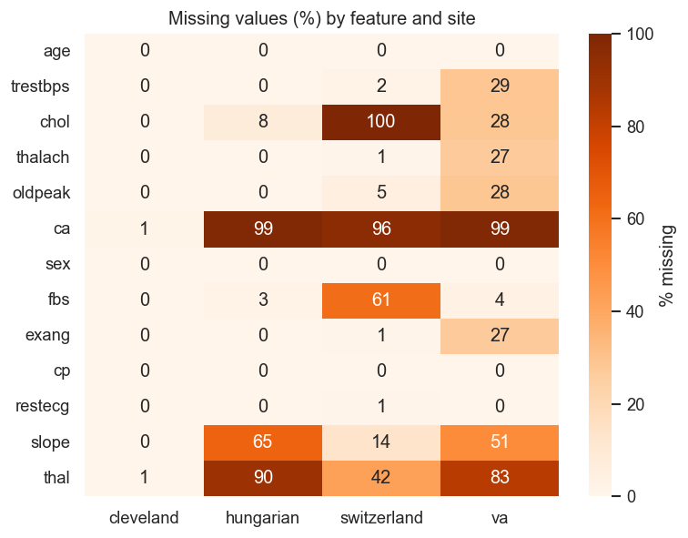
Figure 3. Missing values (%) per feature and site - missingness is site-driven.
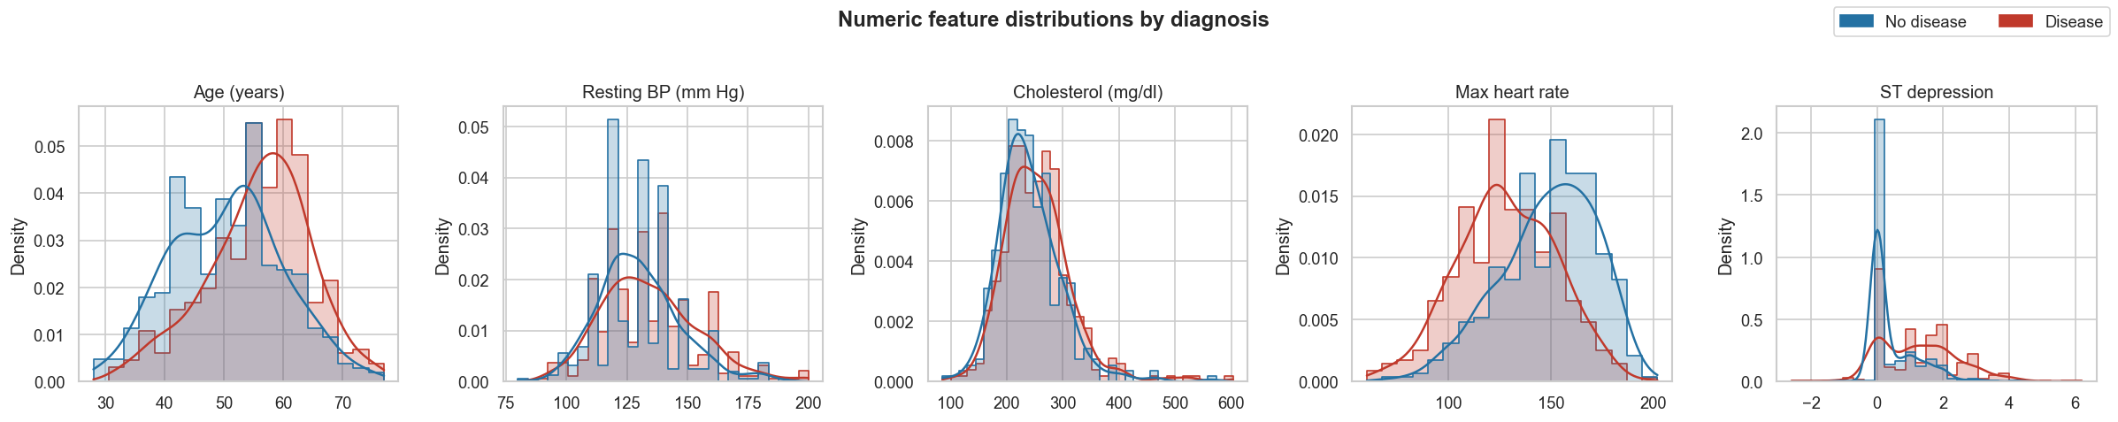
Figure 4. Distributions of numeric features by diagnosis.
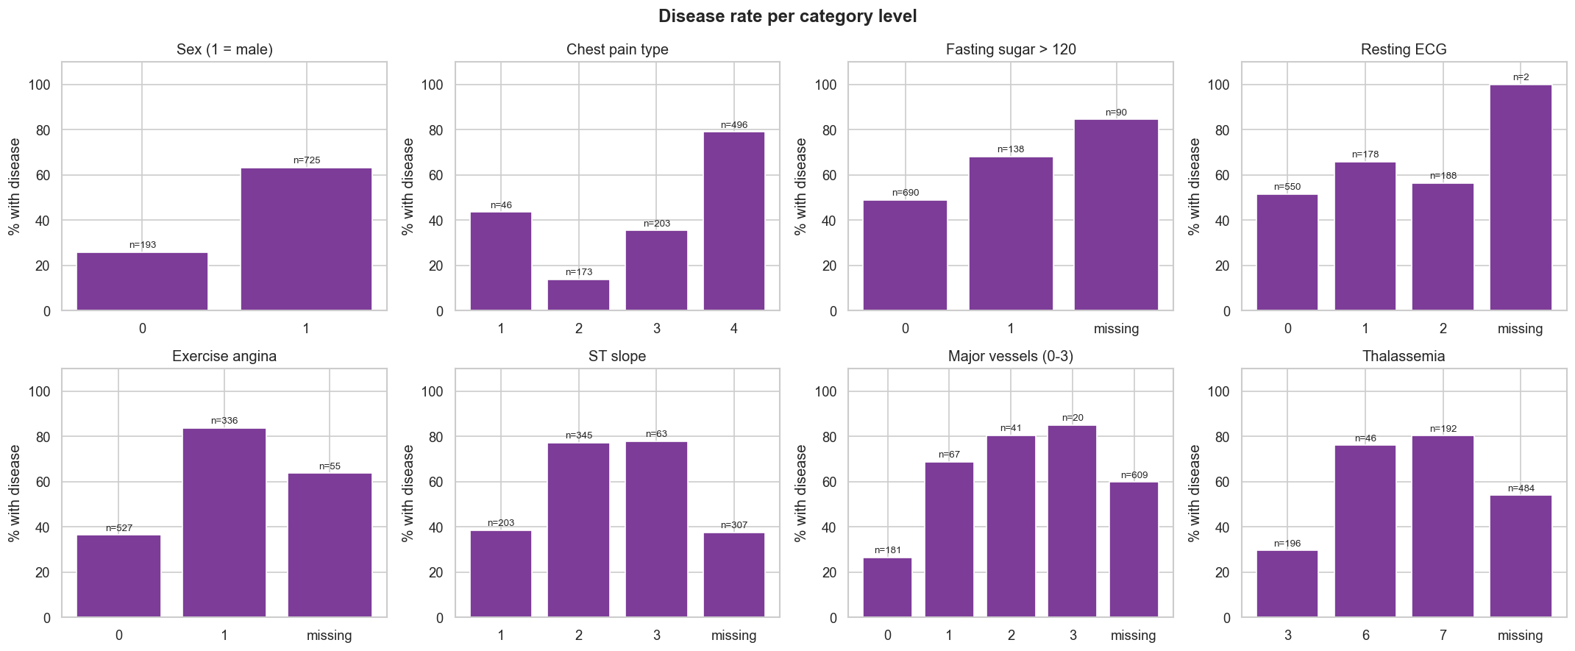
Figure 5. Disease rate per category level (n shown above each bar).
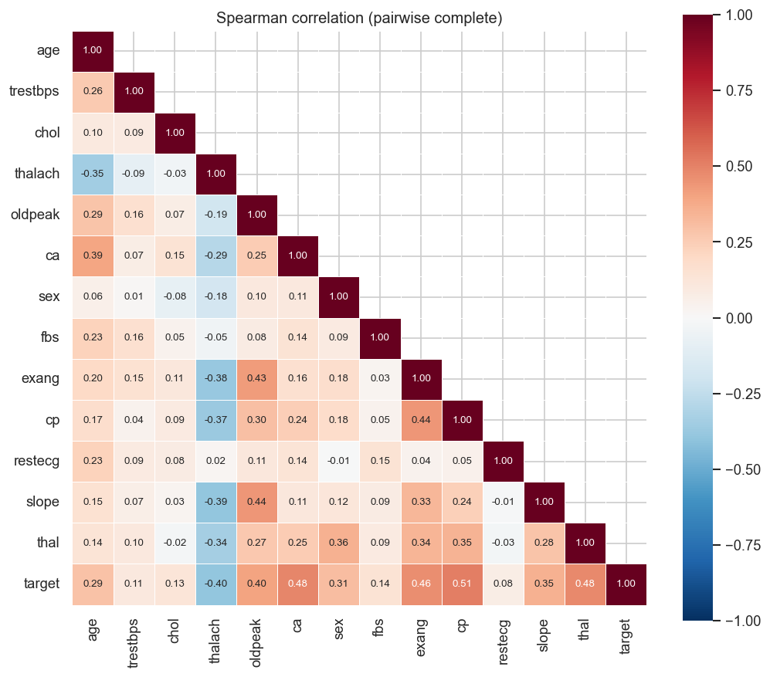
Figure 6. Spearman correlation heat-map (pairwise complete observations).
Observation | Consequence for modelling
Balanced overall (55/45) but prevalence ranges from 36 % (Hungary) to 93 % (Switzerland) | stratified splits; site excluded from features because it would leak centre prevalence
ca 66 %, thal 53 %, slope 33 % missing, mostly outside Cleveland | median/constant imputation plus missing-indicator features
Asymptomatic chest pain, exercise angina, ST depression, flat ST slope, ca > 0 and reversible thal defect are the strongest risk factors; max heart rate is protective | relationships are largely monotone, so linear models are competitive
oldpeak is skewed; chol has outliers | standard scaling; tree models are robust to the rest

4. Feature engineering and model development

4.1 Feature pipeline
heart.features.build_preprocessor() returns one ColumnTransformer that turns the 13 inputs into 31 model features:
Group | Columns | Steps
Numeric | age, trestbps, chol, thalach, oldpeak, ca | median impute + missing indicator, then StandardScaler
Binary | sex, fbs, exang | most-frequent impute
Categorical | cp, restecg, slope, thal | missing becomes level -1, then one-hot with a fixed category list (unknown codes map to all-zeros)

An ablation in notebook 02_model_training (logistic regression, 5-fold CV) confirms the design: ROC-AUC 0.880 without indicators, 0.896 with indicators, and 0.899 with indicators plus a 'missing' category level.

4.2 Models and tuning
Three model families are tuned with GridSearchCV (5-fold stratified CV, refit='roc_auc'; accuracy, precision, recall and F1 are also scored). ROC-AUC is the selection metric because it does not depend on the decision threshold and is robust to the prevalence shift between sites. A majority-class baseline scores 0.500 ROC-AUC and 0.553 accuracy.
Model | Grid searched | Candidates
Logistic regression (liblinear) | C {0.01, 0.1, 0.5, 1, 5} x penalty {l1, l2} x class_weight {none, balanced} | 20
Random forest | n_estimators {200, 400} x max_depth {none, 5, 8} x min_samples_leaf {1, 4} x max_features {sqrt, 0.5} | 24
Hist gradient boosting | learning_rate {0.03, 0.1} x max_depth {3, none} x max_iter {100, 250} x l2 {0, 1} | 16

4.3 Results
Model | CV ROC-AUC | CV acc. | CV prec. | CV recall | Test ROC-AUC | Test acc. | Test recall
Logistic Regression * | 0.888 ± 0.050 | 0.820 | 0.828 | 0.860 | 0.930 | 0.842 | 0.892
Random Forest | 0.884 ± 0.052 | 0.820 | 0.828 | 0.857 | 0.924 | 0.821 | 0.863
Hist Gradient Boosting | 0.878 ± 0.050 | 0.809 | 0.815 | 0.852 | 0.919 | 0.859 | 0.931
* champion
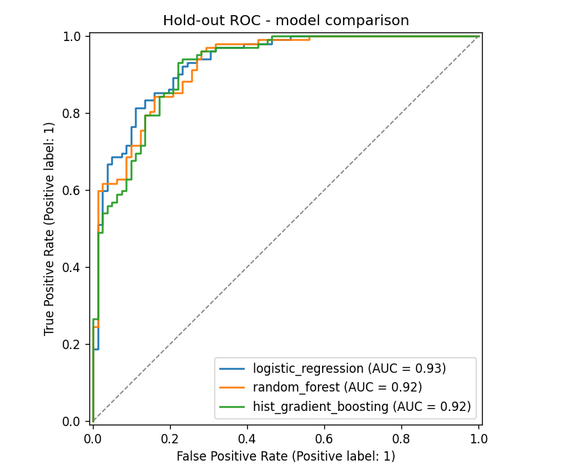
Figure 7. Hold-out ROC curves of the three tuned models.
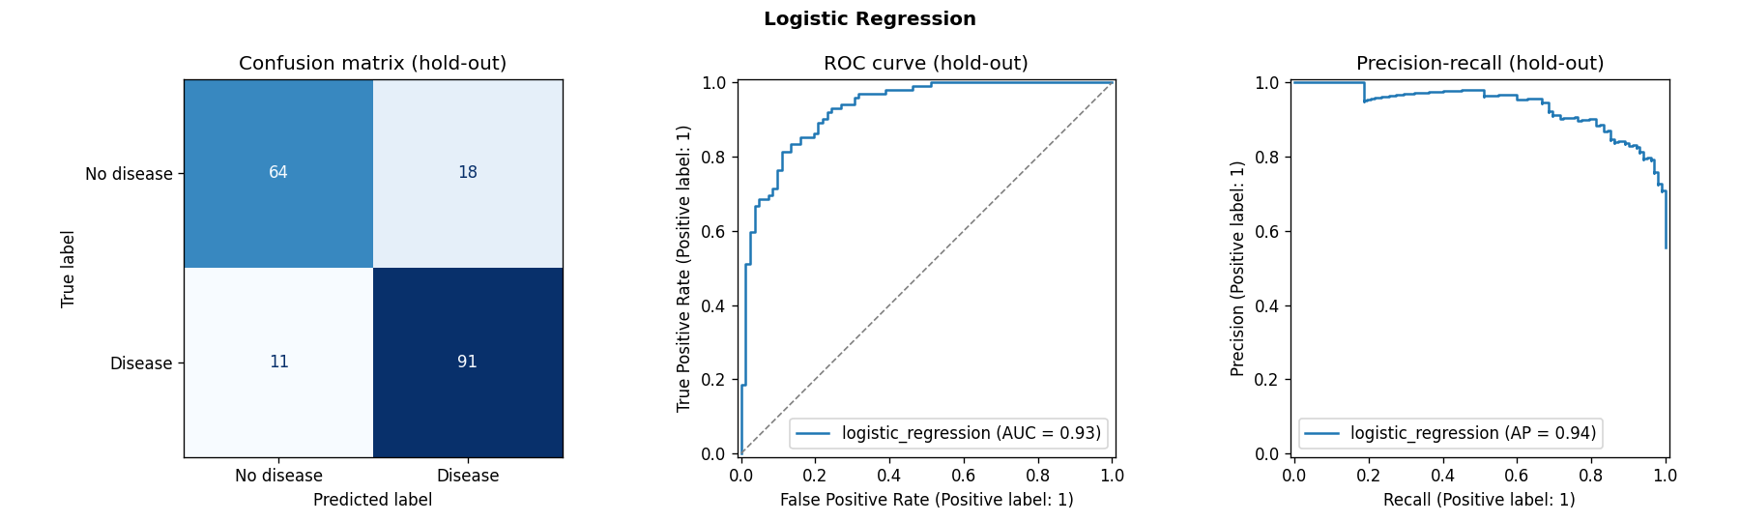
Figure 8. Champion diagnostics on the hold-out set: confusion matrix, ROC and precision-recall.

4.4 Model selection
- The three families are within about 0.01 CV ROC-AUC of each other, which is less than one CV standard deviation (about 0.05).
- Logistic Regression (penalty=l1, C=0.5) has the best mean CV ROC-AUC (0.888). It is also the simplest and fastest model and gives interpretable coefficients, which matters in a clinical setting, so it was chosen as champion. The L1 penalty zeroes 8 of the 31 features, which acts as built-in feature selection.
- On the untouched hold-out set it reaches ROC-AUC 0.930, accuracy 0.842, precision 0.835 and recall 0.892. Recall is the more important clinical metric, and the API returns the raw probability so the decision threshold can be adjusted.
- The champion is then refit on all 918 labelled rows and exported for serving.
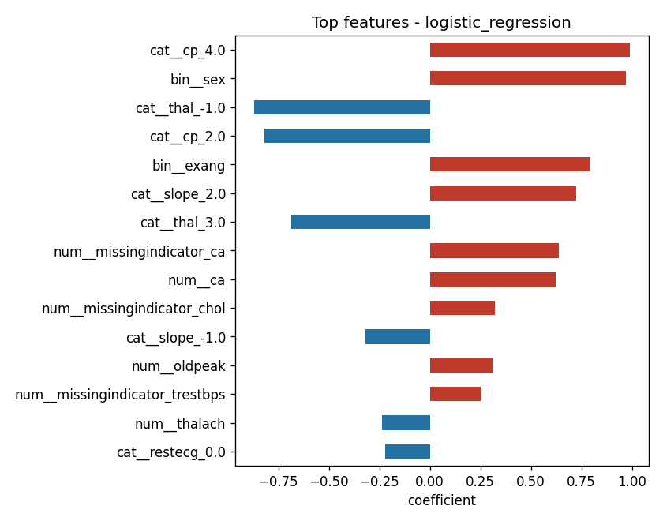
Figure 9. Largest logistic-regression coefficients (red increases risk).

5. Experiment tracking (MLflow)
heart.train logs every run to MLflow (SQLite backend mlflow.db, artifacts in mlruns/) under the experiment heart-disease-classification, 64 runs in total:
- 3 parent runs (one per model family): best parameters, CV mean and standard deviation for 5 metrics, hold-out metrics, fit time, diagnostics and feature-importance plots, the full cv_results_ CSV, and the sklearn model with an input signature and example.
- 60 nested child runs, one per grid candidate, with its parameters, CV metrics and rank. These give the full tuning history (notebook 02 plots them).
- 1 champion-final run: comparison plot and table plus the refit model, registered as heart-disease-classifier version 1 with alias `@champion`.
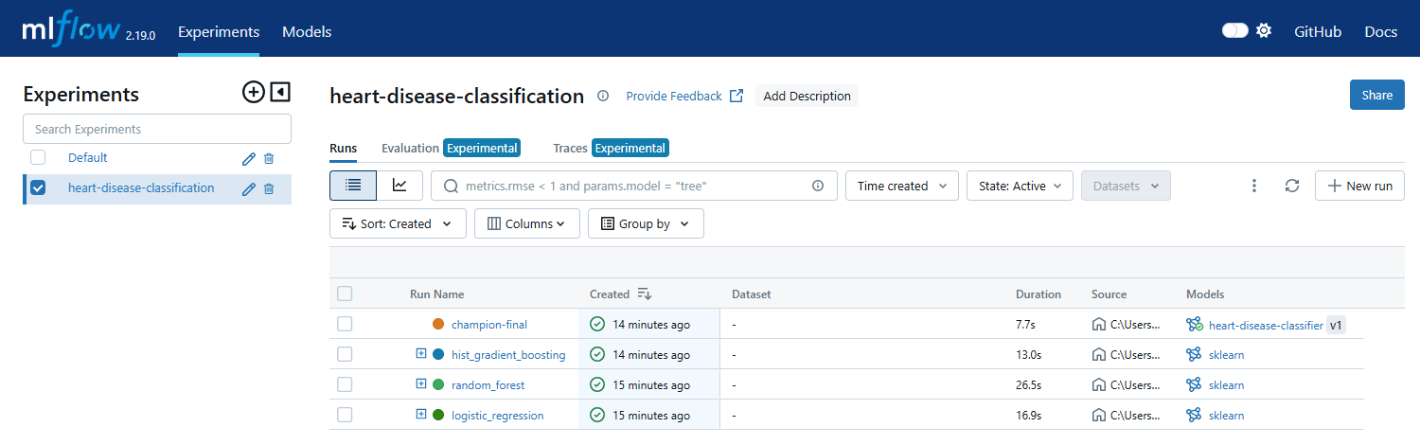
Figure 10. MLflow experiment: parent runs (expandable to nested candidates) and the registered champion.
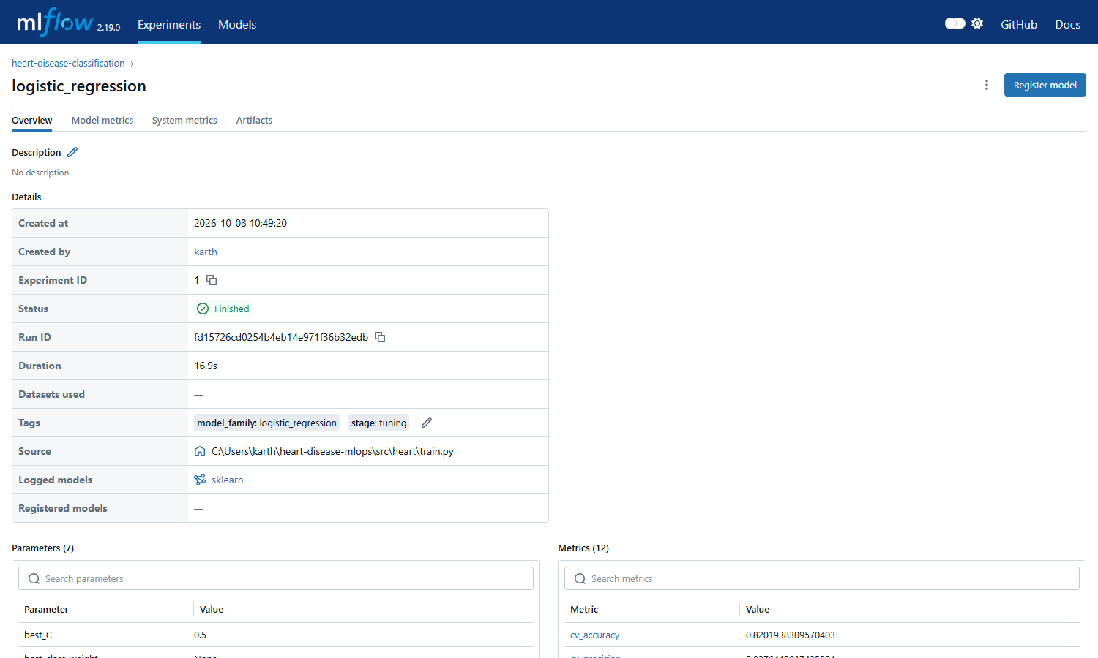
Figure 11. Logistic-regression parent run: parameters and metrics.
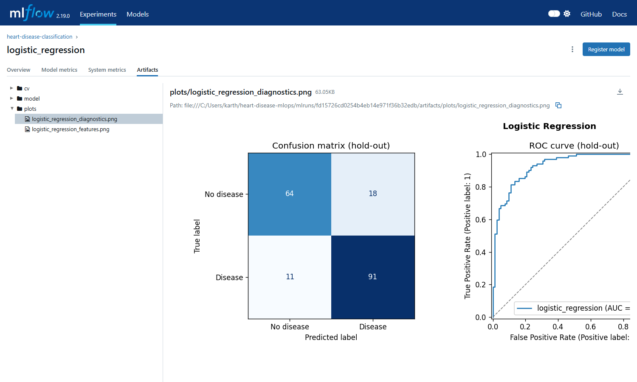
Figure 12. Plots logged as run artifacts.
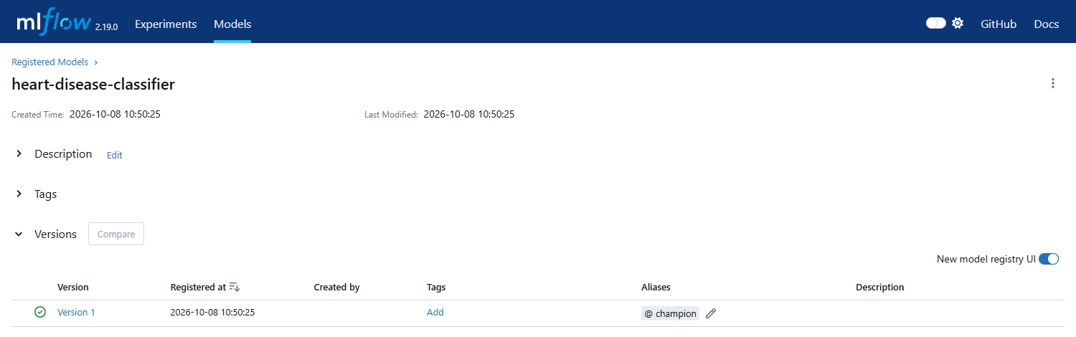
Figure 13. Model registry entry with the @champion alias.

6. Model packaging and reproducibility
Requirement | Implementation
Reusable model format | models/heart_model.joblib (complete sklearn Pipeline) plus MLflow sklearn flavour in the registry; models/model_meta.json stores the run id, parameters, metrics and timestamp
Environment | pinned requirements.txt (training, tests, notebooks) and slim requirements-serve.txt (container); installable package defined in pyproject.toml
Preprocessing | the ColumnTransformer is inside the persisted Pipeline, so a raw JSON request is all that is needed for inference
Determinism | random_state=42 for splits, CV folds and models; data download is versioned by URL
Inference paths | python -m heart.predict samples/patient_high_risk.json, mlflow.sklearn.load_model('models:/heart-disease-classifier@champion'), REST API (notebook 03 shows all three agree)

7. CI/CD pipeline and automated testing

7.1 Unit tests
tests/ contains 34 pytest tests (91 % line coverage). They use a synthetic UCI-shaped dataset with injected faults, so they run offline in about a minute:
File | What is verified
test_data.py | target binarisation, impossible zeros and invalid codes become NaN, duplicates removed, schema, no input mutation, '?' parsing
test_features.py | no NaNs after transform, standardisation, missing indicators, fixed one-hot width, all-missing row
test_model.py | learns signal, valid probabilities, metric helper, every model family fits, joblib round-trip, quality bar on the saved artefact
test_api.py | health/ready, /predict contract (prediction + confidence + request id), optional fields, 422 validation, batch, /metrics, 503 without a model
test_training_pipeline.py | full heart.train run in a sandbox (MLflow runs + registry alias), EDA writes all figures
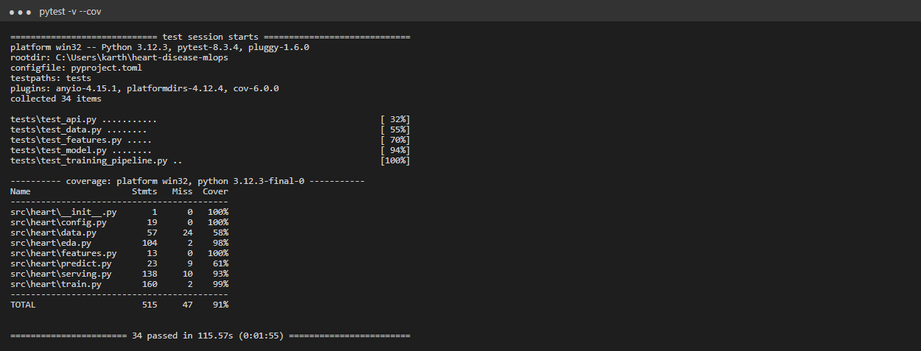
Figure 14. pytest run with coverage report.

7.2 GitHub Actions workflow
.github/workflows/ci.yml runs on every push and pull request. The jobs are chained with needs, so a lint error, failing test, failed quality gate, broken image or failed deployment stops the pipeline with a clear log:
Job | Steps | Artifacts / logging
lint | ruff check (GitHub annotations) | inline annotations
test | pytest with coverage and JUnit output | test-reports (junit.xml, coverage.xml), job summary table
train | download, EDA, train with MLflow, quality gate CV ROC-AUC >= 0.80 | model, mlflow-tracking, reports; model-comparison table in the summary
docker | build the image with the freshly trained model, run it, smoke test | docker-image tarball, container logs
deploy-kind | kind cluster, load image, deploy_k8s.sh, smoke test through the Service | kubectl get all and pod logs
LAB SCREENSHOT - save as screenshots/50_github_actions_run.png and re-run node scripts/build_report.js
Figure 15. GitHub Actions run - all five jobs green.
LAB SCREENSHOT - save as screenshots/51_github_actions_artifacts.png and re-run node scripts/build_report.js
Figure 16. Workflow run summary and uploaded artifacts.

8. Model containerisation
The Dockerfile builds from python:3.12-slim with serving-only dependencies (no MLflow or plotting libraries), installs the heart package, bakes in the model artefact, runs as a non-root user (uid 10001) and declares a HEALTHCHECK on /health. Uvicorn serves heart.serving:app on port 8000.
Endpoint | Purpose
POST /predict | one patient as JSON; returns prediction, label, confidence, probability_disease, risk_band, model name/version
POST /predict/batch | up to 500 patients
GET /health, /ready | liveness (process up) and readiness (model loaded), used by Docker and k8s probes
GET /model-info | metadata and training metrics of the served model
GET /metrics | Prometheus exposition

Inputs are validated by Pydantic with clinical ranges and the allowed category codes. Bad input returns HTTP 422 with field-level messages, and optional measurements may be omitted.
docker build -t heart-disease-api:1.0.0 .
docker run -d -p 8000:8000 --name heart-api heart-disease-api:1.0.0
curl -X POST localhost:8000/predict -H 'Content-Type: application/json' -d @samples/patient_high_risk.json
{"prediction":1,"label":"heart disease","confidence":0.9624,"probability_disease":0.9624,"risk_band":"high",...}
LAB SCREENSHOT - save as screenshots/40_docker_build_run.png and re-run node scripts/build_report.js
Figure 17. Docker build, container run and smoke test in the lab (bash scripts/lab_run.sh docker).
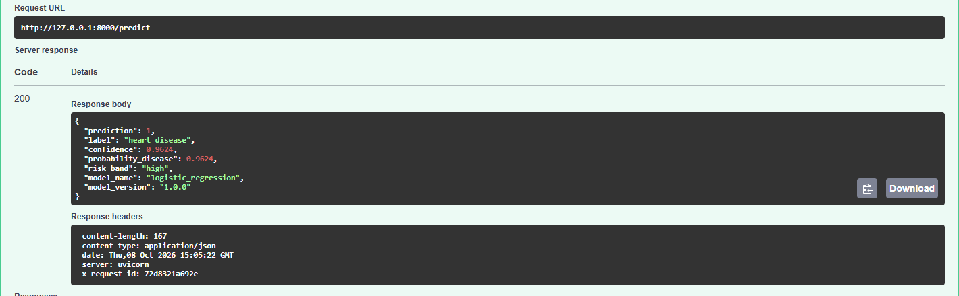
Figure 18. Interactive OpenAPI docs (/docs): /predict executed with the sample patient.
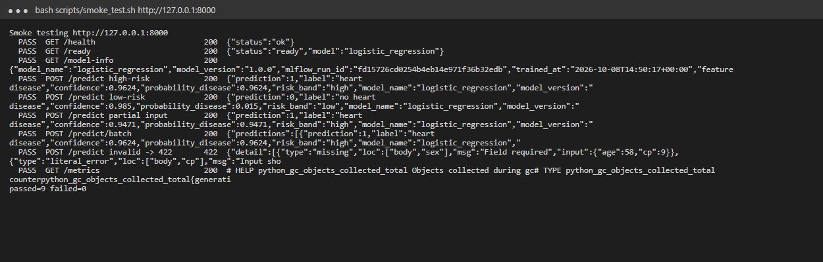
Figure 19. scripts/smoke_test.sh: 9 checks including validation (422) and metrics.

9. Production deployment (Kubernetes)
The API is deployed to a local Minikube cluster (the same manifests work on Docker Desktop, kind, GKE, EKS or AKS). scripts/deploy_k8s.sh applies the kustomization and the monitoring stack, then waits for the rollouts.
Manifest | Highlights
k8s/00-namespace.yaml | isolated namespace heart-mlops
k8s/api-deployment.yaml | 2 replicas, RollingUpdate with maxUnavailable 0, startup/readiness/liveness probes, CPU/memory requests and limits, non-root, read-only root filesystem, Prometheus scrape annotations
k8s/api-service.yaml | type LoadBalancer port 80 to 8000 (EXTERNAL-IP via minikube tunnel)
k8s/api-ingress.yaml | nginx Ingress host heart.local
k8s/api-hpa.yaml | HorizontalPodAutoscaler 2-5 replicas at 70 % CPU
k8s/monitoring/*.yaml | Prometheus (pod discovery, RBAC), Grafana (provisioned datasource and dashboard), NodePorts 30090/30300
minikube start --driver=docker && minikube addons enable ingress && minikube addons enable metrics-server
minikube image load heart-disease-api:1.0.0
bash scripts/deploy_k8s.sh
kubectl -n heart-mlops get all,ingress,hpa
minikube service heart-api -n heart-mlops --url # or: minikube tunnel / heart.local ingress
bash scripts/smoke_test.sh http://localhost:8080 # via kubectl port-forward svc/heart-api 8080:80
LAB SCREENSHOT - save as screenshots/41_k8s_resources.png and re-run node scripts/build_report.js
Figure 20. kubectl get all,ingress,hpa in namespace heart-mlops.
LAB SCREENSHOT - save as screenshots/42_k8s_endpoint_verification.png and re-run node scripts/build_report.js
Figure 21. Endpoint verification through the Kubernetes Service / Ingress.
Access instructions (local): API http://localhost:8080/docs (port-forward), minikube service heart-api -n heart-mlops --url, or http://heart.local after adding $(minikube ip) heart.local to /etc/hosts.

10. Monitoring and logging

10.1 Logging
An HTTP middleware gives every request an x-request-id and writes one JSON log line with method, path, status, latency in ms and client. Predictions are logged with their probability. The logs go to stdout, so they are available through docker logs and kubectl logs and can be shipped to Loki or ELK without changes.
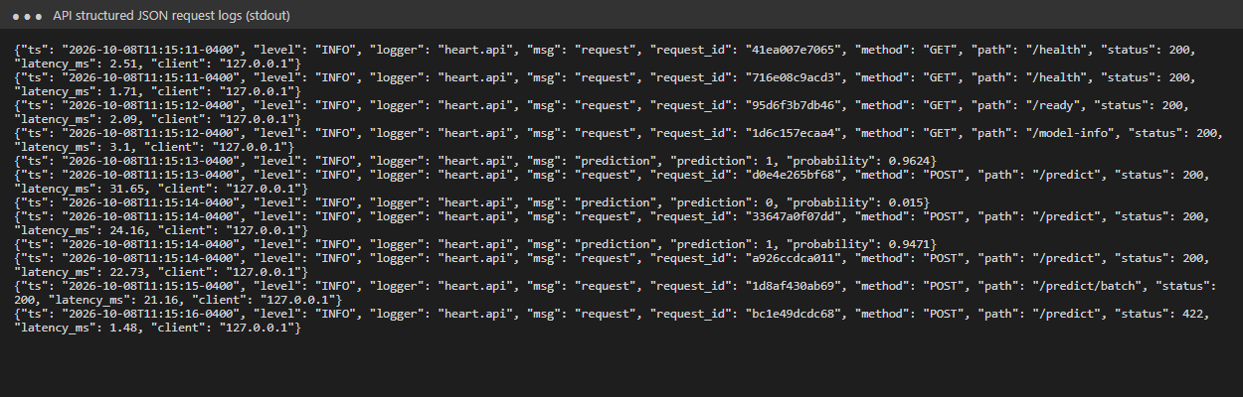
Figure 22. Structured request logs (including a rejected 422 request).

10.2 Metrics, dashboard and alerts
Metric | Type | Use
heart_api_requests_total{method,path,status} | counter | traffic and error rate
heart_api_request_latency_seconds{path} | histogram | p50/p95/p99 latency
heart_api_predictions_total{outcome} | counter | prediction mix (drift signal)
heart_api_disease_probability | histogram | score distribution
heart_api_model_loaded | gauge | readiness

Prometheus discovers and scrapes every API pod every 10 s. Grafana is provisioned with the *Heart Disease API - Service & Model Monitoring* dashboard. monitoring/alert_rules.yml defines four alerts: API down, 5xx rate > 5 %, p95 latency > 500 ms, and a positive-prediction rate above 85 %, which would suggest input drift since the training prevalence is 55 %. scripts/generate_traffic.py replays real patients plus 5 % invalid payloads to populate the panels.
LAB SCREENSHOT - save as screenshots/43_prometheus_targets.png and re-run node scripts/build_report.js
Figure 23. Prometheus targets - each API pod discovered and UP.
LAB SCREENSHOT - save as screenshots/44_grafana_dashboard.png and re-run node scripts/build_report.js
Figure 24. Grafana dashboard under generated traffic.

11. Conclusion and deliverables
The project delivers a heart-disease classifier (CV ROC-AUC 0.888, hold-out ROC-AUC 0.930) behind a validated, observable API. It is reproducible from a clean checkout with one command and automatically linted, tested, trained, quality-gated, containerised and deployed by CI.
Deliverable | Location
Code, Dockerfile, requirements | src/heart/, Dockerfile, requirements*.txt, pyproject.toml
Cleaned dataset + download script | data/processed/heart_clean.csv, python -m heart.data
Notebooks / scripts | notebooks/01_eda, 02_model_training, 03_inference; scripts/
Unit tests | tests/ (34 tests)
CI/CD workflow | .github/workflows/ci.yml
Deployment manifests | k8s/, k8s/monitoring/, docker-compose.yml
Screenshots | screenshots/
Repository | https://github.com/<your-account>/heart-disease-mlops
Video | <link to pipeline video recording>

Possible extensions
- Probability calibration and a cost-sensitive threshold chosen with clinicians.
- Feature-level drift detection (e.g. Evidently) on logged requests, with automated retraining through the existing CI train job.
- Push the image to a registry (GHCR) and add a GitOps continuous-delivery step (Argo CD) to a managed cluster.

