Data Structures & Big-O Notation — Detailed Notes

1️⃣ Why Data Structures Matter
- Data structures are fundamental for technical interviews and computer science problem solving
- Each data structure is optimized for specific scenarios
- Choosing the right data structure improves:
  - Performance
  - Scalability
  - Code clarity
- To compare efficiency, we use Big-O notation

2️⃣ Big-O Notation (Time Complexity)
Big-O measures how runtime grows as input size (n) increases

🔹 O(1) — Constant Time (Fastest 🚀)
- Runtime does not change with input size
- Example:
  - Accessing an array element by index
  - Taking the first item from a list
- Extremely efficient

🔹 O(n) — Linear Time
- Runtime grows proportionally with input size
- Example:
  - Searching for a name in an unsorted list
- Worst case requires checking every element

🔹 O(n²) — Quadratic Time (Very Slow 🐌)
- Every element interacts with every other element
- Example:
  - Nested loops
  - Handshake problem (n × n)
- Poor scalability → usually avoid in interviews

🔹 O(log n) — Logarithmic Time (Very Efficient ⚡)
- Each step cuts the problem in half
- Example:
  - Binary search
  - Dictionary lookup
- Much faster than O(n) for large data

3️⃣ Arrays
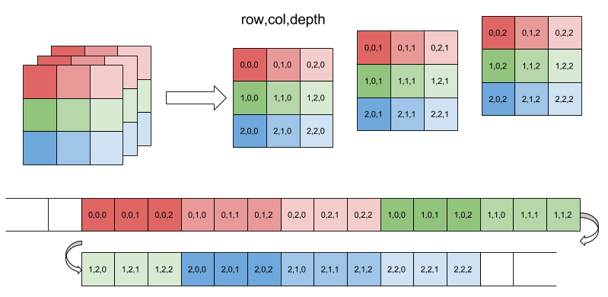
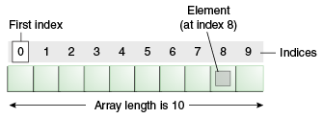

🔹 Concept
- Fixed-size, contiguous memory
- Each element has a direct index
- Think of numbered lockers

🔹 Strengths
- Extremely fast access
- Cache-friendly

🔹 Weaknesses
- Fixed size (resizing is expensive)
- Insertions/deletions cause shifting

🔹 Time Complexity
Operation | Time
Access by index | O(1)
Insert (end) | O(1)
Insert (middle / resize) | O(n)
Delete (end) | O(1)
Delete (middle) | O(n)

4️⃣ Linked Lists

🔹 Concept
- Nodes connected via pointers
- No fixed memory location
- Think of a train of cars

🔹 Strengths
- Easy insertion & deletion
- No resizing issues

🔹 Weaknesses
- Slow access (no indexing)
- Extra memory for pointers

🔹 Time Complexity
Operation | Time
Access | O(n)
Insert (with reference) | O(1)
Insert (without reference) | O(n)
Delete (with reference) | O(1)
Delete (without reference) | O(n)

5️⃣ Stacks (LIFO)

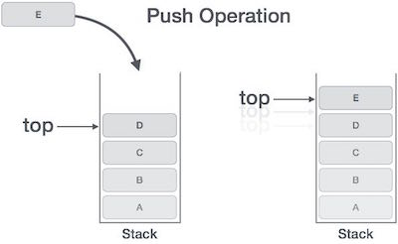

🔹 Concept
- Last In, First Out
- Think of a stack of plates

🔹 Operations
- Push → Add to top
- Pop → Remove from top

🔹 Use Cases
- Function calls
- Undo/Redo
- Depth-First Search (DFS)

🔹 Time Complexity
Operation | Time
Push | O(1)
Pop | O(1)
Search | O(n)

6️⃣ Queues (FIFO)

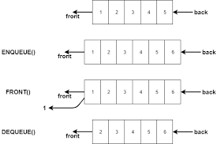

🔹 Concept
- First In, First Out
- Think of a line at a store

🔹 Operations
- Enqueue → Add at back
- Dequeue → Remove from front

🔹 Use Cases
- Scheduling
- Breadth-First Search (BFS)
- Music streaming queues

🔹 Time Complexity
Operation | Time
Enqueue | O(1)
Dequeue | O(1)
Search | O(n)

7️⃣ Heaps (Priority Queue)

🔹 Concept
- Complete binary tree
- Always keeps highest priority element on top

🔹 Types
- Min Heap → smallest at root
- Max Heap → largest at root

🔹 Key Property
- Insertions and deletions re-heapify the tree

🔹 Time Complexity
Operation | Time
Access root | O(1)
Insert | O(log n)
Delete | O(log n)
Search | O(n)

8️⃣ Hash Maps (Key-Value Store)
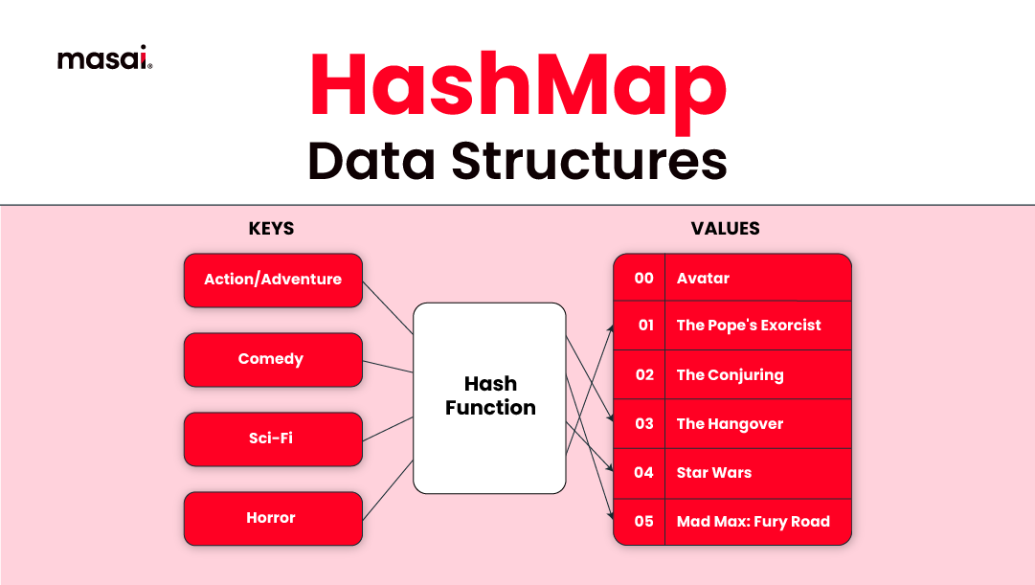

🔹 Concept
- Uses a hash function
- Maps keys → values
- Think of mailboxes

🔹 Strengths
- Extremely fast lookups
- Flexible key types

🔹 Weakness
- Hash collisions
- Performance degrades if poorly implemented

🔹 Time Complexity
Operation | Average | Worst
Access | O(1) | O(n)
Insert | O(1) | O(n)
Delete | O(1) | O(n)
Python dictionaries = Hash Maps

9️⃣ Binary Search Trees (BST)
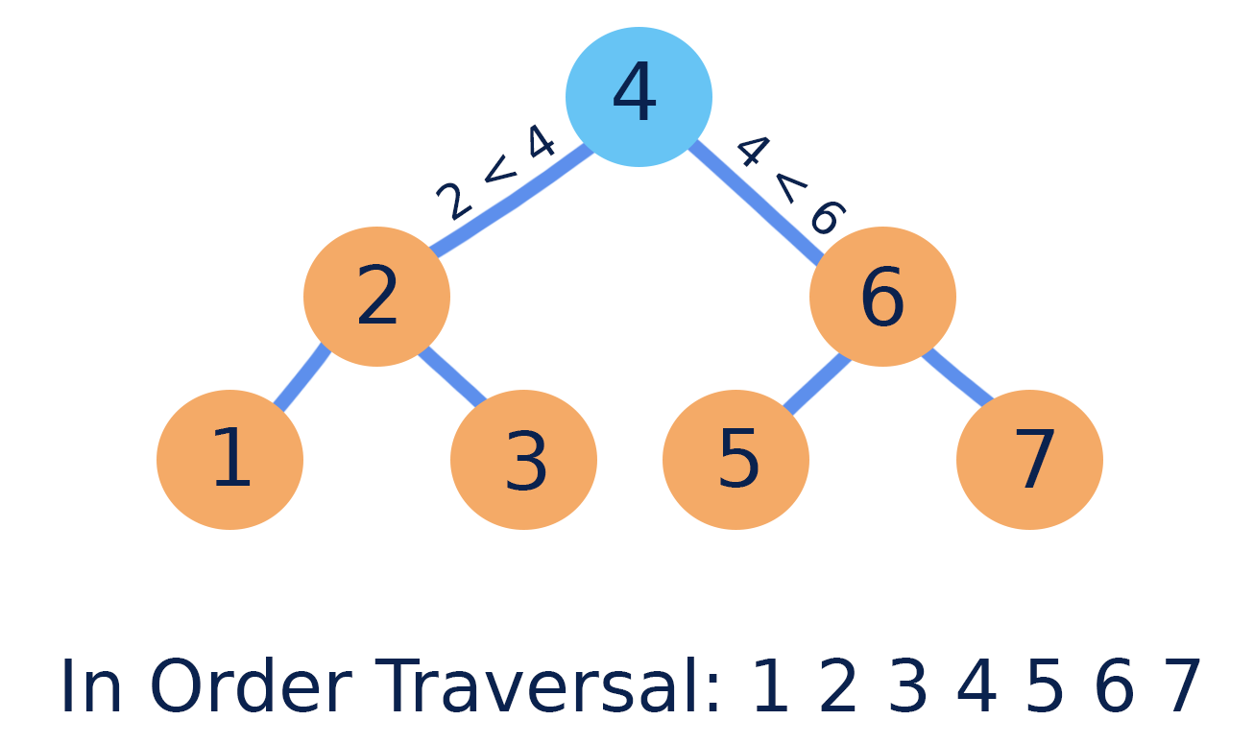

🔹 Concept
- Left < Parent < Right
- Ordered hierarchical structure

🔹 Strengths
- Fast search
- Sorted traversal

🔹 Weakness
- Performance drops if unbalanced

🔹 Time Complexity
Operation | Balanced | Worst
Search | O(log n) | O(n)
Insert | O(log n) | O(n)
Delete | O(log n) | O(n)

🔟 Sets

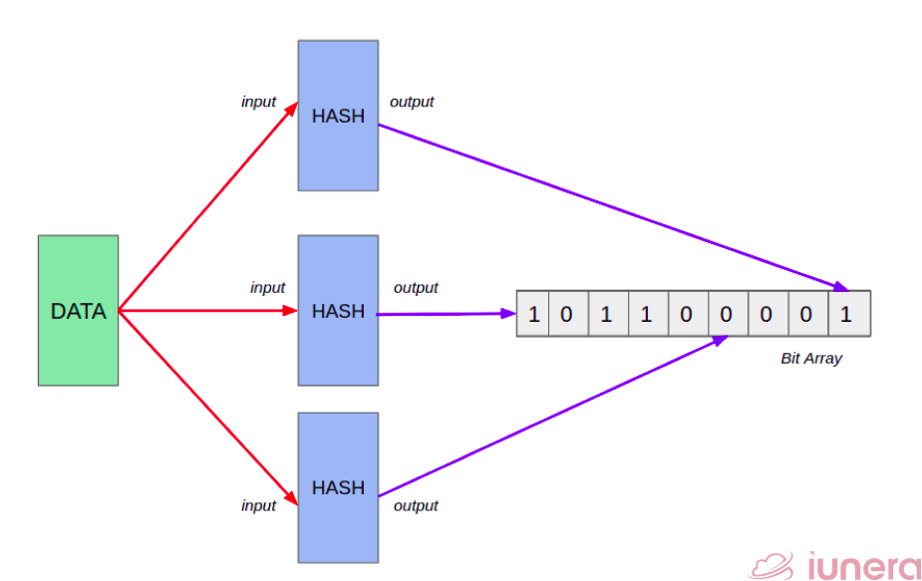

🔹 Concept
- Unordered
- Unique elements only
- Usually implemented using hash tables

🔹 Use Cases
- Remove duplicates
- Membership checks
- Tracking visited nodes (graphs/trees)

🔹 Time Complexity
Operation | Average | Worst
Insert | O(1) | O(n)
Delete | O(1) | O(n)
Contains | O(1) | O(n)

🎯 Interview Takeaways
- Always justify your data structure choice
- Prefer:
  - HashMap for fast lookup
  - Heap for priority problems
  - Stack/Queue for traversal
- Avoid O(n²) unless unavoidable
- Understand trade-offs, not just definitions

