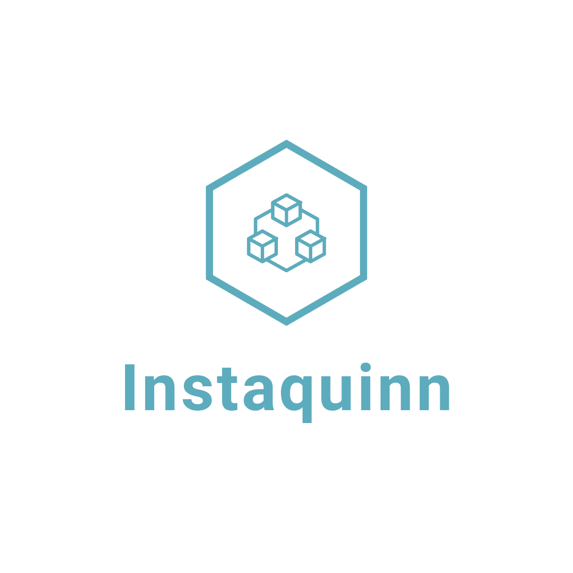

**User Manual**

**Mobile App Details:**

**Features:**

1. **Screen 1:** List of feeds, with multiple posts in one feed.
2. **Screen 2:** Calendar view with posts arranged according to the date. On clicking on any date all feeds on that date will be displayed.

**Technology Used:**

1. **Front-End:** React-Native, React functional components, and React Hooks. Error Boundaries are used for error handling in front-end. Used AsyncStorage for API caching for better user experience.
2. **Back-End:** Public restful API by Quinn care.

**Download and install the app** which is share in the below link.

[https://drive.google.com/file/d/1LuFm2vO8fcwrR8 OOHpk3h2yzuGtAX4a0/view?usp=sharing](https://drive.google.com/file/d/1LuFm2vO8fcwrR8OOHpk3h2yzuGtAX4a0/view?usp=sharing)