# General News

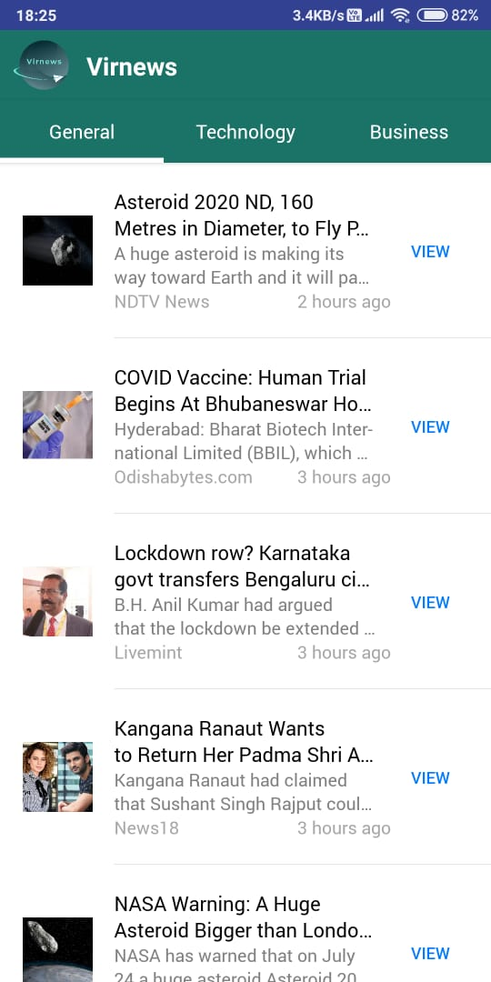

**General News**

Latest news will be displayed with India region. All latest news will be fetched automatically and can refresh manually by pulling down in app.

# Technology News

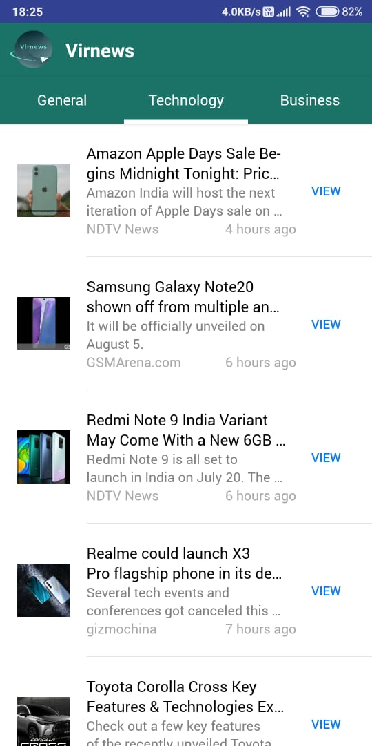

**Technology News**

Latest news regarding technology is displayed. All news are latest and got from trusted sources.

# Business News

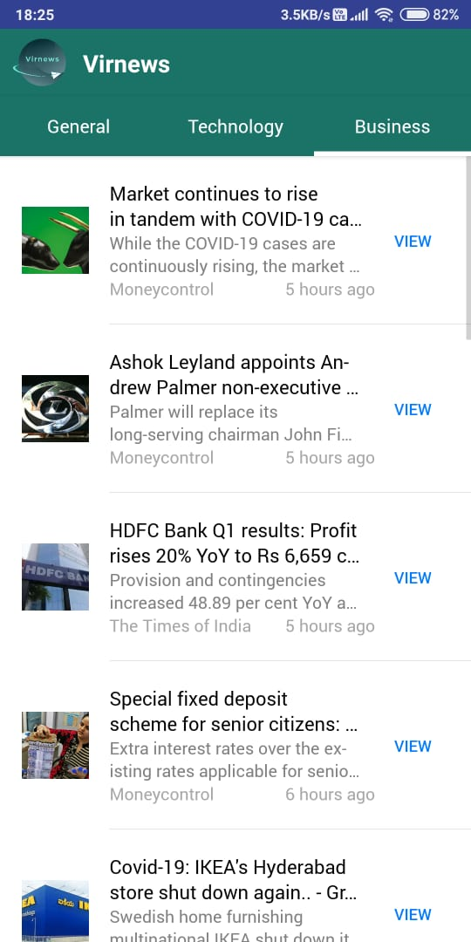

**Business News**

Latest news regarding business is displayed. User can view this news in detail, users can read complete article.

# Detailed Articles

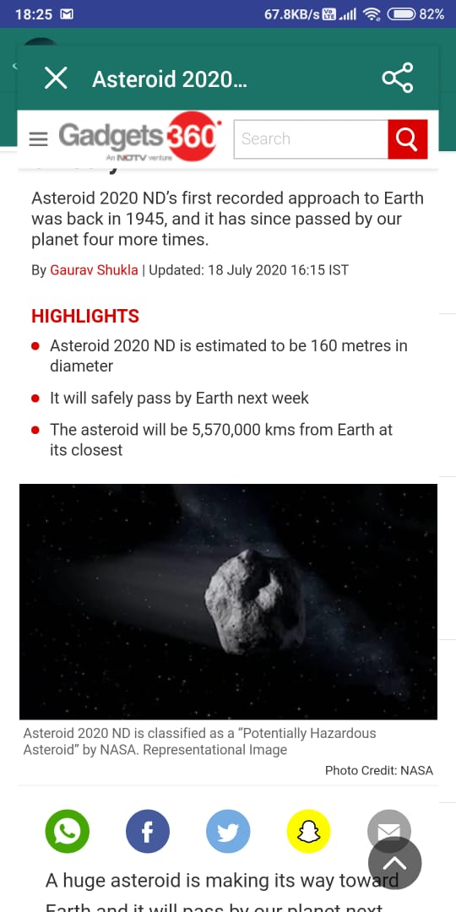

**Detailed Articles**

Users can click on view button to view complete articles to read. User can click on cross button to close the article and view multiple news.

# Share Article

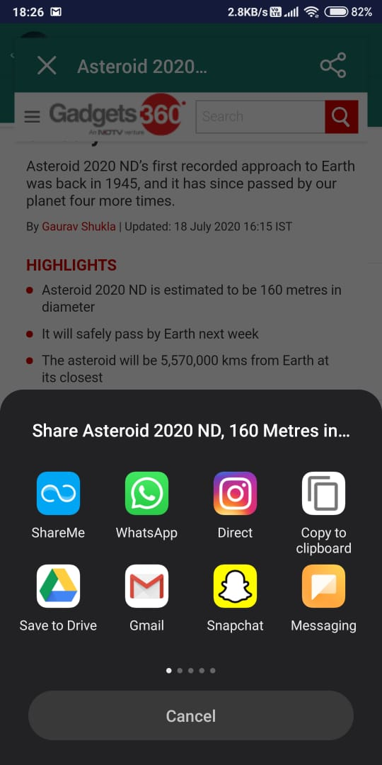

**Share Article**

Users can click on share button to share any article and they can also copy the article link.