

**User Manual**

**Using the Mobile App:**

1. Download and Install the app which will is upload in the below link.

<https://drive.google.com/file/d/1bhirPRBL2VUvFw9xocCLZW_kj_quwL1G/view?usp=sharing>

1. List of candidates will be displayed which are coming from context API. User can also search for any candidate by name.

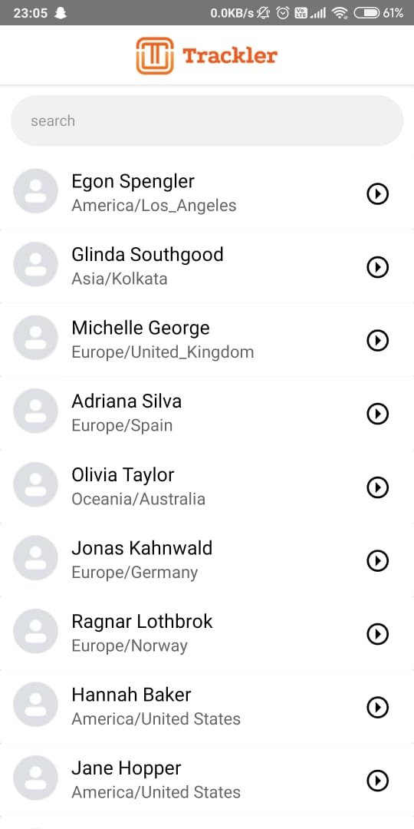

1. User can search a candidate by name. On clicking on any user the app screen will navigate to activity screen where candidates activity for the current date will be displayed.

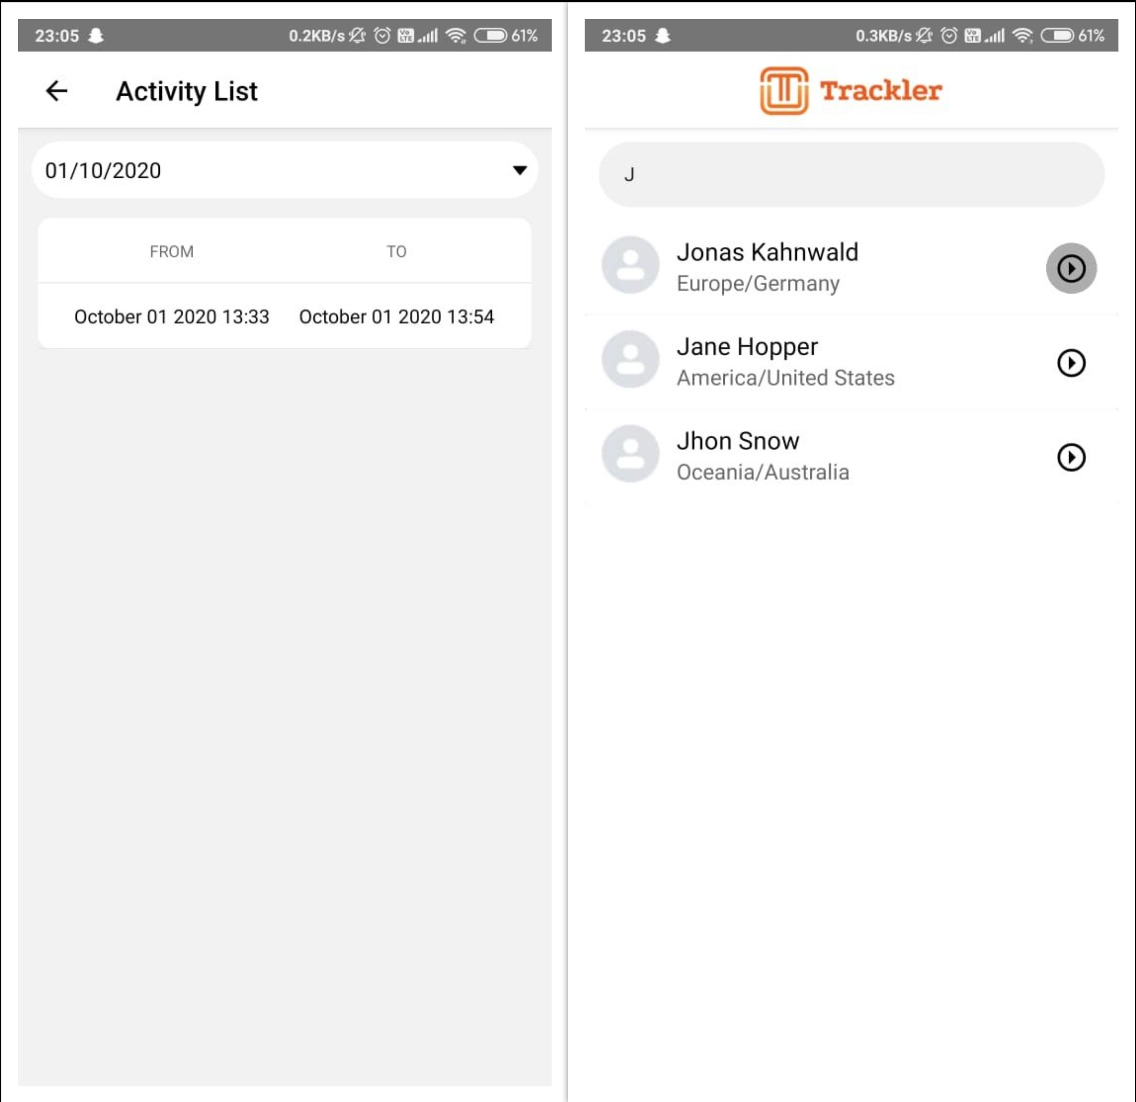

1. The user can select a specific date from the calendar(date picker) and the candidate activity with that date will be displayed.

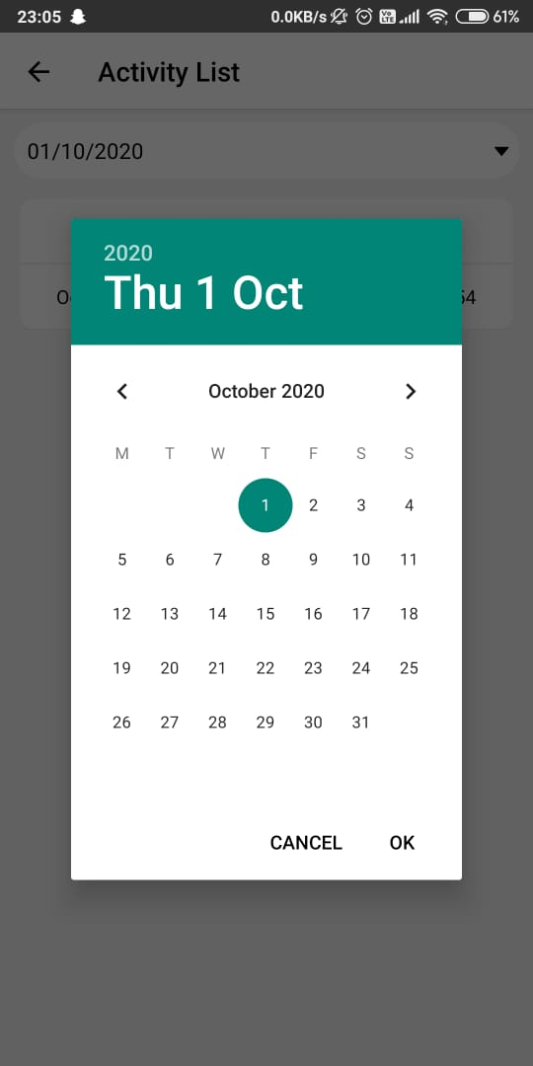

**CONTACT DETAILS**

If there is any query please contact me on the below provided email.

**Email ID:** [karthikcy06@gmail.com](mailto:karthikcy06@gmail.com)

**Mobile:** +91-8105810894

**Github Repo:** <https://github.com/karthikcyadav98>