Floyd’s Triangle
Floyd’s triangle is a right-angled triangular array of natural numbers, used in computer science education. It is named after Robert Floyd. It is defined by filling the rows of the triangle with consecutive numbers, starting with a 1 in the top left corner.
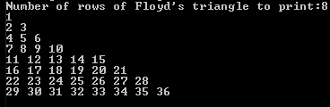
Business Logic
Feature: Print Floyd’s triangle in the console screen based on the number of rows. We will get number of rows as a run time input
Scenario: Print five row Floyd’s triangle
Given Enter number of rows for Floyd’s triangle as “5”
When we calculate logic for Floyd’s triangle
Then the output should be
1
2 3
4 5 6
7 8 9 10
11 12 13 14 15

Pseudo Code
Step 1: Declare integer variable rows, counter and j
Step 2: Declare and Initialize integer variable number as 1
Step 3: To get number of rows at run time as a input
Step 4: Copying user input into an integer variable named rows
Step 5: Initialize counter integer variable as 1
Step 6: Compare the counter variable and rows variable, if counter variable is less than or equal to rows variable repeat the process till Step 11 until counter is greater than rows. If counter is greater than rows do Step 12
Step 7: Initialize j integer variable as 1
Step 8: Compare the j variable and counter variable, if j variable is less than or equal to counter variable repeat the process till Step 9 until j is greater than counter. If j is greater than counter do Step 10 and Step 11
Step 9: Print number and increment the number by 1
Step 10: Start with new line for next iteration
Step 11: Increment the counter by 1 and go back to Step 6
Step 12: Exit from the loop

Flow Chart
