
Power Load Prediction
- Soma Karthikesh

AI Powered Power Load Prediction

Introduction
Electrical grids and industrial facilities need to know, interval by interval, how heavily their network is being used. Operators who can label demand as light, medium or maximum can schedule power dispatch, avoid transformer overloads and plan around peak periods. Doing this by hand from raw meter readings is slow and inconsistent. This project builds a machine learning classifier that predicts the Load Type of an industrial power network from 15 minute electricity consumption and electrical sensor measurements.

Our Solution
The solution is an end-to-end classification pipeline in a Jupyter notebook. It audits and repairs the raw telemetry, engineers time features from the timestamp, compares several classifiers using time-aware validation, and evaluates the chosen model on the final calendar month, which is kept untouched until the end. The trained pipeline is saved with joblib and exposed through a standalone prediction script (src/predict.py) for new readings.

The Three Load Classes
Class |  | Meaning
Light_Load |  | Off peak, idle, night-time or weekend periods with minimal active power draw.
Medium_Load |  | Normal daytime factory operation and operational transitions.
Maximum_Load |  | Peak industrial capacity, with heavy inductive machinery and motors running together.
Load_Type (target) | Light_Load, Medium_Load or Maximum_Load

Data Quality Findings
A data audit found several real-world defects, which the pipeline corrects before modelling:
- Duplicate timestamp: the raw file has 35,041 rows against the 35,040 expected intervals. The timestamp 31-12-2018 20:00 appeared twice; the duplicate had a missing Usage_kWh and an impossible power factor of 217.27%, so it was dropped.
- Missing values: every measurement column has roughly 1.0% to 4.5% missing, with Usage_kWh missing 1,559 values. These are filled by median imputation, fitted only on training data inside the pipeline.
- Corrupted NSM column: 9.87% of NSM entries (3,414 rows) were corrupted, with values above 86,400 s and up to 248,821 s. NSM is replaced by seconds_from_midnight calculated directly from the parsed timestamp.
- Class imbalance: Light_Load dominates the data, so Macro F1 is used to judge the minority classes fairly.
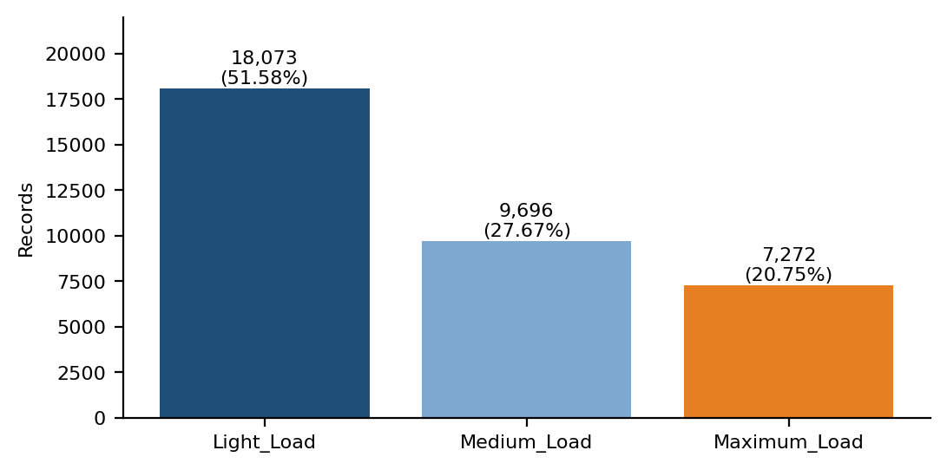
Figure 1: Class distribution of Load_Type in the raw dataset before duplicate removal.

Design & Implementation

Technology & Overview
The system is written in Python 3.10+ using pandas and numpy for data handling, matplotlib and seaborn for plots, and scikit-learn for the models (Pipeline, ColumnTransformer, SimpleImputer, StandardScaler, DecisionTree, RandomForest, HistGradientBoosting and LogisticRegression). The final pipeline is serialised with joblib.

How the System Works
Each stage has one simple job: clean the telemetry, split it by time, fit models inside a pipeline so no information leaks, choose a model using only past data, and finally score it once on the held-out month
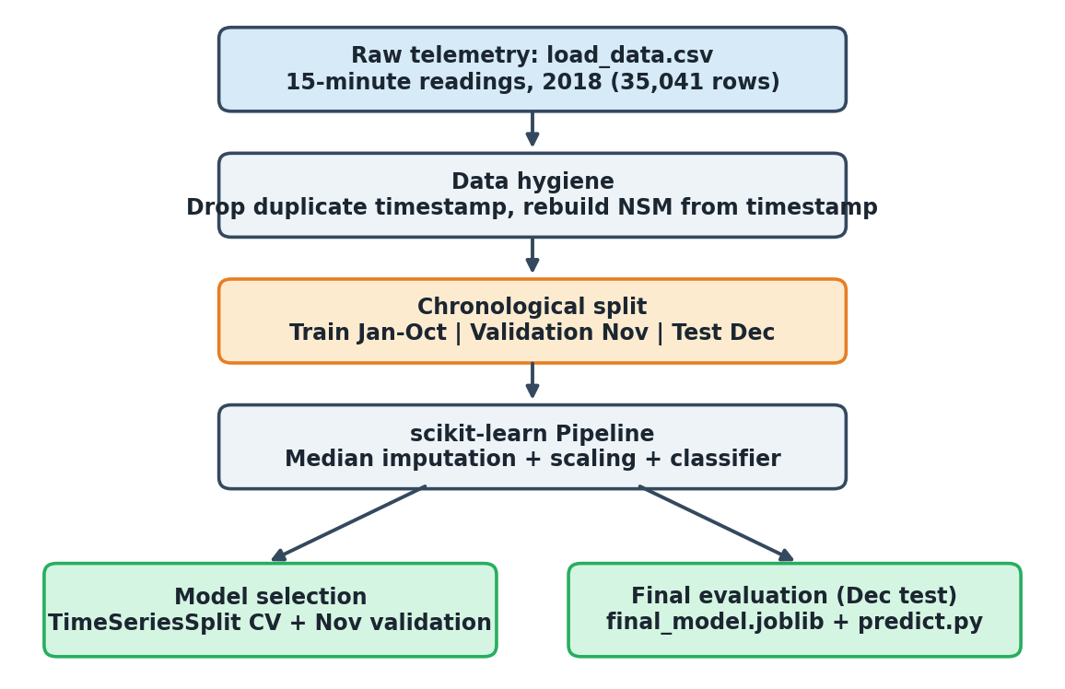
Figure 2: End-to-end workflow

Key Components
- Data hygiene: removes the duplicate timestamp and rebuilds the seconds-from-midnight feature from the timestamp.
- Feature engineering: time features derived from Date_Time, including seconds_from_midnight and dayofweek, which turn out to be the most informative inputs.
- Pipeline encapsulation: imputation medians and scaling are fitted only on training data inside a scikit-learn Pipeline.
- Model comparison: Logistic Regression, Decision Tree, Random Forest and HistGradientBoosting, with balanced-class variants of some.
- Inference module: src/predict.py loads models/final_model.joblib and predicts the load type for a new reading.

Chronological Validation & Leakage Prevention
The problem statement requires the last calendar month to be the test set. The final month in the data, December 2018 (2,976 observations), was set aside at the start and not used in exploratory analysis, preprocessing, cross-validation or model selection. The month before it, November 2018 (2,880 observations), served as an out-of-time validation set while models were compared.
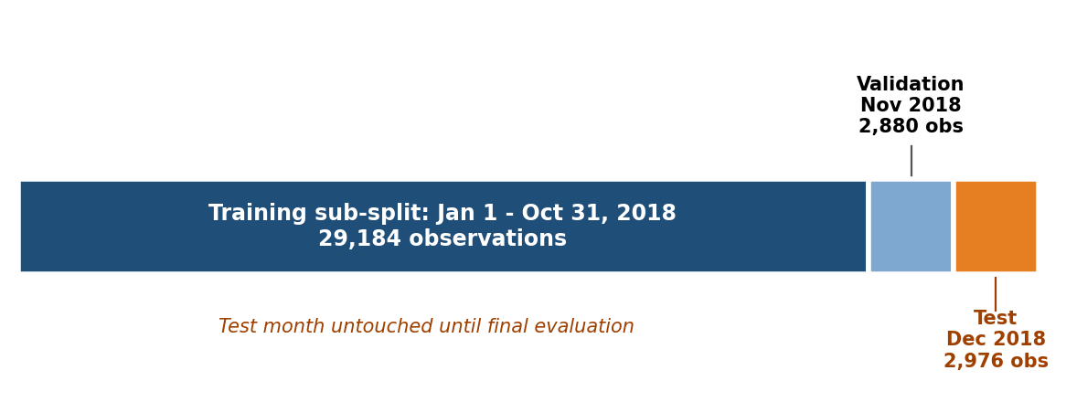
Figure 3: Chronological train / validation / test split

Results

Time Aware Cross-Validation
An expanding 5-fold TimeSeriesSplit was run on the January to November training data to check how stable each model is, without touching the test month.
Classifier | Mean CV Accuracy | Std CV Accuracy | Mean CV Macro F1 | Std CV Macro F1
HistGradientBoosting | 84.45% | ± 9.05% | 0.8068 | ± 0.1224
Random Forest (depth=15) | 84.05% | ± 9.11% | 0.8026 | ± 0.1239
Decision Tree (depth=12) | 83.67% | ± 9.34% | 0.7972 | ± 0.1262
Logistic Regression | 70.21% | ± 4.06% | 0.6311 | ± 0.0708

Out-of-Time Validation (November 2018)
Models were trained on January 1 to October 31, 2018 (29,184 observations) and scored on November 2018 (2,880 observations).
Classifier | Val Accuracy | Macro Precision | Macro Recall | Macro F1 | Weighted F1
Decision Tree (depth=12) | 70.52% | 0.6261 | 0.6266 | 0.6263 | 0.7040
Decision Tree (depth=10) | 69.76% | 0.6171 | 0.6178 | 0.6172 | 0.6961
HistGradientBoosting | 69.55% | 0.6149 | 0.6148 | 0.6148 | 0.6958
Random Forest (Balanced) | 68.65% | 0.6073 | 0.6063 | 0.6067 | 0.6885
Random Forest (Standard) | 68.68% | 0.6024 | 0.6031 | 0.6027 | 0.6856
Logistic Regression (Balanced) | 60.10% | 0.5467 | 0.5429 | 0.5401 | 0.6105
Logistic Regression | 61.32% | 0.5369 | 0.5401 | 0.5370 | 0.6065

Final Benchmark on the December 2018 Test Set
All candidates were retrained on January 1 to November 30, 2018 (32,064 records) and evaluated once on the untouched December 2018 test partition (2,976 records).
Model | Test Accuracy | Macro Precision | Macro Recall | Macro F1 | Weighted F1
HistGradientBoosting (Champion) | 74.26% | 0.6259 | 0.6322 | 0.6281 | 0.7514
Decision Tree (depth=12) | 73.32% | 0.6182 | 0.6250 | 0.6202 | 0.7441
Random Forest (Balanced) | 73.15% | 0.6181 | 0.6259 | 0.6203 | 0.7434
Random Forest (depth=15) | 73.05% | 0.6065 | 0.6102 | 0.6076 | 0.7389
Logistic Regression | 66.50% | 0.5459 | 0.5460 | 0.5424 | 0.6721
Logistic Regression (Balanced) | 61.76% | 0.5269 | 0.5206 | 0.5170 | 0.6461

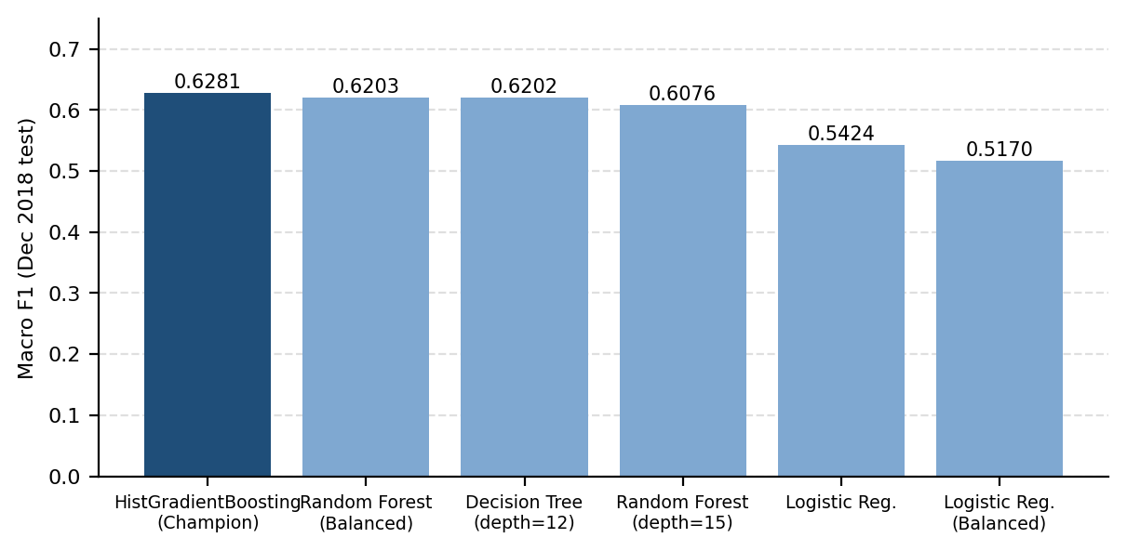
Figure 4: Macro F1 of each model on the December 2018 test set

Champion Model: Validation vs. Test
Metric | Validation (Nov) [Jan-Oct model] | Test (Dec) [Jan-Nov model] | Delta
Accuracy | 69.55% | 74.26% | +4.71%
Macro Precision | 0.6149 | 0.6259 | +1.10%
Macro Recall | 0.6148 | 0.6322 | +1.74%
Macro F1 Score | 0.6148 | 0.6281 | +1.33%
Weighted F1 Score | 0.6958 | 0.7514 | +5.56%

Class-Specific Results (December Test Set)
Class | Precision | Recall | F1-score | Support
Light_Load | 0.9810 | 0.9197 | 0.9494 | 1,744
Medium_Load | 0.4756 | 0.5128 | 0.4935 | 704
Maximum_Load | 0.4210 | 0.4640 | 0.4414 | 528
Accuracy |  |  | 0.7426 | 2,976
Macro average | 0.6259 | 0.6322 | 0.6281 | 2,976
Weighted average | 0.7621 | 0.7426 | 0.7514 | 2,976

Confusion Matrix (December 2018)
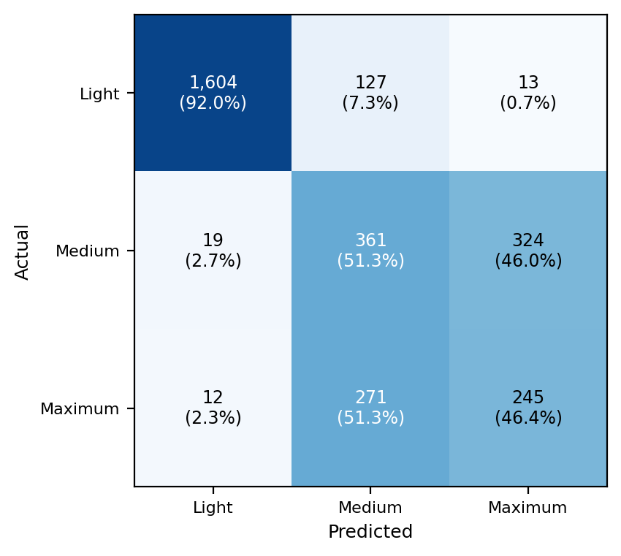
Figure 5: Confusion matrix, counts and row percentages

Analysis of Predictions
- Light load is reliable: off-peak and standby periods are isolated with 98.10% precision, 91.97% recall and an F1 of 0.9494.
- Medium and Maximum load overlap: of 704 actual Medium_Load intervals, 361 were correct (51.28%) and 324 (46.02%) were predicted as Maximum_Load. Of 528 actual Maximum_Load intervals, 245 were correct (46.40%) and 271 (51.33%) were predicted as Medium_Load. The project analysis attributes this to both classes sharing weekday daytime shifts (08:00 to 20:00), similar reactive power and overlapping kWh ranges.
- Validation and test agree: test scores are slightly higher than validation (Macro F1 0.6281 against 0.6148), so there is no sign of the model falling apart on the final month.
- Cross-validation is more optimistic: cross-validation Macro F1 (0.8068) is well above the one-month scores (about 0.61 to 0.63) and varies a lot between folds (± 0.1224). Expect real performance on a new month to be closer to the one-month figures than to the cross-validation average.
- Internal consistency checks: the notebook verifies seven relationships between the confusion matrix and the classification report (for example row sums equal support, and accuracy equals the diagonal sum over the total) with automated assertions.

Benefits
- Leakage-free: strict chronological splits and training-only preprocessing give an honest estimate of performance on a future month.
- Robust to dirty sensors: the duplicate timestamp, missing values and corrupted NSM column are found and repaired.
- Reproducible: a serialised pipeline and prediction script allow the model to be reused on live telemetry.

