

AI Based Metadata Extraction from Rental Agreements

- Soma karthikesh

AI Powered Rental Agreement Metadata Extraction

Introduction
Rental agreements are written by different lawyers, in different cities, using different templates. When a property team needs the monthly rent, the tenancy dates or the names of the parties, someone has to open each file and read through pages of legal text. This is slow, repetitive and easy to get wrong, especially when the agreement is a scanned photo rather than a clean document. We built an AI system that reads a rental agreement in either .docx or scanned image (.png) form and returns six key metadata fields in seconds, irrespective of the template.

Our Solution
Our solution acts as an intelligent document reader. Instead of relying on fixed rules, it uses Google Gemini's multimodal reasoning to understand the contract the way a person would: it tells monthly rent apart from a security deposit, recognises the landlord whether the document calls them Lessor, Owner or First Party, and normalises dates and notice periods into one consistent format. Scanned images are sent directly to the vision model, so no separate OCR tool is needed.

The Six Target Fields
# | Field | CSV Column | Expected Format
1 | Agreement Value | Aggrement Value | Monthly rent as a clean integer string, e.g. 12000 (no deposits or maintenance)
2 | Agreement Start Date | Aggrement Start Date | DD.MM.YYYY, e.g. 01.04.2008
3 | Agreement End Date | Aggrement End Date | DD.MM.YYYY, e.g. 31.03.2009
4 | Renewal Notice (Days) | Renewal Notice (Days) | Notice period in days; months converted (1 month = 30)
5 | Party One | Party One | Landlord / Lessor / Owner, honorifics removed, initials kept
6 | Party Two | Party Two | Tenant / Lessee, honorifics removed, initials kept

Why Contextual AI Instead of Rules
The assignment explicitly asks for a template-independent approach without RegEx or static conditions. Rule-based systems break when:
- Clause order changes: the rent may appear in clause 2 in one agreement and clause 9 in another.
- Vocabulary varies: "Lessor", "House Owner", "Landlord" and "First Party" all mean Party One.
- Scans are imperfect: skewed pages, unusual fonts and compression artefacts defeat positional rules.
A language model reads the whole context, so these variations do not require new code.

Design & Implementation

Technology & Overview
We built the pipeline in Python using the Google Gemini API as the reasoning engine, Pydantic for structured output validation, python docx and Pillow for ingestion, and FastAPI to expose the system as a REST service.The whole solution runs end to end in a single notebook.

How the System Works
Think of it as a small team where each part has one simple job: one part opens the file, one part reads and understands it, one part checks the answer is well formed, and one part measures how good the results are.
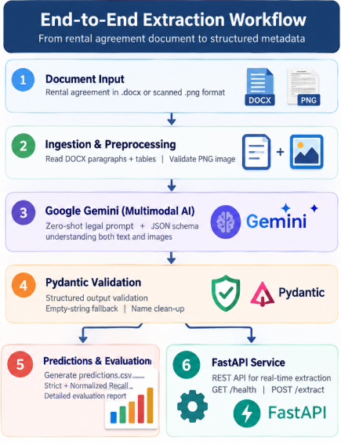
Figure 1: End-to-end extraction workflow

Key Components
- Document Readers: DOCX files are parsed into paragraphs plus table rows (duplicate merged cells removed). PNG files are validated with Pillow and sent straight to Gemini's vision input.
- Extraction Engine: a zero-shot legal prompt tells Gemini how to separate rent from deposits, format dates as DD.MM.YYYY, convert months to days and strip honorifics. The response is forced into a JSON schema at temperature 0.
- Validation Layer: a Pydantic model (RentalMetadata) checks the response. Missing or uncertain fields become empty strings instead of guesses, and failed calls are retried with exponential backoff.
- Evaluation: per field recall using strict exact match (the assignment metric) plus a normalized diagnostic that ignores stray whitespace and punctuation.
- REST API: a FastAPI service with GET /health and POST /extract, exercised inside the notebook using TestClient.

Model Resilience

The notebook probes the preferred Gemini model first. If its free-tier quota is exhausted (HTTP 429), it automatically switches to the next available Gemini Flash model, so batch runs keep going. API keys are loaded from a .env file or Colab Secrets and are masked in all output.

Evaluation Method
Predictions are written to predictions.csv using the exact column names of the dataset. Each field is scored as:
Recall = True / (True + False)
where True is an exact match with the ground truth and False is a mismatch or a missing value. Strict recall is the primary score; normalized recall is shown alongside it and never replaces it. Results are plotted as a grouped bar chart (evaluation_recall_chart.png) and a text summary is saved to evaluation_report.txt.

Final Evaluation Results

Strict Exact-Match Evaluation
Strict exact match recall is the primary assignment metric.
Metadata Field | Strict Recall | Strict Matches
Aggrement Value | 100.00% | 4/4
Aggrement Start Date | 100.00% | 4/4
Aggrement End Date | 100.00% | 4/4
Renewal Notice (Days) | 100.00% | 4/4
Party One | 100.00% | 4/4
Party Two | 75.00% | 3/4
Overall Field Score | 95.83% | 23/24

Normalized Evaluation
Normalized evaluation cleans whitespace and boundary punctuation. It is a secondary diagnostic and does not replace the strict assignment metric.
Metadata Field | Normalized Recall | Normalized Matches
Aggrement Value | 100.00% | 4/4
Aggrement Start Date | 100.00% | 4/4
Aggrement End Date | 100.00% | 4/4
Renewal Notice (Days) | 100.00% | 4/4
Party One | 100.00% | 4/4
Party Two | 100.00% | 4/4
Overall Field Score | 100.00% | 24/24

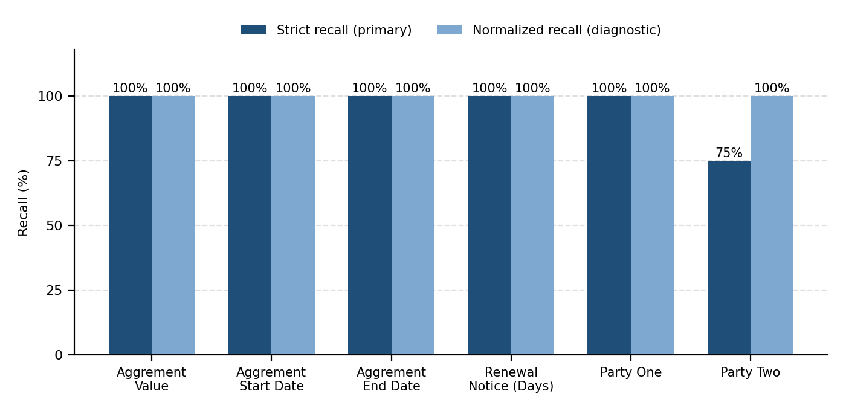
Figure 2: Strict vs. normalized recall per field (plotted from the tables above)

REST API Usage
Method | Endpoint | Purpose
GET | /health | Returns service status, timestamp and active model (no secrets).
POST | /extract | Upload a .docx or .png as multipart form field "file"; returns the six fields as JSON. Rejects other types (415), empty files (400) and files over 15 MB (413).

Testing
Ten automated tests run offline with the Gemini call mocked, covering ID extraction, schema validation, normalization, DOCX and image readers, fallback on invalid responses, metric math, API rejection of unsupported files and CSV column alignment.

Benefits
- Template independent: one prompt handles different layouts, party names and scan quality.
- Multimodal: scanned PNGs and DOCX files go through the same pipeline.
- Safe by design: empty strings instead of hallucinated values, with schema-enforced output.
- Ready to integrate: a documented REST API turns the notebook into a reusable service.

Limitations & Future Work
- Small test set: with only a handful of test documents, performance on other states' templates may reveal new clause variations.
- Poor scans: very low-DPI images may need preprocessing such as deskewing or contrast enhancement.
- Multiple signatories: agreements with co-owners or power-of-attorney holders need clear rules for which party is primary.

