CORNERSTONE PROJECT REPORT
ON
EMPLOYEE LEAVE MANAGEMENT SYSTEM

Submitted in partial fulfillment of the requirements
for the award of the degree of
BACHELOR OF TECHNOLOGY

Department of Computer Science & Engineering
Aditya University
2025 - 2026

TABLE OF CONTENTS
CONTENTS | PAGE NO
ABSTRACT | i
LIST OF FIGURES | ii
LIST OF TABLES | iii
ACRONYMS | iv
1. INTRODUCTION | 1
1.1 Brief Information about the Project | 1
1.2 Motivation and Contribution of Project | 1
1.3 Objectives of the Project | 2
1.4 Scope of the Project | 2
2. SYSTEM ANALYSIS | 3
2.1 Functional Requirements | 3
2.2 Non-Functional Requirements | 4
2.3 Requirements Specification | 5
3. TECHNOLOGY DESCRIPTION | 6
3.1 Programming Language | 6
3.2 Framework / Libraries | 6
3.3 Database Technology | 7
3.4 Tools & IDEs | 8
4. DATABASE DESIGN | 9
4.1 Database Tables | 9
4.2 Table Structure | 9
4.3 Keys and Constraints | 10
4.4 Table Relationships | 11
5. SYSTEM DESIGN | 12
5.1 System Architecture | 12
5.2 Modules Description | 12
6. SYSTEM IMPLEMENTATION | 15
7. CONCLUSION | 19
8. FUTURE ENHANCEMENTS | 20
9. REFERENCES | 21
APPENDIX (Sample Code) | 22
APPENDIX (SQL Queries) | 23

ABSTRACT

The Leave Management System is a software application developed to automate and simplify the process of managing employee leave requests in an organization. Traditional leave management methods are often manual, time-consuming, and prone to errors, leading to inefficiencies and lack of transparency. This project aims to provide a centralized and efficient solution for handling leave applications, approvals, and record maintenance.
The system is designed with two primary roles: Employee and Administrator. Employees can log in to the system, apply for leave by specifying the duration and reason, and track the status of their requests. Administrators, on the other hand, have the authority to review, approve, or reject leave requests and provide appropriate feedback.
The application is supported by a structured database consisting of Users, Leaves, and Holidays tables. The use of relational database concepts ensures data consistency, integrity, and efficient retrieval of information. The system also maintains leave balances and records, which help in better decision-making and tracking.
This project is implemented using Java for application logic and MySQL for database management, with connectivity established through JDBC. The system is designed to be user-friendly, reliable, and scalable for small to medium-sized organizations.
Although the current version provides essential functionalities, future enhancements such as password encryption, automatic leave balance calculation, and notification systems can further improve its efficiency and security.
Overall, the Leave Management System provides a practical and effective solution for modernizing leave management processes and improving organizational productivity.

LIST OF FIGURES

Figure No. | Figure Title | Page No.
1 | Login Screen of Employee Leave Management System | 15
2 | Registration Screen of Employee Leave Management System | 15
3 | Employee Dashboard Screen | 15
4 | Apply Leave Form Screen | 15
5 | Leave History Screen of Employee | 16
6 | Admin Dashboard Screen | 16
7 | Admin Leave Approval Screen | 17
8 | All Leave History Screen | 17
9 | Search Employee Leave Screen | 17
10 | Holiday List Screen | 18

LIST OF TABLES

Table No. | Table Title | Page No.
1 | Users Relational Database Table | 9
2 | Leaves Relational Database Table | 9
3 | Holidays Relational Database Table | 10

ACRONYMS

- ELMS : Employee Leave Management System
- JDBC : Java Database Connectivity
- GUI : Graphical User Interface
- SQL : Structured Query Language
- DB : Database
- IDE : Integrated Development Environment
- JVM : Java Virtual Machine
- OOP : Object-Oriented Programming
- UI : User Interface

1. INTRODUCTION

1.1 Brief Information about the Project
The Employee Leave Management System (ELMS) is a desktop-based application developed to manage and automate the leave application and approval process within an organization. It provides a centralized platform for employees to submit leave requests and for administrators to review and act upon those requests. The system replaces manual, paper-based processes with a structured digital solution, ensuring data accuracy, reducing redundancy, and improving accessibility.

The application is developed using Core Java for programming logic, Java Swing for designing the graphical user interface, JDBC for database connectivity, and MySQL as the backend database. It supports two distinct roles — Employee and Admin — with tailored dashboards and functionalities for each. The system is designed to be intuitive and suitable for deployment in organizations such as offices, colleges, and companies.

1.2 Motivation and Contribution of Project
In many organizations, employee leave requests are still handled through manual registers, email chains, or basic spreadsheet tools. This leads to inefficiencies such as delayed approvals, data duplication, loss of leave records, and difficulty in tracking leave balances. These limitations motivated the development of the Employee Leave Management System.

The key contributions of this project include:
- Providing a digital, automated solution for leave application and approval
- Eliminating manual paperwork and reducing administrative overhead
- Enabling real-time leave balance tracking for employees
- Providing administrators with centralized visibility of all leave requests
- Implementing overlap detection to prevent duplicate leave submissions
- Delivering instant notifications to employees regarding leave status updates

1.3 Objectives of the Project
The main objectives of the Employee Leave Management System are:
- To develop a user-friendly desktop application for managing employee leave requests
- To enable employees to register, log in, apply for leave, and view their leave history
- To enable administrators to approve or reject leave requests with reasons
- To maintain leave balance records and automatically deduct approved leave days
- To provide a holiday list viewer for employees to plan leave effectively
- To notify employees of rejection decisions upon their next login
- To store all data in a structured relational MySQL database

1.4 Scope of the Project
The Employee Leave Management System is designed for small and medium-sized organizations such as offices, colleges, and institutions. The scope of the system includes user registration and authentication with role-based access, leave application with date validation and overlap checking, admin-level leave approval and rejection workflows, leave cancellation for pending requests, leave history viewing for both employees and administrators, and a company holiday calendar accessible to employees.

The current scope is limited to a desktop environment with a local MySQL database. The system does not include payroll integration, biometric attendance, or cloud-based hosting, which are identified as future enhancements.

2. SYSTEM ANALYSIS

2.1 Functional Requirements
Functional requirements define the core operations and functionalities that the Employee Leave Management System (ELMS) must perform to manage leave-related processes effectively.

User Registration and Authentication
The system shall allow new users to register with a unique username, password, and role (Employee or Admin). Registered users can log in to access their respective dashboards. The system must validate credentials and prevent duplicate usernames.

Leave Application
Employees shall be able to apply for leave by specifying a start date, end date, and reason. The system must validate date formats, check for overlapping leave requests, and warn employees when the requested duration exceeds their available leave balance.

Admin Leave Approval and Rejection
Administrators shall be able to view all pending leave requests and either approve or reject them. Upon approval, the system must automatically deduct the approved days from the employee's leave balance. Upon rejection, the administrator must provide a reason.

Leave History and Cancellation
Employees shall be able to view their complete leave history with status details. They shall be able to cancel a pending leave request, provided the cancellation is made before the leave start date.

Admin Leave History Views
Administrators shall be able to view the leave history of all employees in aggregate or search for a specific employee's leave history by employee ID.

Rejection Notifications
The system must notify employees of any rejected leave requests upon their next login, displaying the leave dates and the rejection reason. After the notification is displayed, it shall be marked so it is not shown again.

Holiday List
The system shall display a list of company holidays retrieved from the database, accessible to employees from the leave application screen.

2.2 Non-Functional Requirements

Performance
The system should respond quickly to all operations, including login, leave submission, approval, and data retrieval, without noticeable delays.

Security
Only authorized users should access the system using credential-based authentication. Role-based access control ensures that employees cannot access admin functionalities.

Usability
The interface should be clean, intuitive, and easy to navigate for users of all technical backgrounds. The use of custom GlassFrame components and color-coded status rendering improves usability.

Reliability
The system shall handle exceptions gracefully using try-catch blocks and maintain data consistency without data loss in case of errors.

Scalability
The system should accommodate an increasing number of users and leave records without degradation in performance.

2.3 Requirements Specification

2.3.1 Minimum Hardware Requirements
- Processor: Intel Core i3 or above
- RAM: 4 GB (minimum)
- Hard Disk: 20 GB free space
- Monitor: Standard display (1366 x 768 or higher recommended)
- Keyboard and Mouse

2.3.2 Software Requirements
- Operating System: Windows 7 / 10 / 11
- Programming Language: Java (JDK 8 or above)
- IDE: Eclipse IDE for Java Developers
- Database: MySQL Server (with MySQL Connector/J driver)
- Database Connectivity: JDBC (com.mysql.cj.jdbc.Driver)

3. TECHNOLOGY DESCRIPTION

3.1 Programming Language

3.1.1 Introduction to Java
Java is a high-level, object-oriented programming language originally developed by Sun Microsystems and currently maintained by Oracle. It is widely used for developing desktop, web, and enterprise applications due to its platform independence, robustness, and rich standard library.

In the Employee Leave Management System, Java is used to implement all core application logic. It handles user authentication, leave application workflows, admin approval processes, leave balance calculations, and notification mechanisms. Java's strong exception handling, object-oriented design, and memory management make it ideal for building reliable applications of this type.

3.2 Framework / Libraries

3.2.1 Introduction to Swing
Java Swing is a GUI toolkit included in the Java Foundation Classes (JFC). It provides a comprehensive set of components including JFrame, JPanel, JButton, JTextField, JTable, JScrollPane, and more, enabling developers to build rich desktop interfaces.

In this project, Swing is used to build all user interface screens:
- Login and Registration windows
- Employee Dashboard with leave balance display
- Apply Leave Form with date and reason inputs
- Leave History viewer with cancel functionality
- Admin Dashboard with navigation controls
- Admin Approval Form with table-based leave management
- All Leave History and Search Employee Leave History screens
- Company Holiday List viewer

Custom components include GlassFrame (a reusable transparent panel base class), BackgroundPanel (a full-screen image background), and StatusCellRenderer (a color-coded table cell renderer for leave status).

3.3 Database Technology
The Employee Leave Management System uses a relational database to store and manage user accounts, leave records, and holiday information. The database ensures structured, consistent, and efficient data storage and retrieval.

3.3.1 JDBC (Java Database Connectivity)
JDBC is a standard Java API that enables Java applications to connect to and interact with relational databases. It allows execution of SQL queries including INSERT, UPDATE, DELETE, and SELECT operations.

In this project, JDBC is used via the DB utility class to:
- Establish a connection to the MySQL database (jdbc:mysql://localhost:3306/LeaveSystem)
- Execute parameterized SQL queries using PreparedStatement to prevent SQL injection
- Retrieve and process result sets using ResultSet
- Close database connections automatically using try-with-resources

3.3.2 MySQL Database
MySQL is a widely-used open-source relational database management system known for its reliability, performance, and ease of use. In this project, MySQL is used as the backend to store user credentials, leave applications, and holiday records. The MySQL Connector/J driver (com.mysql.cj.jdbc.Driver) is used for JDBC integration.

3.4 Tools & IDEs

3.4.1 Eclipse IDE
Eclipse IDE for Java Developers is used as the development environment for the Employee Leave Management System. It is a powerful, open-source IDE that provides features such as project management, code editing with syntax highlighting, Java compilation, debugging support, and integrated source control. The project structure observed in the uploaded source code follows the standard Eclipse project layout with separate src and bin directories, along with Eclipse-specific configuration files (.classpath, .project, .settings).

4. DATABASE DESIGN

4.1 Database Tables
The Employee Leave Management System uses a MySQL relational database named LeaveSystem. The database consists of three main tables: users, leaves, and holidays.
- The users table stores user credentials, roles, and leave balance information.
- The leaves table stores all leave requests along with status and notification tracking.
- The holidays table stores company-declared public holidays.

4.2 Table Structure

4.2.1 Users Table

Field Name | Data Type | Description | Constraint
id | INT (AUTO_INCREMENT) | Unique user identifier | Primary Key
username | VARCHAR(100) | Login username | Not Null, Unique
password | VARCHAR(100) | User password | Not Null
role | VARCHAR(50) | User role (Employee/Admin) | Not Null
leave_balance | INT | Remaining leave days | Default 20

Table 1: Users Relational Database Table

4.2.2 Leaves Table

Field Name | Data Type | Description | Constraint
id | INT (AUTO_INCREMENT) | Unique leave record ID | Primary Key
user_id | INT | Employee who applied | Foreign Key (users.id)
from_date | DATE | Leave start date | Not Null
to_date | DATE | Leave end date | Not Null
reason | TEXT | Reason for leave | -
status | VARCHAR(20) | Pending/Approved/Rejected/Cancelled | Default 'Pending'
reject_reason | TEXT | Admin rejection reason | Nullable
notified | BOOLEAN | Rejection notification flag | Default false

Table 2: Leaves Relational Database Table

4.2.3 Holidays Table

Field Name | Data Type | Description | Constraint
id | INT (AUTO_INCREMENT) | Unique holiday ID | Primary Key
holiday_date | DATE | Date of the holiday | Not Null
holiday_name | VARCHAR(100) | Name of the holiday | Not Null

Table 3: Holidays Relational Database Table

4.3 Keys and Constraints
Keys and constraints are used to maintain data integrity and ensure accurate data storage.
- Primary Keys: id in users, leaves, and holidays tables
- Foreign Key: user_id in the leaves table references id in the users table
- NOT NULL Constraints: username, password, role, from_date, and to_date cannot be empty
- UNIQUE Constraint: username must be unique across all user records
- DEFAULT Values: leave_balance defaults to 20; status defaults to 'Pending'; notified defaults to false

4.4 Table Relationships
The users and leaves tables are related through the user_id foreign key. Each employee (user) can have multiple leave records, but each leave record belongs to exactly one employee. This represents a one-to-many relationship between users and leaves. The holidays table is independent and stores organization-wide holiday information accessible to all users.

5. SYSTEM DESIGN

5.1 System Architecture
The Employee Leave Management System follows a three-layer architecture:

- Presentation Layer (User Interface): Developed using Java Swing, this layer provides all forms, dashboards, and interactive controls. Custom components such as GlassFrame, BackgroundPanel, and StatusCellRenderer enhance the visual quality and user experience.

- Application Layer (Business Logic): This layer processes user inputs, enforces business rules (leave balance checks, overlap detection, date validation), and coordinates between the UI and the database.

- Data Layer (Database): MySQL stores all persistent data including user accounts, leave records, and holiday information. The DB utility class manages all JDBC connections.

5.2 Modules Description
The system is divided into the following modules:

5.2.1 Authentication Module
Handles user registration (RegisterForm.java) and login (LoginForm.java). On successful login, routes users to either AdminDashboard or EmployeeDashboard based on their role.

5.2.2 Employee Module
The EmployeeDashboard provides the employee with access to apply for leave, view leave history, and check their remaining leave balance. It also checks for pending rejection notifications at login.

5.2.3 Leave Application Module
ApplyLeaveForm.java allows employees to submit leave requests with date and reason. It validates date formats, checks for leave overlaps with existing requests, compares requested days against balance, and warns users of deficits before submission.

5.2.4 Leave History Module
LeaveHistoryForm.java displays all leave records for the logged-in employee with status information. Employees can cancel pending leave requests if the leave has not yet started.

5.2.5 Admin Module
AdminDashboard.java serves as the control center for administrators, providing navigation to leave approval, all leave history, and employee-specific leave search.

5.2.6 Admin Approval Module
AdminApprovalForm.java displays all pending leave requests in a table. Admins can approve a request (which deducts days from the employee's leave balance) or reject it (with a mandatory rejection reason).

5.2.7 Leave History Admin Module
AllLeaveHistoryForm.java shows all leave records across all employees. SearchEmployeeLeaveForm.java allows admins to search and filter leave records by employee ID.

5.2.8 Holiday Module
HolidayListForm.java retrieves and displays all company holidays from the holidays database table, helping employees plan their leave applications accordingly.

5.2.9 UI Utility Module
GlassFrame.java is a base class providing a consistent semi-transparent glass panel UI across all screens. BackgroundPanel.java renders a full-screen background image. StatusCellRenderer.java applies color-coded formatting to leave status values in all table displays.

5.2.10 Database Connectivity Module
DB.java provides a static getConnection() method that establishes and returns a JDBC connection to the MySQL LeaveSystem database using the MySQL Connector/J driver.

6. SYSTEM IMPLEMENTATION

Login and Registration Screens
The application starts by launching LoginForm.java via the Main class. The login screen presents username and password fields along with Login and Register buttons. The system queries the users table using a PreparedStatement and routes authenticated users to their respective dashboards based on their role. The RegisterForm screen allows new users to create an account with a chosen role of Employee or Admin, with duplicate username validation enforced before insertion.
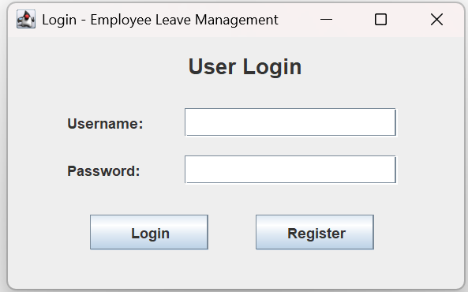

Employee Dashboard Screen
The EmployeeDashboard is displayed for Employee-role users after login. It shows the employee's current leave balance (loaded dynamically from the database) and provides navigation buttons to Apply for Leave and View Leave History. Upon dashboard load, the system checks for any unacknowledged leave rejection notifications and displays them to the user via dialog messages.
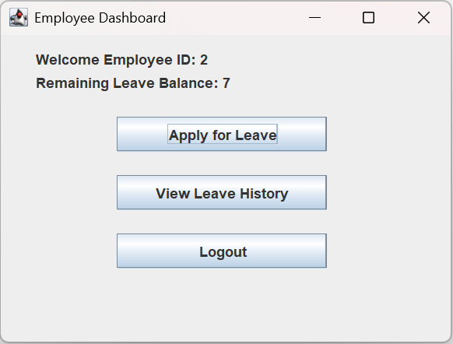

Apply Leave Form Screen
The ApplyLeaveForm allows employees to enter leave dates in YYYY-MM-DD format along with a reason. The system performs three layers of validation: date format parsing (using java.time.LocalDate), overlap detection against existing Pending and Approved leave records, and leave balance comparison. If the balance is insufficient, a confirmation dialog warns the employee before proceeding.
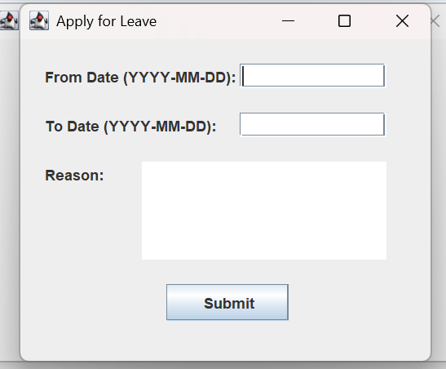

Leave History Screen
The LeaveHistoryForm displays a JTable with columns for ID, From, To, Reason, Status, and Reject Reason. The StatusCellRenderer applies colors: green for Approved, red for Rejected, orange for Pending, and grey for Cancelled. Employees can cancel a selected Pending leave request provided the leave has not yet started.
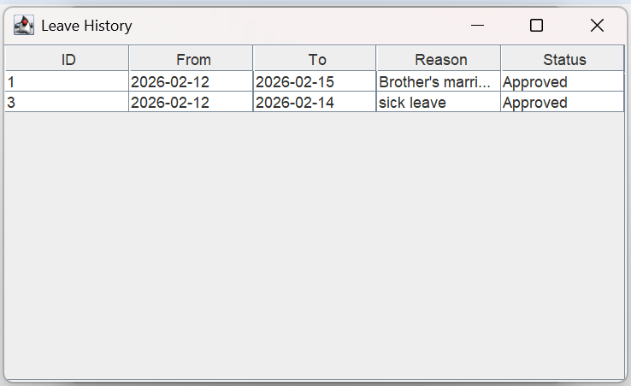

Admin Dashboard Screen
The AdminDashboard provides administrators with three action buttons: Pending Leave Approval, View All Leave History, and View Employee Leave History. Each button navigates to the corresponding functional screen.
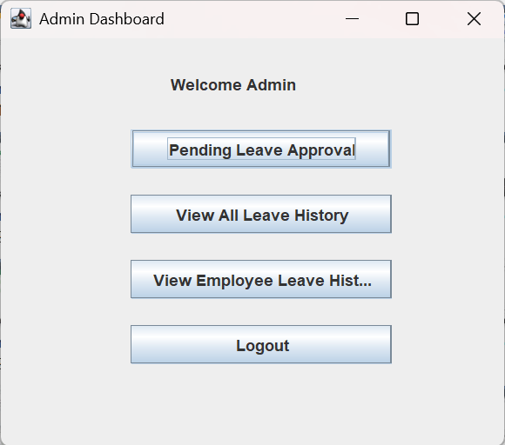

Admin Leave Approval Screen
AdminApprovalForm.java loads all Pending leave requests into a JTable. On approval, the system calculates the number of leave days using ChronoUnit.DAYS.between() and deducts them from the employee's leave_balance via an UPDATE query. On rejection, a JOptionPane prompts the administrator for a reason, which is stored in the reject_reason column with the status set to Rejected.
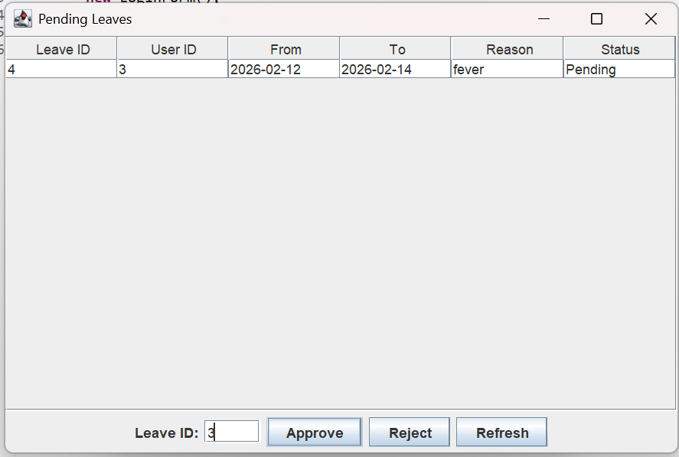

All Leave History and Search Screens
AllLeaveHistoryForm.java retrieves all records from the leaves table ordered by ID in descending order and presents them in a color-coded JTable. SearchEmployeeLeaveForm.java allows the admin to enter a specific employee ID and filter leave records accordingly, with a validation check to ensure the entered ID is numeric.
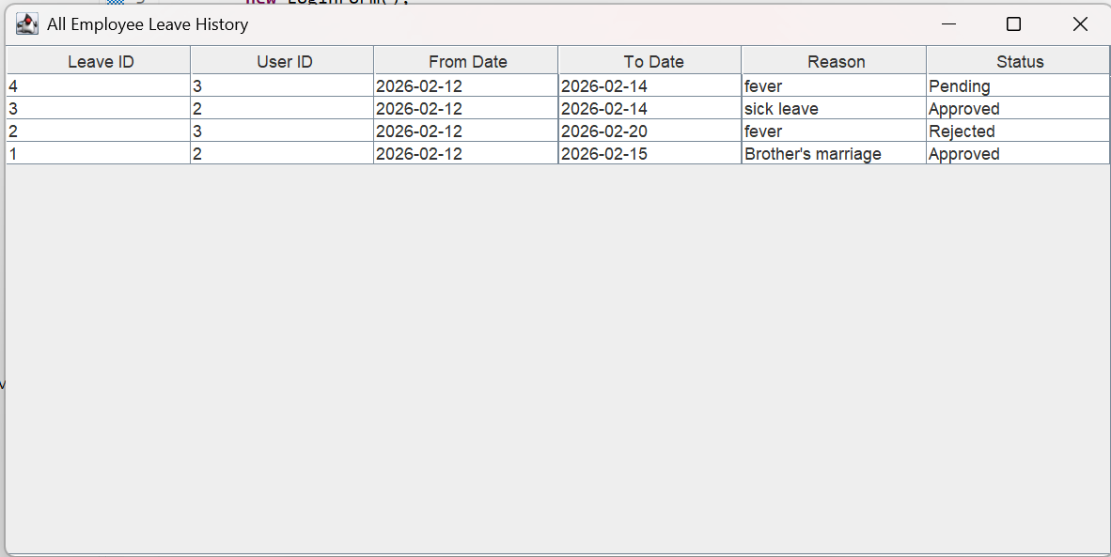

Holiday List Screen
HolidayListForm.java presents a read-only JTable populated from the holidays table, ordered by holiday_date. It can be accessed from the Apply Leave screen, enabling employees to be aware of official holidays when planning leave.
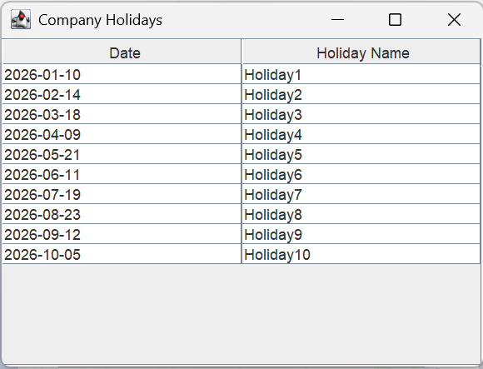

7. CONCLUSION

The Employee Leave Management System has been successfully designed and developed as a fully functional desktop application using Core Java, Java Swing, JDBC, and MySQL. The system effectively addresses the limitations of manual leave management by providing a structured, digital solution for both employees and administrators.

The application provides a comprehensive set of features including secure user authentication, role-based access control, leave application with intelligent validation, admin-level approval and rejection workflows, leave history tracking, leave cancellation, real-time rejection notifications, and a company holiday viewer. The use of custom UI components such as GlassFrame, BackgroundPanel, and StatusCellRenderer enhances the visual quality and usability of the application.

The system meets all defined project objectives and demonstrates the practical application of object-oriented programming, event-driven GUI development, and relational database management. It reduces administrative overhead, improves data accuracy, and provides a scalable foundation that can be extended with additional features in the future.

In conclusion, the Employee Leave Management System serves as an effective, reliable, and user-friendly solution for leave management in small and medium-sized organizations.

8. FUTURE ENHANCEMENTS

The Employee Leave Management System developed in this project provides essential leave management functionalities. The system can be further enhanced by introducing the following advanced features:

- Web-Based Application: Converting the desktop application into a web-based system using technologies such as Java EE, Spring Boot, or a similar framework to enable remote access from any device.
- Email Notifications: Integrating email alerts to notify employees and administrators of leave application submissions, approvals, and rejections automatically.
- Payroll Integration: Adding salary calculation and payslip generation features tied to leave balances to support HR and finance processes.
- Attendance Management: Integrating daily attendance tracking with the leave system to provide a unified HR platform.
- Password Encryption: Implementing secure password hashing (e.g., BCrypt) to replace plain-text password storage.
- Leave Type Categorization: Supporting multiple leave types such as Casual Leave, Sick Leave, Earned Leave, and Maternity Leave with separate balances.
- Report Generation: Adding the ability to generate and export leave reports as PDF or Excel files for administrative and payroll purposes.
- Multi-User Concurrent Access: Enabling simultaneous access by multiple users through proper session management and database connection pooling.
- Mobile Application: Developing a companion mobile app for Android or iOS to allow employees to apply for and track leave on the go.

9. REFERENCES

- Herbert Schildt, Java: The Complete Reference, Oracle Press, 12th Edition.
- E. Balagurusamy, Programming with Java, McGraw Hill Education.
- Korth, Silberschatz, Sudarshan, Database System Concepts, McGraw Hill.
- MySQL Documentation, https://dev.mysql.com/doc/
- Java Documentation (Oracle), https://docs.oracle.com/javase
- JDBC Tutorial - GeeksforGeeks, https://www.geeksforgeeks.org/jdbc/
- Java Swing Tutorial - TutorialsPoint, https://www.tutorialspoint.com/java_swing
- MySQL Connector/J Developer Guide, https://dev.mysql.com/doc/connector-j/en/

APPENDIX

A.1 Sample Code

Database Connection Code (DB.java)
The following code establishes a connection between the Java application and the MySQL database using JDBC.

import java.sql.*;

public class DB {
public static Connection getConnection() throws Exception {
String url = "jdbc:mysql://localhost:3306/LeaveSystem";
String user = "root";
String pass = "";
Class.forName("com.mysql.cj.jdbc.Driver");
return DriverManager.getConnection(url, user, pass);
}
}

Leave Application Code (ApplyLeaveForm.java - Submit Logic)
This code snippet handles the leave submission with overlap checking and balance validation.

java.time.LocalDate fromD = java.time.LocalDate.parse(from);
java.time.LocalDate toD = java.time.LocalDate.parse(to);
long requestedDays = ChronoUnit.DAYS.between(fromD, toD) + 1;

PreparedStatement ps = con.prepareStatement(
"INSERT INTO leaves(user_id, from_date, to_date, reason)
VALUES(?, ?, ?, ?)");
ps.setInt(1, userId);
ps.setString(2, from);
ps.setString(3, to);
ps.setString(4, reasonArea.getText().trim());
ps.executeUpdate();

A.2 SQL Queries

Create Users Table
CREATE TABLE users (
id INT AUTO_INCREMENT PRIMARY KEY,
username VARCHAR(100) NOT NULL UNIQUE,
password VARCHAR(100) NOT NULL,
role VARCHAR(50) NOT NULL,
leave_balance INT DEFAULT 20
);

Create Leaves Table
CREATE TABLE leaves (
id INT AUTO_INCREMENT PRIMARY KEY,
user_id INT,
from_date DATE NOT NULL,
to_date DATE NOT NULL,
reason TEXT,
status VARCHAR(20) DEFAULT 'Pending',
reject_reason TEXT,
notified BOOLEAN DEFAULT false,
FOREIGN KEY (user_id) REFERENCES users(id)
);

Create Holidays Table
CREATE TABLE holidays (
id INT AUTO_INCREMENT PRIMARY KEY,
holiday_date DATE NOT NULL,
holiday_name VARCHAR(100) NOT NULL
);

