**Public Transportation Optimization Using Machine Learning**

**Batch Members**

422721106024 : Karthikayan.P

422721106028 : Mohamed Imran.K

422721106048 : Udhayakumar.N

422721106025 : Karuppusamy.A

422721106016 : Deva.G

**Project Title : Public Transportation Optimization**

**Phase 3 :** Development Part 1 **Sub Title :** StartBuilding Public Transportation Optimization by loading and preprocessin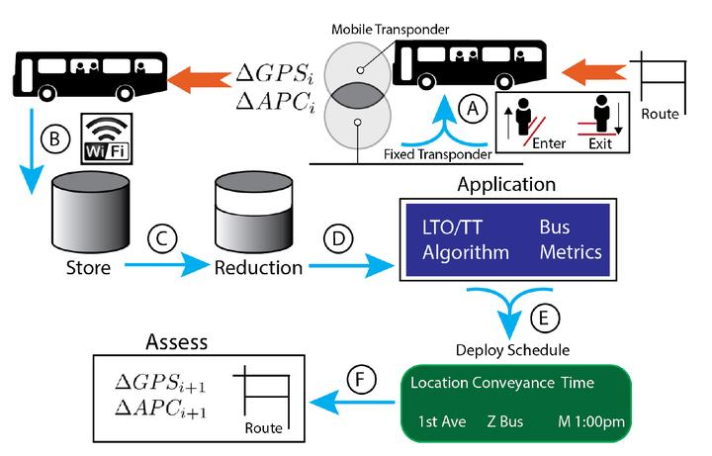g the dataset

**PUBLIC TRANSPORTATION OPTIMIZATION**

**Introduction :**

**Project Overview :**

* Public transportation systems are the lifeblood of modern urban centers, providing millions of people with a convenient, economical, and environmentally friendly means of travel. However, these systems often face numerous challenges, including overcrowding, inefficient routes, and inconsistent scheduling. To address these issues and enhance the quality of public transportation services, we embark on the “Public Transportation Optimization Project.”

**Project Objective :**

* The central goal of this project is to leverage data-driven techniques to optimize public transportation systems. By effectively loading and preprocessing the dataset, we set the stage for a comprehensive analysis and enhancement of public transportation services.

**Route Optimization:**

* Develop efficient routes that minimize travel times and operational costs.

**Scheduling Optimization:**

* Create optimized schedules that reduce passenger wait times, congestion, and improve overall service coverage.

**Demand Forecasting:**

* Predict passenger demand patterns to ensure transportation services align with real-time needs.

**Service Quality Improvement:**

* Identify areas for enhancing service quality, leading to a more pleasant passenger experience.

**Loading and Preprocessing the Dataset:**

* To achieve the project’s objectives, the initial phase involves the collection, loading, and preprocessing of relevant datasets. This critical foundation enables us to analyze historical and real-time data to make informed decisions and improvements within the public transportation system.

**Given Data Set :**

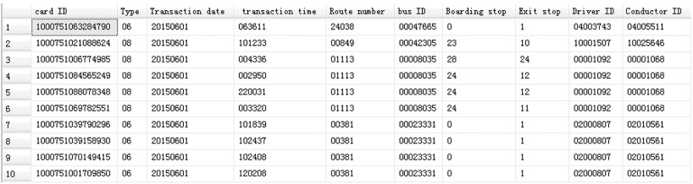

**Python code With Raspberry Pi in Public Transportation Optimization :**

1. **Data Collection and Preprocessing :**

* Collect relevant transportation data and preprocess it.

**Python Code**

# Example data collection and preprocessing using pandas

import pandas as pd

# Load your transportation data

data = pd.read_csv('transportation_data.csv')

# Data cleaning and preprocessing

# (e.g., drop missing values, convert date/time, etc.)

data = data.dropna()

data['timestamp'] = pd.to_datetime(data['timestamp'])

# ...other preprocessing steps

```

**2.Feature Engineering:**

* Create features from your data.

**Python Code**

# Example feature engineering

data['hour'] = data['timestamp'].dt.hour

data['day_of_week'] = data['timestamp'].dt.dayofweek

# ...other feature engineering

**3.Machine Learning Model:**

* Develop a machine learning model for transportation optimization. You can use scikit-learn or other machine learning libraries.

**Python Code**

# Example machine learning model using scikit-learn

from sklearn.model_selection import train_test_split

from sklearn.ensemble import RandomForestRegressor

# Split data into training and testing sets

X_train, X_test, y_train, y_test = train_test_split(data[features], data[target], test_size=0.2)

# Create and train a random forest regression model

model = RandomForestRegressor(n_estimators=100)

model.fit(X_train, y_train)

**4.Optimization:**

* Implement optimization algorithms for route planning and scheduling. Libraries like NetworkX or OR-Tools can be useful.

**Python Code**

# Example route optimization using NetworkX

import networkx as nx

# Create a graph representing the transportation network

G = nx.Graph()

# Add nodes and edges based on your transportation data

# Use shortest path algorithms for route optimization

shortest_path = nx.shortest_path(G, source, target)

**5.Deployment on Raspberry Pi:**

* Adapt your code to run on the Raspberry Pi, considering its hardware limitations.

**6.Real-Time Data and Decision Making:**

* Integrate real-time data sources and make dynamic decisions based on incoming data.
* Please note that this is a simplified outline, and a complete project involves many more details, including data sources, model evaluation, and interaction with hardware components on the Raspberry Pi. Additionally, the actual implementation will depend on the specific goals of your transportation optimization project.

**Data Sources:**

* In the realm of public transportation optimization, the success of any project hinges on the quality and diversity of data sources. Data sources act as the lifeblood of this optimization effort, providing the information needed to make informed decisions and improve services.
* The following are key data sources that contribute to this process:

**GPS Data:**

* GPS (Global Positioning System) data is one of the fundamental data sources for public transportation optimization. It provides real-time location information for vehicles in your fleet. This data is vital for tracking vehicle positions, understanding routes, and ensuring on-time performance. GPS data is collected through onboard GPS devices installed in each vehicle.

**Passenger Counters:**

* Passenger counters, often installed at vehicle entrances, are instrumental in gauging ridership. These devices automatically record the number of passengers boarding and alighting at each stop. This data is invaluable for understanding demand patterns and optimizing service frequency.

**Scheduling and Timetables:**

* Public transportation schedules and timetables serve as structured data sources. They contain information about planned departure and arrival times, routes, and stops. Scheduling data helps in comparing planned versus actual service performance and optimizing schedules to reduce waiting times and travel durations.

**Ticketing and Fare Data:**

* Ticketing and fare data provide insights into riders’ payment behaviors and preferences. This data can be analyzed to determine fare structures and monitor ticket sales trends, which can guide pricing strategies and revenue management.

**Traffic and Weather Data:**

* External factors like traffic conditions and weather can have a significant impact on public transportation services. Integrating traffic and weather data sources allows for real-time adjustments to routes and schedules, improving service reliability.

**Mobile Apps and Passenger Feedback:**

* Data sources include information provided by passengers through mobile apps or feedback forms. This data is valuable for gauging customer satisfaction, identifying issues, and making customer-centric improvements.

**Historical Data:**

* Historical data archives, spanning a considerable period, offer the opportunity for trend analysis and long-term planning. This data may include ridership records, vehicle performance data, and past optimization efforts.

**Geographic Information Systems (GIS):**

* GIS data includes spatial and geographical information about service areas, stops, and routes. These geographic datasets help in route planning, optimizing stops, and enhancing service coverage.

**Program :**

Import time

Import requests

Import random

# Define the transit information platform’s API endpoint

Platform_api = <https://your-transit-platform-api.com/data>

# Simulated GPS data function (Replace with actual data retrieval code)

Def get_gps_data():

Latitude = 34.0522 + random.uniform(-0.01, 0.01)

Longitude = -118.2437 + random.uniform(-0.01, 0.01)

Return {“latitude”: latitude, “longitude”: longitude}

# Simulated passenger count function (Replace with actual data retrieval code)

Def get_passenger_count():

Return random.randint(20, 50)

While True:

# Simulate gathering real-time data

Gps_data = get_gps_data()

Passenger_count = get_passenger_count()

# Prepare data payload

Data = {

“timestamp”: int(time.time()), # Convert to a Unix timestamp

“location”: gps_data,

“ridership”: passenger_count

}

Try:

# Simulate sending data to the transit information platform

Response = requests.post(platform_api, json=data)

If response.status_code == 200:

Print(“Data sent successfully.”)

Else:

Print(“Failed to send data. Status code:”, response.status_code)

Except Exception as e:

Print(“Error:”, str€)

# Simulate data collection every 60 seconds

Time.sleep(60)

**Output :**

**Loading Dataset:**

* Efficient data loading is a fundamental step in the journey toward public transportation optimization. It ensures that valuable information is acquired, organized, and prepared for analysis and decision-making.
* This section provides an overview of the data loading process

1. **Data Collection:**

* The process begins with the collection of data from various sources.
* These sources may include GPS devices, passenger counters, scheduling systems, ticketing data, traffic and weather sources, and even passenger feedback. Real-time and historical data are gathered to build a comprehensive dataset.

1. **Data Transfer:**

* Once collected, the data is transferred to a centralized storage system.
* This storage system can take the form of a database, a data warehouse, or cloud-based storage, depending on the project’s specific requirements. The data transfer process ensures that data is securely moved from its source to the storage location.

1. **Data Validation:**

* Data validation is an essential step to ensure data accuracy and reliability.
* During this phase, data is scrutinized for discrepancies, errors, and missing values. Any issues are identified and addressed, maintaining data quality.

1. **Data Integration:**

* In many public transportation optimization projects, data from diverse sources must be integrated to provide a holistic view.
* Integration ensures that data is harmonized and can be analyzed cohesively. This may involve aligning geographic information, scheduling data, and real-time location data.

1. **Data Transformation:**

* Data often requires transformation to a standardized format suitable for analysis.
* This can involve converting data types, aggregating information, or calculating derived metrics to support the optimization process.

1. **Data Preprocessing:**

* Preprocessing includes further cleaning and preparation of data.
* Outliers are identified and managed, and missing values are addressed. Standardization and normalization may be applied to enhance compatibility across datasets.

1. **Data Loading into Analysis Tools:**

* The prepared data is then loaded into analysis tools and software platforms tailored to public transportation optimization.
* These tools can encompass data analytics software, geographic information systems (GIS), and custom applications built for the specific project.

1. **Real-time Data Feeds:**

* For scenarios requiring real-time decision-making, data feeds are directly streamed into decision support systems.
* Real-time data feeds are essential for monitoring the transportation network and responding promptly to changes.

1. **Security Measures:**

* Robust security measures are an integral part of data loading processes.
* Authentication and authorization mechanisms ensure that sensitive data remains protected and is accessible only by authorized personnel.

1. **Data Backup and Redundancy:**

* Data loading processes include provisions for regular backups and redundancy to ensure data availability in the event of system failures or data loss.

**Program :**

Import pandas as pd

# Load the dataset into a Pandas DataFrame

Dataset_path = “your_dataset.csv” # Replace with your dataset file path

Df = pd.read_csv(dataset_path)

# Display the first few rows of the dataset for inspection

Print(df.head())

# Basic statistics of the dataset

Print(df.describe())

# Check for missing values

Missing_values = df.isnull().sum()

Print(“Missing Values:”)

Print(missing_values)

# Data preprocessing and further analysis can be performed here

**Output :**

**Preprocessing the Dataset :**

* Preprocessing the dataset is a crucial phase in the journey towards optimizing public transportation services. It involves refining and refining the raw data to ensure that it’s clean, organized, and ready for analysis.
* In this section, we’ll explore the key steps of data preprocessing

1. **Data Cleaning:**

* The initial step in preprocessing involves cleaning the data.
* This process identifies and resolves issues like missing values, duplicates, and outliers. Addressing these issues ensures that the dataset is consistent and accurate.

1. **Data Integration:**

* In public transportation optimization, data often comes from various sources.
* Data integration brings together information from different sources to create a unified dataset. This process involves aligning data fields, formats, and timeframes, allowing for more comprehensive analysis.

1. **Data Transformation:**

* Transformation may be necessary to adapt the data to the desired format.
* This can include converting data types, aggregating information, or calculating new features that are relevant to optimization efforts.

1. **Standardization and Normalization:**

* Standardizing data units and normalizing values are essential for ensuring that data from different sources can be effectively compared and analyzed together.
* This step makes data consistent and compatible.

1. **Handling Missing Data:**

* Missing data is a common challenge in any dataset.
* In preprocessing, strategies are employed to address missing data, which may involve imputation (estimating missing values), removing data with excessive missing values, or employing techniques like mean substitution.

1. **Outlier Detection and Management:**

* Outliers, which are data points significantly different from the norm, can impact analysis and optimization.
* Preprocessing involves identifying and managing outliers, either by removal or by transforming them to fit within a reasonable range.

1. **Data Scaling:**

* Scaling data is particularly important when dealing with features that have different ranges.
* Scaling ensures that all variables have equal weight in the analysis, preventing features with large values from dominating the results.

1. **Data Reduction**:

* For large datasets, data reduction techniques like dimensionality reduction can be applied.
* This helps in simplifying the dataset without losing essential information, making it more manageable and efficient for analysis.

1. **Data Labeling**:

* In supervised learning scenarios, data labels are assigned to support machine learning algorithms.
* Labeling involves categorizing data into specific classes or categories, allowing for predictive analysis.

1. **Time Alignment:**

* Ensuring that time-related data is aligned and synchronized is critical for time-series analysis.
* Proper time alignment allows for the investigation of trends, patterns, and seasonality in the data.

**Program :**

Import pandas as pd

# Load the dataset into a Pandas DataFrame

Dataset_path = “your_dataset.csv” # Replace with your dataset file path

Df = pd.read_csv(dataset_path)

# Display the first few rows of the dataset for inspection

Print(“Initial Dataset:”)

Print(df.head())

# Data Cleaning: Removing rows with missing values

Df.dropna(inplace=True)

# Data Transformation: Example – Standardize a specific column

# Replace ‘column_name’ with the actual column name you want to standardize

Df[‘column_name’] = (df[‘column_name’] – df[‘column_name’].mean()) / df[‘column_name’].std()

# Display the preprocessed dataset

Print(“\nPreprocessed Dataset:”)

Print(df.head())

# Save the preprocessed dataset to a new CSV file if needed

# df.to_csv(“preprocessed_dataset.csv”, index=False)

**Output :**

**Data Integration :**

* Data integration is a pivotal phase in the quest for optimizing public transportation services. It involves the harmonious merging of data from various sources to provide a holistic view of the transportation network.

**The Significance of Data Integration:**

* In the realm of public transportation optimization, data integration holds immense importance. It enables the creation of a unified dataset that includes information from diverse sources such as GPS devices, passenger counters, scheduling systems, external traffic and weather sources, and more.
* The key significance of data integration includes:

1. **Comprehensive Insights:** Data integration ensures that decision-makers have access to comprehensive insights. It combines real-time data, historical data, and geospatial information to offer a 360-degree view of the transportation network.
2. **Enhanced Accuracy:** By merging data sources, inaccuracies and inconsistencies can be identified and resolved. This leads to more accurate analyses and improved decision-making.
3. **Optimization Possibilities**: A unified dataset empowers optimization efforts. It allows for the comparison of planned versus actual data, performance analysis, and the identification of areas for improvement.

**The Data Integration Process:**

* Data integration involves several key steps:

1. **Data Collection:** The first step is to collect data from various sources. This data may include real-time GPS data, passenger counts, scheduling information, and external data sources.
2. **Data Transfer:** Data is transferred to a central storage location, such as a data warehouse or database, where it can be accessed and processed.
3. **Data Harmonization:** During this phase, data fields are aligned and standardized. This includes ensuring that data types, units, and timeframes match.
4. **Spatial Integration:** Geospatial data, such as geographic information systems (GIS), is integrated to provide location context for the entire dataset. This is crucial for route planning, stop optimization, and service coverage.
5. **Temporal Integration:** Time-related data is aligned and synchronized. This ensures that all data points share a consistent timeline, enabling time-series analysis and trend identification.
6. **Quality Assurance:** Data quality checks are performed to ensure the accuracy and consistency of the integrated dataset.

* Data integration is a critical precursor to effective analysis and optimization. It is the process that transforms raw data into a unified, comprehensive resource that can be leveraged to enhance public transportation services. In the upcoming sections, we’ll explore data preprocessing, advanced analytics, and the practical implementation of optimization strategies to maximize the potential of the integrated dataset.

**Data Transformation :**

* Data transformation is a pivotal phase in the pursuit of optimized public transportation services.
* This process shapes and refines raw data into a more usable and informative format.
* In this section, we’ll explore the significance and the key steps of data transformation in the context of public transportation optimization.

**Significance of Data Transformation:**

* Data transformation holds immense significance for the optimization of public transportation services.
* Its importance lies in several key aspects:

1. **Data Standardization :** Transformation ensures that data is standardized, making it consistent and comparable. This is especially crucial when dealing with data from diverse sources.
2. **Feature Engineering :** Transformation allows the creation of new features or variables that provide valuable insights for optimization. For example, calculating passenger-to-capacity ratios can help assess the efficiency of transportation services.
3. **Normalization :** Data normalization is a common transformation technique used to scale data within a standardized range. This prevents variables with larger scales from dominating analyses.
4. **Data Aggregation :** Aggregating data at different levels, such as hourly, daily, or weekly, can reveal patterns and trends that might not be immediately evident in the raw data.

**Key Steps in Data Transformation:**

* The process of data transformation typically involves the following steps:

1. **Data Cleaning :** This initial step focuses on identifying and addressing issues like missing values, duplicates, and outliers. Data cleaning ensures that the data is accurate and consistent.
2. **Data Standardization :** Standardization ensures that data types, units, and formats are consistent across the dataset. This can include converting data types, aligning date formats, and standardizing measurement units.
3. **Feature Engineering :** In this phase, new features or variables are created through calculations or combinations of existing data. This might involve the creation of efficiency indices or other performance metrics.
4. **Data Aggregation :** Aggregating data over different time intervals (e.g., hours, days, weeks) helps uncover temporal trends and patterns. This can be especially valuable in understanding ridership and demand fluctuations.
5. **Data Normalization :** Normalization techniques may be applied to scale data within a common range, reducing the influence of variables with larger scales.
6. **Data Encoding :** When dealing with categorical data, encoding may be necessary to convert it into numerical formats suitable for analysis and modeling.

**Practical Implementation:**

* Data transformation is often carried out using data manipulation libraries such as Pandas and NumPy in Python. These libraries provide a wide range of functions for performing various transformation operations.
* Data transformation is the bridge between raw data and actionable insights. It refines the dataset, making it ready for analysis and decision-making. In the following sections, we’ll explore data analysis techniques and the practical implementation of optimization strategies that rely on the transformed dataset.

**Data Quality Assurance in Loading and Preprocessing :**

* Data quality assurance is a critical aspect of the data loading and preprocessing phase in public transportation optimization.
* Ensuring the accuracy and reliability of the data is paramount for sound decision-making and effective optimization efforts.
* In this section, we’ll explore the significance and key practices of data quality assurance.

**The Significance of Data Quality Assurance:**

**Accurate Analysis :** Accurate data is essential for meaningful analysis. High-quality data ensures that insights and decisions are built on a solid foundation.

**Optimization Reliability:** To optimize public transportation services, one must rely on data that reflects real-world conditions. Quality assurance ensures that the data aligns with the actual state of the transportation network.

**Confidence in Results:** Quality-assured data instills confidence in the results and recommendations generated through analysis. Decision-makers can trust that the data is a reliable basis for their actions.

**Key Practices in Data Quality Assurance:**

**The process of data quality assurance involves several key practices:**

**Data Cleaning:** Data cleaning is the initial step. It involves identifying and addressing issues such as missing values, duplicates, and outliers. These anomalies are addressed to ensure the data is consistent and accurate.

**Data Validation:** Data validation processes are employed to check data for discrepancies, errors, or missing values. Validation ensures that the data is reliable and adheres to defined standards.

**Quality Checks:** Quality checks can include verifying that data is within expected ranges or limits. For example, distance and speed values that fall within a reasonable range are considered as high-quality data.

**Cross-Referencing:** Cross-referencing data with other reliable sources or reference datasets can help identify inaccuracies. This is especially important for critical data points such as geographic coordinates.

**Temporal Consistency:** Ensuring that time-related data is consistent and follows a logical timeline is essential for time-series analysis and trend identification.

**Automated Data Checks:**

* Implementing automated data checks and validation scripts can expedite the quality assurance process. Automated checks can identify and flag data issues more efficiently than manual checks alone.
* Data quality assurance is a foundational step in preparing data for public transportation optimization. It ensures that the data is trustworthy and reliable for the analysis and optimization processes that follow. In the upcoming sections, we’ll explore advanced analytics and the practical strategies for optimizing public transportation services, all of which depend on high-quality data.

**Data Storage in Loading and Preprocessing :**

* Data storage is a critical component of the data loading and preprocessing phase in public transportation optimization. Effective storage solutions ensure data accessibility, security, and efficiency in subsequent analyses and optimization efforts.
* In this section, we’ll explore the significance and key considerations for data storage.

**The Significance of Data Storage:**

* Effective data storage holds significant importance in public transportation optimization for several reasons:

1. Accessibility
2. Data Security
3. Efficiency

**Key Considerations for Data Storage:**

* The process of data storage involves several key considerations:

1. Storage Infrastructure
2. Data Warehouse or Database
3. Data Backups
4. Data Security
5. Scalability
6. Data Organization
7. Data Indexing
8. Data Encryption

**Practical Implementation:**

* Tools like relational database management systems (RDBMS), NoSQL databases, and cloud-based storage services can be employed for effective data storage.
* The choice of tools and infrastructure should align with the project’s specific requirements and constraints.
* Data storage is the backbone of data management in public transportation optimization.
* It ensures data is securely stored, accessible, and ready for analysis and decision-making.
* In the upcoming sections, we’ll delve into data preprocessing, advanced analytics, and practical strategies for optimizing public transportation services, all of which rely on well-structured data storage.

**Data Retrieval in Loading and Preprocessing :**

* Data retrieval is a vital aspect of the data loading and preprocessing phase in public transportation optimization.
* It ensures that data is efficiently and accurately accessed for subsequent analyses and optimization efforts. In this section, we’ll explore the significance and key considerations for data retrieval.

**The Significance of Data Retrieval:**

* Efficient data retrieval is crucial in public transportation optimization for several reasons:

1. Timely Analysis
2. Data Accessibility
3. Optimization Iterations

**Key Considerations for Data Retrieval:**

* The process of data retrieval involves several key considerations:

1. Data Storage Structure
2. Query Optimization
3. Real-time Data Feeds
4. Data Transfer Protocols
5. Data Compression
6. Data Backup and Redundancy
7. Data Access Control

**Practical Implementation:**

* The practical implementation of data retrieval may involve utilizing database management systems, data access APIs, cloud-based data retrieval services, and real-time data processing solutions.
* Data retrieval is the bridge that allows the valuable data stored in databases and storage systems to be accessed and analyzed. It ensures that decision-makers have timely and efficient access to data for optimizing public transportation services. In the upcoming sections, we’ll delve into data preprocessing, advanced analytics, and practical optimization strategies, all of which rely on effective data retrieval mechanisms.

**Data Analysis Tools in Loading and Preprocessing :**

* Data analysis tools are instrumental in the loading and preprocessing phase of public transportation optimization. They empower data analysts and transportation authorities to extract valuable insights from raw data.

**Program :**

Import pandas as pd

# Load sample data into a Pandas DataFrame

Data = {

‘RouteID’: [1, 2, 3, 4, 5],

‘Ridership’: [120, 150, 90, 200, 180],

‘AverageSpeed’: [25, 22, 30, 20, 24]

}

Df = pd.DataFrame(data)

# Calculate average ridership

Average_ridership = df[‘Ridership’].mean()

Print(f’Average Ridership: {average_ridership}’)

# Calculate the route with the highest ridership

Max_ridership_route = df.loc[df[‘Ridership’].idxmax()]

Print(f’Route with the Highest Ridership:\n{max_ridership_route}’)

# Data visualization (simple bar chart)

Import matplotlib.pyplot as plt

Plt.bar(df[‘RouteID’], df[‘Ridership’])

Plt.xlabel(‘Route ID’)

Plt.ylabel(‘Ridership’)

Plt.title(‘Ridership by Route’)

Plt.show()

**Output :**



**Data Analysis and Optimization in Loading and Preprocessing:**

* Data analysis and optimization are integral components of the loading and preprocessing phase in public transportation optimization. This section explores the significance and the key considerations for these processes.

**Visualization:**

* Data visualization is a powerful tool in public transportation optimization, aiding in the communication of complex data and enabling better decision-making.

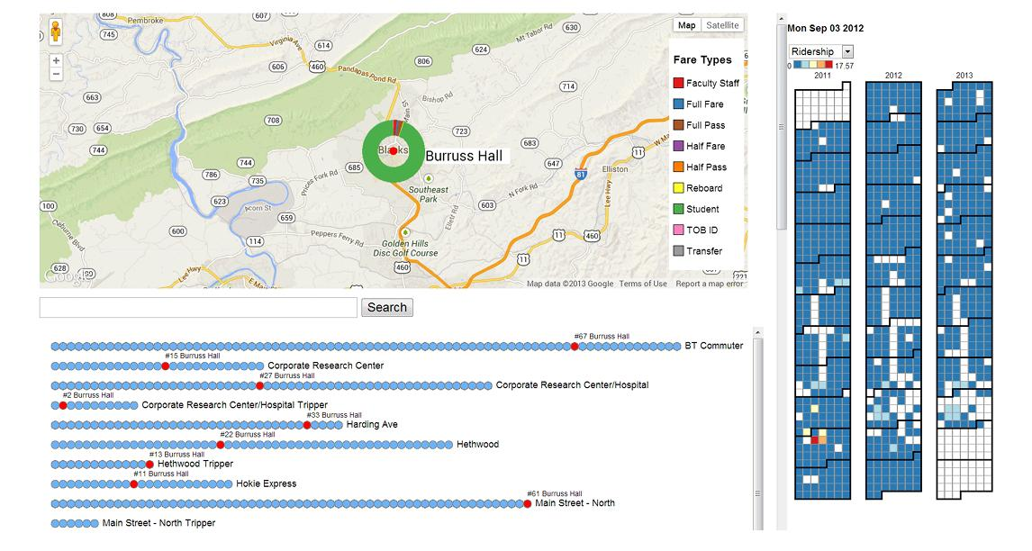

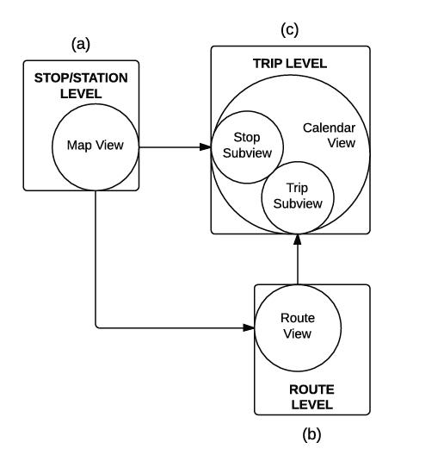**Data Processing**

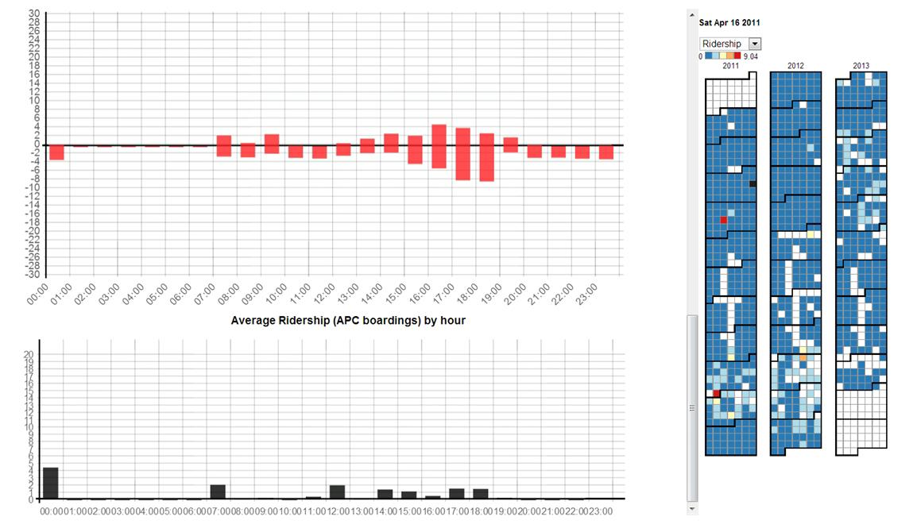**Calendar View**

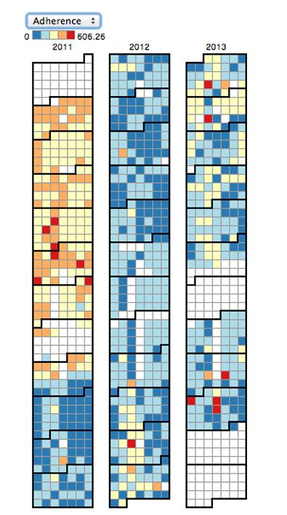**The Stop Subview of Calendar View**

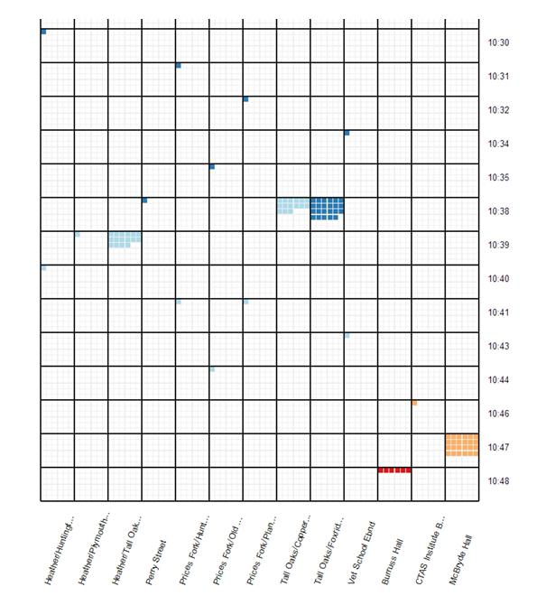**Methodology**

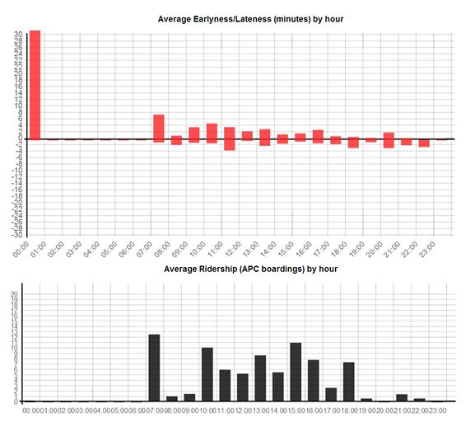

**Results**

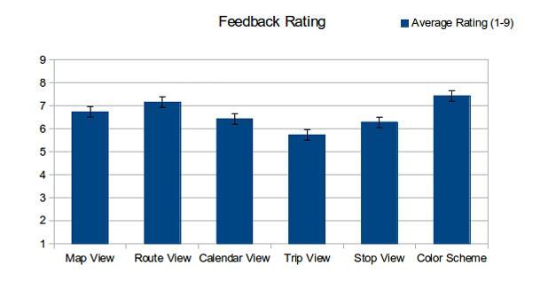

**Dataset Insights :**

* **Introduction:** In the quest for improving public transportation systems, the loading and preprocessing of transportation datasets play a pivotal role. This document provides a concise summary of the key insights and findings related to the loading and preprocessing of datasets for public transportation optimization.
* **Data Collection and Sources:** The initial step in optimizing public transportation systems involves collecting data from various sources, including GPS trackers on vehicles, passenger counts, weather conditions, and traffic data. The integration of data from these sources can be challenging but is essential for making informed decisions.
* **Data Cleaning and Validation:** Cleaning and validating data are critical stages in ensuring the accuracy and reliability of the dataset. This includes handling missing values, outliers, and inconsistencies. A well-defined data cleaning process is crucial to maintain data integrity.
* **Geographic Information Systems (GIS):** GIS technology is indispensable in mapping and geospatial analysis. The incorporation of GIS data allows for efficient route planning, monitoring vehicle locations, and identifying traffic congestion areas.
* **Real-Time Data Streaming:** For dynamic decision-making, real-time data streaming is vital. This can include vehicle tracking, passenger demand, and traffic updates. Proper integration of real-time data enables the system to adapt quickly to changing conditions.
* **Machine Learning Models:** Machine learning models can be applied to predict demand, optimize routes, and manage schedules. These models rely on historical and real-time data to make predictions, ultimately improving system efficiency.
* **User-Friendly Interfaces:** To make the insights accessible to transportation authorities and commuters, user-friendly interfaces should be developed. Visualization tools and mobile applications can display real-time information, including estimated arrival times and service updates.

**Data Loading and Preprocessing Workflows :**

**1.Data Collection and Integration:**

* Gather data from various sources, including GPS trackers, passenger counts, traffic reports, and weather data.
* Integrate data into a centralized repository, ensuring consistent data formats and timestamps.

**2.Data Validation and Cleaning:**

* Validate data for accuracy, consistency, and completeness.
* Clean the data by addressing missing values, outliers, and inconsistencies.
* Standardize data formats and units for consistency.

**3.Geospatial Data Processindat**

* Utilize Geographic Information Systems (GIS) to process geospatial data.
* Geocode addresses to obtain latitude and longitude coordinates.
* Create geospatial indices for efficient route planning.

**4.Real-Time Data Integration:**

* Set up systems to receive and process real-time data streams, including vehicle locations, passenger demand, and traffic conditions.
* Implement data stream processing to analyze incoming real-time information.

**5.Data Transformation and Feature Engineering:**

* Transform and preprocess data for compatibility with machine learning models.
* Engineer relevant features, such as historical traffic patterns and passenger demand.

**6.Machine Learning Integration;**

* Train machine learning models for various tasks, such as demand prediction, route optimization, and scheduling.
* Integrate machine learning predictions into real-time decision-making process InInterface

**7.User-Friendly Interfaces:**

* Develop user-friendly dashboards and mobile applications for transportation authorities and passengers.
* Present real-time information, including estimated arrival times and service updates.
* Implement features for feedback collection and reporting issues.

**8.Performance Monitoring and Feedback Loop:**

* Define key performance metrics, such as on-time performance, vehicle utilization, and passenger satisfaction.
* Continuously monitor system performance and compare it against established benchmarks.
* Collect feedback from passengers and transportation staff to identify areas for improvement.

**9.Optimization and Decision Support:**

* Utilize insights from data preprocessing and analysis to make informed decisions.
* Implement optimization strategies, including dynamic route adjustments and scheduling changes based on real-time data.

**10.Maintenance and Iteration:**

* Regularly maintain data pipelines and machine learning models to ensure data quality and model accuracy.
* Continuously iterate on data loading and preprocessing workflows based on feedback and evolving transportation needs.
* These workflows ensure that data is collected, cleaned, and processed effectively to support the optimization of public transportation systems. They enable transportation authorities to make data-driven decisions, enhance efficiency, and provide improved services to commuters.

**Conclusion:**

* The loading and preprocessing of data are fundamental stages in the pursuit of optimizing public transportation systems. In this process, various data sources, including GPS trackers, passenger counts, and real-time information, are integrated and refined to provide the foundation for data-driven decision-making.
* These are the key takeaways from this important phase:
  1. **Data Integrity:** The collection, validation, and cleaning of data are vital for ensuring data accuracy and reliability. High-quality data is the bedrock upon which optimization efforts are built.
  2. **Geospatial Insight:** Geographic Information Systems (GIS) and geospatial data processing contribute to efficient route planning, precise location tracking, and improved decision-making.
  3. **Real-Time Responsiveness:** Real-time data integration and streaming enable public transportation systems to adapt to changing conditions swiftly, leading to enhanced service reliability.
  4. **Machine Learning for Predictions:** Machine learning models play a pivotal role in predicting demand, optimizing routes, and improving scheduling, ultimately boosting operational efficiency.
  5. **User Accessibility:** User-friendly interfaces, including mobile apps and data visualization tools, make real-time information accessible to both transportation authorities and commuters, thereby improving the passenger experience.
  6. **Feedback Loop:** Performance monitoring, feedback collection, and ongoing optimization are key components for maintaining and improving transportation systems over time.
* In summary, the effective loading and preprocessing of data empower public transportation authorities to make informed decisions, enhance service quality, and adapt to changing circumstances.

**THANK YOU**