**TASK-1**

**Name –** Y. Karthikeya **Section -** 2

**Roll Number –** 2420030351

1. Open Browser on your device.
2. Search for **Cisco Packet tracer download**
3. Go to the link <https://www.netacad.com/cisco-packet-tracer>

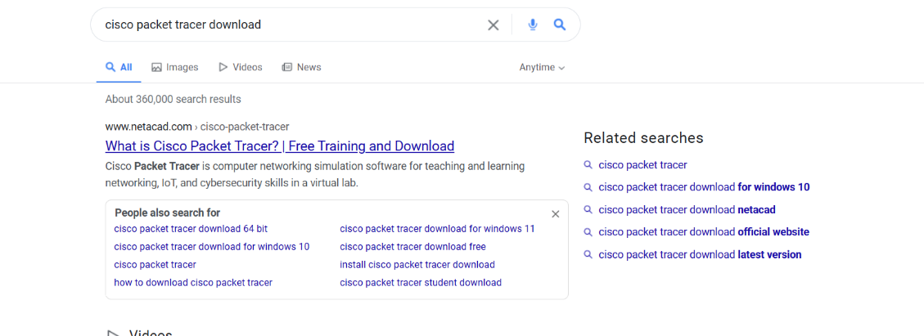

1. In the Start Learning Section, click on **Getting Started with Cisco Packet Tracer**.

1. Click on **Get Started with Self-paced** option

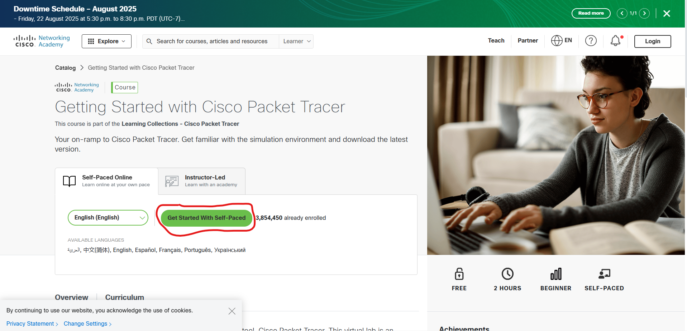

1. Sign-up with your Google account



1. After Sign-up Continue with the course.
2. In the Course Module-1 click on **Download Cisco packet tracer.** You will get the link on the right side of page.

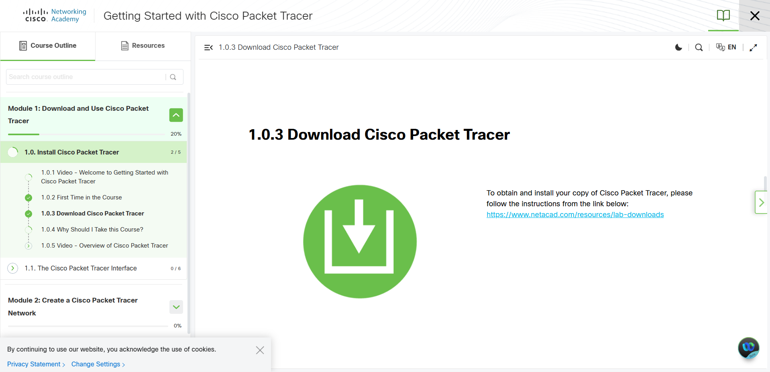

1. Click on the given link and it will show different types of Cisco Packet tracer applications.
2. First appears the Cisco Packet tracer. Click on the link.

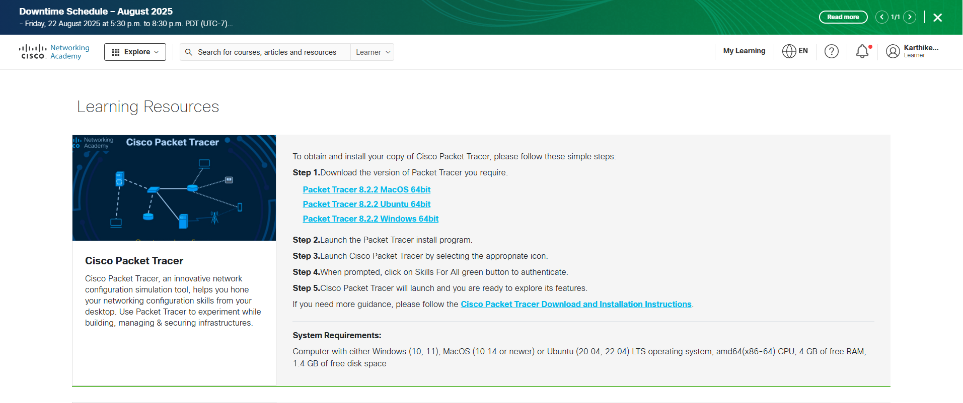

1. After Downloading Cisco Packet tracer on your Device open the application.
2. Click on **Skills for all** option which will appear in green color.

1. It will redirect to your Browser. Enter your Credentials and click on Login.



1. You will be logged in successfully to Cisco Packet Tracer.
2. Open Cisco Packet Tracer, it will appear like this

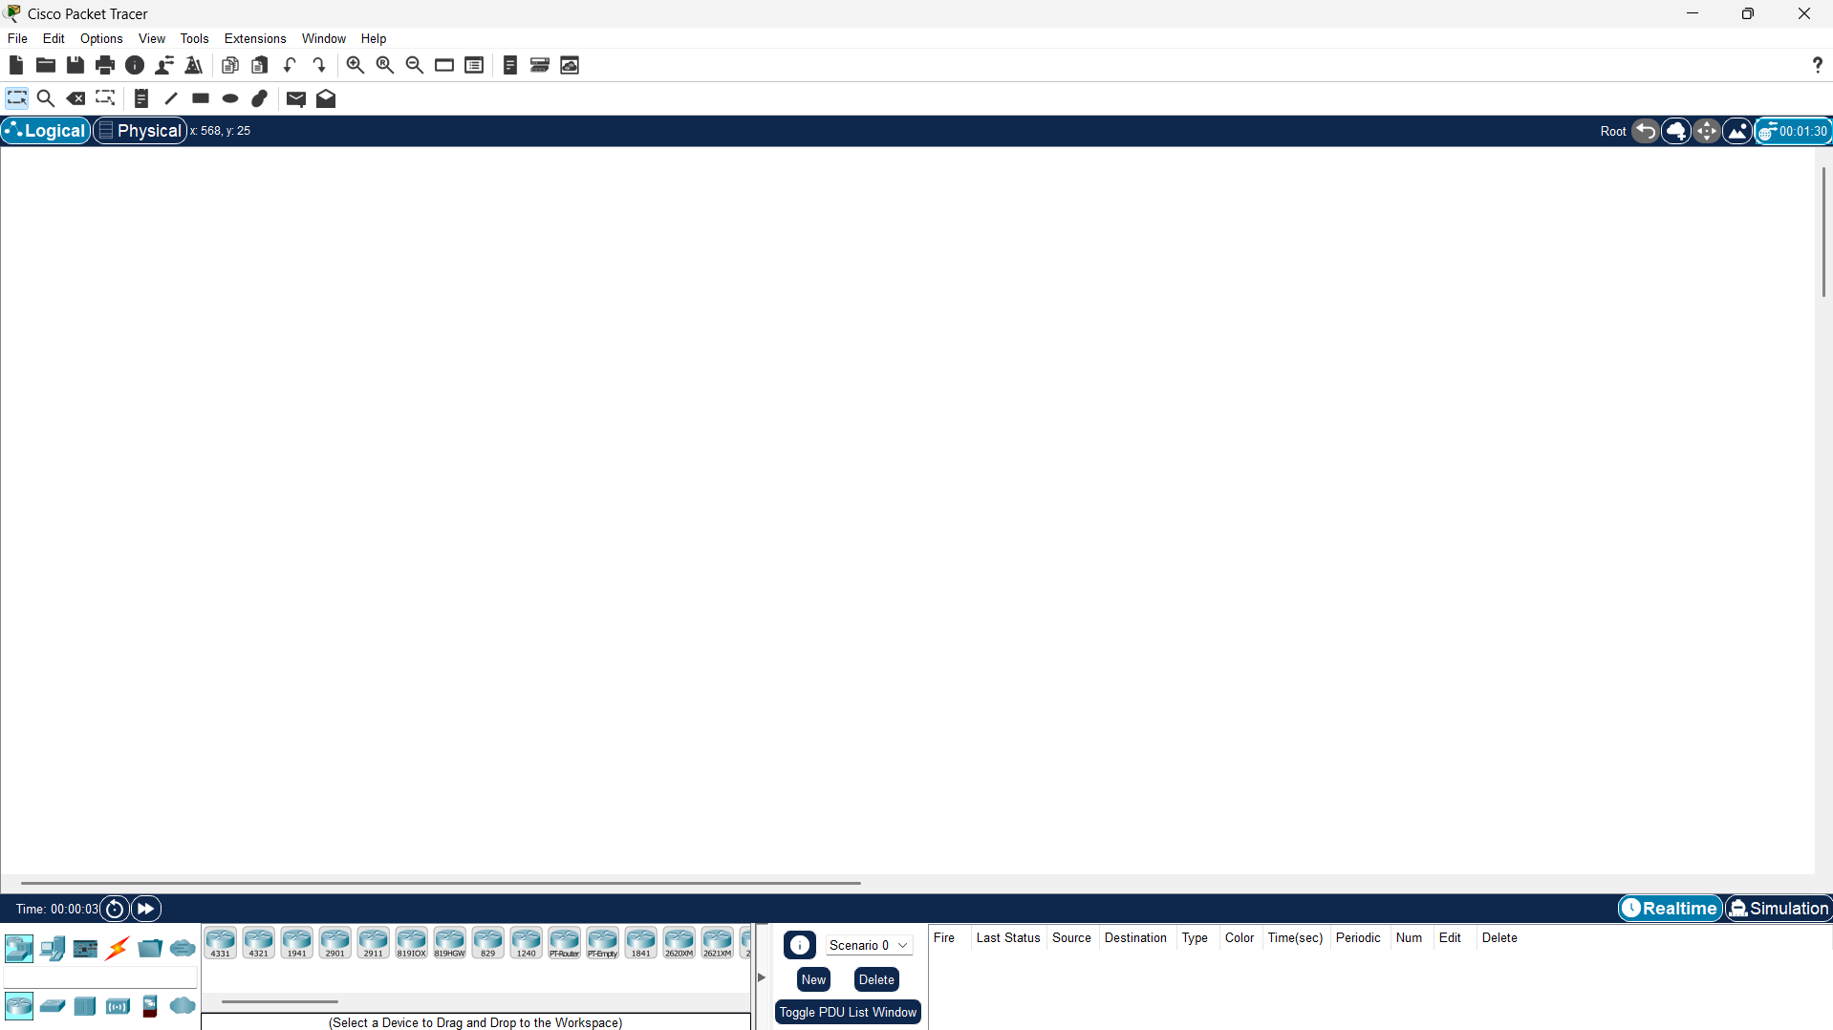

1. Cisco Packet Tracer is installed and opened Successfully.