**TASK-3**

Name: Y. Karthikeya Section-2

Roll no: 2420030351

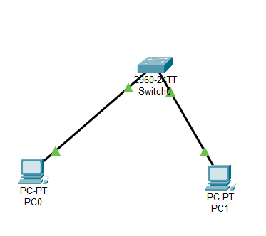

**Step-1:** Launch Cisco Packet Tracer.

Double click the Cisco packet Tracer icon on your Desktop or find it in your applications list and open the program

**Step-2:** Add Devices.

1. Drag and Drop a switch onto the Workspace.
2. Drag and Drop two or more PC’s onto the Workspace

**Step-3:** Connect Devices.

1. Use the connections option and select the Copper Straight Through wire
2. Connect each PC to switch using FastEthernet ports.

**Step-4:** Configure the Switch.

Open the CLI of the Switch and Enter the command.

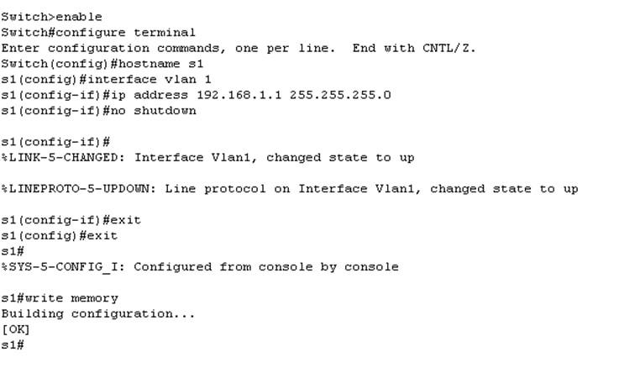

**Step-5:** Configure the PC’s.

1. Click on each PC and open Desktop tab.
2. Go to IP configuration and enter the IP configuration for both PC’s:

PC0:

IP – 192.168.1.2

Subnet – 255.255.255.0

PC1:

IP – 192.168.1.3

Subnet – 255.255.255.0

**Step-6:**  Test Connectivity.

Open Command Prompt in one of the PC’s and enter the ping command to test the connectivity.

