**TASK-6**

**Name –** Y. Karthikeya **Section -** 2

**Roll No -** 2420030351

**Configuration of Network Address translation in Cisco Packet Tracer and verify the configuration**

**`**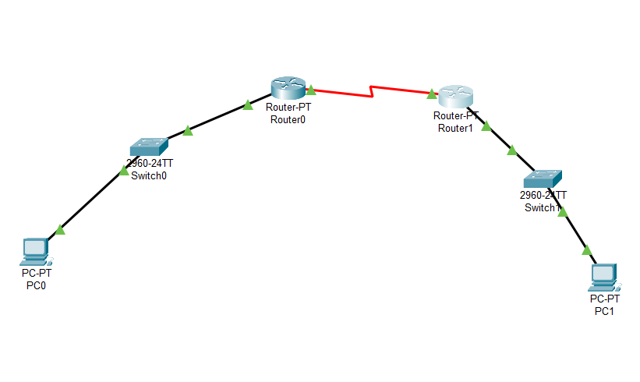

**Step-1 :** Open Cisco Packet Tracer in your device.

**Step-2:** Take two routers and connect them using **Serial DCE** Connecter

**Step-3 :** Take a PC and a Switch and connect Switch0 and router0, Switch0 and PC0 using **copper straight-through wire.**

**Step-4 :** Take a PC and a Switch and connect Switch1 and router1, Switch1 and PC1 using **copper straight-through wire.**

**Step-5 :** Open Router0 and navigate to config and enter the address in it

FastEthernet – 192.162.10.1, Subnet mask – 255.255.255.0

Serial2/0 – 10.10.10.1, Subnet mask – 255.0.0.0

Click on **ON** button in both.

**Step-6 :** Open Router0 and navigate to config and enter the address in it

FastEthernet – 192.162.10.2, Subnet mask – 255.255.255.0

Serial2/0 – 10.10.10.2, Subnet mask – 255.0.0.0

Click on **ON** button in both.

**Step-7 :** Open Router0, go to CLI and enter this.

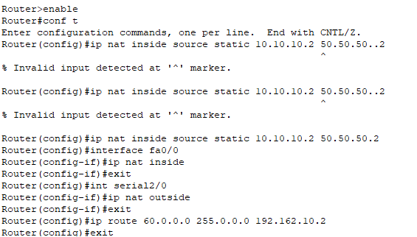

**Step-8 :** Open Router1, go to CLI and enter this

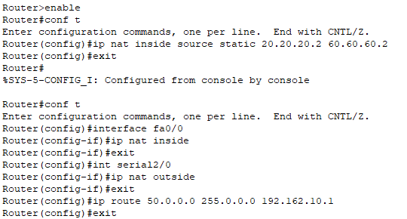

**Step-9 :** Open PC0 and PC1. Go to Desktop and IP configuration.

PC0 – 10.10.10.0

PC1 – 20.20.20.0

**Step-10 :** Check ping for both PC’s through Command Prompt

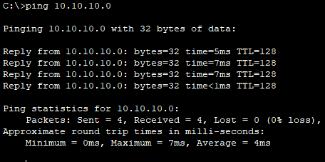

**Step-9 :** Click on Simulation to run it.