**TASK-7**

**Name:** Y Karthikeya **Section:** 2

**Roll Number:** 2420030351

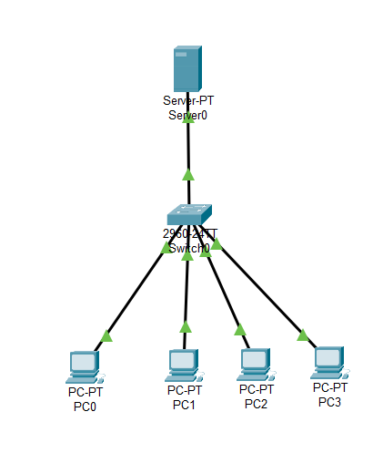

**Step-1: Connect Devices**

1. Take a Server, a Switch and 4 PC’s
2. Connect them using Copper- Straight through wire.

**Step-2: Go to Server**

1. Open Server
2. Go to Services
3. Click on DCHP
4. Enter pool name of your own name and enter start ip address as 10.0.0.0
5. Go to Desktop and click on IP CONFIGURATION
6. Close it

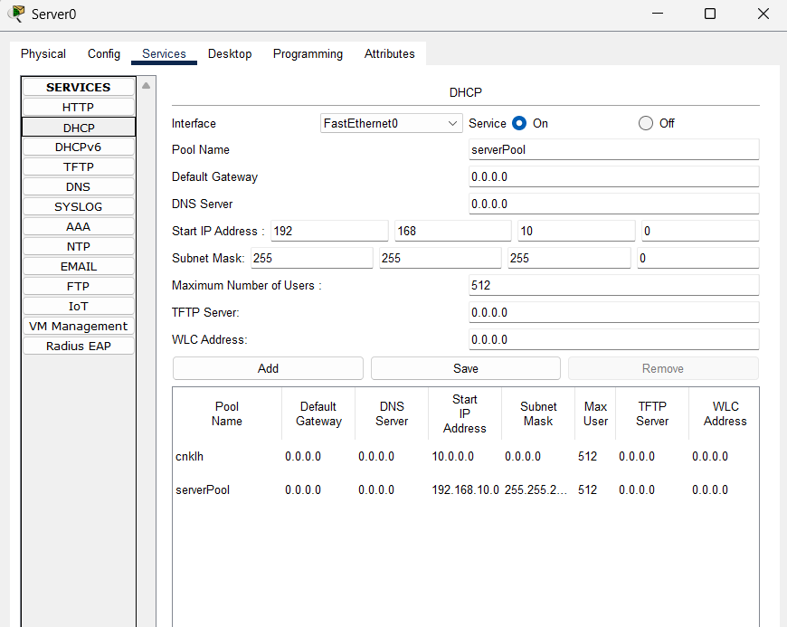

**Step-3: Go to PC’s**

1. Click on all PC’s on by one
2. Go to Desktop and IP Configuration in each PC
3. There you will see a option named DHCP click on that.

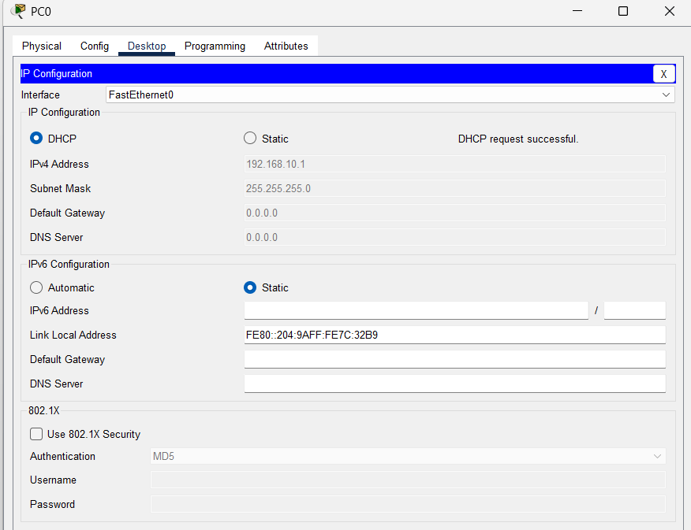

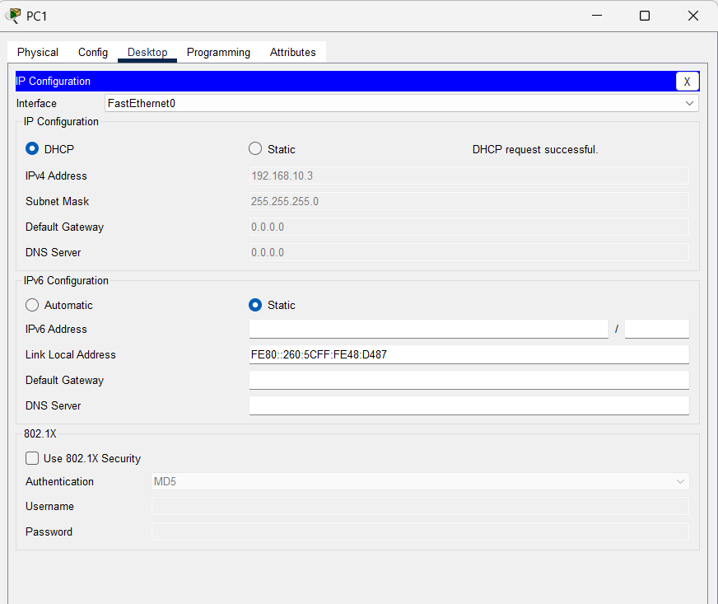

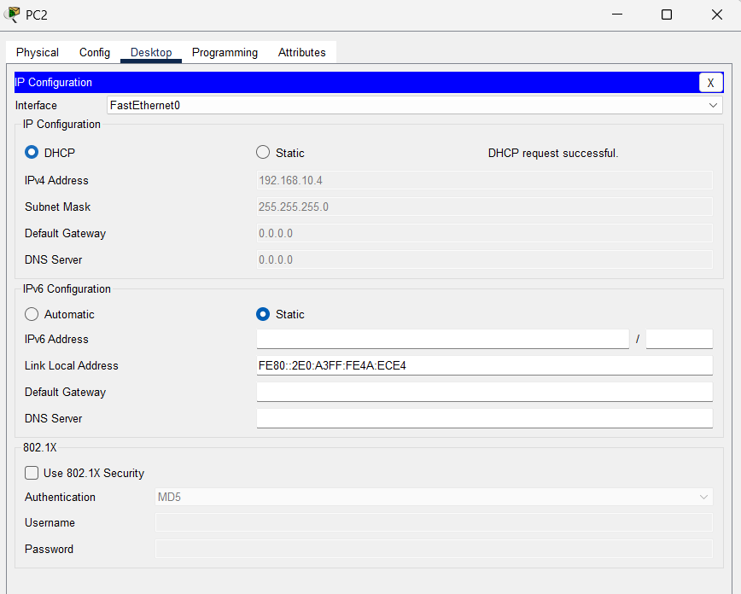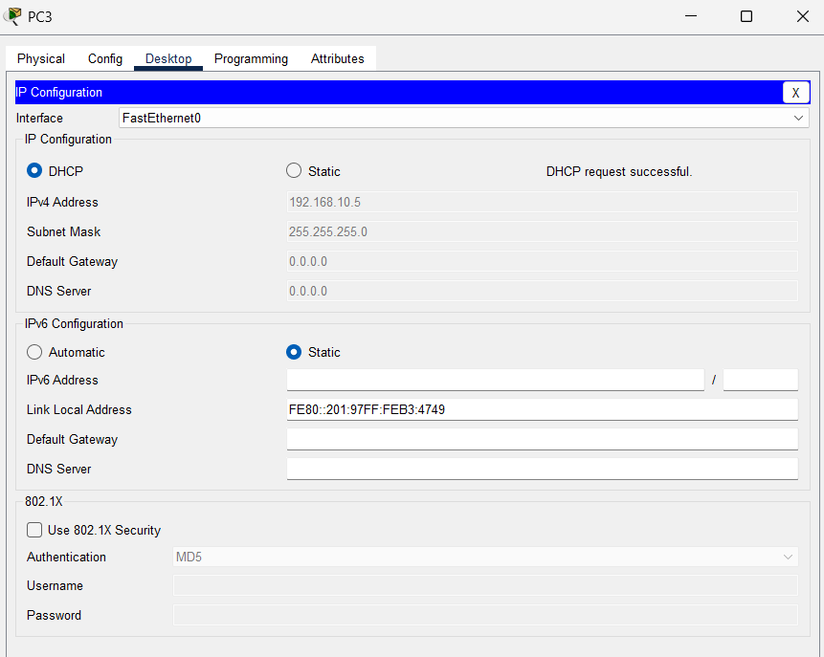

**Step-4: Output**

