**PPS Assignment – 3**

**1)Introduction:**

Our project title is **Hostler’s info interface**, which aims to store the information of students in a particular hostel after that each student information can be displayed individuallyand also all the students in a particular hostel is also displayed based on our requirement.

This can be used by the hostel warden or the hostel management. They can enter the data of the newly joined student, they can view the students info of a particular hostel and individual students with ease. In our project we divided into 4 different hostels–3 Boys hostel(BH-1,BH-2,BH-3) and 1 girls hostel(GH-1).

The main concepts of included in this project are arrays, pointers, functions, files, strings and structures. Even a lot of conditional statements have been used and loops are also included.

This project is evenly contributed and done by:

**N.BHUVAN SWAROOP**(1602-20-737-128)

and

**G.KARTHIKEYA REDDY**(1602-20-737-138)

**2)Functions used in this project:**

**User defined:**

1. void menu() : This is the function which is called at the start of the program. It provides a list of options and the other functions are called upon the user input from the number 1 to 7 using a switch case.
2. void new_entry() : This function is used if the user wants to enter data of a newly joining member to the hostel. It takes the name, roll no., hostel name and other information as input from the user.
3. void edit() : This function is used to change the info of an existing student if there was a mistake previously.
4. void view_list() : This function is used to show the user all the students name, roll no. in every hostel.
5. void erase() : This function is used if there is a student who is leaving the hostel and the user wants to remove his details in the system.
6. void see() : This function is used to show the complete details of a particular student that we want. It takes a roll no. as input and searches the student and shows all his info.
7. void sorter() : This function is used if the user wants to see all the students in a particular hostel. For example giving 1 as input shows the user all the students present in BH-1 hostel.
8. void closer() : This function is used if the user wants to exit the hostel management system.

**Pre-defined:**

1. printf() : To print the info on the screen.
2. scanf() : To take an input from the user
3. fscanf() : The fscanf() function is used to read set of characters from file. It reads a word from the file and returns EOF at the end of file.
4. fprintf() : The fprintf() function is used to write set of characters into file. It sends formatted output to a stream.
5. fopen() : To open a file of our choice and also we can specify the mode we want to open.
6. fclose() : To close the file after it has no use.
7. fseek() : fseek() is used to move file pointer associated with a given file to a specific position. position defines the point with respect to which the file pointer needs to be moved.
8. strcmp() : Used to compare two strings and returns 0 if both are equal.
9. strcpy() : It is used to copy one string to another string.

**3)Project code:**

#include<stdio.h>

#include<stdlib.h>

#include<string.h>

int i,j,main_exit;

void menu();

void new_entry();

void edit();

void view_list();

void erase();

void see();

void sorter();

void closer();

struct date{

int month,day,year;

};

struct {

char name[60];

int age;

char city[60];

char mail_id[30];

char room_no[8];

char father_name[60];

long father_phone;

long phone;

char hostel_name[6];

char roll_no[10];

struct date dob;

}add,upd,check,rem,sort;

int main()

{

menu();

return 0;

}

void menu()

{

system("clear");

int choice;

printf("\n\n\t\t\tHOSTEL MANAGEMENT SYSTEM");

printf("\n\n\n\t\t\xB2\xB2\xB2\xB2\xB2\xB2\xB2 WELCOME TO THE MAIN MENU \xB2\xB2\xB2\xB2\xB2\xB2\xB2");

printf("\n\n\t\t1>> Enter new Student's data\n\t\t2>> Update information of existing account\n\t\t3>> Check the details of existing account\n\t\t4>> View all Students of a particlar Hostel\n\t\t5>> Removing existing account\n\t\t6>> View all students list\n\t\t7>> Exit\n\n\n\n\n\t\t Enter your choice:");

scanf("%d",&choice);

switch(choice)

{

case 1:new_entry();

break;

case 2:edit();

break;

case 3:see();

break;

case 4:sorter();

break;

case 5:erase();

break;

case 6:view_list();

break;

case 7:closer();

break;

default:menu();

break;

}

}

void sorter()

{

int choice,test=0;

long size=1;

printf("Enter your choice:\n\n\t\t >>1. BH-1 \n\t\t >>2. BH-2 \n\t\t >>3. BH-3 \n\t\t >>4. GH-1 \n\n");

printf("Enter a number between 1 to 4\n\n");

scanf("%d",&choice);

FILE *fp, *hostel;

switch(choice)

{

case 1: hostel=fopen("BH-1.dat","a+");break;

case 2: hostel=fopen("BH-2.dat","a+");break;

case 3: hostel=fopen("BH-3.dat","a+");break;

case 4: hostel=fopen("GH-1.dat","a+");break;

default: sorter();break;

}

while(fscanf(hostel,"%s\n",check.roll_no)!=EOF)

{

fp=fopen("record.dat","r");

while(fscanf(fp,"%s %s %d/%d/%d %d %s %ld %s %s %ld %s %s\n",sort.roll_no, sort.name, &sort.dob.month, &sort.dob.day, &sort.dob.year, &sort.age, sort.city, &sort.phone, sort.mail_id, sort.father_name, &sort.father_phone, sort.room_no, sort.hostel_name)!=EOF)

{

if(strcmp(check.roll_no,sort.roll_no)==0)

{

if(test==0)

{

printf("\t\tFollowing is the list of requested students:");

printf("\n\tROLL NO.\tROOM NO.\tNAME\n");

}

printf("\n %8s\t %8s\t \t%s", sort.roll_no, sort.room_no, sort.name);

test++;

}

}

}

if (test==0)

printf("\nNO RECORDS!!\n");

fclose(hostel);

sort_list_invalid:

printf("\n\nEnter 1 to go to the main menu and 0 to exit:");

scanf("%d",&main_exit);

if (main_exit==1)

menu();

else if(main_exit==0)

closer();

else

{

printf("\nInvalid!\a");

goto sort_list_invalid;

}

}

void new_entry()

{

int choice;

FILE *ptr,*hostel;

ptr=fopen("record.dat","a+");

roll_no:

printf("\t\t\t\xB2\xB2\xB2 ADD STUDENTS DATA \xB2\xB2\xB2\xB2");

printf("\nEnter your roll number:");

scanf("%s",check.roll_no);

while(fscanf(ptr,"%s %s %d/%d/%d %d %s %ld %s %s %ld %s %s\n",add.roll_no, add.name, &add.dob.month, &add.dob.day, &add.dob.year, &add.age, add.city, &add.phone, add.mail_id, add.father_name, &add.father_phone, add.room_no, add.hostel_name)!=EOF)

{

if (strcmp(check.roll_no,add.roll_no)==0)

{printf("Students roll no. already in use!");

goto roll_no;

}

}

strcpy(add.roll_no,check.roll_no);

printf("\nEnter the name(without spaces):");

scanf("%s",add.name);

printf("\nEnter the date of birth(mm/dd/yyyy):");

scanf("%d/%d/%d",&add.dob.month,&add.dob.day,&add.dob.year);

printf("\nEnter the age:");

scanf("%d",&add.age);

printf("\nEnter the city:");

scanf("%s",add.city);

printf("\nEnter the phone number: ");

scanf("%ld",&add.phone);

printf("\n Enter your email id :");

scanf("%s",add.mail_id);

printf("\n Enter your Father's name(without spaces):");

scanf("%s",add.father_name);

printf("\n Enter your Father's phone no.:");

scanf("%ld",&add.father_phone);

printf("\n Enter your room no.:");

scanf("%s",add.room_no);

printf("\n Enter your hostel name from BH-1, BH-2, BH-3, GH-1 :");

scanf("%s",add.hostel_name);

fprintf(ptr,"%s %s %d/%d/%d %d %s %ld %s %s %ld %s %s\n",add.roll_no, add.name, add.dob.month, add.dob.day, add.dob.year, add.age, add.city, add.phone, add.mail_id, add.father_name, add.father_phone, add.room_no, add.hostel_name);

if(strcmp(add.hostel_name,"BH-1")==0)

{

hostel=fopen("BH-1.dat","a+");

fprintf(hostel, "%s\n", add.roll_no);

fclose(hostel);

}

else if(strcmp(add.hostel_name,"BH-2")==0)

{

hostel=fopen("BH-2.dat","a+");

fprintf(hostel, "%s\n", add.roll_no);

fclose(hostel);

}

else if(strcmp(add.hostel_name,"BH-3")==0)

{

hostel=fopen("BH-3.dat","a+");

fprintf(hostel, "%s\n", add.roll_no);

fclose(hostel);

}

else if(strcmp(add.hostel_name,"GH-1")==0)

{

hostel=fopen("GH-1.dat","a+");

fprintf(hostel, "%s\n", add.roll_no);

fclose(hostel);

}

fclose(ptr);

printf("\nStudent added successfully!");

add_invalid:

printf("\n\n\n\t\tEnter 1 to go to the main menu and 0 to exit:");

scanf("%d",&main_exit);

if (main_exit==1)

menu();

else if(main_exit==0)

closer();

else

{

printf("\nInvalid!\a");

goto add_invalid;

}

}

void view_list()

{

FILE *view;

view=fopen("record.dat","a+");

int test=0;

long size;

printf("\n ROLL NO.\t NAME\t\t\t city\t\t\t PHONE\n");

while(fscanf(view,"%s %s %d/%d/%d %d %s %ld %s %s %ld %s %s\n",add.roll_no, add.name, &add.dob.month, &add.dob.day, &add.dob.year, &add.age, add.city, &add.phone, add.mail_id, add.father_name, &add.father_phone, add.room_no, add.hostel_name)!=EOF)

{

printf("\n%6s\t %13s\t\t\t%6s\t\t %16ld",add.roll_no,add.name,add.city,add.phone);

test++;

}

fclose(view);

if (test==0)

{

printf("\nNO RECORDS!!\n");}

view_list_invalid:

printf("\n\nEnter 1 to go to the main menu and 0 to exit:");

scanf("%d",&main_exit);

if (main_exit==1)

menu();

else if(main_exit==0)

closer();

else

{

printf("\nInvalid!\a");

goto view_list_invalid;

}

}

void see()

{

FILE *ptr;

int test=0;

int choice;

ptr=fopen("record.dat","a+");

printf("Do you want to check by\n1.Roll no\n2.Name\nEnter your choice:");

scanf("%d",&choice);

if (choice==1)

{ printf("\n\nEnter the roll number:");

scanf("%s",check.roll_no);

while (fscanf(ptr,"%s %s %d/%d/%d %d %s %ld %s %s %ld %s %s\n",add.roll_no, add.name, &add.dob.month, &add.dob.day, &add.dob.year, &add.age, add.city, &add.phone, add.mail_id, add.father_name, &add.father_phone, add.room_no, add.hostel_name)!=EOF)

{

if(strcmp(add.roll_no,check.roll_no)==0)

{

test=1;

printf("\nROLL NO.:%s\nName:%s \nDOB:%d/%d/%d \nAge:%d \ncity:%s \nPhone number:%ld \nE-Mail id:%s \nFather's name:%s \n Father's Phone No.:%ld \nRoom No:%s \nHostel:%s \n",add.roll_no, add.name, add.dob.month, add.dob.day, add.dob.year, add.age, add.city, add.phone, add.mail_id, add.father_name, add.father_phone, add.room_no, add.hostel_name);

}

}

}

else if (choice==2)

{ printf("\n\nEnter the name:");

scanf("%s",check.name);

while (fscanf(ptr,"%s %s %d/%d/%d %d %s %ld %s %s %ld %s %s\n",add.roll_no, add.name, &add.dob.month, &add.dob.day, &add.dob.year, &add.age, add.city, &add.phone, add.mail_id, add.father_name, &add.father_phone, add.room_no, add.hostel_name)!=EOF)

{

if(strcmp(add.name,check.name)==0)

{

test=1;

printf("\nROLL NO.:%s\nName:%s \nDOB:%d/%d/%d \nAge:%d \ncity:%s \nPhone number:%ld \nE-Mail id:%s \nFather's name:%s \n Father's Phone No.:%ld \nRoom No:%s \nHostel:%s \n",add.roll_no, add.name, add.dob.month, add.dob.day, add.dob.year, add.age, add.city, add.phone, add.mail_id, add.father_name, add.father_phone, add.room_no, add.hostel_name);

}

}

}

fclose(ptr);

if(test!=1)

printf("\nRecord not found!!\a\a\a");

see_invalid:

printf("\nEnter 0 to try again,1 to return to main menu and 2 to exit:");

scanf("%d",&main_exit);

if (main_exit==1)

menu();

else if (main_exit==2)

closer();

else if(main_exit==0)

see();

else

{

printf("\nInvalid!\a");

goto see_invalid;

}

}

void edit()

{

int choice,test=0;

FILE *old,*newrec;

old=fopen("record.dat","a+");

newrec=fopen("new.dat","w");

printf("\nEnter the roll no. of the student whose info you want to change:");

scanf("%s",upd.roll_no);

while(fscanf(old,"%s %s %d/%d/%d %d %s %ld %s %s %ld %s %s\n",add.roll_no, add.name, &add.dob.month, &add.dob.day, &add.dob.year, &add.age, add.city, &add.phone, add.mail_id, add.father_name, &add.father_phone, add.room_no, add.hostel_name)!=EOF)

{

if (strcmp(add.roll_no,upd.roll_no)==0)

{ test=1;

printf("\nWhich information do you want to change?\n1.Room no.\n2.Phone\n\nEnter your choice(1 for room no. and 2 for phone ):");

scanf("%d",&choice);

if(choice==1)

{printf("Enter the new room no.:");

scanf("%s",upd.room_no);

fprintf(newrec,"%s %s %d/%d/%d %d %s %ld %s %s %ld %s %s\n",add.roll_no, add.name, add.dob.month, add.dob.day, add.dob.year, add.age, add.city, add.phone, add.mail_id, add.father_name, add.father_phone, upd.room_no, add.hostel_name);

printf("Changes saved!");

}

else if(choice==2)

{

printf("Enter the new phone number:");

scanf("%ld",&upd.phone);

fprintf(newrec,"%s %s %d/%d/%d %d %s %ld %s %s %ld %s %s\n",add.roll_no, add.name, add.dob.month, add.dob.day, add.dob.year, add.age, add.city, upd.phone, add.mail_id, add.father_name, add.father_phone, add.room_no, add.hostel_name);

printf("Changes saved!");

}

}

else

fprintf(newrec,"%s %s %d/%d/%d %d %s %ld %s %s %ld %s %s\n",add.roll_no, add.name, add.dob.month, add.dob.day, add.dob.year, add.age, add.city, add.phone, add.mail_id, add.father_name, add.father_phone, add.room_no, add.hostel_name);

}

fclose(old);

fclose(newrec);

remove("record.dat");

rename("new.dat","record.dat");

if(test!=1)

printf("\nRecord not found!!\a\a\a");

edit_invalid:

printf("\nEnter 0 to try again,1 to return to main menu and 2 to exit:");

scanf("%d",&main_exit);

if (main_exit==1)

menu();

else if (main_exit==2)

closer();

else if(main_exit==0)

edit();

else

{

printf("\nInvalid!\a");

goto edit_invalid;

}

}

void erase()

{

FILE *old,*newrec;

int test=0;

old=fopen("record.dat","a+");

newrec=fopen("new.dat","w");

printf("Enter the roll no. of student whose data you want to delete:");

scanf("%s",rem.roll_no);

while (fscanf(old,"%s %s %d/%d/%d %d %s %ld %s %s %ld %s %s\n",add.roll_no, add.name, &add.dob.month, &add.dob.day, &add.dob.year, &add.age, add.city, &add.phone, add.mail_id, add.father_name, &add.father_phone, add.room_no, add.hostel_name)!=EOF)

{

if(strcmp(add.roll_no,rem.roll_no)==0)

{

test++;

printf("\nRecord deleted successfully!\n");

}

else

fprintf(newrec,"%s %s %d/%d/%d %d %s %ld %s %s %ld %s %s\n",add.roll_no, add.name, add.dob.month, add.dob.day, add.dob.year, add.age, add.city, add.phone, add.mail_id, add.father_name, add.father_phone, add.room_no, add.hostel_name);

}

fclose(old);

fclose(newrec);

remove("record.dat");

rename("new.dat","record.dat");

if(test==0)

printf("\nRecord not found!!\a\a\a");

erase_invalid:

printf("\nEnter 0 to try again,1 to return to main menu and 2 to exit:");

scanf("%d",&main_exit);

if (main_exit==1)

menu();

else if (main_exit==2)

closer();

else if(main_exit==0)

erase();

else

{

printf("\nInvalid!\a");

goto erase_invalid;

}

}

void closer()

{

printf("\n\n\n\nProject by Bhuvan and Karthikeya\n\n\n");

}

**4)Test Cases:**

1. Main menu: 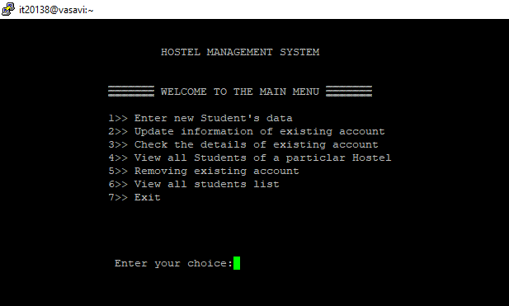

No student’s data at the start:

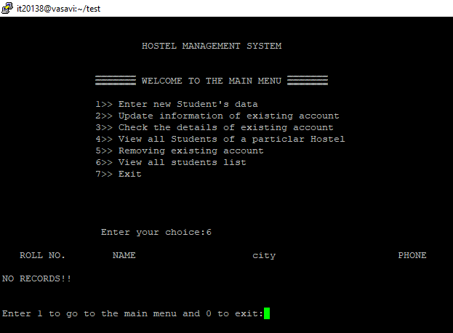

1. Adding new Student’s data:

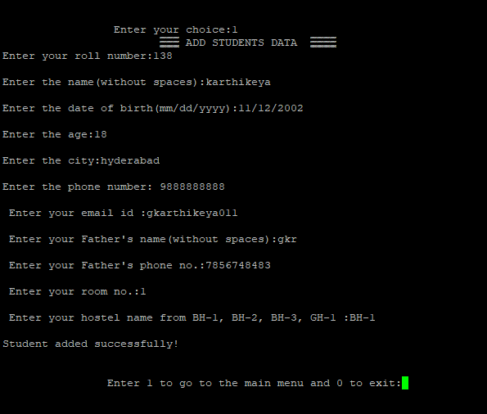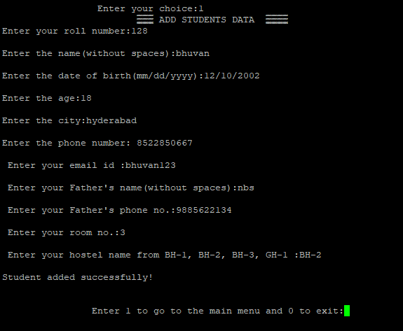

1. Updating the information of an existing student account:

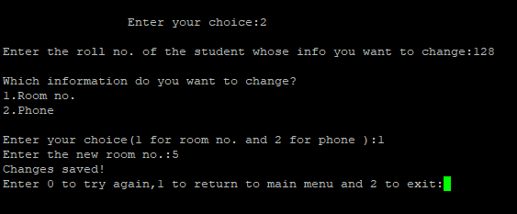

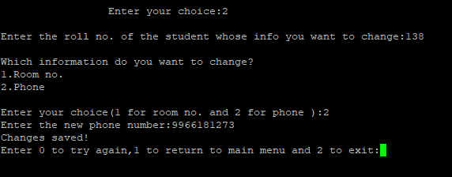

1. Checking details of an account through roll no. or name:

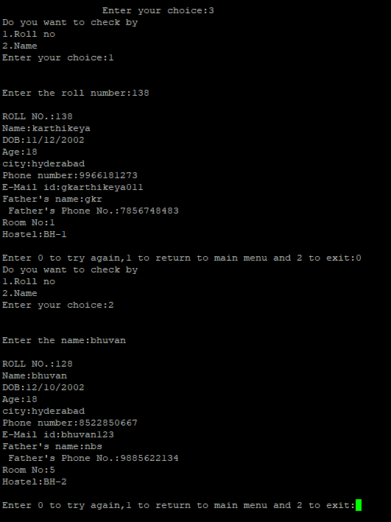

1. View students of a particular hostel:

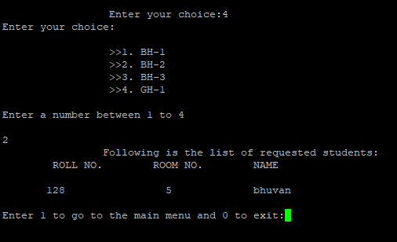

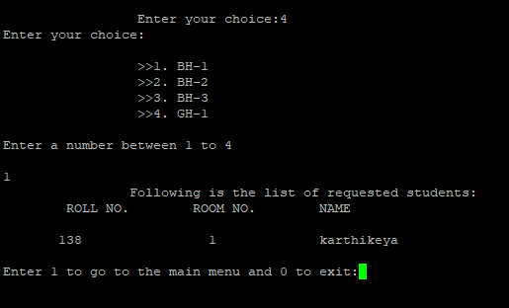

1. View the list of all the students in every hostel:

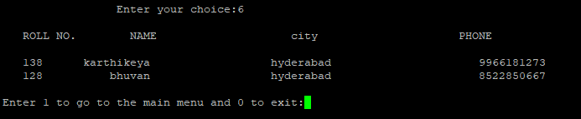

1. Removing an existing account:

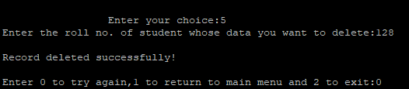

Viewing all the students after deleting the above student data:

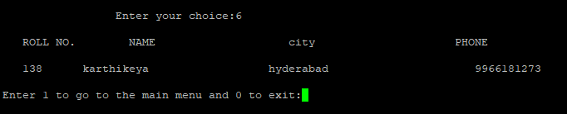

1. To exit:

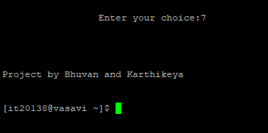

**5)What we have learned from the project:**

We learned a lot about the files concept. How files are used to store data. Normally after execution of a program the data is not stored anywhere with the help of files we stored the data given by the user to create a management system.

Structures concept also really came in handy. Instead of declaring variables of different types and consuming lot of space structures were used to overcome this and it is also global so all the functions had access and it was easy to use.

Also string handling functions, conditional statements and loops were used to manipulate the way of how data is stored on each file.

**6)Conclusion:**

This project was really helpful for us to understand how much of the C language concepts we have been good at. We got to know our strengths and weaknesses in the course.

**7)Future scope:**

In the near future, we would like to carry forward the project by adding much more concepts and make that as a good application.