
Department of Computer Science and Engineering
ALGORITHMIC PROBLEM-SOLVING HACKATHON (APSH 2026)
PROJECT DOCUMENTATION
Date: 03-10-2026 | Venue: 3rd Floor, A & B Blocks
Field | Details
Project Title | Sudoku Solver Arena – Interactive Sudoku Solver with Step-by-Step Backtracking Visualization (Problem 9)
Team Name / Team No. | Team No. 6
Year / Semester / Section | II Year B.Tech / III Sem / E
Algorithm Paradigm Used | Backtracking (with Constraint Checking and the MRV heuristic)
Programming Language / Tools | Python 3 (solver, Streamlit), HTML / CSS / JavaScript (interactive UI and in-browser solver), Streamlit Community Cloud, unittest. Live app: https://sudokugit-vdbwd5hqkkzqxwuwtkq8rw.streamlit.app/
Faculty Mentor | Mamatha
Team Members
S.No | Name of the Student | Roll No. | Role
1 | D. Karthikeya Reddy | 25MVCSMR0389 | Team Lead
2 | G. Charan Tej Reddy | 25MVCSMR0393 | Algorithm Design
3 | B. Ruthwik | 25MVCSMR0377 | UI & Visualization
4 | Gopal Krishna | 25MVCSMR0437 | Testing & Docs

1. Problem Statement
Sudoku is a 9x9 constraint-satisfaction puzzle: every row, every column and every 3x3 box must contain each digit 1 to 9 exactly once. The task (Problem 9) is to build an interactive Sudoku solver that accepts puzzles, validates the entries and visualizes the backtracking process step by step, so that a user can see not only the answer but how the algorithm reached it.
Inputs
- A 9x9 grid of 81 cells: digits 1-9 are given clues; 0 or "." marks a blank. The puzzle can be typed into the grid, pasted as text, or chosen from 8 built-in puzzles.
- Choice of algorithm (plain backtracking or backtracking with MRV) and a search limit (maximum number of digit placements).
Outputs
- Validation result: conflicting cells are highlighted in red and solving is blocked until they are fixed.
- The completed grid, or a clear message that the puzzle has no solution or that the search limit was reached.
- A replayable trace of every decision (place / backtrack) with its cell, digit, legal candidates and depth, plus metrics: placements, backtracks, constraint checks and time.
Constraints
- The given clues must never be changed, and a digit may not repeat in any row, column or 3x3 box.
- Sudoku generalised to n² x n² boards is NP-complete, so the search must be pruned and bounded by a limit (default 100 million placements).
2. Objectives
- Solve correctly: implement backtracking with constraint checking after every decision and undo any choice that makes a valid solution impossible.
- Validate and accept input: reject malformed text, highlight duplicate clues, and support typed, pasted and built-in puzzles.
- Visualize the search: show each placement and backtrack step by step (play, pause, step, scrub) with the candidates considered at every cell.
- Compare approaches: measure plain backtracking against backtracking with the MRV heuristic on easy, hard and extreme puzzles using placements, backtracks and checks.
3. Proposed Approach
Paradigm: Backtracking. Sudoku is a constraint-satisfaction problem. A solution is built one cell at a time; after every placement the row, column and box constraints are checked, and as soon as a partial grid cannot be completed the last choice is undone and the next digit is tried. Because an invalid partial grid is abandoned immediately, whole subtrees of the 9^{m} possible fillings (m = number of blank cells) are never explored.
Two strategies are implemented and compared:
- Plain backtracking always fills the first empty cell in row-major order and tries digits 1 to 9. It is simple and easy to follow, but it can commit to a cell with many options while a later cell has none, and then wastes millions of steps inside a doomed branch.
- Backtracking + MRV (Minimum Remaining Values) always fills the empty cell that has the fewest legal digits. A cell with one candidate is a forced move; a cell with zero candidates exposes a dead end immediately ("fail first"). This keeps the search tree very small.
Alternatives considered. Brute-force enumeration of all 9^{m} fillings is infeasible. Knuth's Dancing Links (Algorithm X) is faster but hides the individual decisions that this project must visualize. Pure human-style logic (naked / hidden singles) cannot solve every puzzle without guessing. Dynamic programming and branch and bound do not fit, because Sudoku has no optimal-substructure or objective to bound, only constraints. Backtracking was therefore chosen because it matches the problem statement and makes every decision visible.
4. Algorithm / Pseudocode
Pseudocode
SOLVE(board, strategy):
if board has duplicate digits in any row/column/box: return INVALID
rows[], cols[], boxes[] <- bit-masks of the digits already used
return SEARCH(depth = 0)

SEARCH(depth):
cell <- PICK(strategy)
if cell = NONE: return TRUE // no empty cell left: solved
mask <- ~(rows[r] | cols[c] | boxes[b]) & 0x3FE // legal digits of cell
for v <- 1 to 9:
checks <- checks + 1
if v not in mask: continue // constraint check
if placements >= LIMIT: abort (limit reached)
place v in cell; update rows/cols/boxes; placements++; record PLACE
if SEARCH(depth + 1): return TRUE
remove v from cell; restore masks; backtracks++; record BACKTRACK
return FALSE // dead end: caller backtracks

PICK(plain): scan row-major and return the first empty cell
PICK(MRV): for every empty cell count the legal digits in its mask;
return the cell with the smallest count (stop early if count <= 1)

The browser version runs the same logic with an explicit stack (arrays holding the chosen cell, its remaining untried digits and the last digit tried at each depth) instead of recursion. The search can then run in short time slices, so the page stays responsive and shows progress with a Cancel button.
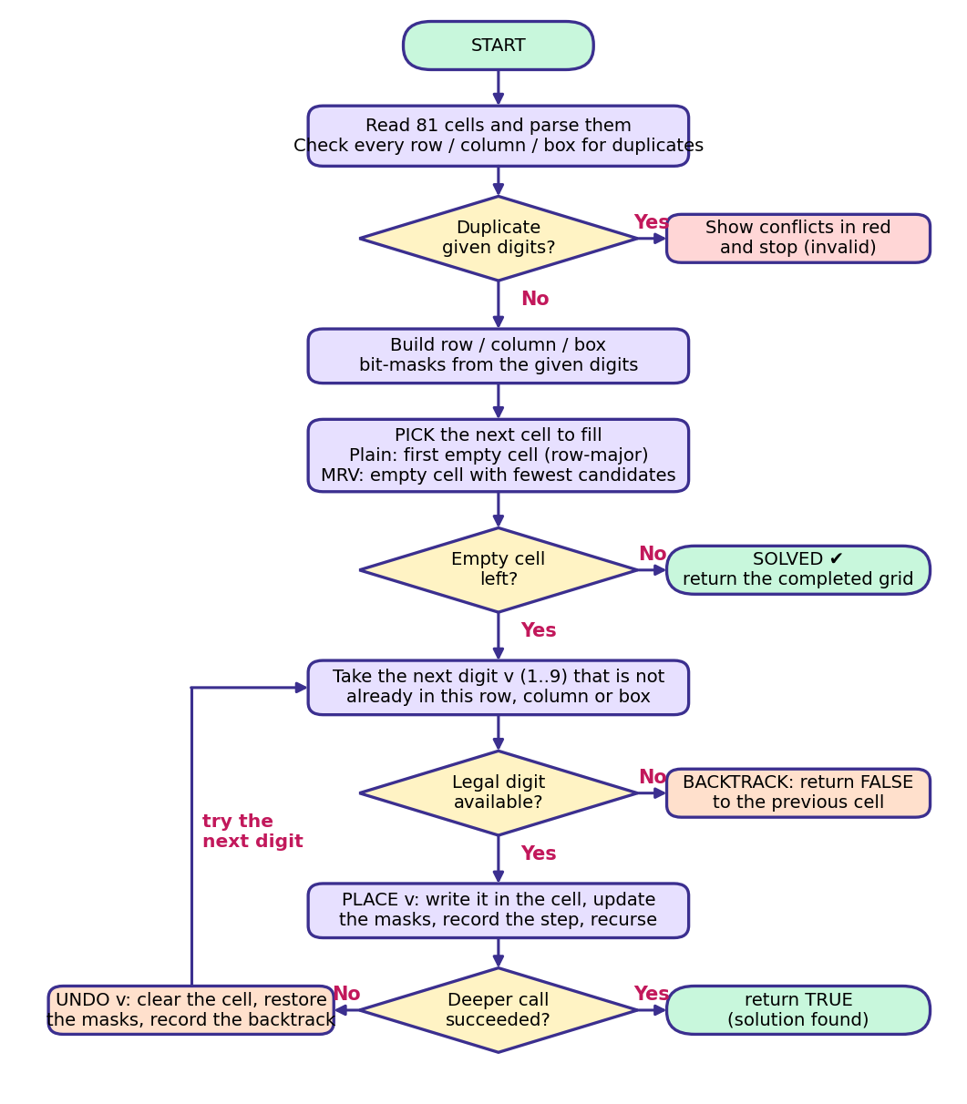
Figure 1: Flowchart of the backtracking solver (cell selection differs between plain and MRV).
5. Complexity Analysis
Let m be the number of blank cells (m <= 64 for valid puzzles with at least 17 clues; the board has 81 cells). At each of the m levels at most 9 digits are tried, and each digit is checked against the row, column and box in O(1) with bit-masks.
Complexity | Best Case | Average Case | Worst Case
Time | O(m) with no backtracking (MRV on Easy / Medium: 49-51 placements) | Exponential but heavily pruned: 200 to 69 million placements (plain) and 49 to 58,233 (MRV) on our 8 puzzles | O(9^{m}) placements (each costing O(1) for plain, O(81) for MRV cell selection)
Space | O(m) recursion / stack depth | O(m) | O(m)
Justification. Time: in the best case every placement is legal and no backtracking happens, so the work is linear in the m blank cells (plain: O(9m) digit checks; MRV: each step also scans at most 81 cells, still O(m) for a fixed board). In the worst case every cell may try all nine digits before failing, giving O(9^{m}). Pruning by constraint checking makes the average far smaller, and the MRV heuristic lowers it further (Section 7).
Space: the recursion depth (or explicit stack) never exceeds m <= 81 frames, and the three bit-mask arrays hold 27 integers, so the algorithm itself needs O(m) space. The optional replay trace is capped at 20,000 steps.
6. Implementation
Modules
File | Role
solver.py | Core algorithms with no UI dependency: parse_puzzle, find_conflicts, candidates, and solve for both strategies. Records every decision as a Step (action, row, col, value, depth) and returns a Result with counts and timing.
web/index.html | The interactive interface and in-browser solver: puzzle panels, grid editor with colour number pad, validation, step-by-step player, comparison tab, search limit, dark mode.
app.py | Streamlit launcher that serves the interface (this is the deployed app).
app_classic.py | Original Streamlit interface that uses solver.py directly (visualizer and comparison).
tests/test_solver.py | Six unit tests covering samples, known solution, unsolvable grid, validation, candidates and the search limit.

Data structures
- Board: a 9x9 array of digits (list of lists in Python, Int8Array in JavaScript); 0 means blank.
- Bit-masks: three arrays of 9 integers (rows, columns, boxes) in which bit v is set when digit v is used. Legal digits of a cell = ~(rows | cols | boxes) & 0x3FE, so each constraint check is O(1).
- Explicit search stack (cell, remaining-digit mask, last digit per depth) for the time-sliced solver, and a trace list of Step records capped at 20,000 for replay.
- Result cache keyed by puzzle and search limit, so the comparison tab does not repeat work.
Main features
- Validation with red conflict highlighting, 8 built-in puzzles (Easy to Extreme), a Custom puzzle panel with grid editor, number pad (with remaining-count per digit) and paste box.
- Step-by-step player: slider, play / pause, step back and forward, speed control, "Jump to solution"; each step lists the cell, its legal candidates and the depth. Placed cells are yellow, backtracked cells orange.
- Compare tab with placements, backtracks, checks, time, bar charts, and a check that both algorithms reach the same solution.
- Adjustable search limit (500 thousand to 1 billion placements) with live progress and Cancel; light and dark themes.
Tools and platform
Python 3, Streamlit (deployed on Streamlit Community Cloud), HTML / CSS / JavaScript, unittest. Live application: https://sudokugit-vdbwd5hqkkzqxwuwtkq8rw.streamlit.app/
7. Results and Test Cases
The two algorithms were run on all 8 built-in puzzles (from 32 clues down to the 17-clue extreme). Every puzzle was solved and both algorithms produced the same solution grid. The counts below are machine-independent; the identity placements - backtracks = number of blank cells held in every run.
Sample input and output
Input (Medium puzzle, 0 = blank):
530070000600195000098000060800060003400803001700020006060000280000419005000080079

Output (solved grid):
534 678 912
672 195 348
198 342 567
859 761 423
426 853 791
713 924 856
961 537 284
287 419 635
345 286 179

Plain backtracking needed 4,208 placements and 4,157 backtracks; backtracking + MRV needed 51 placements and no backtracks.
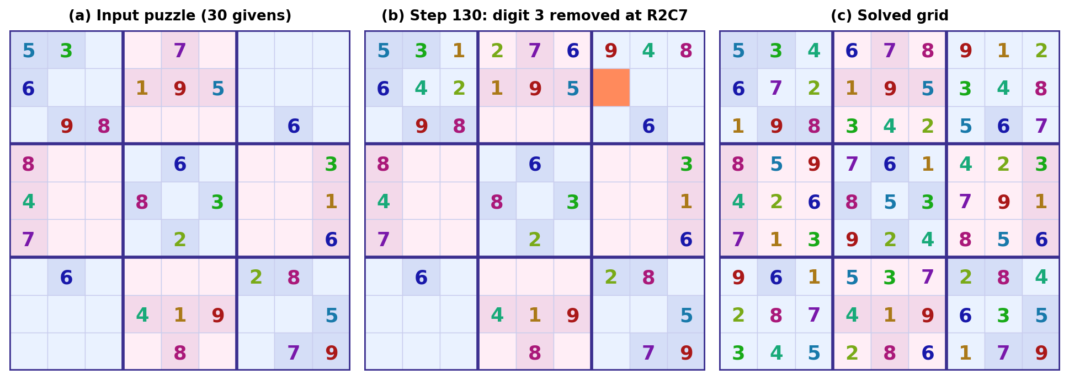
Figure 2: Board states rendered from the solver's recorded step trace (plain backtracking, Medium puzzle): (a) input, (b) after a backtrack at step 130 (orange cell), (c) solved grid. The live app shows the same view with the step controls.
Performance: plain backtracking vs backtracking + MRV
Puzzle | Clues | Plain: placements | Plain: backtracks | MRV: placements | MRV: backtracks | Plain / MRV
Easy | 32 | 200 | 151 | 49 | 0 | 4.1x
Medium | 30 | 4,208 | 4,157 | 51 | 0 | 83x
Hard | 17 | 9,727,396 | 9,727,332 | 718 | 654 | 13,548x
Hardest (Inkala) | 21 | 49,558 | 49,498 | 13,810 | 13,750 | 3.6x
Easter Monster | 21 | 262,014 | 261,954 | 6,273 | 6,213 | 42x
Golden Nugget | 21 | 304,053 | 303,993 | 14,712 | 14,652 | 21x
17-clue extreme | 17 | 69,175,316 | 69,175,252 | 58,233 | 58,169 | 1,188x
Norvig's hardest | 22 | 335,637 | 335,578 | 4,875 | 4,816 | 69x

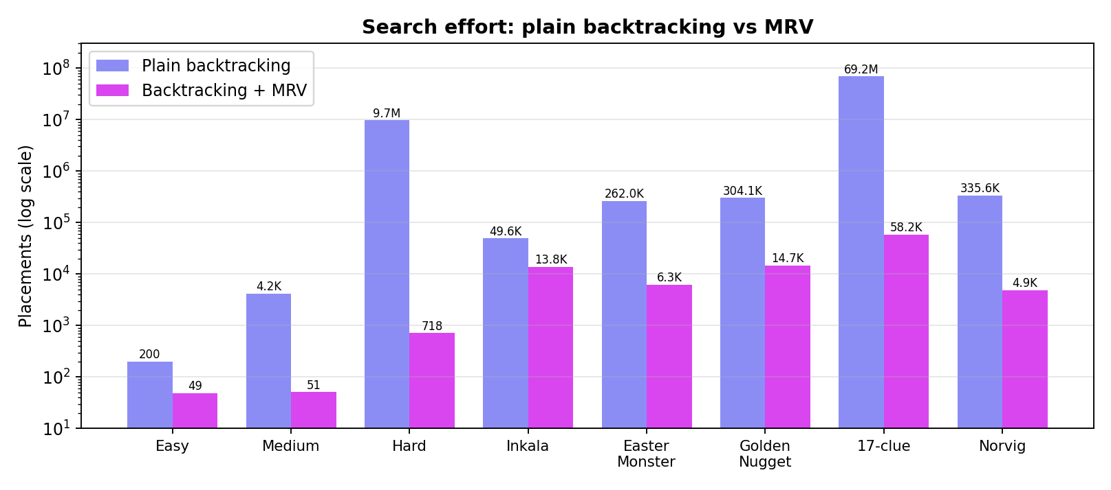
Figure 3: Placements needed by each algorithm (log scale).
Functional test cases
No. | Test | Input | Expected result | Result
T1 | All built-in puzzles, both algorithms | 8 samples (raised limit for Hard and 17-clue) | Valid solution, same grid from both algorithms | Pass
T2 | Duplicate clues | "55" followed by 79 blanks | Cells R1C1 and R1C2 flagged; solving blocked | Pass
T3 | Unsolvable puzzle | Row 1 = 12345678. and a 9 below it in the last column | Reports no solution; grid unchanged | Pass
T4 | Malformed input | "123" and 81 x characters | Error: expected 81 cells / invalid character | Pass
T5 | Search limit | Hardest (Inkala), limit 100 | Search stops, flagged as limit reached | Pass
T6 | Known answer | Medium puzzle with MRV | First row of solution is 534678912 | Pass
T7 | Trace integrity | Every solved sample | Replaying the trace rebuilds the solved grid | Pass

Observations
- MRV removed almost all backtracking on Easy and Medium (49 and 51 placements, zero backtracks) because forced moves chain together like human logic.
- On the Hard sample plain backtracking needed 9,727,396 placements against 718 for MRV, about 13,500 times more. On the 17-clue extreme it needed 69,175,316 against 58,233.
- Inkala's puzzle is hard for both (about 3.6 times difference), which shows that MRV helps most when many forced moves exist.
- Speed: the in-browser solver finished the 9.7 million placements of the Hard sample in about half a second; the Python solver took about 35 seconds. All 6 unit tests pass (python -m unittest).
8. Conclusion and Future Scope
Sudoku Solver Arena meets the problem statement: it accepts and validates puzzles, solves all tested puzzles including extreme ones, and makes the backtracking process visible step by step. The comparison shows that the order in which cells are chosen matters as much as pruning itself: MRV cut the search from millions of placements to a few hundred on the Hard sample while returning the same solution. Plain backtracking remains valuable for teaching because its behaviour is easy to follow.
Future scope
- Add human-style techniques (naked and hidden singles, pairs) and a "give me a hint" mode that explains the next logical move.
- Implement Dancing Links / Algorithm X as a third algorithm for comparison.
- Generate new puzzles with a unique-solution check and a difficulty rating based on search effort.
- Support 4x4 and 16x16 boards, puzzle import from images (OCR), and saving or sharing puzzles by link.
9. References
[1] T. H. Cormen, C. E. Leiserson, R. L. Rivest, and C. Stein, Introduction to Algorithms, 4th ed. Cambridge, MA, USA: MIT Press, 2022.
[2] S. Russell and P. Norvig, Artificial Intelligence: A Modern Approach, 4th ed. Hoboken, NJ, USA: Pearson, 2021 (constraint satisfaction problems, backtracking search and the minimum-remaining-values heuristic).
[3] A. Levitin, Introduction to the Design and Analysis of Algorithms, 3rd ed. Boston, MA, USA: Pearson, 2012 (backtracking).
[4] P. Norvig, "Solving every Sudoku puzzle," 2006. [Online]. Available: https://norvig.com/sudoku.html
[5] T. Yato and T. Seta, "Complexity and completeness of finding another solution and its application to puzzles," IEICE Trans. Fundamentals, vol. E86-A, no. 5, pp. 1052-1060, May 2003.
[6] D. E. Knuth, "Dancing links," arXiv:cs/0011047, 2000. [Online]. Available: https://arxiv.org/abs/cs/0011047
[7] Streamlit Inc., "Streamlit documentation." [Online]. Available: https://docs.streamlit.io
[8] Sudoku Solver Arena (project web application). [Online]. Available: https://sudokugit-vdbwd5hqkkzqxwuwtkq8rw.streamlit.app/

