SR UNIVERSITY
PROJECT REPORT
SMARTCART
Implementing Behavioral Design Patterns with Object-Oriented Concepts

Submitted by: Punna Shiva Karthikeya
Roll Number: 2403a51027
B.Tech — Computer Science and Engineering
Third Year | Academic Year 2026–2027
Course: Software Engineering / System Design

Abstract
SmartCart is a demonstration e-commerce website designed to illustrate how Object-Oriented Programming (OOP) concepts can be applied through behavioral design patterns. It demonstrates price-drop notifications using the Observer Pattern, runtime payment-method selection using the Strategy Pattern, and shopping-cart operations with undo/redo support using the Command Pattern. The interface is built with HTML, CSS, and JavaScript classes. UML-style diagrams explain the system structure and interactions, while Git and GitHub provide version control and a branching-and-merging workflow. Payment processing in this academic prototype is simulated; it does not connect to a real payment provider.

Table of Contents
- 1. Introduction
- 2. Problem Statement
- 3. Objectives and Scope
- 4. Requirements Analysis
- 5. OOP Concepts
- 6. Behavioral Design Patterns
- 7. System Design and UML Diagrams
- 8. Implementation Details
- 9. Testing and Results
- 10. Git and GitHub Workflow
- 11. Limitations and Future Enhancements
- 12. Conclusion
- 13. References

1. Introduction
E-commerce applications contain behaviors that respond to user actions and changing data. Examples include notifying customers when prices fall, selecting a payment method at checkout, and supporting reversible cart actions. Behavioral design patterns provide reusable structures for communication and responsibility between objects. SmartCart is a small browser-based prototype that demonstrates these concepts.

2. Problem Statement
The system must support product price notifications, multiple selectable payment methods, and shopping-cart operations that can be undone or repeated. The design should keep responsibilities separate, reduce coupling between UI elements and business logic, and demonstrate key OOP principles.

3. Objectives and Scope
- Implement Observer to notify subscribers about price drops.
- Implement Strategy to select UPI, card, or wallet behavior at runtime.
- Implement Command objects for adding items, removing items, and applying coupons.
- Demonstrate undo and redo through command history.
- Explain encapsulation, inheritance, polymorphism, abstraction, and composition.
- Document the design with UML-style diagrams and use Git/GitHub for version control.
Scope: This prototype uses sample products in a browser. It does not provide user accounts, persistent storage, real payment processing, or email/SMS delivery.

4. Requirements Analysis

4.1 Functional Requirements
- Display sample products and current prices.
- Subscribe to and unsubscribe from product price alerts.
- Simulate price reductions and notify subscribed observers.
- Add products to and remove products from a shopping cart.
- Apply a valid SAVE10 coupon for a 10% discount.
- Undo and redo cart commands.
- Choose UPI, card, or wallet and display a simulated payment result.

4.2 Non-functional Requirements
- Usability: controls and messages should be understandable.
- Maintainability: responsibilities are separated into classes.
- Portability: runs in a modern browser.
- Reliability: invalid coupons and empty-cart checkout show feedback.
- Security awareness: the demo must not collect real payment credentials.

5. Object-Oriented Programming Concepts
Concept | Meaning | SmartCart example
Encapsulation | Keep state and operations together; restrict direct access. | Product protects price/observers; CartService manages cart state.
Inheritance | Specialized classes derive from a base class. | Customer extends Observer; concrete strategies and commands extend base contracts.
Polymorphism | Different objects implement a shared operation differently. | UPI, card, and wallet strategies each implement pay().
Abstraction | Expose essential operations while hiding implementation details. | Observer, PaymentStrategy, and Command define method contracts.
Composition | An object delegates work to another object. | CheckoutService uses a selected payment strategy.

6. Behavioral Design Patterns

6.1 Observer Pattern
Intent: define a one-to-many dependency so when a subject changes state, its registered observers are notified.
Participants: Product is the subject; Observer defines update(message); Customer is a concrete observer. Product provides subscribe(), unsubscribe(), changePrice(), and notify().
Flow: a customer subscribes; the price changes; Product compares old and new values; if the price falls, notify() calls update() on each observer and the interface displays an alert.
OOP connection: encapsulation protects the price and observer list; polymorphism allows different observers to implement update().

6.2 Strategy Pattern
Intent: encapsulate a family of algorithms and make them interchangeable at runtime.
Participants: PaymentStrategy defines pay(amount); UPIPayment, CardPayment, and WalletPayment implement it; CheckoutService stores and delegates to the selected strategy.
Flow: the customer selects a payment method; CheckoutService receives the corresponding strategy; checkout(amount) calls pay(amount) on that strategy.
OOP connection: composition lets CheckoutService use any compatible strategy, and polymorphism allows the implementation to vary.

6.3 Command Pattern
Intent: encapsulate a request as an object so it can be executed, undone, or repeated.
Participants: Command defines execute() and undo(); AddItemCommand, RemoveItemCommand, and ApplyCouponCommand are concrete commands; CartInvoker manages history; CartService changes cart state.
Flow: the UI creates a command; the invoker executes it and saves it to history. Undo calls the command's undo() method; redo executes it again.
OOP connection: each request and its reversal are encapsulated in an object, decoupling UI controls from cart logic.

7. System Design and UML Diagrams
The following Mermaid diagrams describe use cases, class relationships, and interactions. The user has also exported diagram images; insert those images in the final report if your professor requires rendered diagrams. Mermaid source can be rendered at https://mermaid.live/.

7.1 Use-Case Diagram
flowchart LR
Customer([Customer]) --> Subscribe[Subscribe to price alerts]
Customer --> Browse[Browse products]
Customer --> Cart[Manage cart]
Customer --> Coupon[Apply coupon]
Customer --> Undo[Undo or redo]
Customer --> Pay[Select payment and checkout]
Subscribe --> Product[Product system]
Product --> Notify[Send price-drop notification]
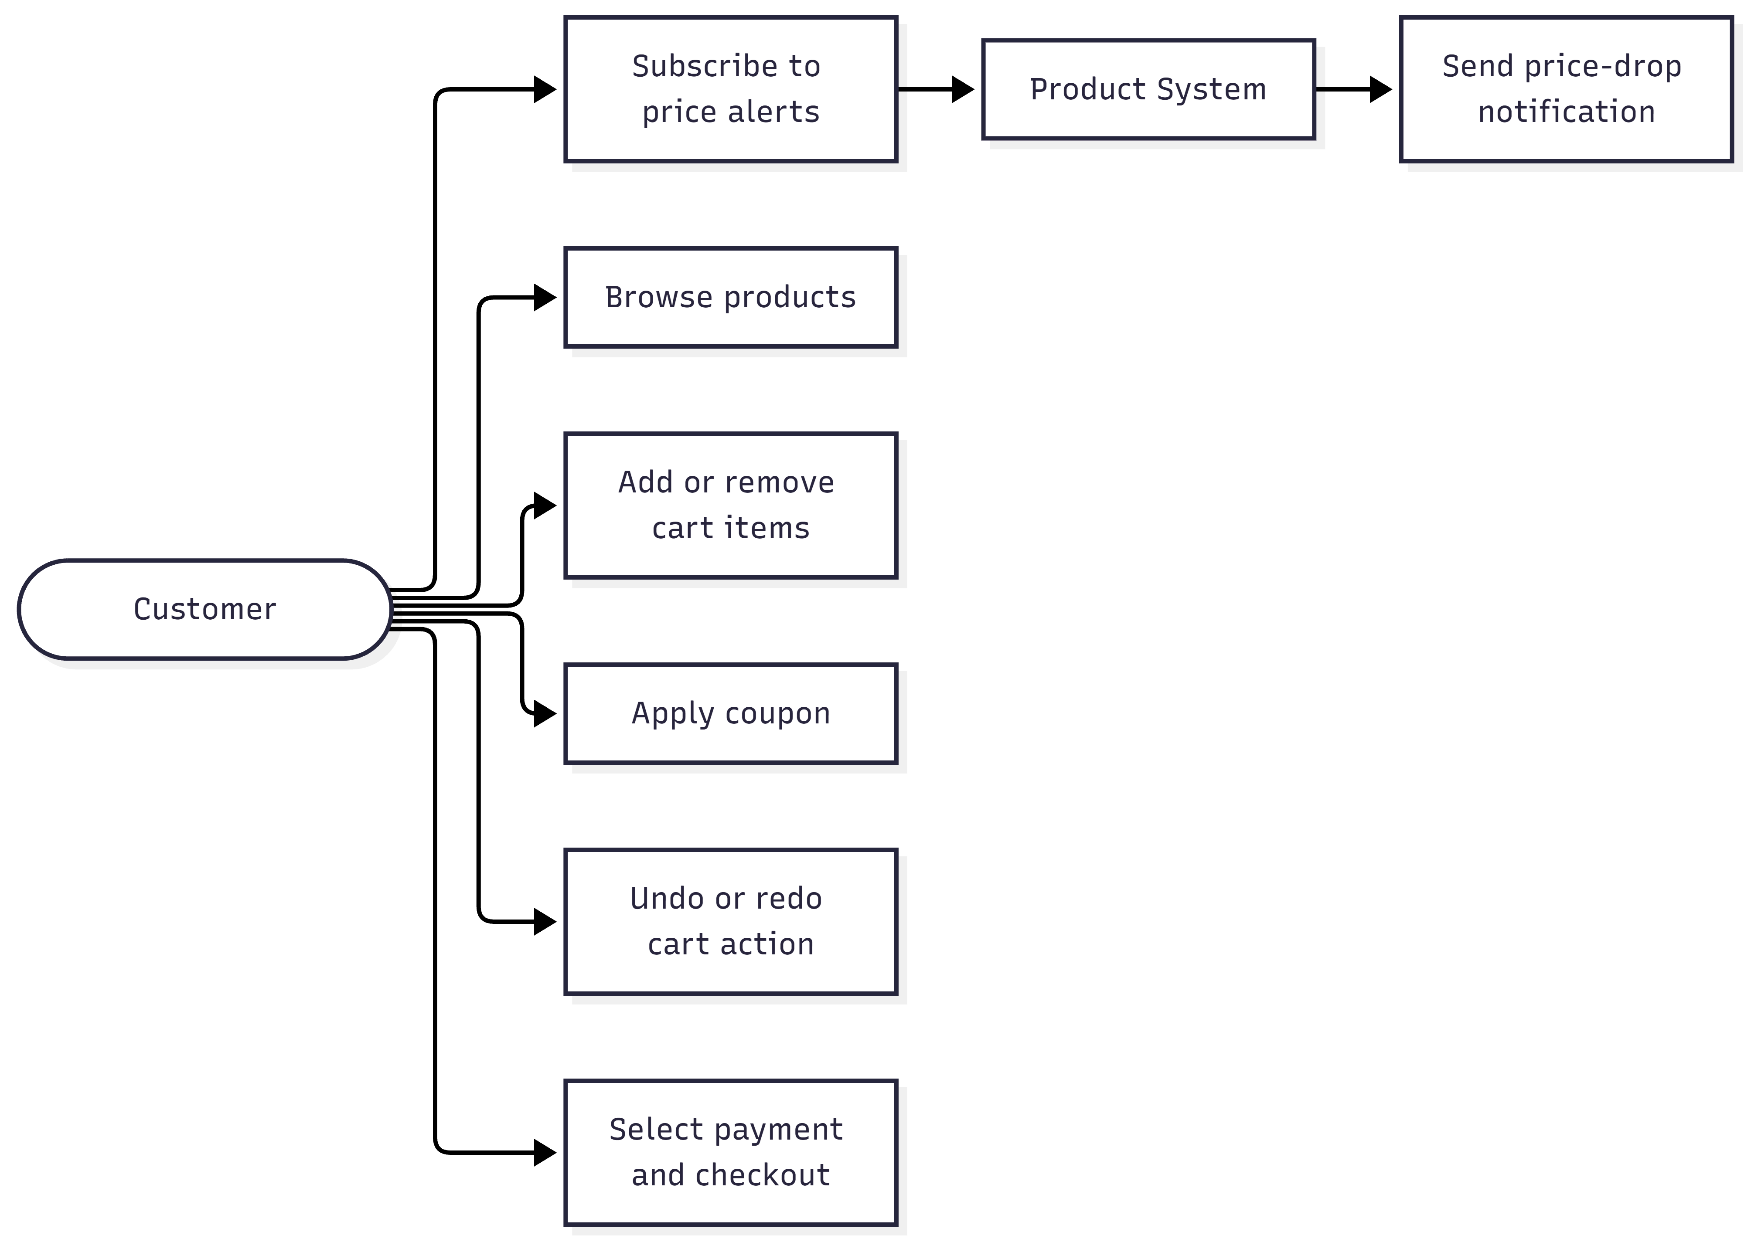

7.2 Observer Class Diagram
classDiagram
class Observer { <<abstract>> +update(message) }
class Customer { +name +update(message) }
class Product { -price -observers +subscribe(observer) +unsubscribe(observer) +changePrice(price) +notify() }
Observer <|-- Customer
Product o-- Observer : notifies
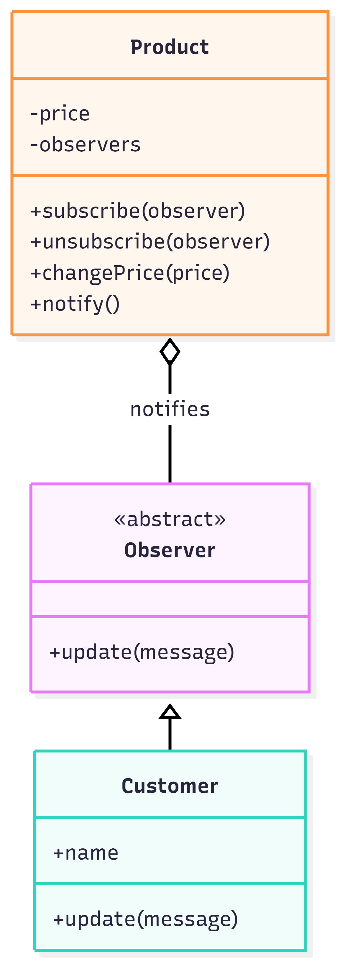

7.3 Strategy Class Diagram
classDiagram
class PaymentStrategy { <<abstract>> +pay(amount) }
class UPIPayment { +pay(amount) }
class CardPayment { +pay(amount) }
class WalletPayment { +pay(amount) }
class CheckoutService { -strategy +setStrategy(strategy) +checkout(amount) }
PaymentStrategy <|-- UPIPayment
PaymentStrategy <|-- CardPayment
PaymentStrategy <|-- WalletPayment
CheckoutService o-- PaymentStrategy : uses
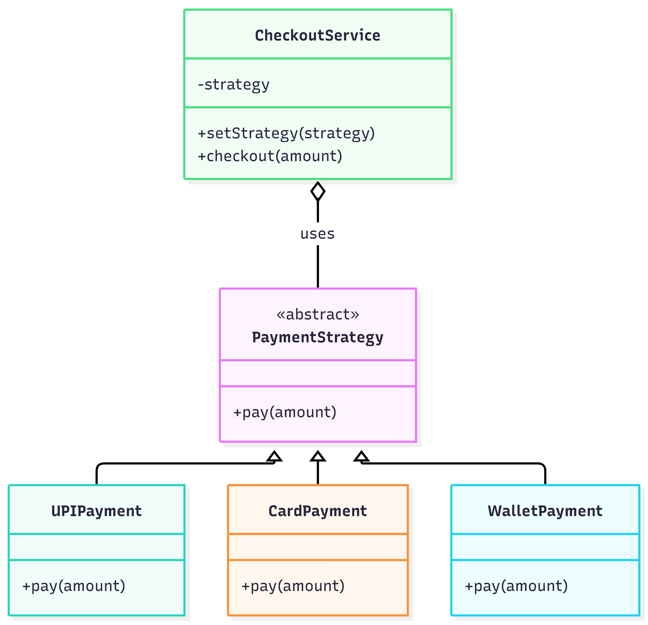

7.4 Command Class Diagram
classDiagram
class Command { <<abstract>> +execute() +undo() }
class AddItemCommand
class RemoveItemCommand
class ApplyCouponCommand
class CartInvoker { -undoStack -redoStack +run(command) +undo() +redo() }
class CartService { -items -coupon +add() +remove() +setCoupon() }
Command <|-- AddItemCommand
Command <|-- RemoveItemCommand
Command <|-- ApplyCouponCommand
CartInvoker o-- Command : executes
AddItemCommand --> CartService : modifies
RemoveItemCommand --> CartService : modifies
ApplyCouponCommand --> CartService : modifies
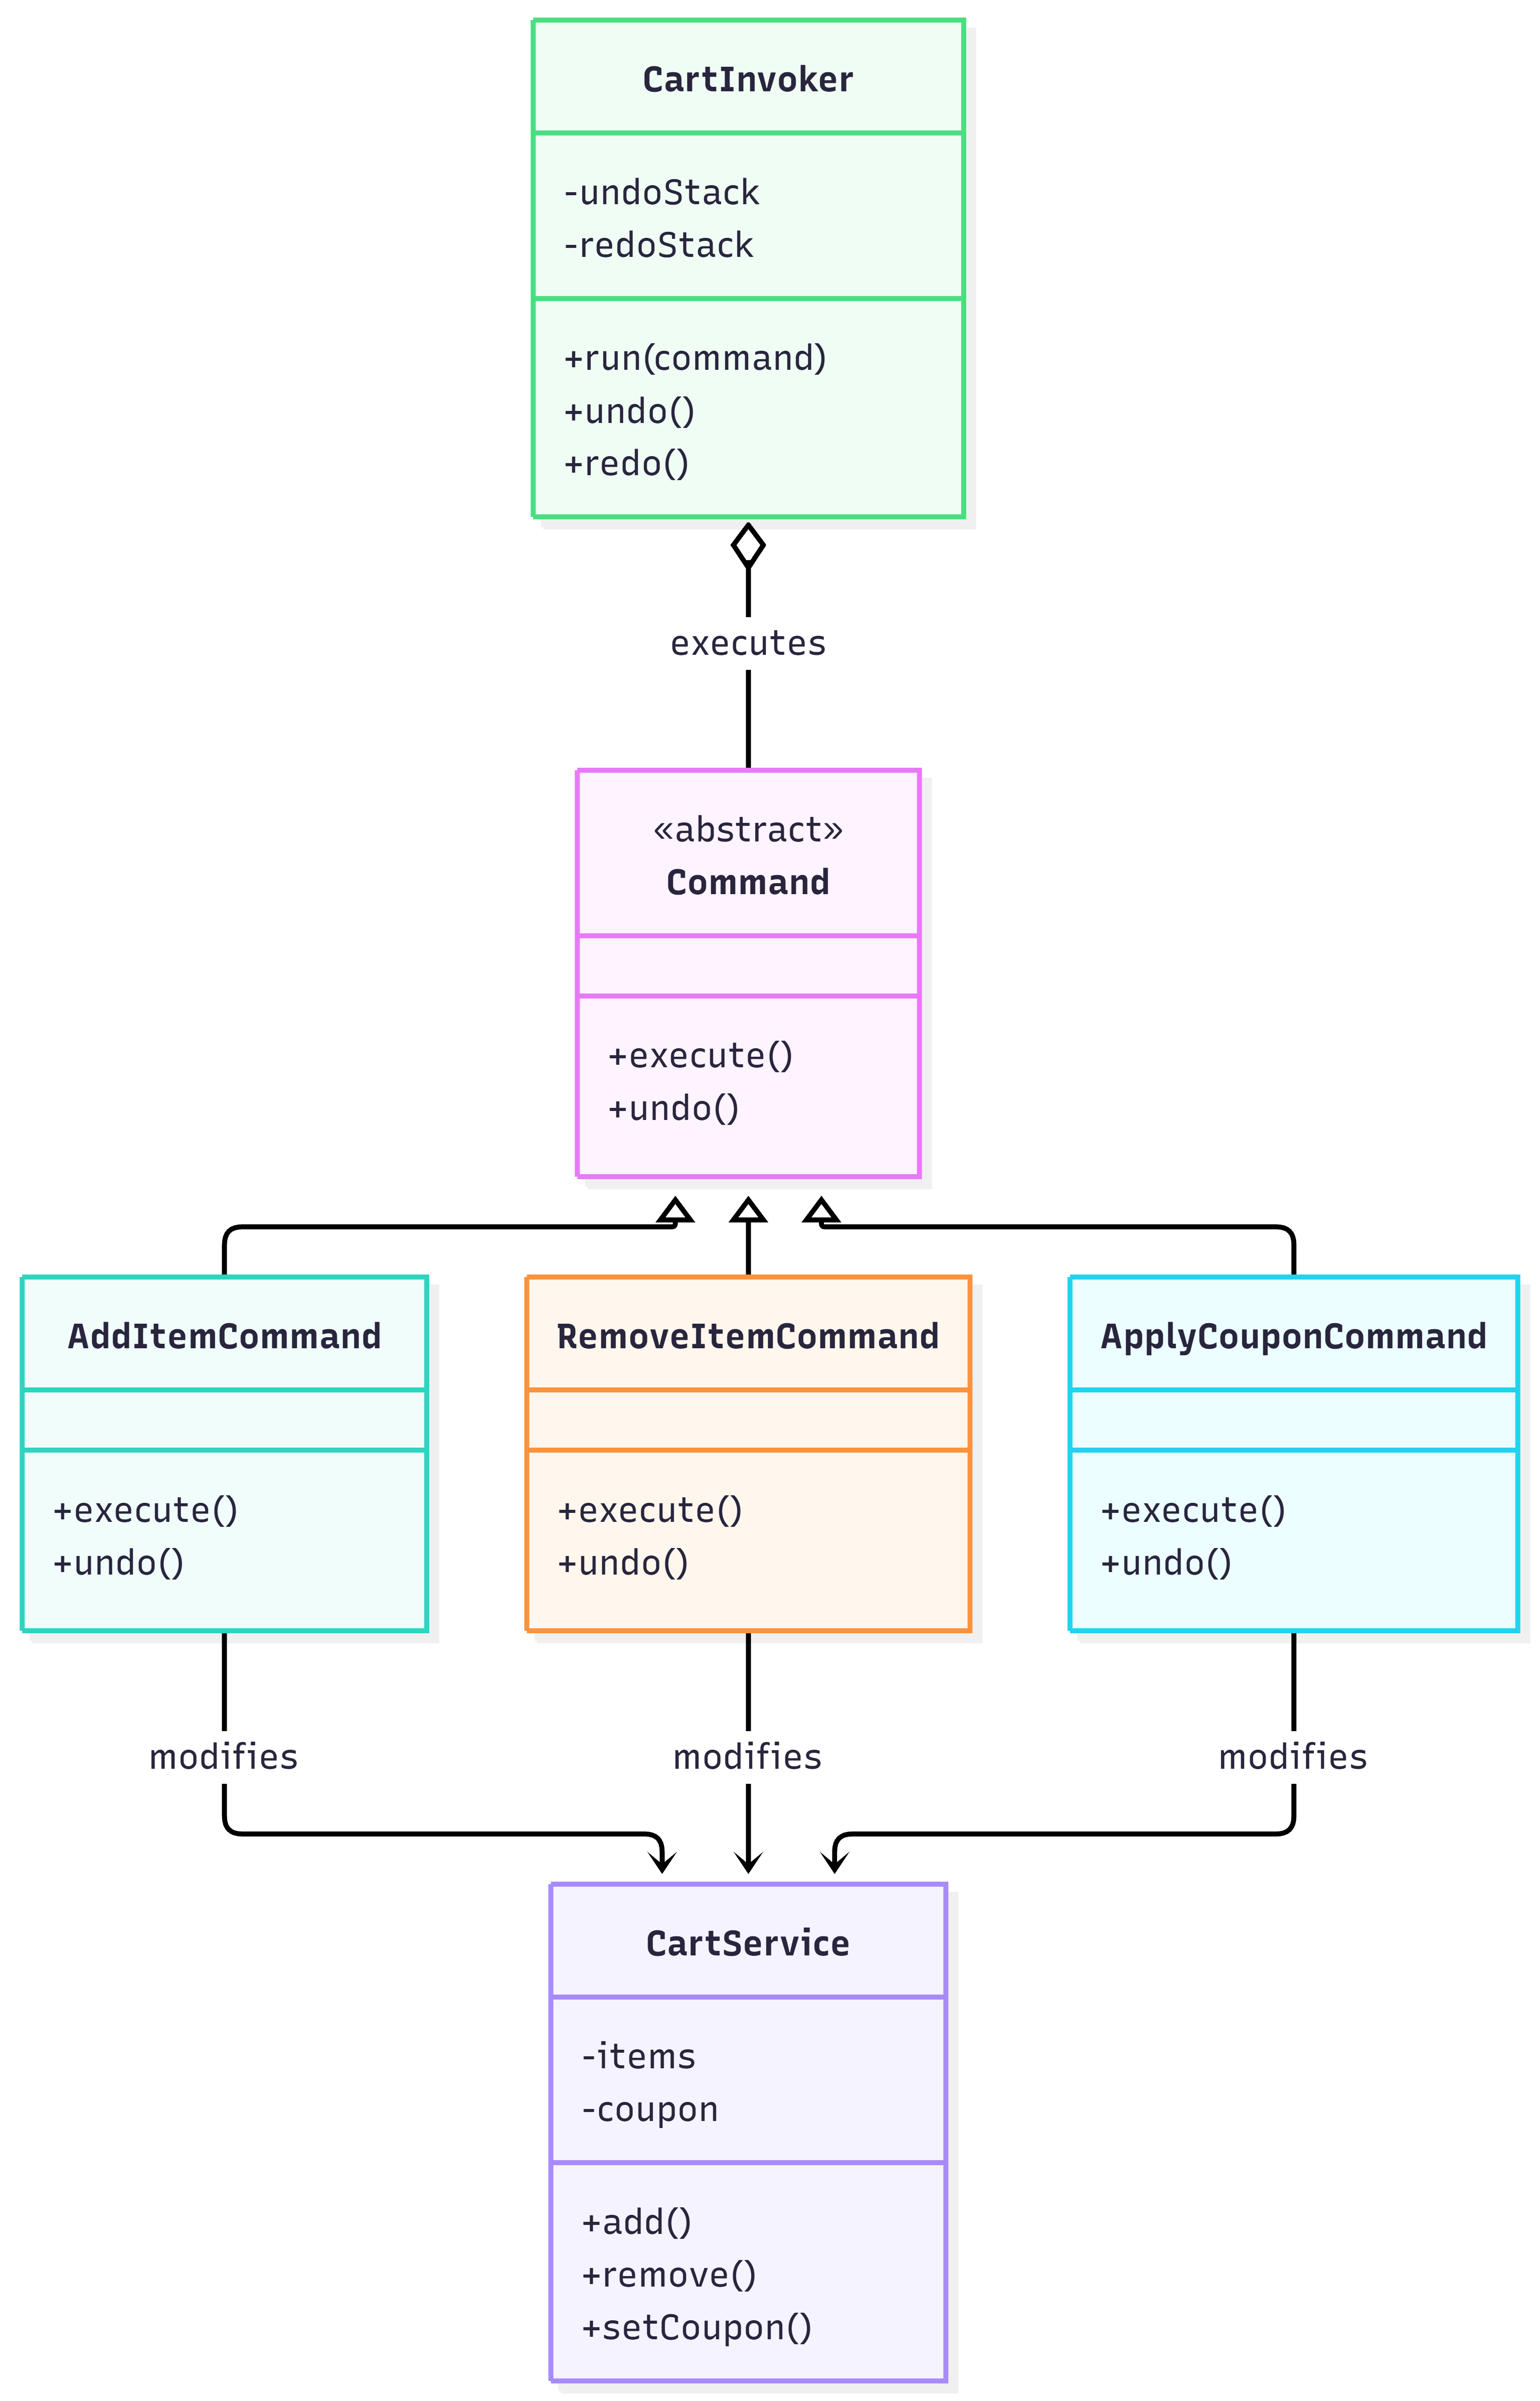

7.5 Observer Sequence Diagram
sequenceDiagram
actor Customer
participant Product
participant Observer
Customer->>Product: subscribe(observer)
Customer->>Product: changePrice(newPrice)
Product->>Product: Compare old and new price
Product->>Observer: update(notification)
Observer-->>Customer: Display price-drop alert
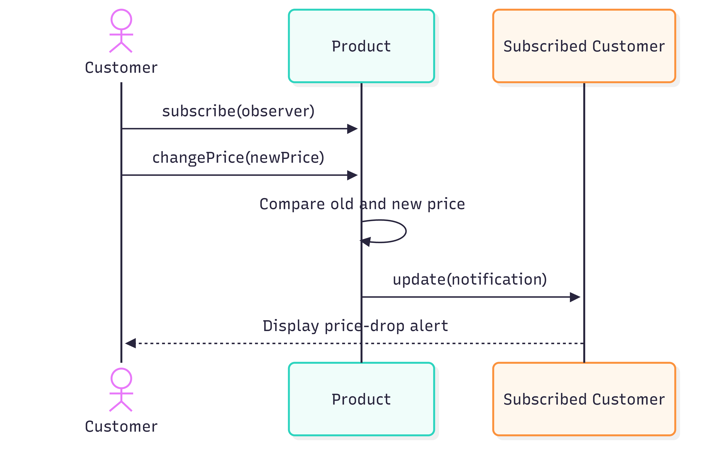

7.6 Strategy Sequence Diagram
sequenceDiagram
actor Customer
participant CheckoutService
participant Strategy
Customer->>CheckoutService: setStrategy(strategy)
Customer->>CheckoutService: checkout(amount)
CheckoutService->>Strategy: pay(amount)
Strategy-->>CheckoutService: Demo result
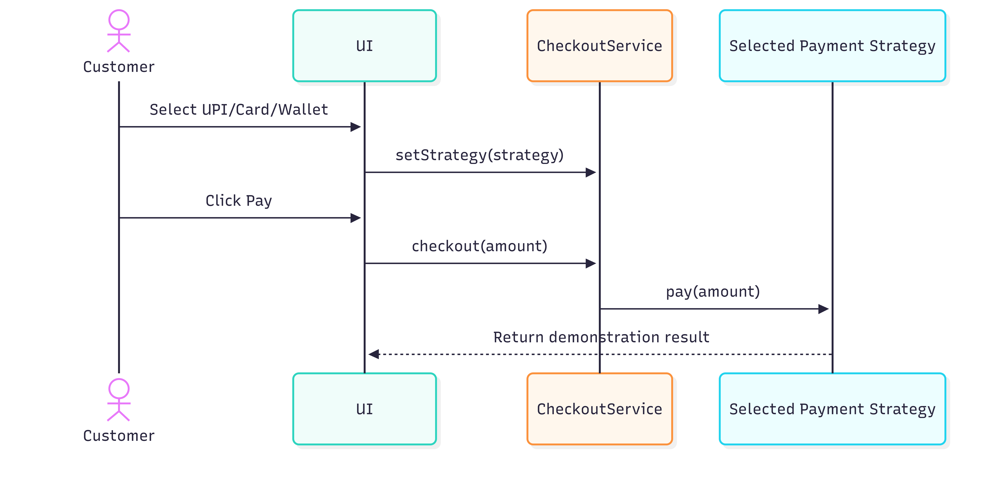

7.7 Command Sequence Diagram
sequenceDiagram
actor Customer
participant Invoker as CartInvoker
participant Command
participant Cart as CartService
Customer->>Invoker: run(command)
Invoker->>Command: execute()
Command->>Cart: modify cart
Invoker->>Invoker: Save command in history
Customer->>Invoker: undo()
Invoker->>Command: undo()
Command->>Cart: restore previous state
s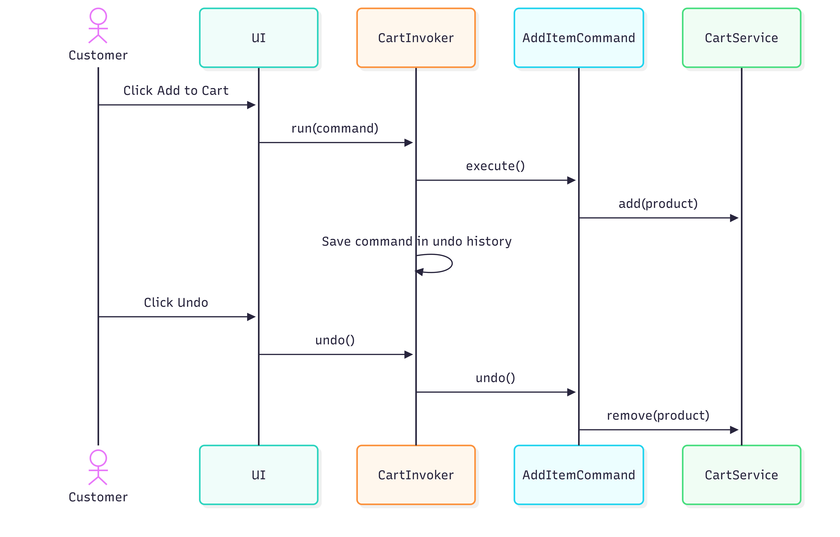

8. Implementation Details
Module | Classes / functions | Responsibility
Products and alerts | Product, Observer, Customer | Track price, maintain subscriptions, notify on price drops.
Checkout | PaymentStrategy, UPIPayment, CardPayment, WalletPayment, CheckoutService | Select and invoke payment behavior.
Cart | CartService, Command, AddItemCommand, RemoveItemCommand, ApplyCouponCommand, CartInvoker | Manage cart, coupon, undo/redo history.
UI | HTML elements and JavaScript event handlers | Render products and connect controls to pattern objects.
Run instructions: save the implementation as index.html and open it in a modern browser, or use the Live Server extension in Visual Studio Code. No backend is required.

9. Testing and Results
Test ID | Test action | Expected result | Actual result
TC01 | Subscribe and simulate a price drop. | Subscribed customer receives notification. | Fill after testing
TC02 | Unsubscribe and simulate a price drop. | Unsubscribed customer receives no alert. | Fill after testing
TC03 | Add a product. | Cart and total update. | Fill after testing
TC04 | Apply SAVE10. | Total reduces by 10%. | Fill after testing
TC05 | Undo coupon application. | Previous coupon state is restored. | Fill after testing
TC06 | Undo and redo a cart action. | Action is reversed and reapplied. | Fill after testing
TC07 | Try all payment options. | Method-specific demo message appears. | Fill after testing
TC08 | Checkout with empty cart. | Error message is shown. | Fill after testing
Run each test in the browser and replace the actual-result placeholders with observed results. Do not claim a test passed until it has been performed.

10. Git and GitHub Workflow
Repository: https://github.com/karthikeya12151/SmartCart
The main branch stores the integrated project. Feature branches were created for Observer, Strategy, and Command patterns, then merged into main. A typical workflow is: create a feature branch, make a meaningful code change, run tests, stage files with git add, commit with git commit, push the branch, merge it into main, and push main.
For a strong academic demonstration, ensure each feature branch includes meaningful implementation changes rather than only comments. GitHub Pages can be configured from Settings → Pages, using the main branch and root folder. Verify the deployment URL after publishing.

11. Limitations and Future Enhancements
- Add a backend and database to persist users, products, subscriptions, and carts.
- Integrate a legitimate payment provider in a secure test environment.
- Send real notifications using email or push notifications.
- Add authentication, authorization, and server-side validation.
- Add automated tests for command-history edge cases and multiple observers.

12. Conclusion
SmartCart demonstrates how behavioral design patterns organize common e-commerce interactions. Observer separates price changes from notification recipients, Strategy makes payment behavior interchangeable, and Command encapsulates cart operations to support undo and redo. These patterns, combined with OOP principles and Git-based version control, provide a practical introduction to modular software design. The prototype is educational and requires further backend, security, and payment integration before real-world deployment.

13. References
- Gamma, E., Helm, R., Johnson, R., and Vlissides, J. Design Patterns: Elements of Reusable Object-Oriented Software. Addison-Wesley.
- MDN Web Docs, JavaScript classes: https://developer.mozilla.org/en-US/docs/Web/JavaScript/Reference/Classes
- Mermaid Documentation: https://mermaid.js.org/
- Git Documentation: https://git-scm.com/doc
- GitHub Pages Documentation: https://docs.github.com/en/pages

