Ex.No. 12: NB-IoT vs LTE-M Throughput Simulation
AIM: To simulate and compare the performance of NB-IoT and LTE-M communication technologies in terms of Throughput (Mbps), Latency (ms), and Packet Delivery Ratio (%) using MATLAB.
Objective:
- To evaluate and compare the Throughput (Mbps) performance of NB-IoT and LTE-M under varying network conditions.
- ​
To analyze the Latency (ms) characteristics of NB-IoT and LTE-M and study their impact on real-time communication.
- ​
To measure and compare the Packet Delivery Ratio (%) of NB-IoT and LTE-M systems for reliability assessment.
Procedure
- Define system parameters for NB-IoT and LTE-M such as bandwidth, transmission power, and modulation efficiency.
- Generate network conditions by varying Signal-to-Noise Ratio (SNR) or channel quality values.
- Compute Throughput (Mbps) for both NB-IoT and LTE-M using their respective data rate models.
- Calculate Latency (ms) based on transmission time, scheduling delay, and network load.
- Determine Packet Delivery Ratio (PDR %) by comparing successfully received packets with transmitted packets.
- Simulate multiple iterations to observe performance under different channel conditions.
- Plot comparison graphs for Throughput, Latency, and PDR between NB-IoT and LTEM.
- Analyze results to identify which technology performs better under different IoT

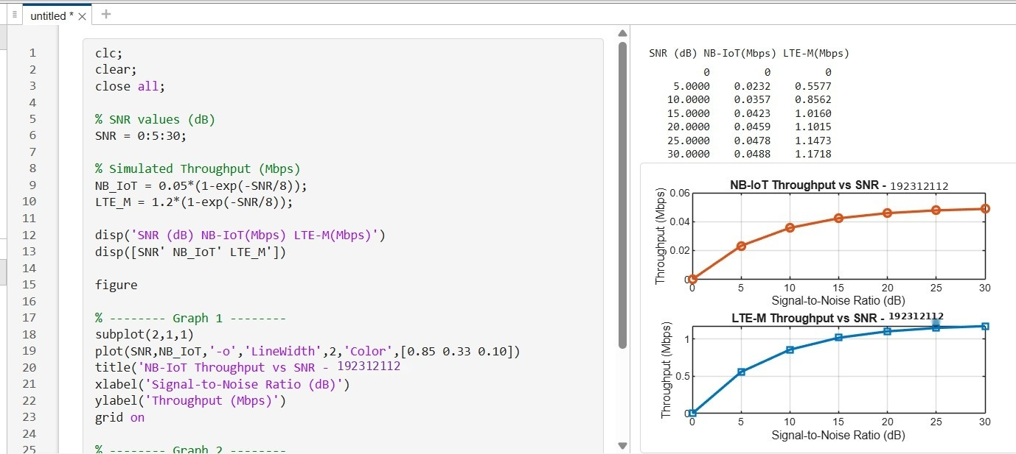
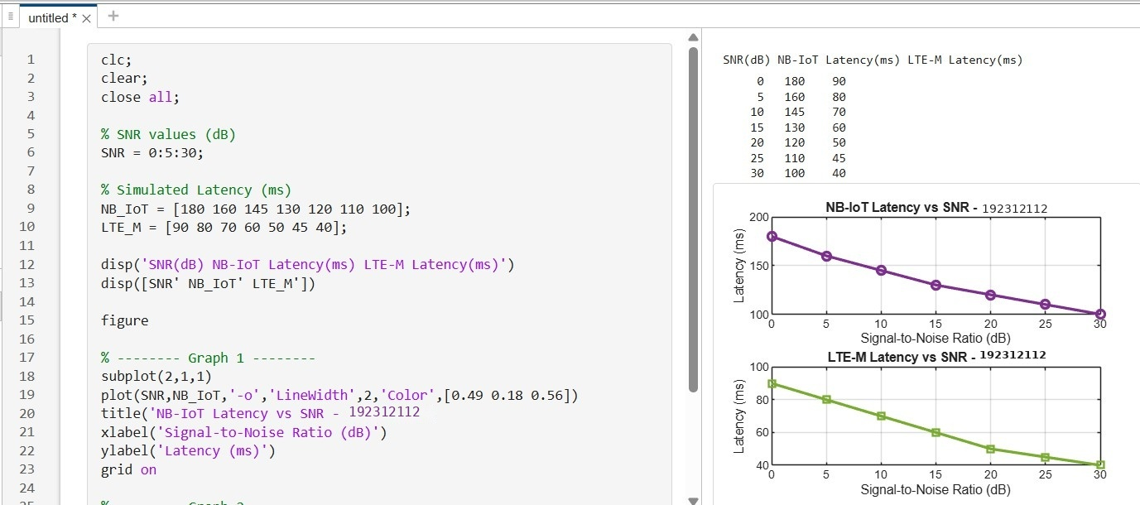
scenarios.

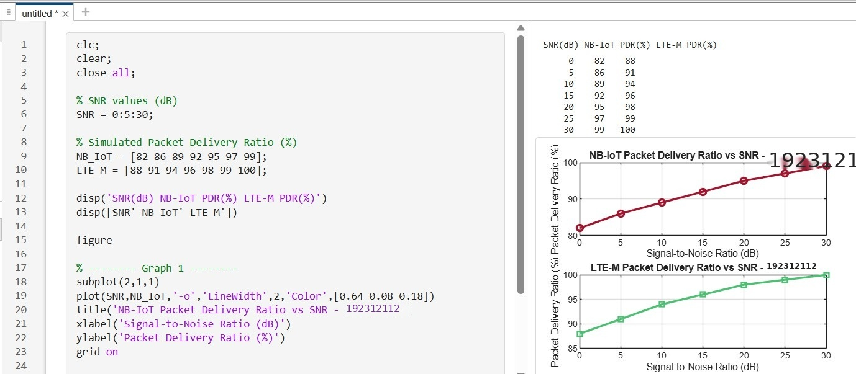
Result:
- The throughput performance of both NB-IoT and LTE-M was successfully simulated, and LTE-M achieved higher throughput than NB-IoT under the same network conditions.
- The latency analysis showed that LTE-M provides lower communication delay compared to NB-IoT, making it more suitable for real-time IoT applications.
- The Packet Delivery Ratio (PDR) of both technologies improved with increasing SNR, with LTE-M demonstrating slightly higher reliability than NB-IoT during data transmission.

