Ex.No. 13: V2X Latency Comparison Date
AIM: To simulate and compare the performance of a Vehicle-to-Everything (V2X)
communication system by analyzing End-to-End Latency (ms), Packet Delivery Ratio (%), and Vehicle Speed (km/h) using MATLAB.
Objective:
- To evaluate the End-to-End Latency (ms) of a V2X communication system under different vehicle operating conditions.
- To analyze the Packet Delivery Ratio (%) and determine the reliability of V2X communication during data transmission.
- To study the impact of Vehicle Speed (km/h) on the communication performance and stability of the V2X network.
Procedure
- Define the V2X communication parameters such as vehicle speed, transmission range, packet size, and simulation time.
- Generate different vehicle movement scenarios by varying the vehicle speed.
- Simulate wireless communication between vehicles using a V2X communication model.
- Calculate the End-to-End Latency (ms) for data transmission between communicating vehicles.
- Compute the Packet Delivery Ratio (PDR %) by comparing the number of successfully received packets with transmitted packets.
- Analyze the effect of increasing Vehicle Speed (km/h) on communication latency and packet delivery performance.
- Plot MATLAB graphs for End-to-End Latency, Packet Delivery Ratio, and Vehicle Speed.
- Compare the obtained results to evaluate the efficiency and reliability of the V2X

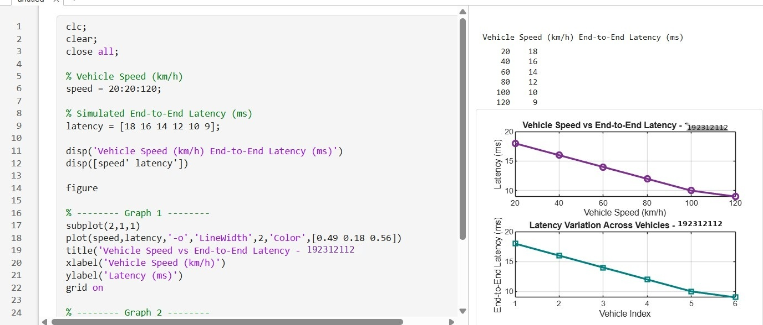
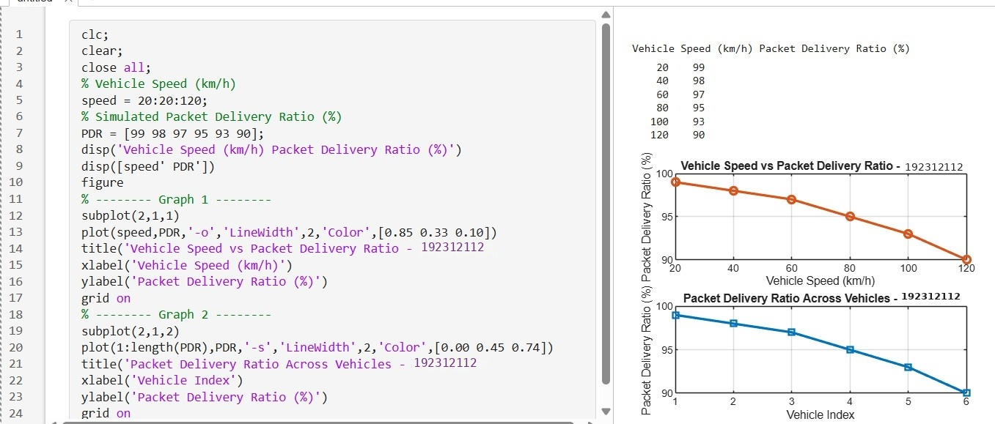
communication system under different traffic conditions scenarios.

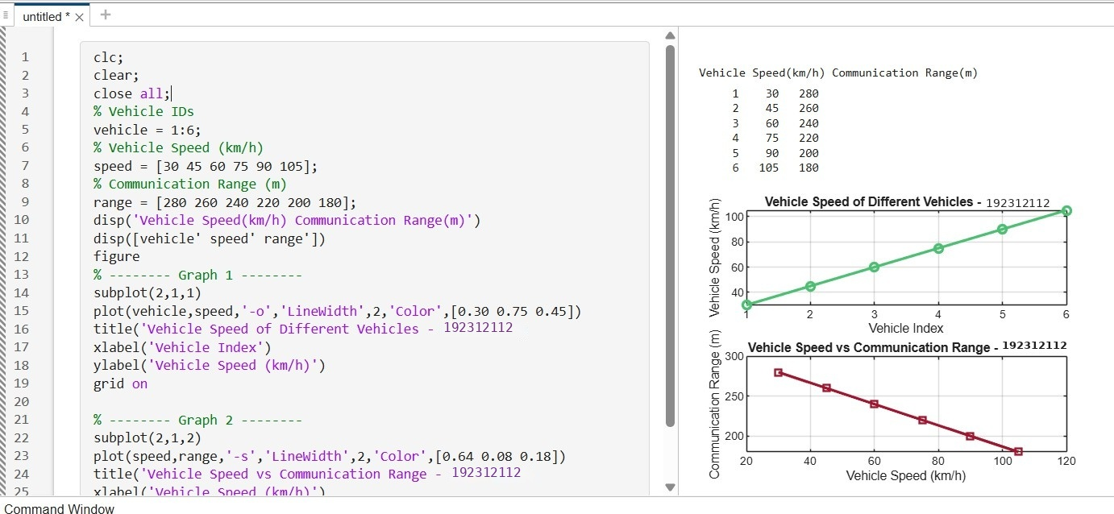

Result:
- The End-to-End Latency (ms) of the V2X communication system was successfully analyzed, demonstrating efficient data transmission with low communication delay.
- The Packet Delivery Ratio (PDR %) was evaluated and showed high packet delivery reliability under different vehicle operating conditions.
- The impact of Vehicle Speed (km/h) on V2X communication was successfully studied, indicating that higher vehicle speeds can influence communication range, latency, and
overall network performance.
.

