Ex.No. 14: 5G Throughput vs SNR with Modulation Labels
AIM: To simulate the performance of a 5G wireless communication system using MATLAB by analyzing the relationship between Throughput (Mbps), Signal-to-Noise Ratio (SNR) (dB), and different Modulation Schemes (QPSK, 16-QAM, 64-QAM, and 256-QAM).
Objective:
- To evaluate the Throughput (Mbps) of a 5G communication system under different Signal-to-Noise Ratio (SNR) conditions.
- To analyze the effect of Signal-to-Noise Ratio (SNR) (dB) on the performance and reliability of the 5G communication system.
- To compare the performance of different Modulation Schemes (QPSK, 16-QAM, 64-QAM, and 256-QAM) and determine their suitability for varying SNR conditions.
Procedure
- Define the simulation parameters such as SNR range, bandwidth, modulation schemes (QPSK, 16-QAM, 64-QAM, and 256-QAM), and transmission settings.
- Generate random binary data and modulate it using the selected modulation schemes.
- Simulate the transmission of the modulated signals through an Additive White Gaussian Noise (AWGN) channel with different SNR values.
- Calculate the Throughput (Mbps) achieved for each modulation scheme at different SNR levels.
- Analyze the impact of Signal-to-Noise Ratio (SNR) on communication performance and throughput.
- Compare the performance of QPSK, 16-QAM, 64-QAM, and 256-QAM under identical channel conditions.
- Plot MATLAB graphs for Throughput vs SNR and SNR vs Modulation Scheme to visualize the system performance.
- Interpret the results to identify the most suitable modulation scheme for different SNR

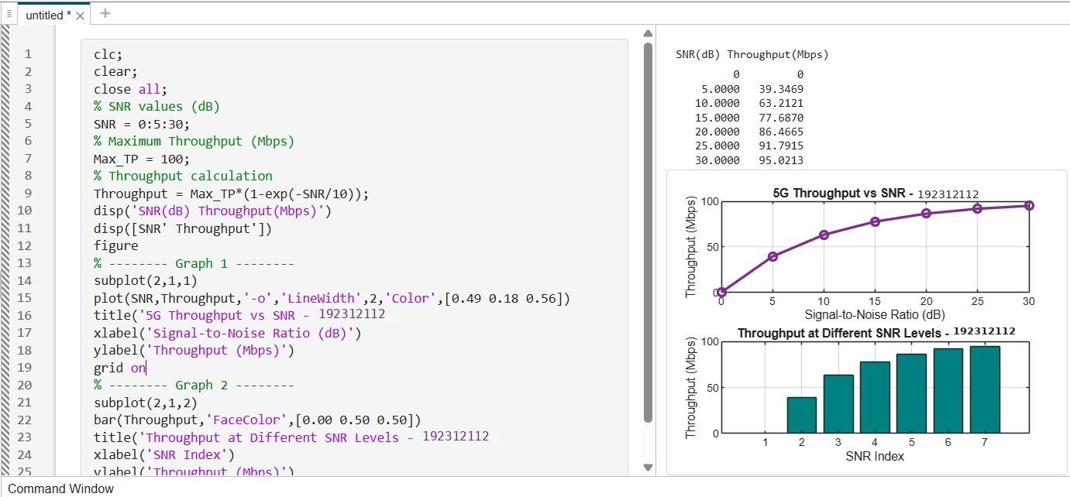
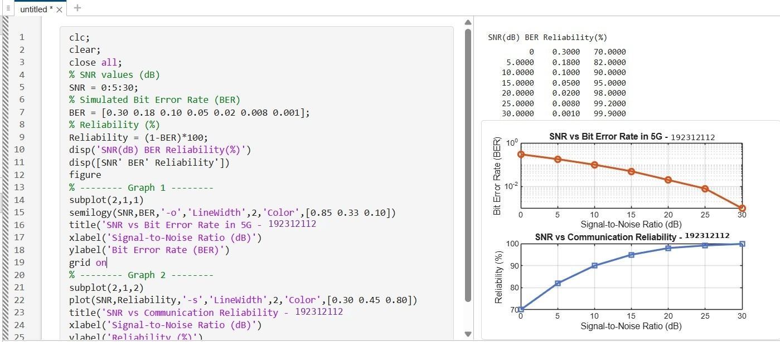

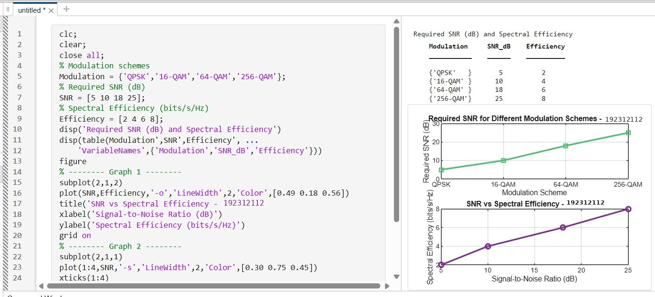
Result:
- The Throughput (Mbps) of the 5G communication system increased with increasing Signal-to-Noise Ratio (SNR), demonstrating improved data transmission performance.
- The simulation showed that higher SNR (dB) reduced transmission errors and enhanced the reliability and quality of 5G communication.
- The comparison of QPSK, 16-QAM, 64-QAM, and 256-QAM revealed that higherorder modulation schemes achieved greater throughput and spectral efficiency but
required higher SNR for reliable communication.

