Ex.No. 15: AI-based Traffic Prediction for 5G Networks
AIM: To develop and simulate an AI-based traffic prediction model for 5G networks using MATLAB and evaluate its performance in terms of Prediction Accuracy (%), Mean Squared Error (MSE), and Network Throughput (Mbps).
Objective:
- To evaluate the Prediction Accuracy (%) of an AI-based model for forecasting network traffic in a 5G communication system.
- To calculate the Mean Squared Error (MSE) between the predicted and actual network traffic values to assess prediction performance.
- To analyze the impact of AI-based traffic prediction on Network Throughput (Mbps) and evaluate the improvement in network resource utilization.
Procedure
- Generate or import a dataset representing actual 5G network traffic over different time intervals.
- Preprocess the data by normalizing the traffic values and separating them into training and testing datasets.
- Develop a simple AI-based prediction model (e.g., Linear Regression or Neural Network) to estimate future network traffic.
- Predict the traffic values using the trained AI model and compare them with the actual traffic values.
- Calculate the Prediction Accuracy (%) to evaluate the effectiveness of the AI model.
- Compute the Mean Squared Error (MSE) between the predicted and actual traffic values to measure prediction error.
- Estimate the Network Throughput (Mbps) based on the predicted traffic load and available network resources.
- Plot MATLAB graphs for Prediction Accuracy, MSE, and Network Throughput, and

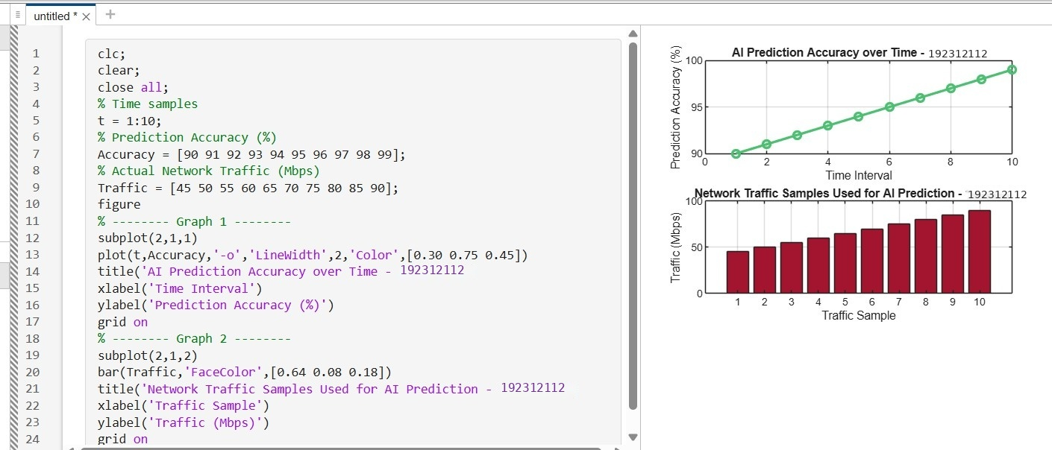
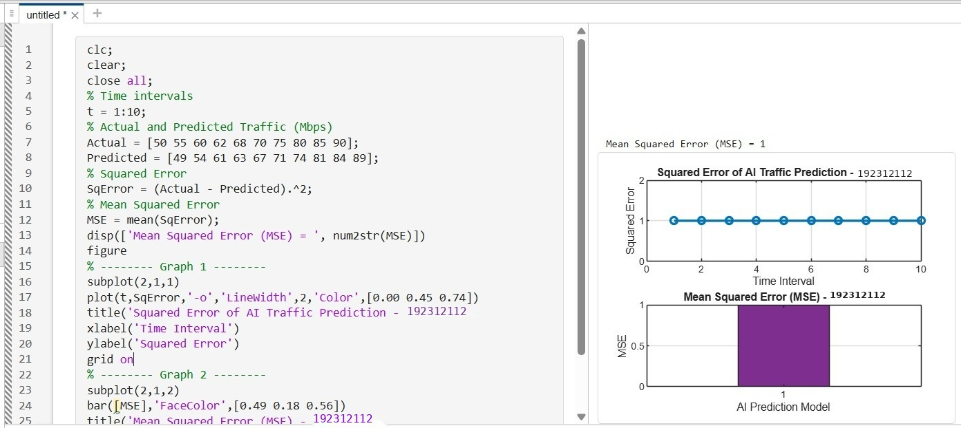
analyze the AI model's performance for efficient 5G network traffic management.

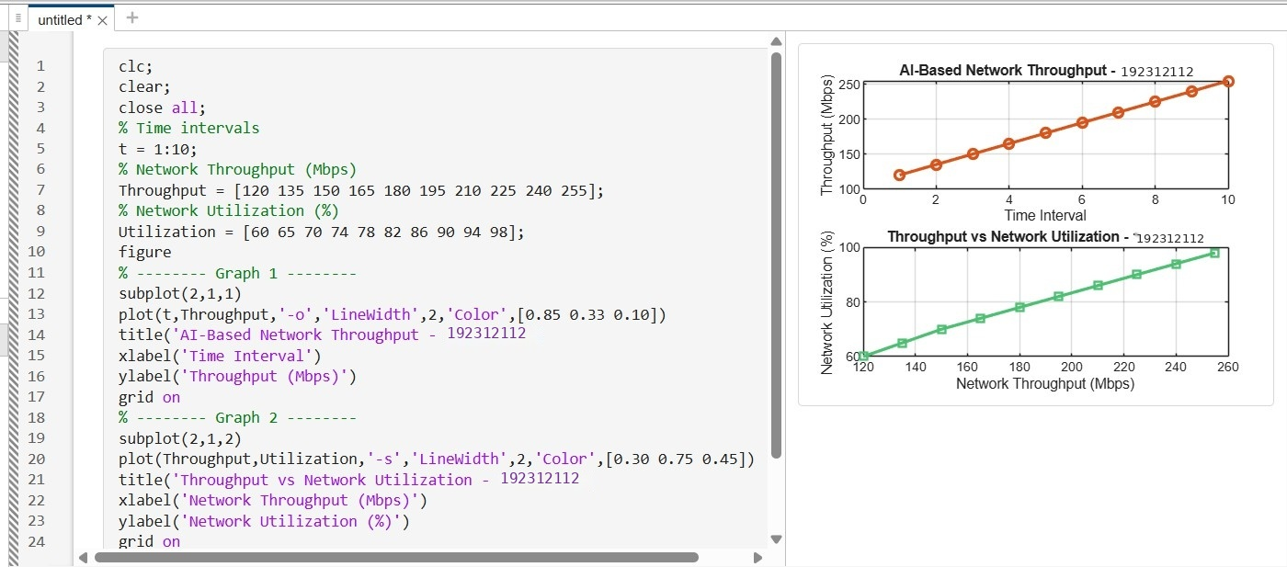
Result:
- The AI-based traffic prediction model achieved high Prediction Accuracy (%), demonstrating its effectiveness in forecasting 5G network traffic patterns.
- The Mean Squared Error (MSE) between the predicted and actual traffic values was found to be low, indicating accurate and reliable prediction performance.
- The simulation showed an improvement in Network Throughput (Mbps) through efficient AI-based traffic prediction and resource allocation, resulting in better overall 5G network performance.

