Exp .No. 2: Implementing TDMA Slot Allocation in GSM. Date
AIM: To implement TDMA (Time Division Multiple Access) slot allocation in GSM using MATLAB and analyze system performance in terms of time slot duration, frame utilization, and number of allocated slots.
Objective:
- To calculate the Time Slot Duration in a GSM TDMA frame by dividing the total frame time into equal time slots. This helps in understanding the time structure of GSM
communication.
- To determine the Frame Utilization (%) based on the number of allocated time slots
compared to total available slots. This evaluates the efficiency of TDMA resource usage.
- To compute the Number of Allocated Time Slots for multiple users in the GSM system. This ensures proper scheduling and interference-free communication.
Procedure:
- Define GSM frame parameters such as total frame duration and number of time slots.
- Compute time slot duration by dividing frame duration by number of slots.
- Assign time slots to multiple users based on availability.
- Calculate frame utilization percentage using allocated slots vs total slots.
- Determine total number of allocated slots for active users.
- Plot time slot allocation and utilization using MATLAB graphs.
- Display results in the command window for analysis

Output
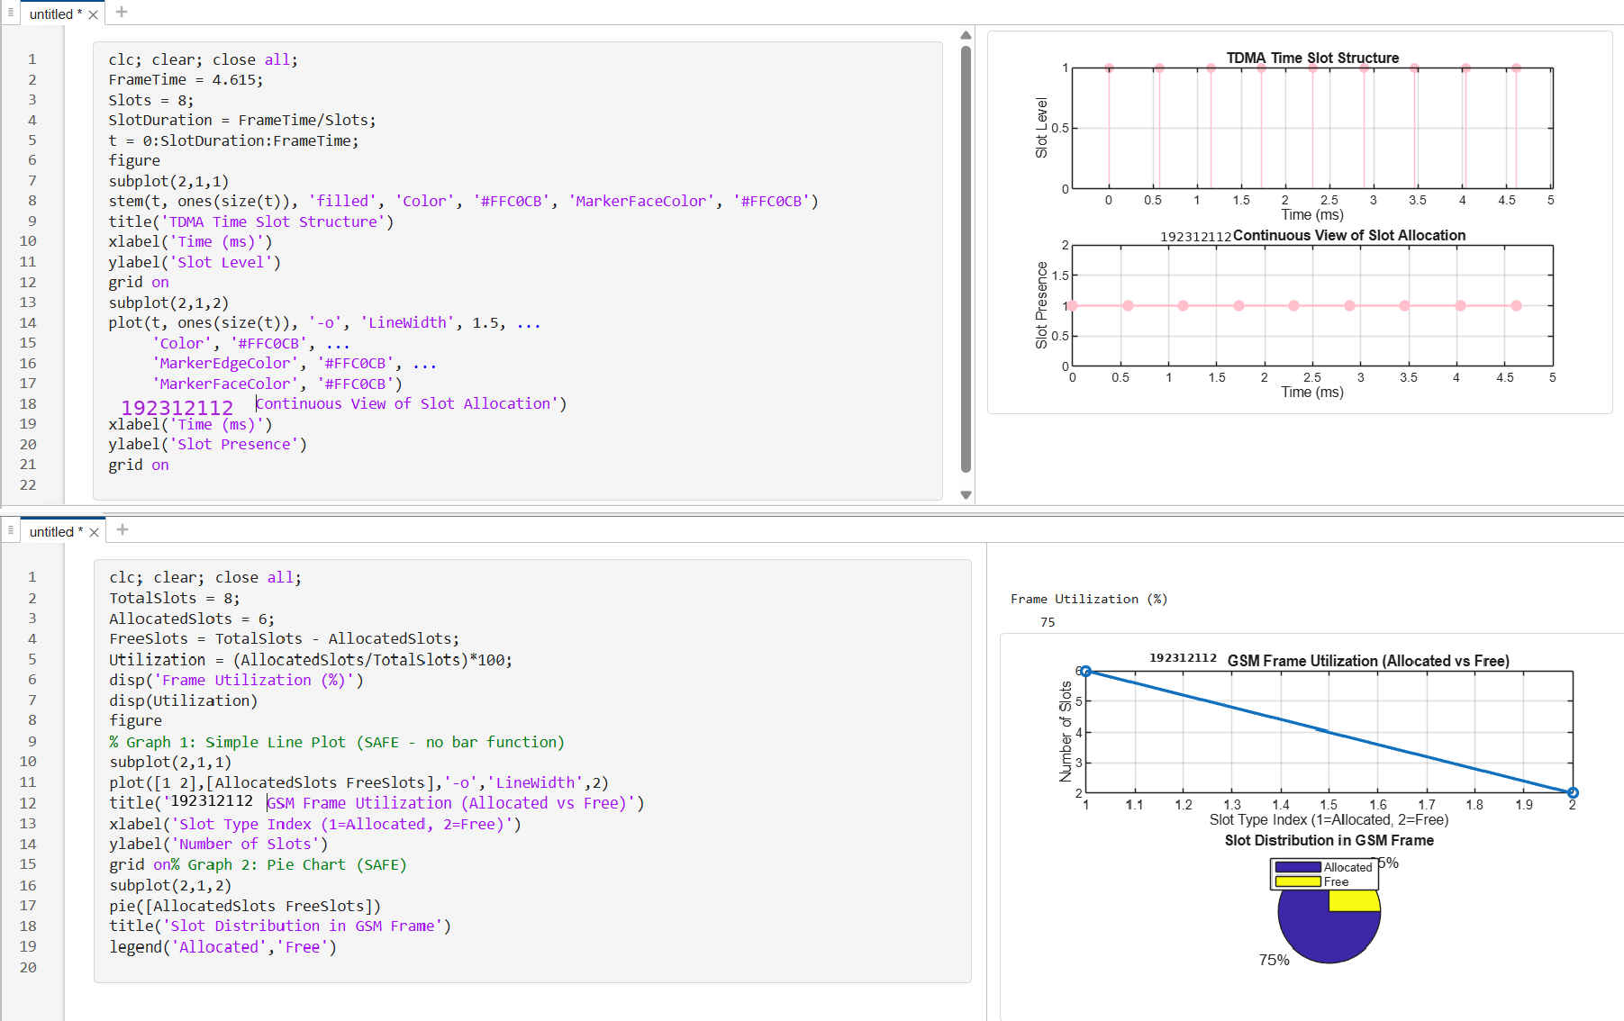
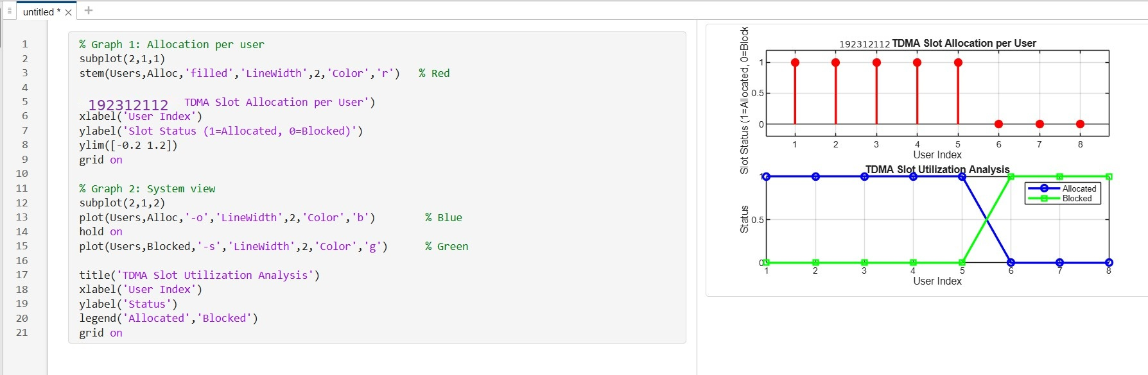

Result:
- The time slot duration in the GSM TDMA frame was successfully calculated, confirming equal division of the frame into fixed time intervals.

- The frame utilization was effectively analyzed, showing the proportion of allocated and free slots in the TDMA system.
- The Signal-to-Noise Ratio (SNR) for different users was successfully evaluated, showing that higher SNR values provide better communication quality and reliable data transmission.

