Exp.3:
Spectrum Analysis of Sub-1 GHz, Mid-band & mmWave by Plotting Propagation loss AIM:
To analyze the propagation loss characteristics of different frequency bands (Sub-1 GHz, Midband, and mmWave) in wireless communication systems and compare their performance over
varying distances using MATLAB. Objective :
- To compute the Propagation Loss (dB) for Sub-1 GHz, Mid-band, and mmWave frequency ranges using standard path loss models.
- To evaluate the impact of different Operating Frequencies (GHz) on signal attenuation and coverage performance.
- To analyze how Communication Distance (km) affects propagation loss across different spectrum bands.
Procedure
- Define frequency bands: Sub-1 GHz (0.9 GHz), Mid-band (3.5 GHz), and mmWave (28 GHz).
- Set communication distance range (e.g., 0.1 km to 5 km).
- Use Free Space Path Loss (FSPL) formula to compute propagation loss: PL(dB)=20log10(d)+20log10(f)+32.44
- Calculate propagation loss for each frequency band over varying distances.
- Plot distance vs propagation loss curves for comparison.
- Analyze how higher frequencies experience higher attenuation.
- Compare coverage efficiency of each spectrum band.
- Display results using MATLAB plots.

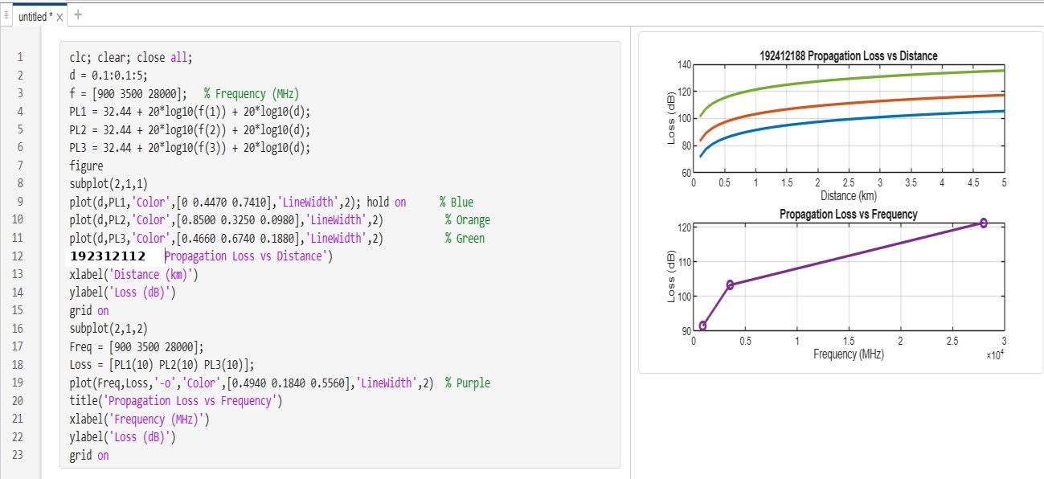
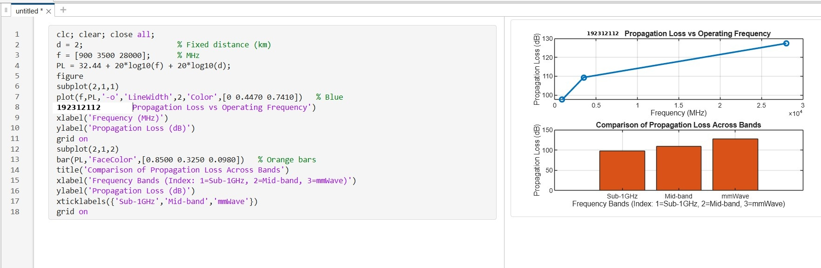
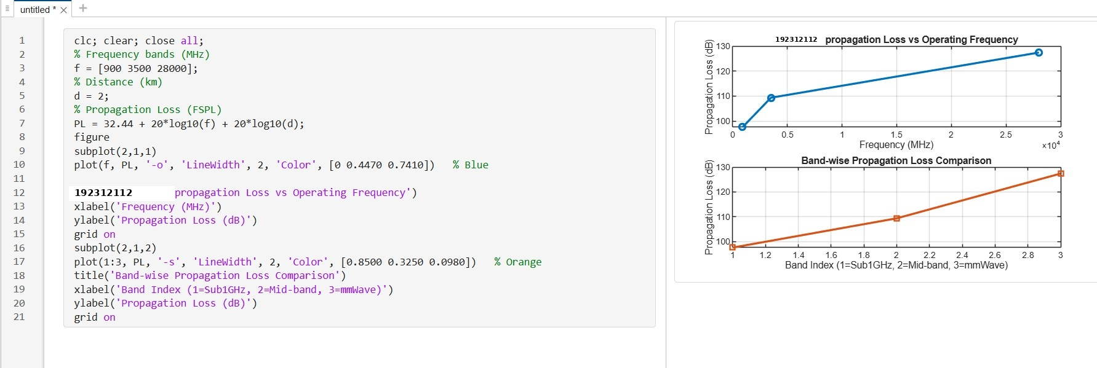
Output

Result:
- The propagation loss was successfully computed for Sub-1 GHz, Mid-band, and mmWave frequency bands using the Free Space Path Loss (FSPL) model.
- It was observed that propagation loss increases with increase in operating frequency, with mmWave showing the highest attenuation and Sub-1 GHz showing the lowest loss.
- The comparative analysis of spectrum bands clearly demonstrates that lower frequency bands are more suitable for long-range communication, while higher frequency bands require advanced techniques like beamforming for efficient performance.

