Ex.No.4: OFDMA Resource Block Allocation Date
AIM: To simulate and analyze OFDMA (Orthogonal Frequency Division Multiple Access) resource block allocation and evaluate system performance in terms of resource utilization and user throughput using MATLAB.
Objective
- To determine the Number of Resource Blocks (RBs) allocated in an OFDMA system based on available bandwidth and system configuration.
- To evaluate the Resource Block Utilization (%) by analyzing how efficiently available RBs are assigned to active users.
- To calculate the User Throughput (Mbps) based on allocated resource blocks and modulation efficiency in the OFDMA system.
Procedure
- Define the system bandwidth and calculate the number of available resource blocks (RBs) based on RB size (e.g., 180 kHz per RB).
- Identify the number of active users in the OFDMA system for resource sharing.
- Allocate resource blocks to each user based on a predefined or equal distribution strategy.
- Compute Resource Block Utilization (%) using the ratio of allocated RBs to total RBs.
- Assign modulation efficiency values (e.g., QPSK, 16-QAM, 64-QAM) for each user.
- Calculate User Throughput (Mbps) using allocated RBs and modulation efficiency.
- Plot graphs for RB allocation and utilization/throughput analysis using MATLAB.
- Analyze results to evaluate spectrum efficiency and system performance.

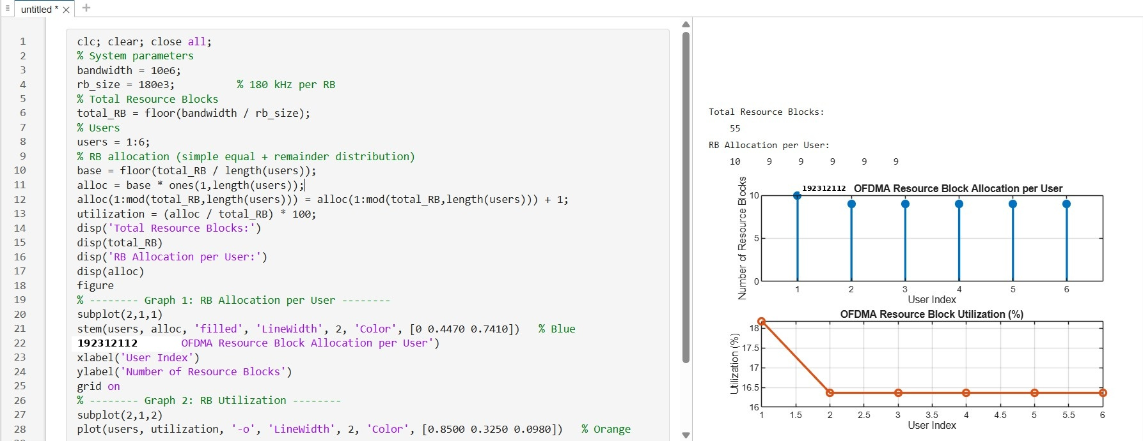
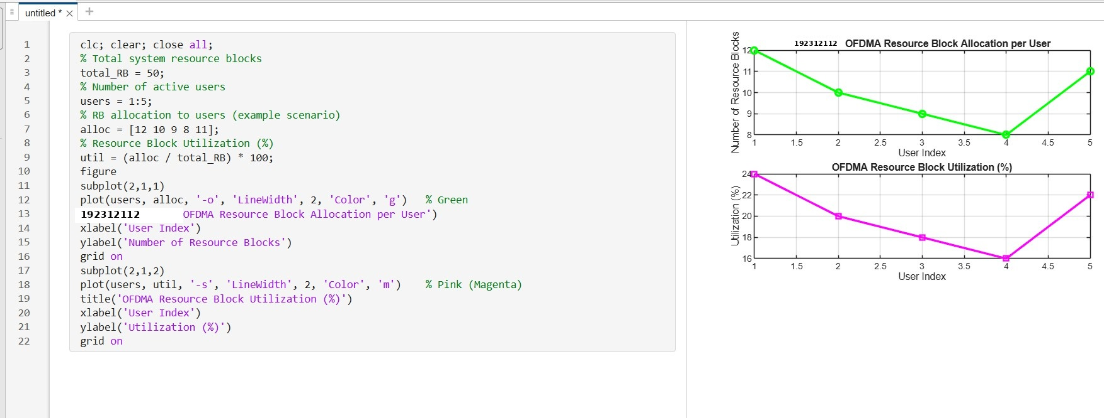
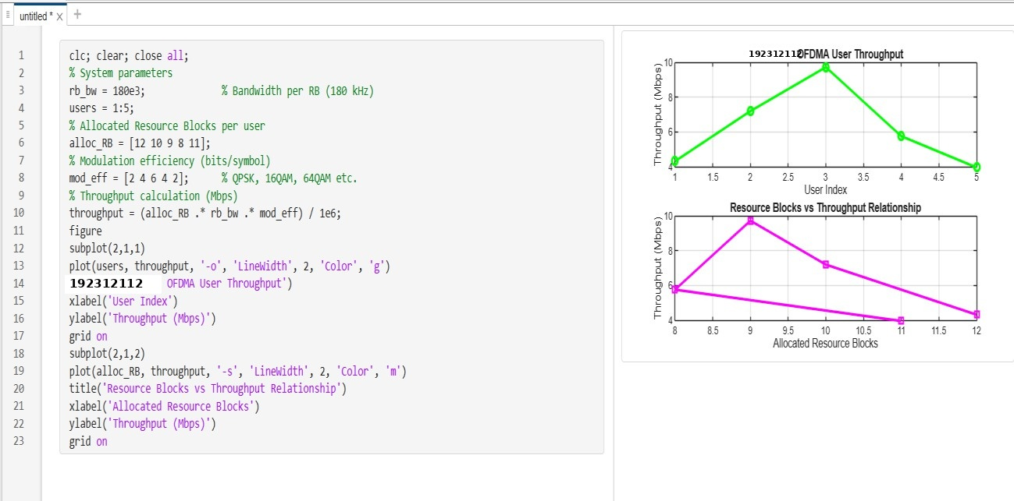
Output

Result:
- The Resource Block (RB) allocation was successfully simulated for multiple users in the OFDMA system, demonstrating how available spectrum is distributed among active
users.
- The Resource Block Utilization (%) analysis showed efficient usage of system resources, indicating how effectively the available RBs are assigned to users.
- The User Throughput (Mbps) was successfully calculated based on RB allocation and modulation efficiency, showing that higher allocated RBs and higher modulation
schemes result in increased throughput.

