Experiment: 7
Analog Beamforming Analysis Using MATLAB
Aim
To analyze the performance of analog beamforming by studying beamforming gain, beam width,
and main lobe direction using MATLAB. Objectives
- To analyze the beamforming gain achieved by varying the number of antenna elements in an analog beamforming system using MATLAB.
- To compare the beam width of an antenna array for different beamforming configurations using MATLAB.
- To analyze the main lobe direction by steering the antenna array beam to different angles using MATLAB.
Software Required
  - MATLAB
Theory
Analog beamforming is a beam steering technique in which a single RF chain drives multiple
antenna elements through adjustable phase shifters. By controlling the phase of the transmitted or
received signals, the antenna array forms a directional beam toward the intended user, thereby improving signal strength, coverage, and spectral efficiency. Analog beamforming is widely employed in millimeter-wave (mmWave) communication systems due to its reduced hardware complexity and lower power consumption.
Objective – 1
Analyze Beamforming Gain (dB)
Generate beamforming gain values for different antenna array sizes using MATLAB. Compare how increasing the number of antenna elements improves the beamforming gain and enhances

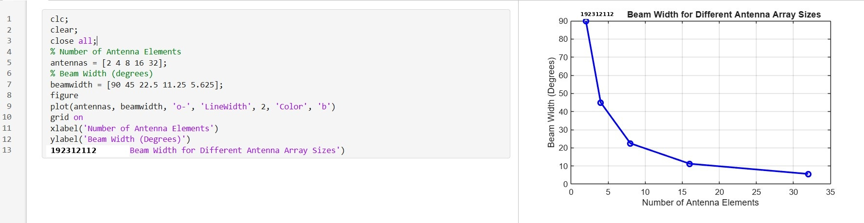
signal strength.

Objective – 2
Compare Beam Width (Degrees)
Analyze the beam width corresponding to different antenna array sizes using MATLAB. Observe how increasing the number of antenna elements results in a narrower beam, thereby improving spatial resolution.
Objective – 3
Analyze Main Lobe Direction (Degrees)
Simulate beam steering by varying the steering angle of the antenna array using MATLAB.
Observe the change in the main lobe direction and understand how analog beamforming directs energy toward the intended user.

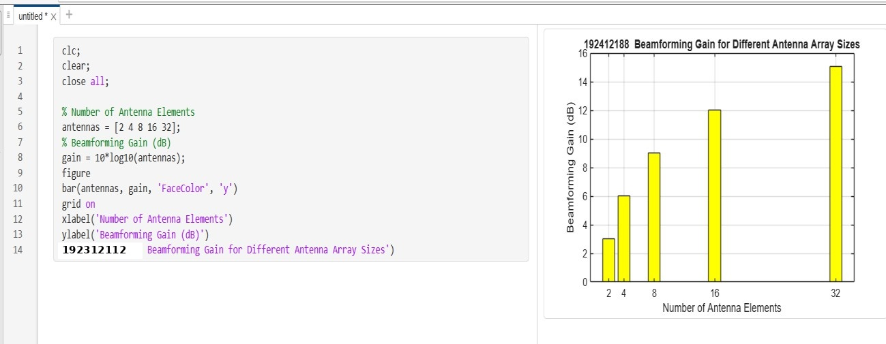
Output

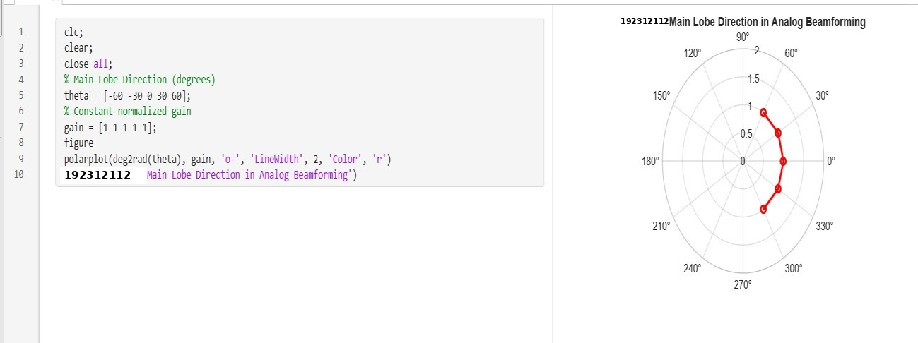

Result
Polar plot or beam pattern showing the main lobe steered to different angles. The MATLAB analysis successfully demonstrated the characteristics of analog beamforming. The results showed that increasing the number of antenna elements improves beamforming gain and reduces beam width, while phase adjustment enables the main lobe to be steered toward different directions.

