Experiment: 8
Steering Angle Variation in MIMO Beamforming Using MATLAB
Aim
To analyze the effect of steering angle variation in a MIMO beamforming system by studying steering angle, array gain, and beam direction error using MATLAB.
Objectives
- To analyze the steering angle of a MIMO beamforming system by directing the beam towards different target directions using MATLAB.
- To compare the array gain achieved for different steering angles in a MIMO beamforming system using MATLAB.
- To evaluate the beam direction error between the desired steering angle and the actual beam direction using MATLAB.
Software Required
  - MATLAB
Theory
MIMO (Multiple-Input Multiple-Output) beamforming enhances wireless communication by employing multiple antenna elements to direct transmitted energy toward a desired user. By adjusting the steering angle through appropriate phase shifts, the beam can be focused in
different
directions, improving signal strength and reducing interference. Important performance parameters include steering angle, array gain, and beam direction error, which collectively determine the effectiveness of beam steering in modern wireless systems such as 5G NR. Objective – 1
Analyze Steering Angle (Degrees)
Analyze different steering angles of a MIMO beamforming system using MATLAB. Observe how the beam can be directed toward various target directions by varying the steering angle.

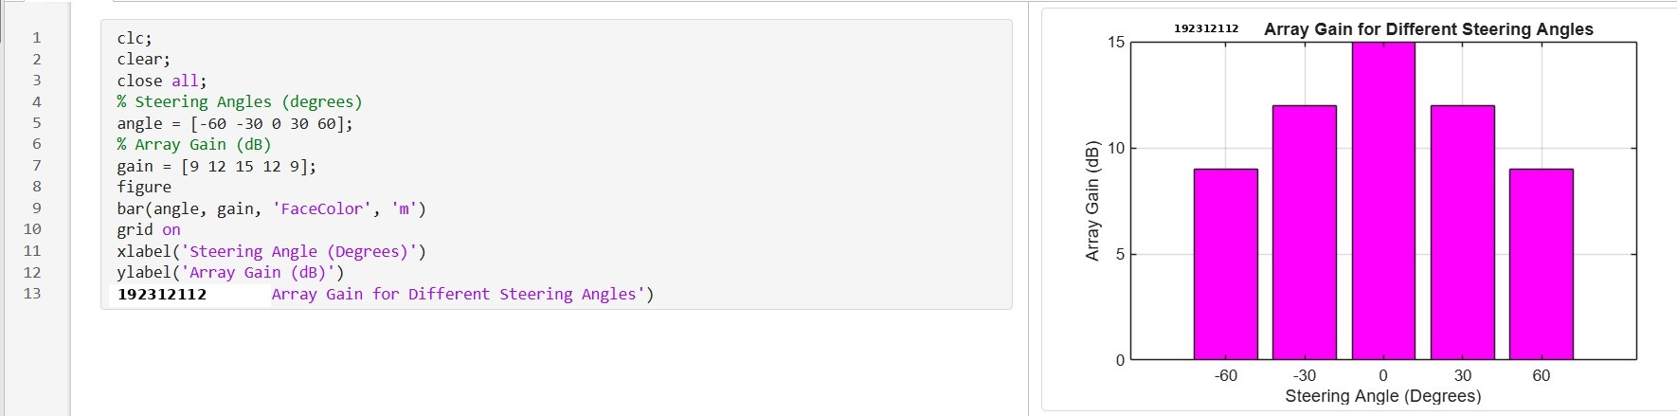
Objective – 2
Compare Array Gain (dB)
Compare the array gain obtained at different steering angles using MATLAB. Observe the improvement in signal strength achieved through beamforming.

Objective – 3
Evaluate Beam Direction Error (Degrees)
Analyze the difference between the desired steering angle and the measured beam direction using
MATLAB. Compare the beam direction error for various steering angles and evaluate the beam steering accuracy.

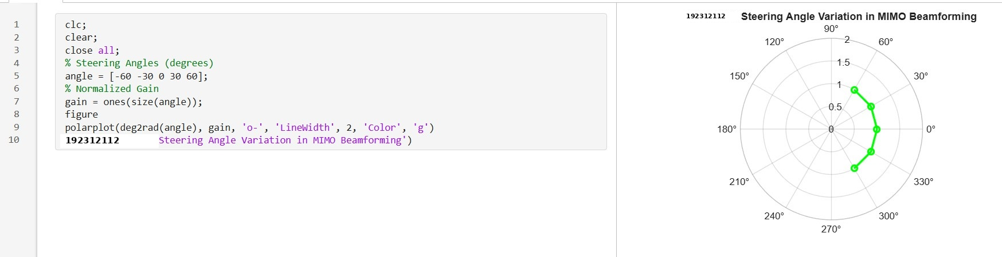
Output

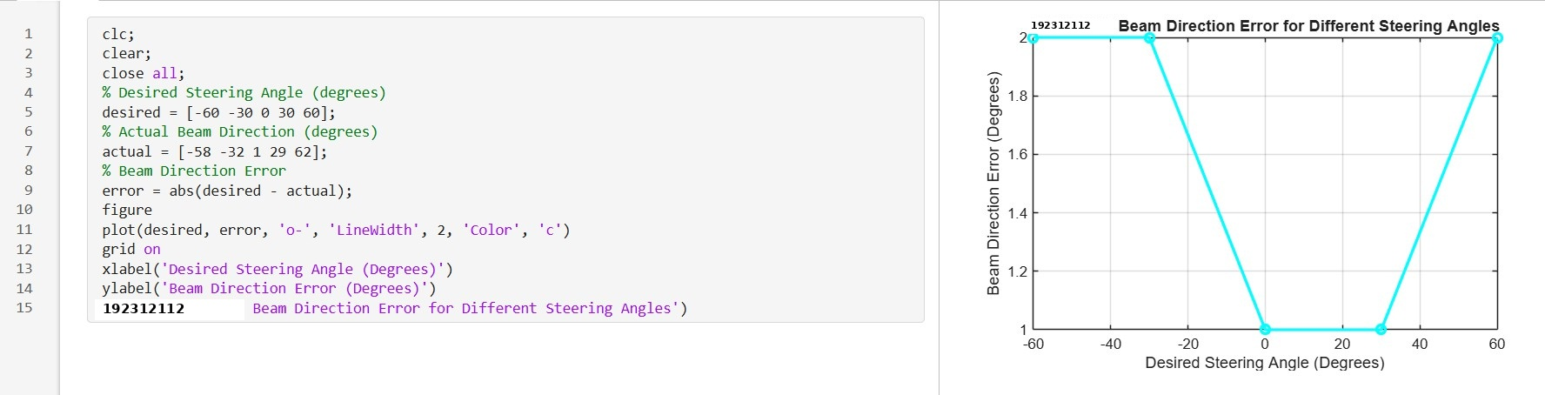

Result
Line graph showing beam direction error versus steering angle.
The MATLAB analysis successfully demonstrated steering angle variation in a MIMO
beamforming system. The results showed that beam steering effectively directs the transmitted energy toward different angles, while maintaining high array gain and minimizing beam
direction error.

