DATA ANALYTICS PROJECT
Startup Profit Analysis
Written analysis report: exploratory data analysis and multiple linear regression
Dataset source: DB (MySQL database project_profit_analysis, table startup), exported to CSV for analysis
Tools: Python (pandas, matplotlib, seaborn, scikit-learn) in Google Colab; Power BI dashboard

1. Executive summary
This report examines what drives profit for 50 startups, using how much each one spends on research and development (R&D), administration and marketing, along with the state it operates in. The analysis combines exploratory data analysis with a multiple linear regression model.
The main finding is that R&D spending is by far the strongest driver of profit. It has a correlation of 0.97 with profit, and the regression model estimates that each extra dollar of R&D adds about $0.80 of profit when the other budgets are held constant. Marketing is also linked to profit (correlation 0.75), but most of that link overlaps with R&D. Administration spending has almost no relationship with profit.
The regression model explains 90% of the variation in profit (R² = 0.90) on test data it had not seen, with an average prediction error of about $7,000. For the two new startups given in the assignment, it predicts profits of $71,236.89 and $71,040.76.

2. Objective
The project has three goals:
- Understand how R&D, administration and marketing spend relate to profit, and whether profit differs by state.
- Build a regression model that predicts profit from the three spend variables.
- Use the model to predict profit for two new startups with given spend values.

3. Dataset source confirmation
Source type: DB (database). The data was extracted directly from a MySQL database and then saved as a CSV file for analysis.
Item | Detail
Database type | MySQL
Database name | project_profit_analysis
Table | startup
Connection | Python mysql.connector from Google Colab
Extraction query | SELECT * FROM startup
CSV used for analysis | startup_profit_analysis.csv
CSV prepared for Power BI | startup_profit_analysis_powerbi.csv (imported as .xlsx)
Power BI dashboard | Startup_Profit_Analysis_Dashboard.pbix

4. Data understanding

4.1 Structure
The dataset has 50 rows (one per startup) and 5 columns:
Column | Type | Description
RD_Spend | Numeric | Money spent on research and development
Administration | Numeric | Money spent on administration and overhead
Marketing_Spend | Numeric | Money spent on marketing
State | Text | New York (17), California (17) or Florida (16)
Profit | Numeric | Profit earned; the target variable

4.2 Data quality
The data was checked for missing values and duplicate rows. There were no missing values in any column and no duplicate rows, so no cleaning was needed. All three states are almost equally represented.
R&D spend and marketing spend both have a minimum of $0, meaning some startups reported no spending in those areas. These values were kept because they are plausible for early-stage companies.

4.3 Summary statistics
Variable | Mean | Std dev | Min | Median | Max
R&D Spend | 73,722 | 45,902 | 0 | 73,051 | 165,349
Administration | 121,345 | 28,018 | 51,283 | 122,700 | 182,646
Marketing Spend | 211,025 | 122,290 | 0 | 212,716 | 471,784
Profit | 112,013 | 40,306 | 14,681 | 107,978 | 192,262

Marketing is the largest budget on average ($211,025), almost three times the average R&D spend ($73,722). Profit ranges widely, from $14,681 to $192,262, with an average of $112,013.

5. Exploratory data analysis

5.1 Correlation analysis
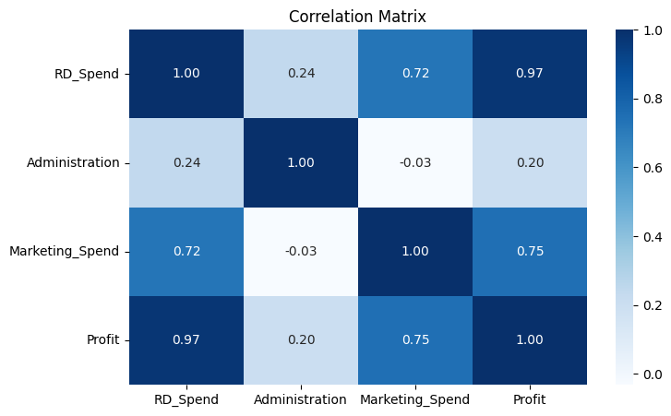
Figure 1. Correlation matrix of the numeric variables
Variable | Correlation with Profit | Strength
R&D Spend | 0.97 | Very strong, positive
Marketing Spend | 0.75 | Strong, positive
Administration | 0.20 | Weak, positive

R&D spend has an almost perfect positive relationship with profit. Marketing spend also has a strong positive relationship. Administration has only a weak one.
R&D and marketing are themselves correlated (0.72): startups that spend more on R&D tend to spend more on marketing too. This matters for the regression, because it means the two variables partly carry the same information.

5.2 Spend versus profit
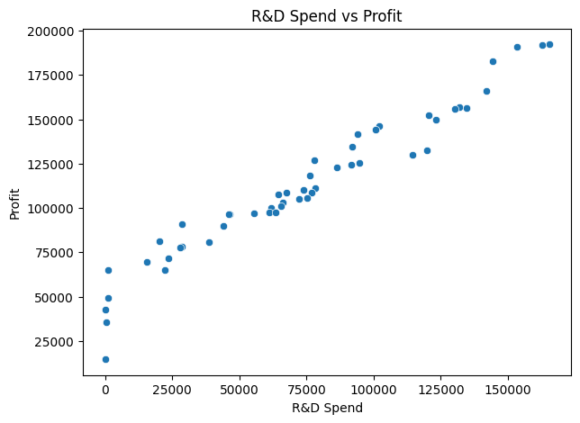
Figure 2. R&D spend vs profit
The points form an almost straight line rising from left to right. Startups that invest more in R&D consistently earn more profit, with little scatter around the trend.
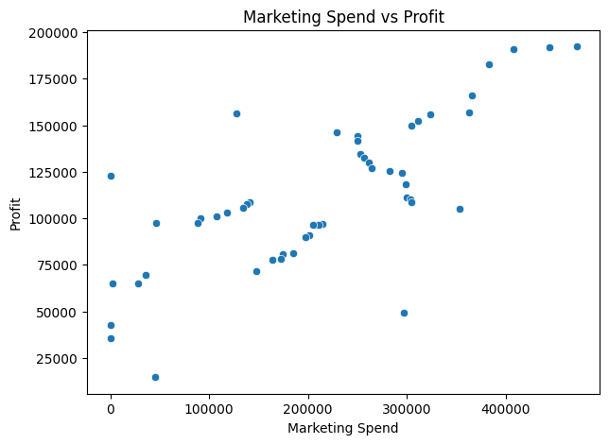
Figure 3. Marketing spend vs profit
Profit also rises with marketing spend, but the points are more spread out. Some startups with high marketing spend earn only moderate profit, so marketing on its own is a less reliable guide.
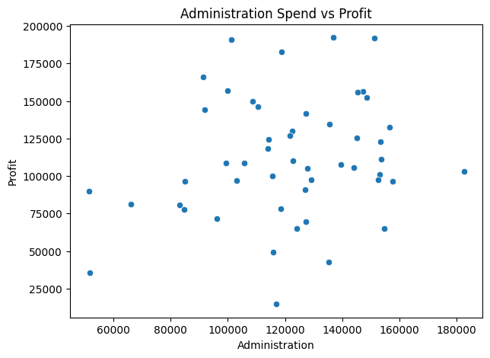
Figure 4. Administration spend vs profit
There is no clear pattern here. Startups with similar administration budgets earn very different profits, which supports the weak correlation of 0.20.

5.3 Profit by state
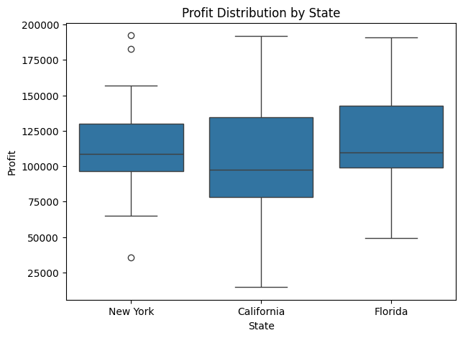
Figure 5. Profit distribution by state
The typical (median) profit is similar in all three states, roughly $98,000 to $110,000, and the boxes overlap heavily. California shows the widest spread, including the lowest profit in the dataset. New York has two unusually high earners and one unusually low one, shown as outliers. Overall, the state a startup is in appears to matter much less than how it spends its money.

6. Regression model

6.1 Method
A multiple linear regression model was built with scikit-learn to predict profit from the three spend variables. State was not included as an input.
Setting | Value
Inputs (X) | RD_Spend, Administration, Marketing_Spend
Target (y) | Profit
Train / test split | 80% training (40 rows), 20% testing (10 rows)
Random state | 42
Algorithm | LinearRegression

6.2 Coefficients
Term | Coefficient | Meaning
Intercept | 54,071.88 | Baseline profit when all spend is zero
RD_Spend | 0.8038 | +$0.80 profit per extra $1 of R&D
Administration | −0.0679 | −$0.07 profit per extra $1 of administration
Marketing_Spend | 0.0312 | +$0.03 profit per extra $1 of marketing

Fitted equation: Profit = 54,071.88 + 0.8038 × RD_Spend − 0.0679 × Administration + 0.0312 × Marketing_Spend
Each coefficient shows the change in profit for one extra dollar of that spend, with the other two held constant. R&D has by far the largest effect. Marketing's coefficient is small even though its correlation with profit is strong. This is because marketing and R&D overlap: once the model knows a startup's R&D spend, marketing adds little extra information. Administration has a small negative coefficient, suggesting that higher overhead does not translate into higher profit.

6.3 Model performance
Metric | Value | Interpretation
R² score | 0.9001 | The model explains 90% of the variation in profit
Mean absolute error (MAE) | 6,979.15 | Predictions miss by about $7,000 on average
Mean squared error (MSE) | 80,926,321.22 | Average squared error (used to compute RMSE)
Root mean squared error (RMSE) | 8,995.91 | Typical error, about 8% of average profit

An R² of 0.90 on unseen test data is a strong result. The RMSE of $8,996 is about 8% of the average profit of $112,013, so predictions are usually close to actual values. Because the test set has only 10 startups, these figures could change somewhat with a different split.

6.4 Predictions for new startups
Input | R&D Spend | Administration | Marketing Spend | Predicted Profit
Startup 1 | 21,892.92 | 81,910.77 | 164,270.70 | 71,236.89
Startup 2 | 23,940.93 | 96,489.63 | 137,001.10 | 71,040.76

Both startups are predicted to earn about $71,000, well below the dataset average of $112,013. This is mainly because their R&D spend (about $22,000 to $24,000) is far below the average of $73,722.
The two predictions are close even though the inputs differ. Startup 2 spends $2,048 more on R&D (about +$1,646 profit), but $14,579 more on administration (about −$990) and $27,270 less on marketing (about −$852). These effects almost cancel, leaving Startup 2 just $196 below Startup 1.

6.5 Power BI dashboard
The results are also presented in an interactive Power BI dashboard (Startup_Profit_Analysis_Dashboard.pbix). The exported data was saved as an Excel file and imported into Power BI. A calculated DAX column, Predicted Profit, applies the regression equation above to every startup, and a separate REGRESSION_RESULTS table holds the four model metrics.
Dashboard element | What it shows
Regression result cards | R² 0.90, MAE 6,979, MSE 80.9M, RMSE 8,996
Totals card | Total R&D $3.69M, administration $6.07M, marketing $10.55M, profit $5.60M
Spend vs profit scatter plots | R&D, administration and marketing spend against profit, one dot per startup
Actual vs predicted scatter | Model fit across all 50 startups (R² 0.95, average miss $6,674)
Average profit by state | Florida $118,774, New York $113,756, California $103,905

Across all 50 startups, the predicted values closely follow actual profit. The fit is higher than the test score because this view includes the 40 training startups. The largest miss is a California startup with no R&D spend, which earned $14,681 against a predicted $47,537.

7. Key insights and recommendations
- Prioritise R&D. It is the strongest driver of profit, returning about $0.80 for every $1 spent in this data.
- Use marketing to support R&D, not replace it. Marketing is linked to profit, but adds little once R&D is taken into account.
- Keep administration costs lean. Higher overhead does not raise profit and is associated with a slight decrease.
- Do not rely on location. Profit ranges overlap across New York, California and Florida, so state is a secondary factor.

8. Limitations
- Small sample. Only 50 startups were available, and the model was evaluated on just 10.
- State not modelled. State was explored visually but not included in the regression.
- Correlated inputs. R&D and marketing are correlated (0.72), which makes their separate effects harder to pin down.
- No significance testing. scikit-learn does not report p-values, so it is not confirmed whether the administration and marketing coefficients differ meaningfully from zero.
- Correlation is not causation. The data shows that R&D and profit move together, not that R&D directly causes higher profit.

Suggested next steps
- Add State to the model as dummy variables to test whether location affects profit.
- Fit the model with statsmodels OLS to obtain p-values and confidence intervals.
- Use k-fold cross-validation for a more reliable accuracy estimate.
- Collect data on more startups to make the estimates more reliable.

9. Conclusion
R&D spending is the main driver of startup profit in this dataset. A multiple linear regression using R&D, administration and marketing spend explains 90% of the variation in profit on unseen data, with an average error of about $7,000. Startups that want to maximise profit should invest in R&D first, use marketing to support it, and keep administrative overhead under control.

