Customer Segmentation of U.S. Shoppers
Insights & Analytics Report
Project CDACL-002 · Shopping Trends Analysis
Team: Team 5
Data source: MySQL database “customer segmentation”, table shopping_trends_dataset (3,900 records, 18 attributes)
Tools: Python (Google Colab) · pandas · SQLAlchemy/PyMySQL · scikit-learn · SciPy · matplotlib/seaborn
Date: October 2026

1. Executive summary
We analysed 3,900 purchases from U.S. shoppers to answer three business questions: where discounts should be applied, how card spending varies with age, season and location, and how customers can be grouped into segments for targeted marketing. The main findings are:
- Discounts: prioritise Sports (lowest revenue share and least loyal buyers, but the highest rating), and use bundle or threshold offers on Clothing, where discounted baskets are 6.5% larger. Do not discount Home Decor: discounted orders are 5% smaller and its low rating points to a product-quality issue.
- Card spending: 40.4% of purchases ($405,807) are paid by credit or debit card. Spend per card purchase is the same across age, season and city (all p > 0.8). Totals differ only because of transaction volume: 36–45 year olds, Spring and New York generate the most card spend.
- Segments: K-Means with K = 4 on value features found Frequent Regulars (34% of revenue), Big Spenders at Risk (33%, but rating 2.3/5), Happy Occasionals (22%, rating 4.6) and Unhappy Bargain Buyers (11%). A second clustering found that offer behaviour (discount and promo-code use) splits customers into four equal offer-response groups.
- Action: target customers by value segment and choose the offer by offer-response segment. The most urgent priority is retaining the Big Spenders, who hold one third of revenue but are dissatisfied.

2. Data and methodology

2.1 Dataset
The data was loaded from the MySQL server (18.136.157.135) using SQLAlchemy with the team account dm_team5. The table shopping_trends_dataset contains 3,900 purchase records and 18 attributes: customer ID, age, gender, item purchased, category, purchase amount (USD), location, size, color, season, review rating, subscription status, shipping type, discount applied, promo code used, previous purchases, payment method and frequency of purchases.
Attribute | Values in this dataset
Category | Accessories 820 · Clothing 796 · Electronics 772 · Home Decor 760 · Sports 752
Location | New York 812 · Los Angeles 806 · Chicago 777 · Houston 764 · Miami 741
Payment | Credit Card 802 · UPI 792 · PayPal 791 · Debit Card 772 · Cash 743
Season | Spring 1,047 · Fall 987 · Winter 961 · Summer 905
Frequency | Monthly 1,319 · Weekly 1,308 · Fortnightly 1,273
Numeric ranges | Age 18–64 · Amount $10.08–$499.84 · Rating 1–5 · Previous purchases 0–14

2.2 Data preparation
- Column names were standardised (the database stores them without underscores, e.g. purchaseamountusd → amount).
- Quality checks: no missing values and no duplicate rows. All 3,900 records were kept.
- Derived fields: age groups (18–25 … 56–65), card flag (credit or debit card), purchases per year (Weekly 52, Fortnightly 26, Monthly 12), and 0/1 flags for discount, promo code, subscription, gender and express shipping.

2.3 Methods
- Task 1: category comparison on revenue share, order value, rating, subscriber share and discount response (average order with ÷ without discount), combined into a rank-based discount priority score.
- Task 2: aggregation of card spend by age group, season and city, with ANOVA, Kruskal-Wallis and chi-square tests.
- Task 3: standardised features, K-Means for K = 2–8, K chosen by elbow and silhouette score, Random-Forest feature importance and centroid spread to identify dominant factors.

3. Task 1 – Where should discounts be applied?
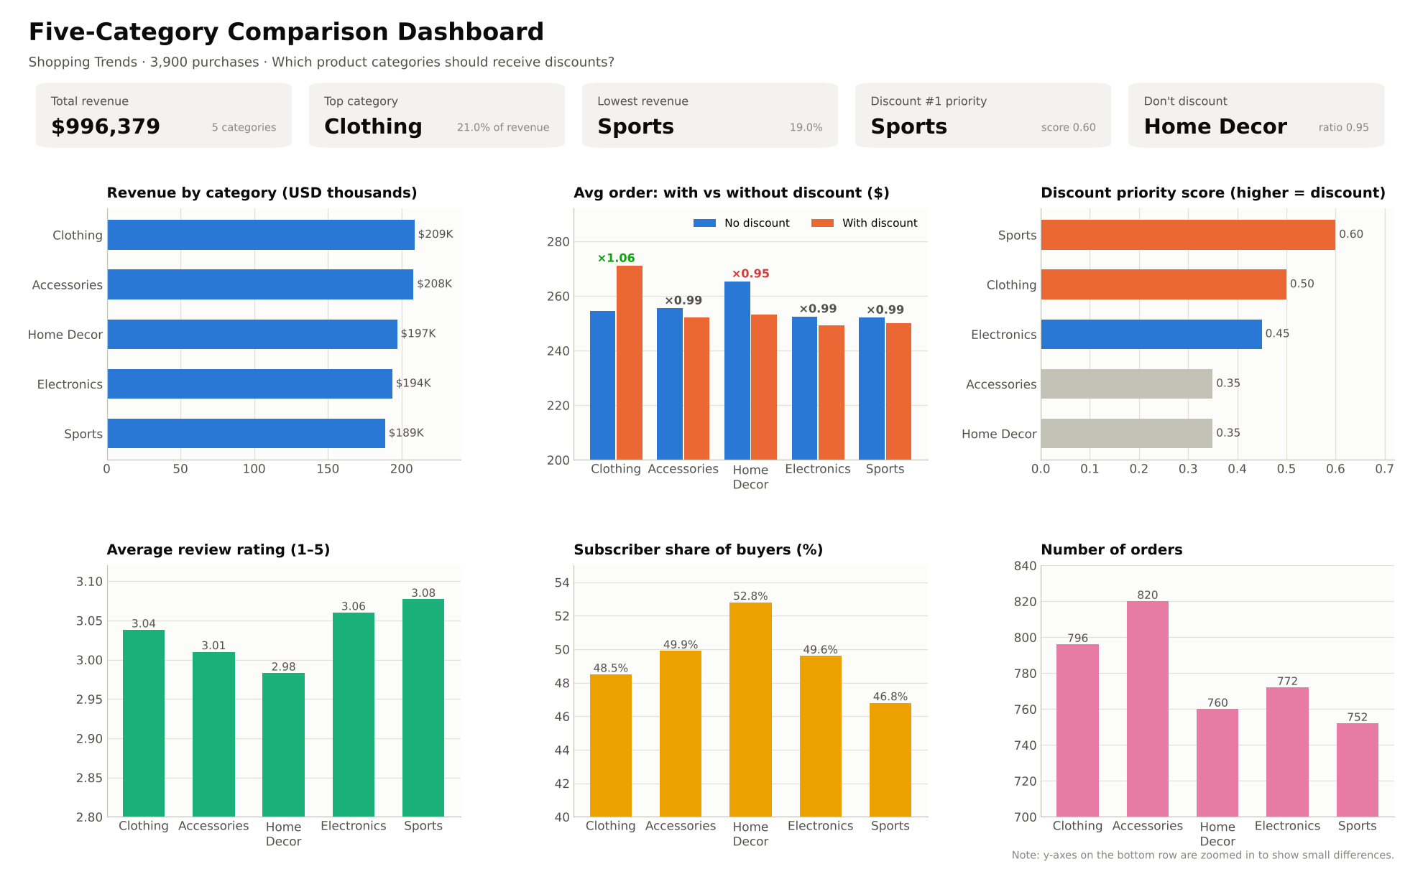
Figure 1. Five-category comparison dashboard
Category | Revenue | Share | Avg order | Rating | Subscribers | With disc. | Without | Ratio
Clothing | $208,775 | 21.0% | $262.28 | 3.04 | 48.5% | $270.98 | $254.42 | 1.065
Accessories | $208,063 | 20.9% | $253.74 | 3.01 | 49.9% | $252.05 | $255.48 | 0.987
Home Decor | $197,000 | 19.8% | $259.21 | 2.98 | 52.8% | $253.10 | $265.29 | 0.954
Electronics | $193,683 | 19.4% | $250.88 | 3.06 | 49.6% | $249.13 | $252.43 | 0.987
Sports | $188,858 | 19.0% | $251.14 | 3.08 | 46.8% | $250.16 | $252.05 | 0.993
Table 1. Category metrics (ratio = average order with discount ÷ without discount)

3.1 Discount priority score
Each category was ranked on four signals and the ranks were averaged: low revenue share, low rating, low subscriber share (low loyalty) and discount responsiveness (ratio). A higher score means a discount is more justified.
Category | Low revenue | Low rating | Low loyalty | Disc. response | Priority score
Sports | 0.8 | 0.0 | 0.8 | 0.8 | 0.60
Clothing | 0.0 | 0.4 | 0.6 | 1.0 | 0.50
Electronics | 0.6 | 0.2 | 0.4 | 0.6 | 0.45
Home Decor | 0.4 | 0.8 | 0.0 | 0.2 | 0.35
Accessories | 0.2 | 0.6 | 0.2 | 0.4 | 0.35

3.2 Recommendation and reasoning
- Sports – apply discounts (priority 0.60). It has the lowest revenue ($188,858, 19.0%) and the lowest subscriber share (46.8%), so buyers are the least loyal. Yet it has the highest rating (3.08), so customers like the products. Spend holds up when discounted ($250 vs $252). A discount here brings in new buyers rather than subsidising existing ones.
- Clothing – use bundle or threshold discounts (priority 0.50). Clothing is already the top category, but it is the only one where discounted orders are larger ($271 vs $254, +6.5%). Discounts should be designed to increase basket size, e.g. “10% off orders over $300”, not blanket price cuts.
- Home Decor – do not discount. Discounted orders are 5% smaller ($253 vs $265), so discounts lose revenue. It has the most subscribers (52.8%) but the lowest rating (2.98), which points to product quality or description issues rather than price.
- Electronics and Accessories show a neutral response (ratio 0.99) and need only occasional seasonal promotions.
Caveat: all five categories are close (19–21% of revenue, ratings 2.98–3.08), so the ranking is a relative priority. Item-to-category labels in the dataset are not always consistent (e.g. Football appears under Clothing), so recommendations are made at category level.

4. Task 2 – Card spending by age, season and location
1,574 of 3,900 purchases (40.4%) were paid by credit or debit card, worth $405,807 (40.7% of revenue). Credit cards (802) are used slightly more than debit cards (772).
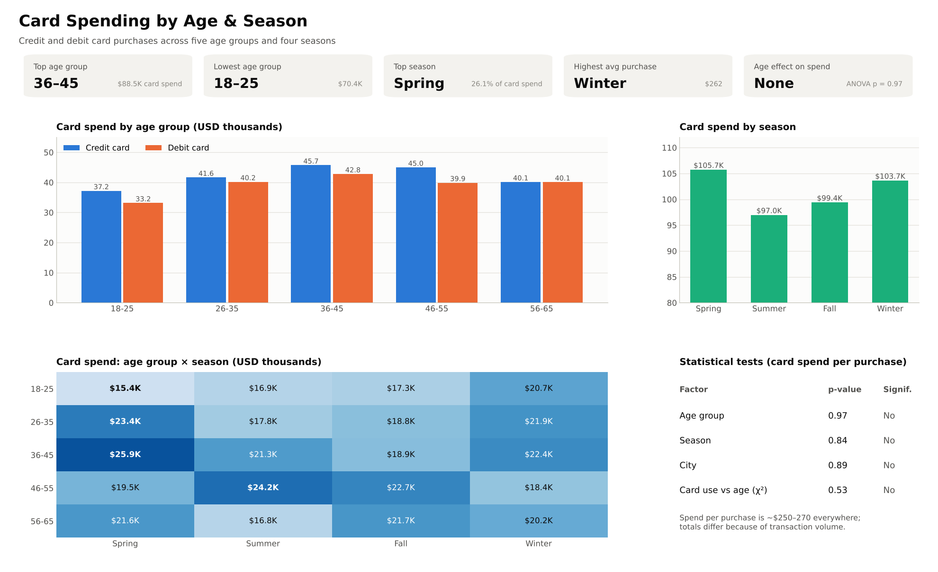
Figure 2. Card spending by age group and season

4.1 Card spending by age
Age group | Credit card | Debit card | Total card spend | Transactions | Avg (credit / debit)
18–25 | $37,198 | $33,169 | $70,367 | 269 | $257 / $267
26–35 | $41,641 | $40,181 | $81,821 | 321 | $259 / $251
36–45 | $45,720 | $42,803 | $88,523 | 347 | $269 / $242
46–55 | $44,988 | $39,893 | $84,881 | 328 | $249 / $271
56–65 | $40,125 | $40,090 | $80,215 | 309 | $277 / $244

- 36–45 year olds spend the most on cards ($88.5K) and 18–25 the least ($70.4K, about 21% lower).
- Credit card spend exceeds debit card spend in every age group.
- Spend per card purchase is $242–$277 in every age group. The higher totals come from more card purchases, not larger ones. No customers in the data are over 65.

4.2 Effect of season
Season | Transactions | Card spend | Avg purchase | Share of card spend
Spring | 416 | $105,748 | $254.20 | 26.1%
Summer | 374 | $96,989 | $259.33 | 23.9%
Fall | 389 | $99,419 | $255.58 | 24.5%
Winter | 395 | $103,651 | $262.41 | 25.5%

- Spring brings the most card spend (26.1%) and Summer the least (23.9%). Winter has the highest average purchase ($262).
- Age × season hotspots: 36–45 in Spring ($25.9K, the largest cell), 46–55 in Summer ($24.2K) and 26–35 in Spring ($23.4K). Young shoppers (18–25) peak in Winter ($20.7K), consistent with holiday shopping.

4.3 Effect of location
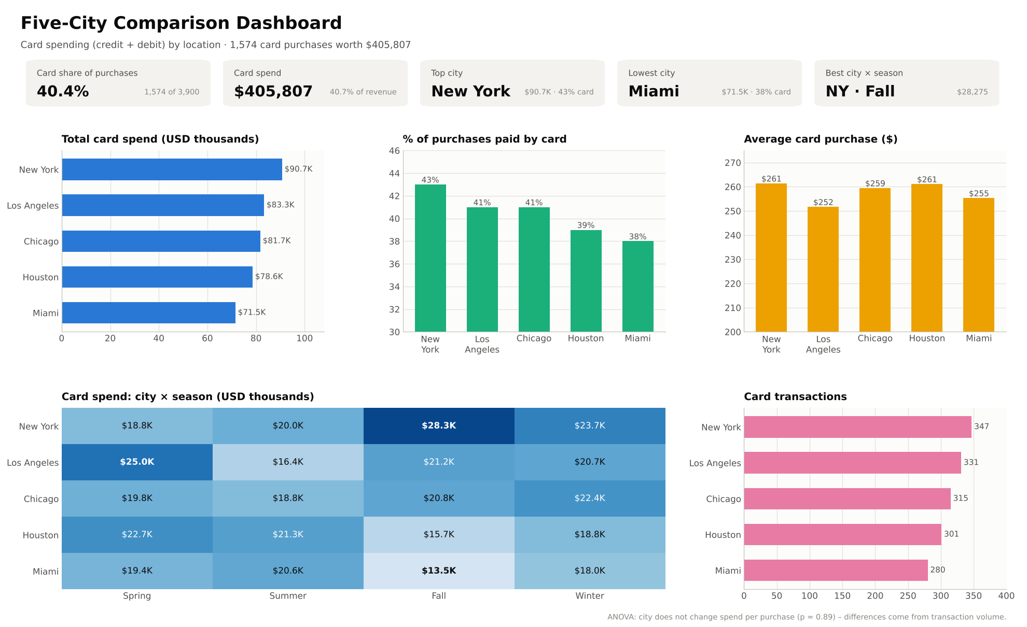
Figure 3. Five-city comparison dashboard
City | Transactions | Card spend | Avg purchase | Card share of purchases
New York | 347 | $90,703 | $261.39 | 43%
Los Angeles | 331 | $83,298 | $251.66 | 41%
Chicago | 315 | $81,731 | $259.46 | 41%
Houston | 301 | $78,588 | $261.09 | 39%
Miami | 280 | $71,488 | $255.31 | 38%

- New York leads in card spend ($90.7K) and card usage (43%); Miami is lowest ($71.5K, 38%).
- Strongest city–season combinations: New York in Fall ($28.3K) and Los Angeles in Spring ($25.0K). Weakest: Miami in Fall ($13.5K) and Houston in Fall ($15.7K).

4.4 Statistical tests
Test | ANOVA p | Kruskal-Wallis p | Significant (p < 0.05)?
Card spend vs age group | 0.9717 | 0.9748 | No
Card spend vs season | 0.8431 | 0.8279 | No
Card spend vs city | 0.8881 | 0.8892 | No
Card use vs age group (chi-square) | 0.5306 | – | No

Conclusion: age, season and location do not change how much customers spend per card purchase. The differences in totals come from how many card purchases each group makes. Card campaigns should therefore aim to increase card transaction volume in the hotspot groups (36–45 in Spring, New York in Fall, 18–25 in Winter) and raise card usage in Miami and Houston (38–39%).

5. Task 3 – Customer clustering

5.1 Choosing the number of clusters
Eight features (age, purchase amount, previous purchases, purchases per year, rating, subscription, discount and promo-code flags) were standardised and K-Means was run for K = 2 to 8. The elbow curve has no sharp bend, so the silhouette score was used. Among practical cluster counts (3–5), K = 4 scores best (0.145 vs 0.120 for K = 3 and 0.119 for K = 5). K = 7–8 score slightly higher but are too many to act on. The four clusters are balanced (943–1,052 customers).
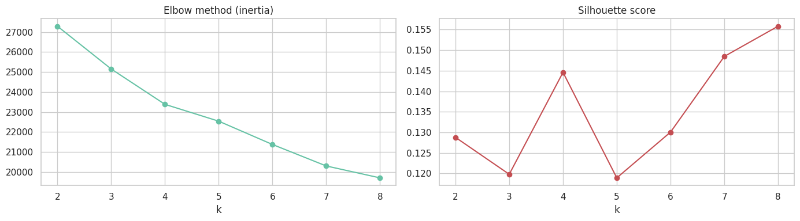
Figure 4. Elbow method and silhouette score
The low silhouette value shows that customer behaviour is continuous rather than sharply separated, so segments should be read as tendencies.

5.2 Clustering 1 – offer-response segments
Random-Forest importance and centroid spread both show that discount use and promo-code use are the dominant factors (about 94% of combined importance). Each cluster is 0% or 100% on these flags, while age (≈41), order value ($252–$261), previous purchases (≈7), purchases per year (≈30) and rating (≈3.0) are almost identical.
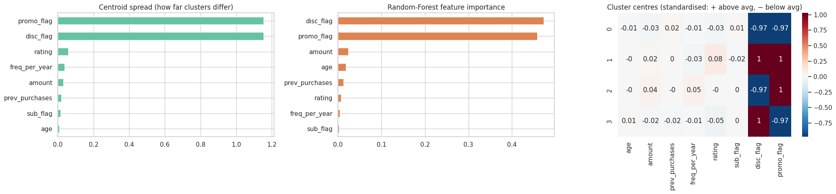
Figure 5. Dominant factors for clustering 1
Segment | Discount | Promo code | Customers | Revenue share | Peak season | Top payment
0 · Full-Price Loyalists | No | No | 1,052 | 27% | Spring | Credit Card
1 · Deal Maximisers | Yes | Yes | 943 | 24% | Fall | UPI
2 · Promo-Code Responders | No | Yes | 951 | 25% | Spring | PayPal
3 · Discount-Only Shoppers | Yes | No | 954 | 24% | Fall | Credit Card

The two discount-using segments shop most in Fall and the non-discount segments in Spring, a small but useful timing signal.

5.3 Clustering 2 – value segments
To find segments based on customer value, K-Means (K = 4) was repeated using only value features: age, order value, previous purchases, purchases per year and rating. The dominant factors are purchase frequency, order value and rating; age and previous purchases do not separate customers.
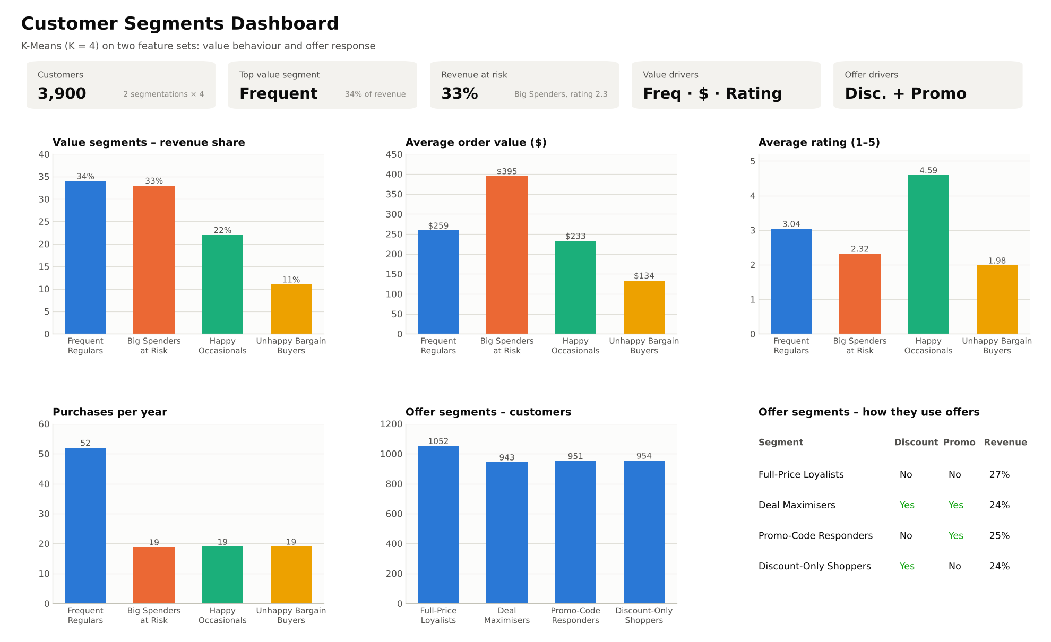
Figure 6. Customer segments dashboard
Value segment | Customers | Avg order | Buys / year | Rating | Revenue share
Frequent Regulars | 1,305 | $259 | 52 | 3.04 | 34%
Big Spenders at Risk | 838 | $395 | 19 | 2.32 | 33%
Happy Occasionals | 939 | $233 | 19 | 4.59 | 22%
Unhappy Bargain Buyers | 818 | $134 | 19 | 1.98 | 11%

A cross-tabulation shows each value segment contains all four offer-response groups in roughly equal numbers, so offer behaviour is independent of customer value. The two segmentations can therefore be combined.

6. Targeted marketing campaigns

6.1 By value segment (who to prioritise)
- Frequent Regulars (34% of revenue, weekly buyers): loyalty points and free express shipping, bundles to increase basket size, cross-sell from Accessories to Clothing. Avoid deep discounts.
- Big Spenders at Risk (33% of revenue, rating 2.3): post-purchase follow-up, quality guarantee and easy returns, a VIP programme with priority support and early access to new Electronics and Sports lines, and a win-back voucher after a low rating. This is the highest-priority segment.
- Happy Occasionals (22%, rating 4.6): monthly reminder emails, back-in-stock alerts, a “Give $10, get $10” referral programme, and requests for reviews and testimonials.
- Unhappy Bargain Buyers (11%, $134 per order): low-cost discounts on entry-level items, a short satisfaction survey with a coupon reward, and limited marketing spend.

6.2 By offer segment (which offer to send)
- Full-Price Loyalists: no discounts; new arrivals, premium Clothing and loyalty perks. Spring launches, Los Angeles focus, credit card cashback.
- Deal Maximisers: “spend more, save more” tiers and Accessories + Shoes bundles, one offer per order. Fall sale, Chicago, UPI checkout offers.
- Promo-Code Responders: personalised codes by email/SMS with a 7-day expiry, tied to Electronics and Accessories. Spring, Los Angeles, PayPal offers.
- Discount-Only Shoppers: on-site sale banners, price-drop alerts on wish-listed items and seasonal clearance. Fall, New York, card cashback.

6.3 Combined strategy matrix
Value \ Offer | Full-price | Deal maximiser | Promo-code | Discount-only
Frequent Regulars | Loyalty points, no offers | Bundle tiers | Weekly personal codes | Member-only sales
Big Spenders at Risk | VIP service & guarantee | Premium bundles | VIP code after bad review | Early sale access
Happy Occasionals | Referral programme | Seasonal deals | Comeback codes | Price-drop alerts
Unhappy Bargain Buyers | Survey, fix issues | Entry-level bundles | Survey-reward codes | Clearance items

7. Conclusions, limitations and next steps

7.1 Conclusions
- Discount Sports; use bundle discounts on Clothing; fix Home Decor quality instead of cutting prices.
- Card spend per purchase is the same across age, season and city; volume peaks with 36–45 year olds, in Spring and in New York.
- Customer value is driven by purchase frequency, order value and satisfaction; offer behaviour forms a separate, independent dimension.
- One third of revenue sits with dissatisfied Big Spenders, so retention is the most valuable action.

7.2 Limitations
- Differences between categories, ages, seasons and cities are small; several are not statistically significant.
- Silhouette scores are low (0.15–0.17), so clusters overlap.
- Item and category labels are inconsistent in the dataset, limiting item-level analysis.
- There are no transaction dates, so trends over time and true recency cannot be measured.

7.3 Next steps
- A/B-test each campaign against a control group and measure revenue per customer.
- Track segment size and revenue share quarterly, especially the Big Spenders at Risk.
- Collect reasons behind low ratings to guide product fixes in Home Decor.
- Add transaction dates and re-cluster with recency, frequency and monetary (RFM) features.

Appendix – Submission files
- Customer_Segmentation_Presentation.pptx – presentation with speaker notes
- Customer_Segmentation_Report.docx – this report
- dashboard_1 to dashboard_4 (.png) – dashboard screenshots, including the five-category and five-city comparisons
- customer_clustering.ows – Orange workflow for K-Means clustering (optional)
- customer_segmentation.ipynb – Google Colab notebook with all code and outputs

