ROCK,PAPER AND SCISSORS

A report submitted in partial fulfillment of the requirements for the Award of Degree of
BACHELOR OF TECHNOLOGY
in
ARTIFICIAL INTELLIGENCE AND MACHINE LEARNING
By
CHAGALAMARRI UMMAR FAROOK
Y22ACM418


Department of CBDS & AIML
Bapatla Engineering College
(Autonomous)
Affiliated to Acharya Nagarjuna University, Guntur
Bapatla-522102
2024

CERTIFICATE
This is to certify that the Internship report entitled “PYTHON PROGRAMMING” being submitted by “CHAGALAMARRI UMMAR FAROOK ” “Y22ACM418 “is work done by him/ her and submitted during 2023– 2024 academic year, in partial fulfillment of the requirements for the award of the degree of BACHELOR OF TECHNOLOGY in AIML at “VAULT OF CODES” from 05-05-2024 and 05-06-2024

Department Internship Coordinator Head of the Department

DECLARATION

I hereby declare that the dissertation entitled Rock,Paper And Scissors submitted for the BTech Degree is my work and the dissertation has not formed the basis for the award of any degree, associates, fellowship or any other similar titles.

Place: Bapatla CHAGALAMARRI UMMAR FAROOK
Date:01-08-2024 Y22ACM418

INTERSHIP CERTIFICATE ISSUED BY VAULTOFCODES
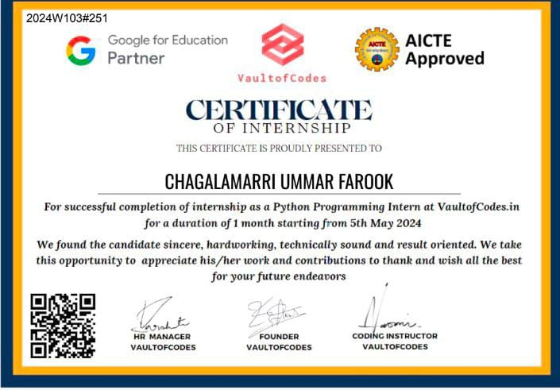

Training completion CERTIFICATE ISSUED BY VAULTOFCODES
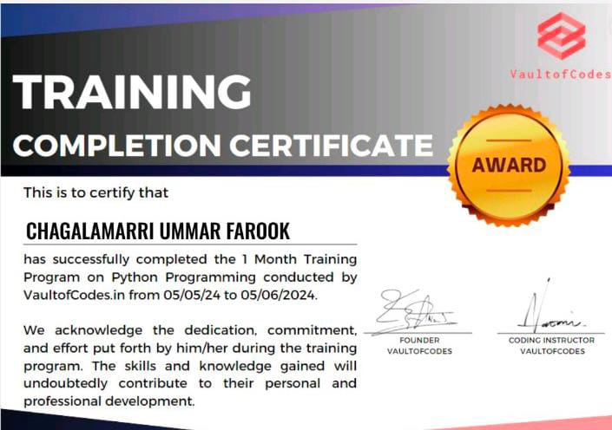

COMPANY PROFILE and EXTERNAL GUIDE DETAILs
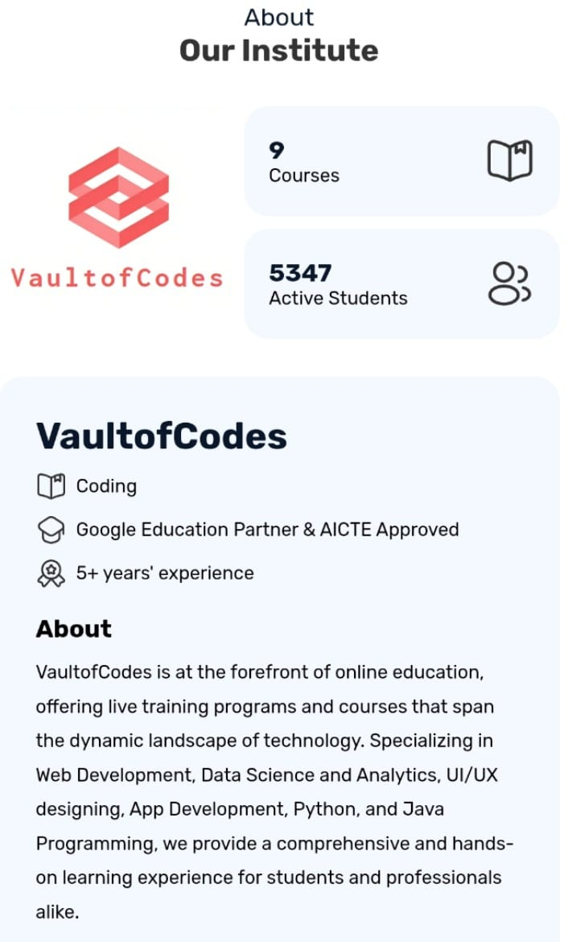



ACKNOWLEDGEMENTS
First I would like to thank Mr. NUR AHAMED MONDAL, VAULTOFCODES for giving me the opportunity to do an internship with in the organization.

Humbly express my thanks to our principal Dr. Nazeer Shaik for extending his support and for providing us with an environment to complete our internship successfully.

I am deeply grateful to our Head of Department, Sri.V.Chakradhar, who modelled us both technically and morally for achieving greater success in life.

I would like to thank all the teaching and non-teaching staff members of Artificial Intelligence And Machine Learning, who have extended their full cooperation during the course of my internship.

Finally, I thank every one who helped directly or indirectly to complete the internship in time.

CHAGALAMARR UMMAR FAROOK
Y22ACM418

ABSTRACT
Title : Rock paper scissor using Python Programming.

Task Objective: Create a Rock Paper Scissors game that allows users to play against a computer, tracks game results, and maintains user scores.
The Rock Paper Scissors game project is a web-based application designed to offer an engaging and interactive experience for users. The primary goal of the project is to enable users to play the classic Rock Paper Scissors game against a computer opponent, with features for user registration, game play, and score tracking.
The project aims to create a robust and user-friendly Rock Paper Scissors game using modern web technologies. It provides an intuitive interface for users to interact with the game, while also ensuring that game results and user scores are accurately recorded and managed.

Introduction To Python Programming

Python: Python is a widely used high-level, general-purpose, interpreted, dynamic programming language. Its design philosophy emphasizes code readability, and its syntax allows programmers to express concepts in fewer lines of code than would be possible in languages such as C++ or Java. The language provides constructs intended to enable clear programs on both a small and large scale. Python supports multiple programming paradigms, including object-oriented, imperative and functional programming or procedural styles. It features a dynamic type system and automatic memory management and has a large and comprehensive standard library. Python interpreters are available for installation on many operating systems, allowing Python code execution on a wide variety of systems.


- Developed by Guido van Rossum
- On February 20,1991

Python, a high-level, interpreted programming language, was created by Guido van Rossum and first released in 1991. Van Rossum began working on Python in the late 1980s as a successor to the ABC language, which he had worked on at Centrum Wiskunde & Informatica (CWI) in the Netherlands. His goal was to create a language with an easy-to-read syntax and strong emphasis on code readability. Python 1.0 was officially released in January 1994, and it quickly gained attention for its simplicity and versatility.

Over the years, Python has undergone significant development. Python 2.0, released in 2000, introduced many new features, including list comprehensions and garbage collection. In 2008, Python 3.0 was released with a focus on removing redundant features and improving language consistency. This version marked a major milestone but was not backward-compatible with Python 2.x, leading to a transitional period for developers.

Python's growth has been fueled by its large and active community, which contributes to a rich ecosystem of libraries and frameworks. Today, Python is widely used in web development, data science, artificial intelligence, scientific computing, and more. Its design philosophy emphasizes code readability and simplicity, making it a popular choice for both beginners and experienced programmers.

Features Of Python
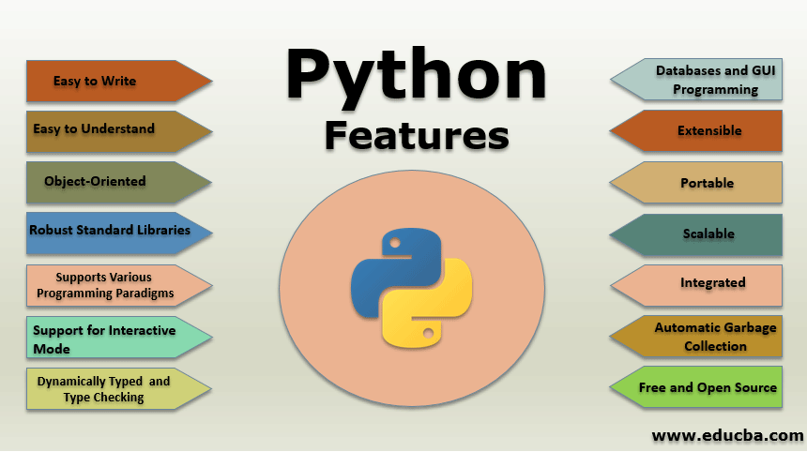

SCOPE OF PYTHON
1- Automation And Scripting
- Tasks
2- Cybersecurity
- Tools
3-Game Development
- Libraries
4- Web Application Development
-Frameworks

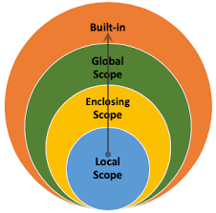
What Can We do With Python?
1-Image Processing
2-XML Processing
3 - Robotics
4 – Web Development
5 – Scientific computing
6 – Security, Finance, Cloud Computing and more

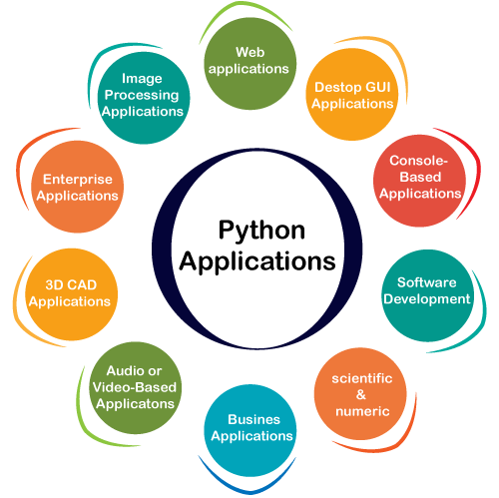

PROJECT

1.INTRODUCTION:

The Rock-Paper-Scissors game is a simple hand game where each player simultaneously chooses one of three options: rock, paper, or scissors. The game follows these rules:
Rock crushes scissors.
Scissors cuts paper.
Paper covers rock.

WINNING RULES AS FOLLOWS:
Rock vs paper-> paper wins
Rock vs scissor-> Rock wins
paper vs scissor-> scissor wins

In this Python project, we will create a basic version of this game where:
The user inputs their choice.
The computer randomly selects a choice.
The winner is determined based on the game rules provided as above.

2.Literature Survey/Existing System

1. Game Mechanics and Basics:
Rock-Paper-Scissors is a simple hand game with deterministic outcomes based on player choices. It serves as a basic example of game theory in action.

2. Python Programming Fundamentals:
Python’s simplicity makes it an ideal language for beginners. Essential concepts like conditionals and loops are fundamental for implementing the game.

3. Random Choice Generation:
The random module in Python is used to simulate the computer’s choice, ensuring that the game is fair.

4. User Interaction:
Handling user input effectively is crucial for a smooth gameplay experience.

3.Software Requirement Analysis:

1.Functional requirements definitions-
- User Interface Requirements:
  - The game must provide a user interface that allows the player to select one of the three options: Rock, Paper, or Scissors.
  - The interface must display the user's choice.
  - The interface must display the computer's choice.
  - The interface must show the result of the game (win, lose, draw).
- Game Logic Requirements:
  - The game must randomly select Rock, Paper, or Scissors for the computer.
  - The game must compare the user’s choice and the computer’s choice to determine the result based on the following rules:
    - Rock beats Scissors.
    - Scissors beats Paper.
    - Paper beats Rock.
    - The same choices result in a draw.
  - The game must accurately calculate and display the result of each round.
- Score Tracking Requirements:
  - The game must keep track of the number of games won, lost, and drawn by the player.
  - The game must display the current score to the player.
- Play Again Option:
  - After each round, the game must offer the player the option to play again.
  - If the player chooses to play again, the game must reset the round and allow the player to make a new selection.
  - If the player chooses not to play again, the game must end and display the final score.
- End Game Requirements:
  - The game must provide a way for the player to exit or end the game at any time.
  - Upon exiting, the game must display the final score.
- Accessibility and Usability:
  - The game interface must be easy to use and understand.
  - The game must provide clear instructions on how to play.
  - The game must be accessible to players of all ages and abilities.
- Error Handling:
  - The game must handle invalid inputs gracefully (e.g., if an invalid option is selected, prompt the user to select a valid one).

2.Non-functional requirements definitions:-

Non-functional requirements for a Rock Paper Scissors game are the criteria that judge the operation of the system, rather than specific behaviors or functions. These requirements focus on the performance, usability, reliability, and other quality attributes of the system. Here are some key non-functional requirements for a Rock Paper Scissors game:
1.Performance Requirements:
  - The game must load within 2 seconds on average.
  - The game must respond to user inputs within 100 milliseconds.
2.Usability Requirements:
  - The game interface must be intuitive and easy to navigate.
  - Instructions on how to play the game must be clear and accessible.
  - The game should be accessible to users with disabilities, following relevant accessibility standards (e.g., WCAG).
3.Reliability Requirements:
  - The game must have an uptime of 99.9% over any given month.
  - The game must handle at least 1,000 concurrent users without crashing.
4.Scalability Requirements:
  - The game architecture must support scaling up to accommodate an increasing number of users.
5.Security Requirements:
  - The game must protect user data and ensure that any personal information is securely stored and transmitted.
  - The game must implement measures to prevent cheating or manipulation of game outcomes.
6.Compatibility Requirements:
  - The game must be compatible with major web browsers (e.g., Chrome, Firefox, Safari, Edge).
  - The game must be responsive and work on various devices, including desktops, tablets, and smartphones.

Source Code:

import random

print('Winning rules of the game ROCK PAPER SCISSORS are :\n'
+ "Rock vs Paper -> Paper wins \n"
+ "Rock vs Scissors -> Rock wins \n"
+ "Paper vs Scissors -> Scissor wins \n")

while True:

print("Enter your choice \n 1 - Rock \n 2 - Paper \n 3 - Scissors \n")

choice = int(input("Enter your choice :"))

while choice > 3 or choice < 1:
choice = int(input('Enter a valid choice please '))

if choice == 1:
choice_name = 'Rock'
elif choice == 2:
choice_name = 'Paper'
else:
choice_name = 'Scissors'

print('User choice is \n', choice_name)
print('Now its Computers Turn....')

comp_choice = random.randint(1, 3)

while comp_choice == choice:
comp_choice = random.randint(1, 3)

if comp_choice == 1:
comp_choice_name = 'RocK'
elif comp_choice == 2:
comp_choice_name = 'Paper'
else:
comp_choice_name = 'Scissors'
print("Computer choice is \n", comp_choice_name)
print(choice_name, 'Vs', comp_choice_name)

if choice == comp_choice:
print('Its a Draw', end="")
result = "DRAW"

if (choice == 1 and comp_choice == 2):
print('paper wins =>', end="")
result = 'Paper'
elif (choice == 2 and comp_choice == 1):
print('paper wins =>', end="")
result = 'Paper'

if (choice == 1 and comp_choice == 3):
print('Rock wins =>\n', end="")
result = 'Rock'
elif (choice == 3 and comp_choice == 1):
print('Rock wins =>\n', end="")
result = 'RocK'

if (choice == 2 and comp_choice == 3):
print('Scissors wins =>', end="")
result = 'Scissors'
elif (choice == 3 and comp_choice == 2):
print('Scissors wins =>', end="")
result = 'Rock'

if result == 'DRAW':
print("<== Its a tie ==>")
if result == choice_name:
print("<== User wins ==>")
else:
print("<== Computer wins ==>")
print("Do you want to play again? (Y/N)")

ans = input().lower()
if ans == 'n':
break

print("Game is over")

random.randint():

The `random.randint()` function in Python's `random` module generates a random integer within a specified range, inclusive of both endpoints. For example, `random.randint(1, 10)` could return any integer from 1 to 10, making it a versatile tool for various applications, such as simulations, games, and randomized tasks. By importing the `random` module and calling `random.randint(a, b)`, developers can easily introduce randomness into their programs. This function is widely used due to its simplicity and effectiveness in generating pseudo-random numbers. However, for applications requiring cryptographic-level randomness, the `secrets` module is recommended.

Output Screens / Results:-

selecting choice Rock

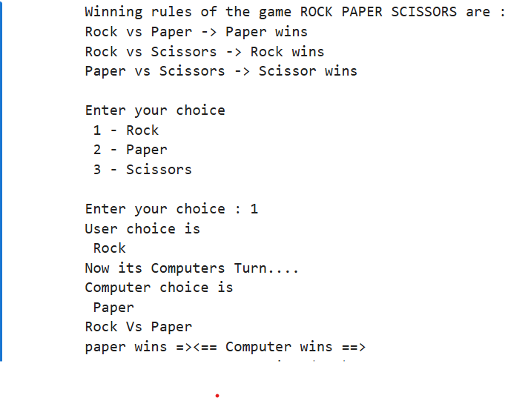

Selecting choice Paper

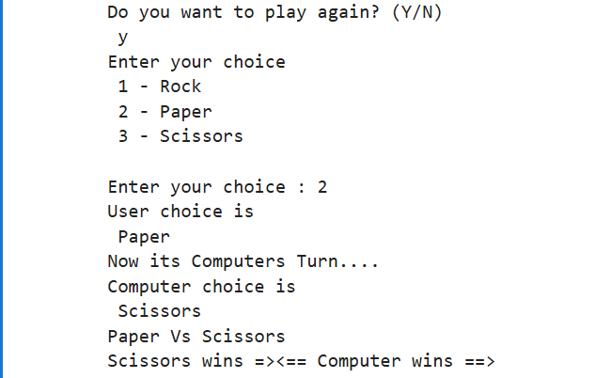
Selecting choice Scissor

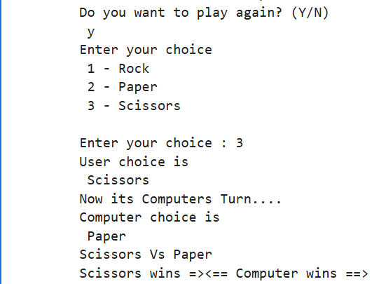

Terminating the game
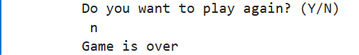

Conclusion:-

In conclusion, the Rock-Paper-Scissors game serves as an excellent example of a simple yet effective decision-making tool rooted in probability theory. Despite its basic rules, the game encapsulates fundamental principles of game theory, illustrating the concept of Nash equilibrium where no player can benefit by changing their strategy unilaterally. The game's balance, where each option equally counters another, underscores the inherent fairness and unpredictability that makes it a staple in casual decision-making contexts.

Throughout the analysis, it becomes evident that Rock-Paper-Scissors is not merely a game of chance but one where strategic thinking and psychological elements come into play. By analyzing various strategies and outcomes, players can develop patterns and adapt their approach to gain a competitive edge. This simple game thus highlights how complex decision-making can be derived from elementary rules.

The adaptability of Rock-Paper-Scissors extends beyond entertainment, as it finds applications in resolving disputes, selecting options, and even in programming and algorithm design. The game's structure facilitates a clear understanding of randomization and equilibrium, making it a valuable tool for educational purposes.

Overall, Rock-Paper-Scissors exemplifies how a straightforward game can reveal intricate concepts in probability and strategy, demonstrating that even the simplest games can offer deep insights into human behavior and decision-making processes.

10.References:-

- Python program to implement Rock Paper Scissor game - GeeksforGeeks
- Books: ”Automate The Boring Stuff with python” by AI Sweigrat
- Git Hub repository: Libraries and packages

