Alpha Generation Project Report

# Model Summary

- Model Type: LSTM (Long Short-Term Memory)  
- Layers:  
 - LSTM Layer 1: 50 units (return_sequences=True)  
 - LSTM Layer 2: 50 units (return_sequences=False)  
 - Dense Output Layer: 1 unit (final prediction)  
- Optimizer: Adam  
- Loss Function: Mean Squared Error

# Feature Importance Visualization

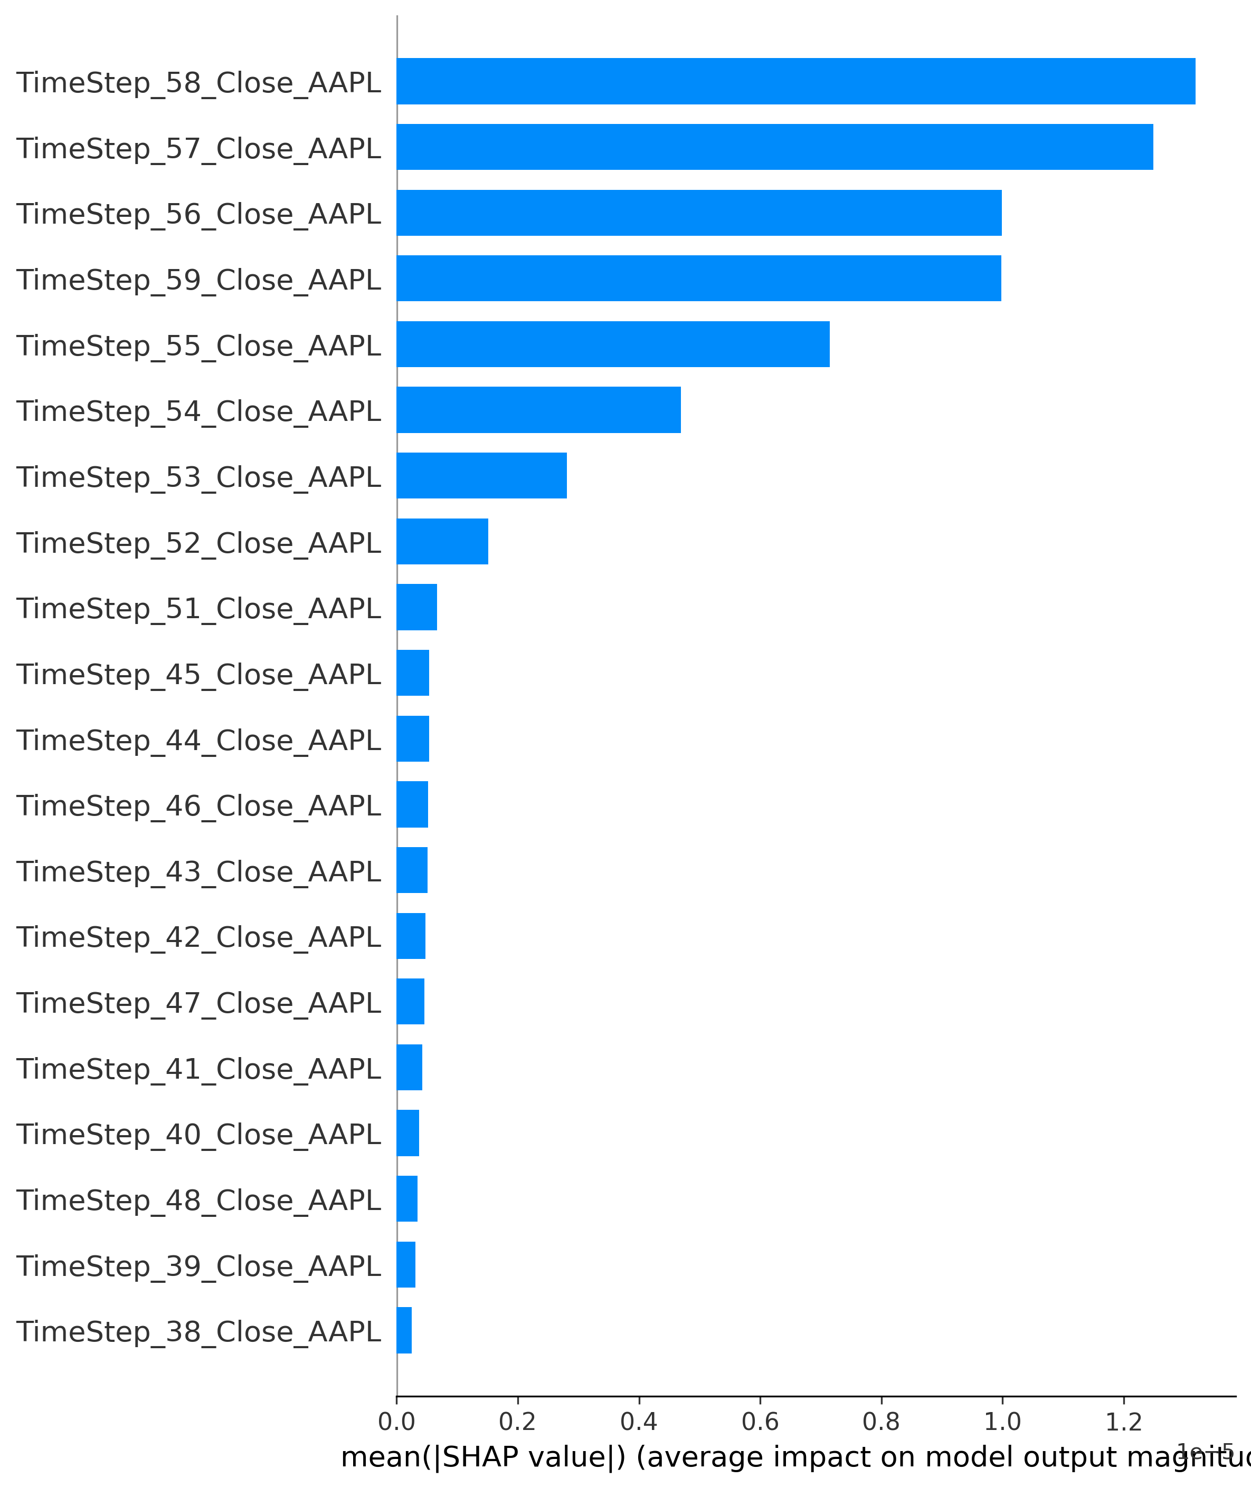

# Top Features Based on SHAP Values

|  |  |
| --- | --- |
| Feature | Importance |
| TimeStep_58_Close_AAPL | 0.000013 |
| TimeStep_57_Close_AAPL | 0.000012 |
| TimeStep_56_Close_AAPL | 0.000010 |
| TimeStep_59_Close_AAPL | 0.000010 |
| TimeStep_55_Close_AAPL | 0.000007 |
| TimeStep_54_Close_AAPL | 0.000005 |
| TimeStep_53_Close_AAPL | 0.000003 |
| TimeStep_52_Close_AAPL | 0.000002 |
| TimeStep_51_Close_AAPL | 0.000001 |
| TimeStep_45_Close_AAPL | 0.000001 |

# Prediction Example

The model was tested with a sequence of 60 time steps for AAPL stock prices. A sample prediction is shown below:

Predicted Price: $174.01

# Conclusion

This report presents the results of the LSTM-based model for stock price prediction.   
The SHAP values highlight the importance of recent time steps in influencing the model's predictions.   
  
Next steps:  
- Improve data preprocessing for better feature engineering.  
- Experiment with other architectures like GRU or Transformer-based models.  
- Deploy the model using a scalable cloud solution for real-time predictions.